 | Synoptic Display Studio  Rules and Scripting

Kai Meyer

C1 WPS GmbH
Vogt-Kölln-Straße 30
D-22527 Hamburg
[kai.meyer]@c1-wps.de

Table of Contents
1. Introduction 4
2. Rules 5
2.1. Java-based rules 5
2.1.1. Define a Java-based rule 5
2.1.2. Register the rule 6
2.1.3. Configuration 7
2.2. Scripted rules 8
2.2.1. Define a JavaScript rule 8
2.2.2. Configuration 9
3. General scripts 10
4. SDS Script Editor 11
5. References 12

Document History

Document version | Author | Comments
1.0 (20.03.2009) | C1 WPS | Initial version

Introduction
This document is intended to guide users of Synoptic Display Studio (SDS) who want to use and create new rules and scripts for their displays.
Rules are used to translate values coming from the control system to something the SDS can understand. Because the rules are such a fundamental part of the communication with the control system, some basic rules are encoded completely in Java and added through the extensible system architecture, based on the extension points of the eclipse rich client platform (RCP). For more flexibility and customization rules can be written in JavaScript as well. Those scripts must have special global variables and a specific method, to enable the communication with the SDS.
The integration of JavaScript into the SDS is done by the RHINO framework.
Scripts can also be used to implement more complex functions and thus enrich the functionality of the SDS. Those scripts can be triggered by the Timer widget or by an action defined for any widget.
Chapter 2 describes how Java-based and scripted rules are created and integrated into the SDS. Chapter 3 contains an example of a custom script and some functions the SDS provides for scripts. The editor for scripts provided by the SDS is described in chapter 4. The document ends with references to other documents.

Rules
As mentioned above the rules can be used to translate values of the control system into something the SDS can handle. If a property should be dynamic, a org.csstudio.sds.model.DynamicDescriptor has to be attached to it. That can be done by the Dynamics Wizard. The DynamicDescriptor can contain several input and output channels. Every channel is associated with a breakpoint of the control system. The control system notifies the DynamicDescriptor every time the value of an input channel changes. Afterwards the descriptor uses its configured rule to calculate the new value for the property. The org.csstudio.sds.model.logic.NullRule can be used to pass the value of an input channel directly to the property.
The following descriptions and examples are based on this case:
The foreground color of a widget should be changed corresponding to the current integer value of the channel associated with the channel “local://FillValue”. If the current value is greater than 66 the color will be red, between 66 and 33 yellow and under 33 the foreground will be green. Is the value negative, than black should be used.
At first we describe the implementation of the rule in Java and its registration at the SDS. The second section shows how to implement the rule with JavaScript. Afterwards there is a sample configuration within the Dynamic Wizard for both rules.

Java-based rules
Due to the extensible architecture of the SDS three steps have to be performed to integrate a new Java-based rule into the SDS. First you have to define the rule itself. The second step is to register the rule via an extension point at the SDS. Finally the rule has to be configured and attached to property. Because the rule returns a RGB value, the property has to be Color property, for example the foreground color.
    - Define a Java-based rule
Every Java rule has to implement org.csstudio.sds.model.logic.IRule. The following code shows the complete org.csstudio.sds.model.logic.AdvancedColorRule. The code is discussed afterwards.

public final class AdvancedColorRule implements IRule {

/**
* BLACK color.
*/
private static final RGB COLOR_BLACK = ColorConstants.black.getRGB();

/**
* Standard constructor.
*/
public AdvancedColorRule() {
}

/**
* {@inheritDoc}
*/
public Object evaluate(final Object[] arguments) {
if (arguments != null && arguments.length > 0 && arguments.length < 5) {
if (arguments[0] instanceof Number) {
RGB highColor = COLOR_BLACK;
RGB mediumColor = COLOR_BLACK;
RGB lowColor = COLOR_BLACK;
if (arguments[1] instanceof RGB) {
highColor = (RGB) arguments[1];
}
if (arguments[2] instanceof RGB) {
mediumColor = (RGB) arguments[2];
}
if (arguments[3] instanceof RGB) {
lowColor = (RGB) arguments[3];
}

double d = ((Number) arguments[0]).doubleValue();

if (d > 66) {
return highColor;
}

if (d > 33) {
return mediumColor;
}

if (d > 0) {
return lowColor;
}
}
}

return COLOR_BLACK;
}
}

IRule only defines the method evaluate(..), which contains the complete logic of the rule. The AdvancedColorRule expects four parameters: the first is a java.lang.Double, the next three parameters are org.eclipse.swt.graphics.RGB’s. Corresponding to the given double value, the associated color is returned. In this case the colors are not specified in the code, but given as parameters. That allows using this rule also for other color sets. Thus this rule is generic and more flexible than org.csstudio.sds.model.logic.SimpleColorRule which specifies the colors in the code.
    - Register the rule
Now the rule has to be register at the SDS. For that a new extension for the extension point org.csstudio.sds.rules of plug-in org.csstudio.sds is required.
The following example shows the complete extension for the AdvancedColorRule:

<extension point="org.csstudio.sds.rules">
<rule
class="org.csstudio.sds.model.logic.AdvancedColorRule"
name="Advanced Color Rule"
returnType="org.eclipse.swt.graphics.RGB"
ruleId="org.csstudio.sds.AdvancedColor">
<parameterDescription
name="Value"
type="java.lang.Double">
</parameterDescription>
<parameterDescription
name="High Color"
type="org.eclipse.swt.graphics.RGB">
</parameterDescription>
<parameterDescription
name="Medium Color"
type="org.eclipse.swt.graphics.RGB">
</parameterDescription>
<parameterDescription
name="Low Color"
type="org.eclipse.swt.graphics.RGB">
</parameterDescription>
</rule>
</extension>

The extension specifies the class the ruleId the name and the returnType. The system-wide unique ID indentifies the rule within the SDS and the stored XML file of the display. The name is used as a label within the Dynamic Wizard while the return type is used to filter the rules. Thus only rules with a return type corresponding to the value of the chosen property are available. The parameterDescriptions describe the expected parameters for the rule and the optional type allows the SDS to provide an adequate editor for the default value. If the type is missing the default value will not be configured. For every parameter expected by the rule, there has to be a corresponding parameterDescriptor. The Dynamics Wizard will initialize an entry for an input channel for every registered parameterDescriptor.
    - Configuration
A configuration for a Color property using the AdvancedColorRule can look like this:
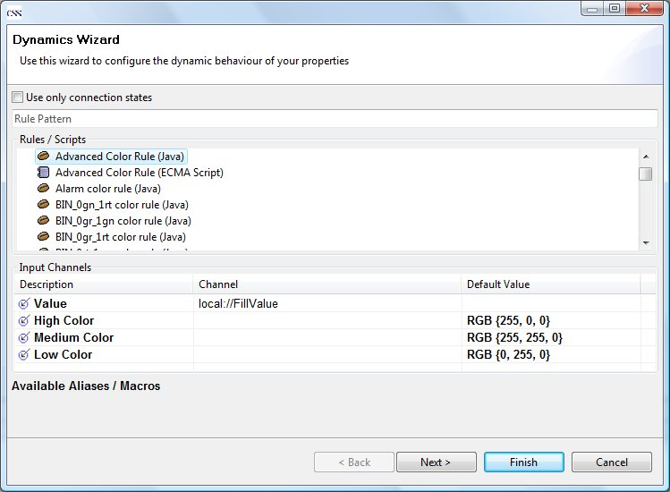
Figure 1: Configured AdvancedColorRule (Java)
The list for the rules in the upper section contains only rules with the return type RGB, because a color property was selected. As you can see there are two icons for the rules. The bean stands for Java-based rules while the paper points to a scripted rule. Because the “Advanced Color Rule (Java)” is selected, four parameters corresponding to the four parameterDescriptions in the extension are displayed. Only the Value parameter gets a configured channel. Thus the three colors are handled as constants. If you configure a channel and a default value, than the values are used initially and will be updated when the control system notifies the rule of a change.

Scripted rules
Scripted rules are pretty much the same as Java-based rules. Because they are written in JavaScript, they can’t be attached through an extension. The files containing the rules (*.css-sdss) have to be located in the “SDS Script Rules” folder or in a folder configured in the preference “CSS Application > Display > Rule Folders”. It is recommended that there is one file per scripted rule and that every file has a different name, because the name of the file is used as ID within the SDS.
    - Define a JavaScript rule
The SDS provides an integrated editor for the scripts. So no external tool is needed to create scripts or rules. You can use the “Display > Scripted Rule” wizard to create a new scripted rule. The wizard only needs to know the name and the folder for the file. It generates a new file containing global variables and methods required by the SDS. Those are necessary, because a scripted rule has to provide the same information as a Java-based rule. Information like the name, the return type, the parameters and their types belonging to the rule are declared by global variables.
The rule has to contain the variable “returns” and has to be located in a folder known to the SDS. Otherwise you won’t find your rule in the Dynamics Wizard.
The following code shows the complete scripted AdvancedColorRule:

var returns = "org.eclipse.swt.graphics.RGB";
var description = "Advanced Color Rule";
var parameters = new Array("An arbitrary PV", "High Color", "Medium Color", "Low Color");
var parameterTypes = new Array("java.lang.Double", "org.eclipse.swt.graphics.RGB",
"org.eclipse.swt.graphics.RGB", "org.eclipse.swt.graphics.RGB");

var BLACK = new Packages.org.eclipse.swt.graphics.RGB(0, 0, 0);

function execute(args) {
var dataElement = args[0];
var highColor = args[1];
var mediumColor = args[2];
var lowColor = args[3];

if (dataElement > 66) {
return highColor;
}

if (dataElement > 33) {
return mediumColor;
}

if (dataElement > 0) {
return lowColor;
}

return BLACK;
}

A scripted rule has an execute(..) method instead of the evaluate(..) method of a Java-based rule, but they are used the same way. The three global variables at the top are required, because they provide the same information as an extension for a Java-based rule. Because the rule expects four parameters, the “parameters” variable contains for Strings as descriptions for the parameters. “parameterTypes” is optionally, but highly recommended, because otherwise the default values can’t be configured. Just like a missing type of a parameterDescriptor for Java-based rules. Furthermore it is strongly recommended that arrays of “parameters” and “parameterTypes” have the same length.
It is possible to use Java classes in a script. As you can see the AdvancedColorScript uses java.lang.Double and org.eclipse.swt.graphics.RGB. You can find a more detailed description for the usage of Java classes within scripts in chapter 3.

    - Configuration
A sample configuration for a Color property is shown below:
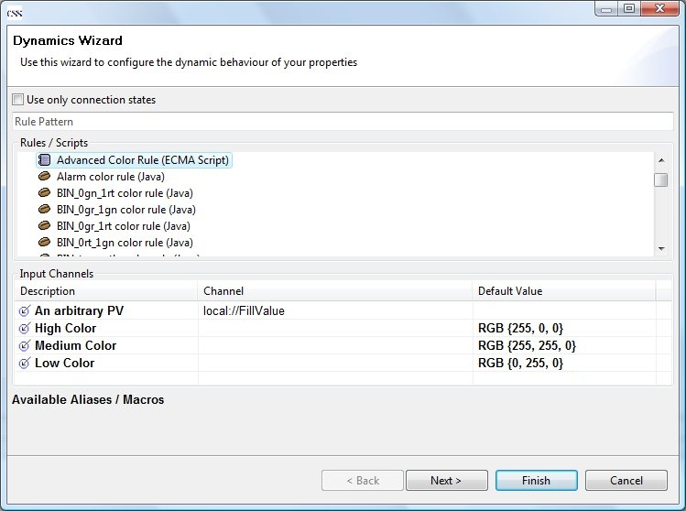
Figure 2: Configuration of AdvancedColorRule (Script)
As you can see the configuration differs only in the selected rule, because both rules provide the same functionality. Within the Dynamics Wizard Java-based and scripted rules are treated like the same.

General scripts
JavaScript can also be attached to widgets of the SDS to perform more complex tasks, for example open a display after a short delay or play sounds. General scripts can be created by the “Display > SDS Script” wizard, which also generates a template for the new script. Those scripts have the same file-extension (*.css-sdss) and can be implemented with the same editor as the rules, but they are not bounded to special folders. Scripts can be triggered by the Timer widget or by a special action contained in the Action Data property of any widget.
The following code shows a script which starts an mp3 file, opens another display, waits for 30 seconds, closes the display and stops the replay.

importPackage(Packages.org.csstudio.sds.ui.scripting);

function execute() {
/* Play an arbitrary MP3. */
Functions.playMp3("%workspace%SDS Demo Display//Training//MP3//Adiemus.mp3");
/* Open a SDS display in a shell. */
Functions.openDisplay("%workspace%SDS Demo Display/Testcases/helper/composite1.css-sds");

/* Wait for some seconds */
Functions.wait(30);

/* Close all instances of a SDS display. */
Functions.closeDisplay("%workspace%SDS Demo Display/Testcases/helper/composite1.css-sds");
/* Stop playing */
Functions.stopPlaying();
}

SDS scripts need the execute(..) method in the same way as the scripted rules, but global variables are not required. The class org.csstudio.sds.ui.scripting.Functions offers various methods to use SDS and special functionalities. The methods provided by Functions are:

- alert()
- beep()
- siren()
- playMp3(String path)
- stopPlaying()
- openDisplay(String path)
- closeDisplay(String path)
- wait(int seconds)

Please refer to the JavaDocs of that class to get more details about the methods.
You can use the Java classes directly as shown in the scripted AdvancedColorRule or you can import the complete package of the classes you want to use by using importPackage(..).
The prefix %workspace% will be replaced by the path to the current workspace of the CSS application. So you don’t have to specify full qualified paths for displays or other files.

SDS Script Editor
The Script Editor provided by the SDS is a custom-made editor. It is built upon a generic Language Editor, which is also used for the SNL Editor. The current version of the Script Editor supports highlighting of specific language elements (operators, numbers, Strings, comments …), an outline view, a syntax check and it checks the compatibility to the SDS of rules.
Every time the file is saved the editor parses the content to find all declared variables and functions. That information is used for the Outline View and to check the compatibility to the SDS. If the script contains a global variable with the name “returns”, the editor will treat the script as a rule and for that expects global variables for “parameters” and “description” and “parameterTypes”. A missing “parameterTypes” variable is not an error but a warning, because the “parameterTypes” are optional.
The syntax check is done by RHINO. It tries to compile the file and the first detected error is marked within the file.
All errors and warnings are marked on the left side of the editor. The following screenshot shows a scripted rule with some errors and warnings and the outline of the file:
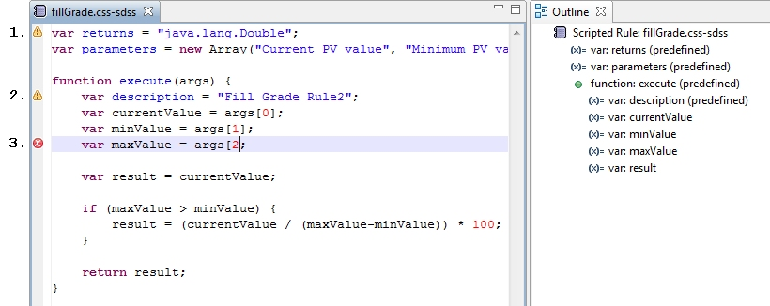
If you point to the warning and error marks a hint with more detailed information will appear. In this case it will be:
- Missing variable declaration for ‘parameterTypes’
- ‘description’ should be a global variable for rules
- Missing ] in index expression (fillGrade.css-sdss#8)
The Outline on the right side shows the corresponding Abstract Syntax Tree (AST) for the file.

References
The following list contains some references to documents that provide a more detailed discussion of SDS-related technologies.
RHINO Mozilla.org: Rhino: JavaScript for Java, http://www.mozilla.org/rhino/, https://developer.mozilla.org/en/Rhino_documentation

