Technical Whitepaper

Synoptic Display Studio
A Display Editing and Runtime Environment for Control Systems
October 2007

Stefan Hofer, Sven Wende, Alexander Will

C1 WPS GmbH
Vogt-Kölln-Straße 30
D-22527 Hamburg
[sven.wende|alexander.will|stefan.hofer]@c1-wps.de

About the Synoptic Display Studio
The Term Synoptic Display is commonly used for online graphical representation of changing data. The Synoptic Display Studio is a new approach for a versatile display editing tool and a corresponding runtime environment. This document gives a brief overview of its context and the main features as well as technical background information. It is assumed that the reader is somewhat familiar with the application domain of control systems.
The Synoptic Display Studio (SDS) provides an editing tool and a runtime environment for technical displays that visualize control system data in physical institutes. It is built upon three pillars (illustrated in Figure 1):
- The Eclipse Rich Client Platform (RCP) and associated projects: These frameworks provide the base for a rich client and graphical editing application like the SDS.
- The Control System Studio (CSS): The CSS is a framework that enriches the Eclipse RCP framework by adding infrastructure. Among these things are APIs for data handling, authorization and authentication, management of installations and more.
- The Data Access Layer (DAL): This API encapsulates access to specific control systems. Thus, with this layer of abstraction it is possible to write applications that work with multiple control systems. So far, bindings for the EPICS and TINE control systems are under development.
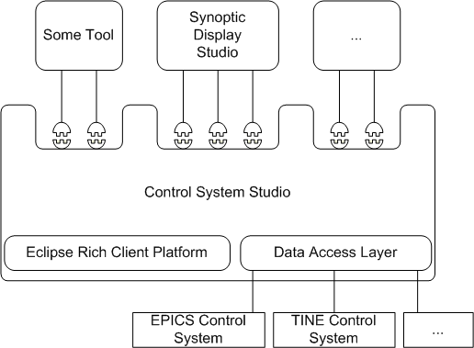
Figure 1: Architecture overview
The SDS is realized as a set of Eclipse plug-ins and integrates seamlessly into a CSS environment. Both SDS and CSS were initiated at DESY Hamburg. Their development is an open process and interested readers may support development by testing, giving feedback, joining the according mailing list or developing applications.

Motivation And Design Goals
Lots of software products for creating and running synoptic displays already exist (like DM2K, JoiMint and Iconics Genesis 32, to name just a few). They were built by researchers or companies, are based on a wide range of technologies, focus on different aspects of synoptic displays and were more or less successful. Yet, they all have at least one of the following shortcomings:
- Commercial, closed source product: The software is owned and licensed by a company. Using commercial software is not only a monetary issue but also makes you depend on the producer. Typically, modifications are only possible as far as customization options are available or have to be ordered as change requests. Participation in future development is limited.
- Extensibility: The original developers are the bottleneck for extensibility. Development may require special knowledge, such as about an outdated technology or detailed information of the (possibly undocumented) software design.
- Independence of control system: The software only works with a certain type of control system (e.g. EPICS) or is even bundled with it by a commercial vendor. Displays created with other software need to be converted or re-implemented.
- Isolated solution: The software is only capable of creating and running displays but not part of a solution that covers the needs of other control system usage scenarios. Integration with such other tools is not possible or limited to a basic set of operations provided by an operating system.
Since both the SDS and the CSS assert their claim to found a new generation of control system tools, they have to address these shortcomings. Of course the SDS must provide all the features that users expect of a modern display editor as well. Thus, the SDS pursues the following goals:
- Rich editing and visualization features: A display editor and manager respectively have to provide a rich set of features that suites the needs of a heterogeneous group of users.
- Usability: Creating and managing displays involves a lot of configuration work. This should be made as easy as possible without cutting back features.
- Generality: The SDS has to work with lots of different control systems and devices.
- Extensibility: The SDS is not a closed product but an open project. It should invite its users to participate in its development and extension by lowering the technical barrier of software development. Since this can only by achieved to a certain extent, the design should make simple extension tasks easy and complex extension tasks possible.
- Adaptability: Due to its use context, the SDS should encounter the need for customization by an adaptable design.
- Tool integration: The SDS should leverage the rich means of tool interaction that are possible in the CSS environment.
- Cooperative usage: Sharing displays and knowledge between users saves time and effort and should thus be made possible by the SDS.
In the next sections we explain how we met these goals. We start with an overview of the usage scenarios and the main elements of the SDS. Then we elaborate how the concepts of configuration, extension and reuse are applied in the SDS to implement the above requirements. Finally, we will point to additional documentation and download locations.

SDS Overview
The SDS is built upon the proven Eclipse Graphical Editing Framework (GEF), inheriting its rich set of editing features. The tool works in two modes: An editing mode and a run mode. As both of them use GEF, the gap between editing and running a display is small and a display developer can receive direct feedback by switching between modes. During editing, you define the static (such as layout and data sources) and dynamic aspects (how to react on data changes) of a display. Running a display means a connection to the control system is established and its data is visualised and continuously refreshed. This is illustrated in Figure 2 and Figure 3 which show the same display in both modes. Note that the run mode window may also be attached to the CSS workbench.
Widgets are the building blocks of displays. In the SDS, widgets are abstract graphical items and do not have to correspond to devices. A widget may represent data from an arbitrary number of devices, regardless of which vendor they were produced by or whether they are assembled in a single installation. It does not even matter which control system is used to receive values as the SDS accesses control systems not directly but via the Data Access Layer (DAL) library. That way, a display can be used with any control system that is supported by DAL. It is even possible to connect widgets of a single display to several control systems, because they use different namespaces to avoid name clashes.
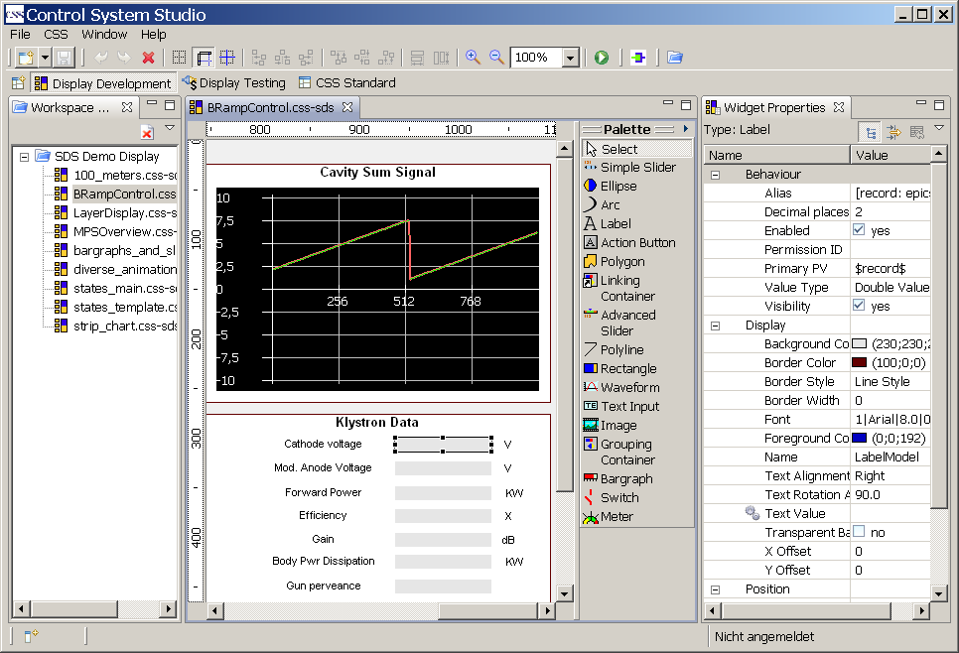
Figure 2: Display editing: Workspace with displays (left), graphical editor with widget palette (center) and properties of the selected widget.
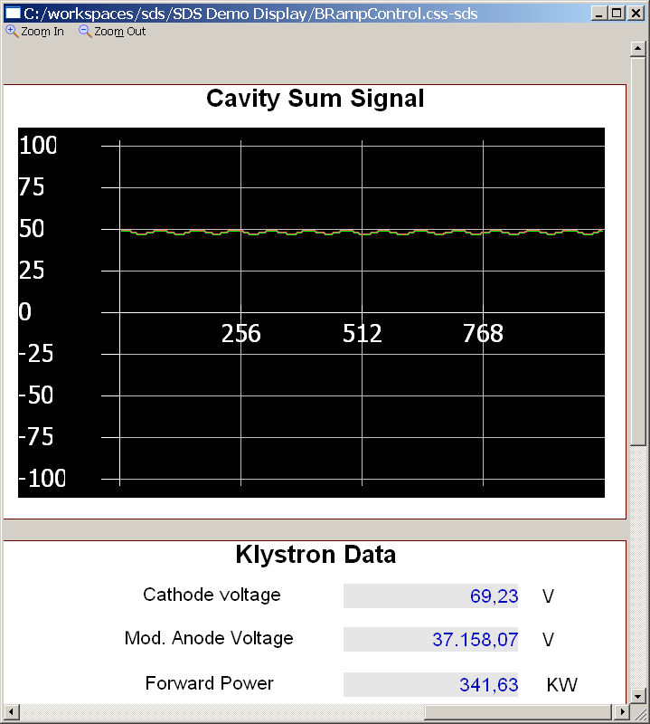
Figure 3: The same display as above in run mode, visualising control system data.

Configure – Reuse – Extend
Since the displays that can be built using the SDS are very flexible, the editing tool has to reflect this flexibility. A typical way of dealing with this problem is to offer lots of configuration options. The SDS goes one step further: Additionally to a huge set of options it is possible to contribute components that extend certain parts of the SDS. This gives you a lot of freedom to adopt the tool. Besides reusing existing components you may even write custom ones.

Configure
Considered the complexity of the application domain of the SDS one would expect a lot of configuration work to get a display up and running. Since the SDS was designed to be a configurable as necessary and as usable as possible it cannot rely on the means of user interaction provided by the Eclipse platform only. We provide additional help by
- the way how the sources of control system values (so-called process variables) are handled and presented to the user and
- different means of user interaction and data input.
To ease the use of long and clumsy process variables the SDS provides a kind of macro replacement mechanism using aliases. An alias is a logical name that is defined once and used as a substitute for parts of a process variable (see Figure 4). This way the definition of a process variable becomes more comprehensive and saves a lot of typing. Aliases can have a display wide scope, allowing for their use across several widgets, or a widget wide scope so that they can only be used for process variable definitions within a widget.
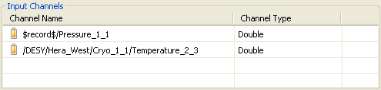
Figure 4: Two process variables. The upper one contains an alias.
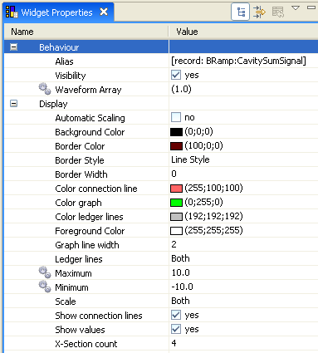
The SDS provides different means of display manipulation so that the users can choose which one suite their needs best. Graphical editing is only possible to a limited extent, as some properties (e.g. dynamic behaviour) do not represent visible aspects of displays or widgets. Properties can be manipulated either by a set of wizards that guide the user through the configuration process or inline in the SDS property sheet (see Figure 5). This table of properties and values is synchronized with the corresponding widgets or the display. A change in one of them instantly changes the other one, providing the user immediate feedback about the change. Another way to manipulate a display is by drag & drop. The SDS uses the generic drag & drop API that comes with the CSS. All applications that use this API can exchange data by drag & drop. This exchange is not limited to simple strings of characters. In fact, it is possible to transfer complex objects like process variables that represent information about control system values.
Figure 5 Section of the property sheet.

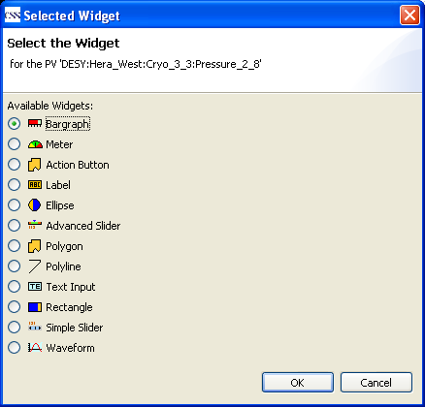
Extend
Since it is hard to anticipate a display designer’s needs, the SDS widget set is extensible. This means that you can integrate third party widgets as well as write own widgets. We will elaborate on this scenario so you get an impression how to extend the SDS.
In case of a widget, you have to extend four Java classes and need a little Draw2d experience. Error: Reference source not found shows how one of those classes for a rectangle widget looks like. The rectangle can be filled to a certain percentage with a foreground color. The example class is only responsible for drawing the widget. The API is kept simple and allows you to focus on the widget itself, freeing you from burdens like how to persist your widgets or how to connect them to control systems. Once you packaged your widgets in a plug-in and installed it, the SDS will automatically add the new widgets to the widget set. For example, they will appear in the widget selection dialog shown in Figure 6.
Figure 6: Contributed widgets will be added to the existing ones.
SDS widgets are very flexible. All of their properties (such as size, fore- and background color, font size, visibility and so on) can be dynamic, which means the values of these properties can change corresponding to the control system values they display. The way how changes of control system values are mapped to changes of widget properties are defined in rules. Rules allow for the post-processing of values and can be arbitrary complex. For example, it is possible to sum up several control system values in a rule and use the result as input value for a text widget. Error: Reference source not foundshows the code of a rule that maps a value to a color. Rules are JavaScript files that are automatically interpreted by an engine included in the SDS. This keeps the technical barrier low and makes rules reusable and exchangeable. The summing rule mentioned above can be used with every property that takes numbers as values, like the fill level of a bar widget or the text of a text widget. To avoid performance issues, rules can alternatively be implemented in Java.
public final class RefreshableRectangleFigure extends RectangleFigure{
…
private double _fillPercentage = 100;

protected synchronized void fillShape(final Graphics graphics){
Rectangle figureBounds = getBounds();
int newW = (int) Math.round(figureBounds.width *
(getFill() / 100));
graphics.setBackgroundColor(getBackgroundColor());
graphics.fillRectangle(getBounds());
graphics.setBackgroundColor(getForegroundColor());
graphics.fillRectangle(new Rectangle(figureBounds.getLocation(),
new Dimension(newW, figureBounds.height)));
}

public void setFill(final double fill) {
_fillPercentage = fill;
}

public double getFill() {
return _fillPercentage;
}
…
}
Listing 1: Excerpt of a class responsible for drawing a fillable rectangle
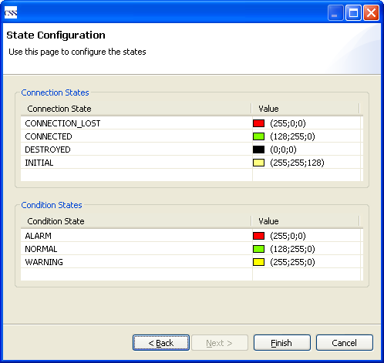
Although, for the freedom of adaptation, it is possible to configure all aspects of a display manually the need for user input can be minimized using initialization components. The initialization components may, for example, take care of the burdensome task of handling connection errors of the control system. Error handling requires mapping the different kinds of errors (e.g. a certain process variable is not updated any more) to visual representations such as textual warnings or color changes of widgets. Contribute an initialization component and all SDS installations that plug in this component can create displays that obey the error handling procedure you defined in this component. For a color property (e.g. the background color of a widget), the configuration might look like Figure 7.
function evaluate(value) {
if (value > 66) {
return RED;
}
if (value > 33) {
return YELLOW;
}
return GREEN;
}
Listing 2: JavaScript implementation of a rule
Figure 7: Error handling configuration
Since other display managers have been in use for a long time there are large numbers of existing displays that may need to be replaced by SDS widgets. Manually re-implementing those widgets with the SDS would be cumbersome. For this reason, the SDS offers a convenient API to create displays using Java, enabling users to write converters.

Reuse
What can be extended can also be reused. In case of the SDS, this includes widgets, initializers, rules and converters (see Figure 8). Converters, initializers widgets and rules (if implemented in Java) are deployed as Eclipse plug-ins. One plug-in may contain one or more extensions. Additionally, whole displays may be shared as they are persisted as XML files on the file system. Rules (if not implemented in Java) are saved as Javascript files. This enables for the exchange of displays and rules between users – even across sites. Thus, sharing your contributions to the SDS is as easy as exchanging any file.
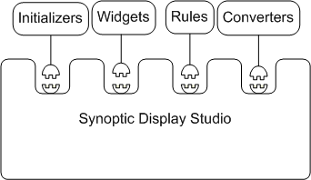
Figure 8: Overview of SDS extensions

Further Information

Download SDS and see for yourself
First, download and install the CSS platform (http://css.desy.de/content/e413/index_eng.html). When you run the CSS for the first time, it automatically opens a manual that describes how to use the preconfigured update site to install plug-ins for the CSS. SDS is available as plug-in on that update site. Once you installed the SDS, a so called Cheat Sheet explains the next steps. Go to “Help à Cheat Sheets à Synoptic Display Studio” to display the sheet.

Technical documents
More information on the Eclipse projects used by the SDS is available online:
- Eclipse RCP Project: http://www.eclipse.org/home/categories/rcp.php
- Eclipse GEF Project: http://www.eclipse.org/gef
There is a set of technical documents available at the Developers Corner on the CSS homepage at http://css.desy.de/content/e428/index_eng.html. They explain the details of the SDS:
- Handling Channel Connection and Condition States in the SDS: A document about the usage of DAL in the SDS and how this is made transparent to widget developers.
- SDS Developers Guide: A guide on how to develop widgets for the SDS.

http://www.eclipse.org/home/categories/rcp.php
http://css.desy.de
http://css.desy.de/content/e428/e791/e792/index_eng.html
See section 5 for further information.
http://www-csr.bessy.de/control/SoftDist/dm2k/
http://joimint.desy.de/
http://www.iconics.com/products/genesis32.asp
http://www.eclipse.org/gef
For details see the SDS Developers Guide mentioned in section 5.

