Chapter 3 Linear-Quadratic (LQ) Optimal Reinforcement Learning Mechanism in Discrete-Time (Hewer’s Algorithm)

Essence of the Hower’s RL Policy Iteration Algorithm
The essence of the Hewer algorithm is to use successive approximations (feedback iterations 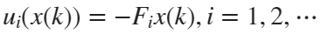, which is equivalent to the reinforcement learning policy iteration) as follows
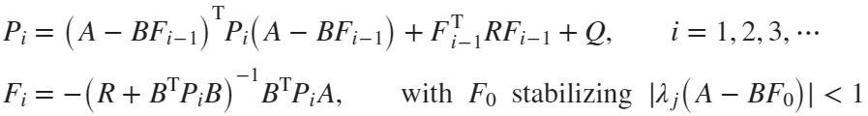
This requires solving in each iteration a discrete-time algebraic Lyapunov equation and updating the approximate feedback gain after initializing the procedure with a stabilizing feedback gain 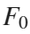, which is much simple and faster than directly solving highly nonlinear algebraic discrete-time Riccati equation (DARE). These iterations converge to the unique stabilizing solution of DARE
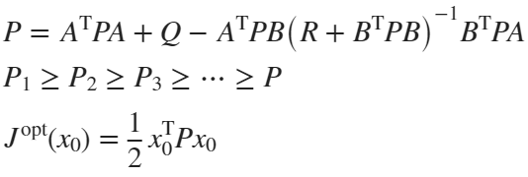
When 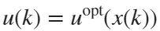 then 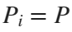, where satisfies DARE. Having obtained 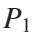, we can use
This approximate control leads to
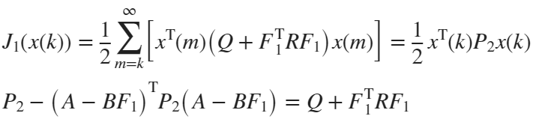
This procedure is iteratively repeated
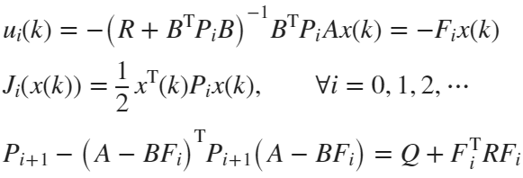
The generated sequence of matrices has the property
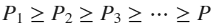
where is the unique stabilizing solution of DARE, and with the approximate performance criterion values converging to the optimal performance criterion value, that is
It was stated and proved in the papers by Hewer that this algorithm has a quadratic rate of convergence.

Project Report Format:
The project reports are supposed to be typed and contain the standard technical paper main parts: introduction (about the general methodology used), problem formulation (what you plan to do and what you are supposed to achieve), main results obtained (obtained simulation results, tables, and figures), discussion/comments (on obtained results and some observations), conclusions, appendix (with MATLAB code), references.
Project Data:
The project considers a Boeing 747 flight controls system from a very recent paper (see Section 3.6 for details). Assuming level flight at 40,000 ft at a speed of 774 ft/s, and the discretization interval of 1 s, the linearized aircraft dynamic is represented in the discrete-time domain by
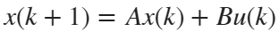
where
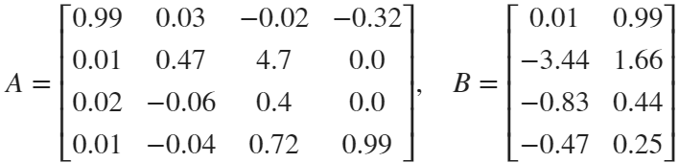
The penalty matrices in the corresponding linear-quadratic optimal control problem were selected as, 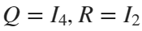. The Lyapunov and Riccati algebraic equations can be solved using the corresponding MATLAB functions “dlyap” and “idare” or “dlqr”. Use >> help dlyap or >> help idare, … to learn more about the MATLAB functions of interest.
Hint: Since matrix A is asymptotically stable, that is 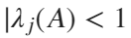 for every 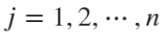, you can use as a zero matrix. Since we are dealing with vectors and matrices, the dimensions of all matrices are important. Hence, in MATLAB we input >>F0=zeros(2,4).
Project Task:
Running policy iterations of the Hewer algorithm generate a table that shows how the approximate performance values converge per iteration to the optimal values. In general, you need to run only five to six iterations, in a are case nine or ten iterations due to the quadratic convergence of the algorithm. Plot on one figure all approximates feedback controls obtained for 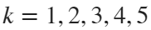, and on another figure plot the approximate system state trajectories for a selected (the one that performs the worst) state variable for .
System Initialization:
clear all; close all; clc
The discrete time state space model is given by:
A=[0.99 0.03 -0.02 -0.32;
0.01 0.47 4.7 0;
0.02 -0.06 0.4 0;
0.01 -0.04 0.72 0.99];
B=[0.01 0.99;
-3.44 1.66;
-0.83 0.44;
-0.47 0.25];
x0=[1;1;1;1]; % system initial conditions
LQ Control Problem Formalization, Verification, Solution:
% LQ optimal control problem initialization
Q=eye(4); R=eye(2);

% Test for Controllability and Observability
CO=ctrb(A,B); % forms the controllability matrix
rankCO=rank(CO) % finds the rank of the controllability matrix
rankCO = 4
% the rank is equal to n (system order) implies controllability
OM=obsv(A,Q); % forms the observability matrix
rankOM=rank(OM) % rank equal to n implies observability
rankOM = 4
% Note that the same rank is obtained by using obsv(A,Chol(Q))

% Direct solution of the optimal LQ problem
[Fopt,P]=dlqr(A,B,Q,R);
Jopt=0.5*x0'*P*x0
Jopt = 14.9453

% [X,K,L] = idare(A,B,Q,R)
% Jopt1=0.5*x0'*X*x0
Reinforcement Learning Solution:
ev=eig(A);
% Since A is asymptotically stable (all eigenvalues inside of unit circle
% we can use F0 = 0 (pay attention to the dimension of this zero)
F0=zeros(2,4)
F0 = 2×4
0 0 0 0
0 0 0 0
% In general, to find F0 that stabilize the system,
% we can use the MATLAB function place that finds the feedback
% matrix that places the closed loo (A-B*F0) ev in the desired locations
% lambda_desired=[-0.5; 0.2; -0.1+j*0.5 -0.1-j*0.5] can use complex conjugate ev
% F0=place(A,B,lambda_desired); check eigenvalues of (A-B*F0); evF0=eig(A-B*F0);
Hewer's Reinforcer
% Set-up total iteration
Iter=6
Iter = 6
Ji=0;

% Policy iterations of the Hewer algorithm
Pi{1} = dlyap((A-B*F0)',Q+F0'*R*F0);
F{1} = inv(R+B'*Pi{1}*B)*B'*Pi{1}*A;
Ji(1)=0.5*x0'*Pi{1}*x0;
Error(1) = norm((A-B*F{1})'*Pi{1}*(A-B*F{1})-Pi{1}+Q+F{1}'*R*F{1});
for i=2:Iter
Pi{i}=dlyap((A-B*F{i-1})',Q+F{i-1}'*R*F{i-1});
i;
Ji(i)=0.5*x0'*Pi{i}*x0;
F{i}=inv(R+B'*Pi{i}*B)*B'*Pi{i}*A;
Error(i) = norm((A-B*F{i})'*Pi{i}*(A-B*F{i})-Pi{i}+Q+F{i}'*R*F{i});
end
Plotting the obtained results:
% Performance Criterion
figure (1)
plot([1:Iter],Ji,'*')
grid on
xlabel('Iteration Number')
title('Approximate Optimal Performance')
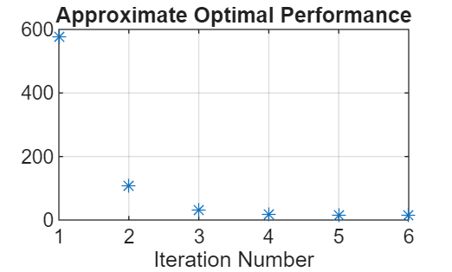

% System running time
run_time = 50
run_time = 50

% Iteration-wise Approximate System State Trajectories Variable
figure (2)
for i=1:Iter
Iname = sprintf('Iteration %d', i);
k=1:1:run_time;
for j=1:run_time
x(:,j)=((A-B*F{i})^k(j))*x0;
end
plot(k,x(1,:),'*--','DisplayName',Iname)
hold on
end
grid on
legend('NumColumns',5,'Location','southoutside'); xlabel('Time [s]'); % ylabel('State Variable x1')
title('Iteration-wise Approximate System State Trajectories for Variable x_1')
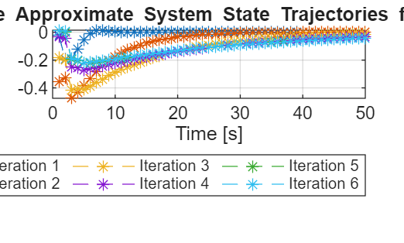

figure (3)
for i=1:Iter
Iname = sprintf('Iteration %d', i);
k=1:1:run_time;
for j=1:run_time
x(:,j)=((A-B*F{i})^k(j))*x0;
end
plot(k,x(2,:),'*--','DisplayName',Iname)
hold on
end
grid on
legend('NumColumns',5,'Location','southoutside'); xlabel('Time [s]');% ylabel('State Variable x2')
title('Iteration-wise Approximate System State Trajectories for Variable x_2')
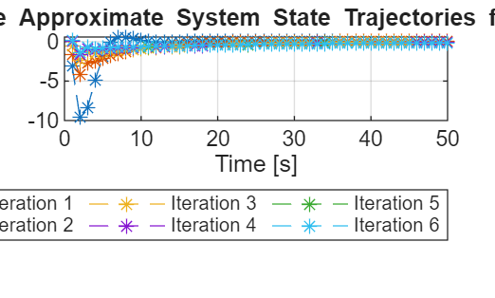

figure (4)
for i=1:Iter
Iname = sprintf('Iteration %d', i);
k=1:1:run_time;
for j=1:run_time
x(:,j)=((A-B*F{i})^k(j))*x0;
end
plot(k,x(3,:),'*--','DisplayName',Iname)
hold on
end
grid on
legend('NumColumns',5,'Location','southoutside'); xlabel('Time [s]'); % ylabel('State Variable x3')
title('Iteration-wise Approximate System State Trajectories for Variable x_3')
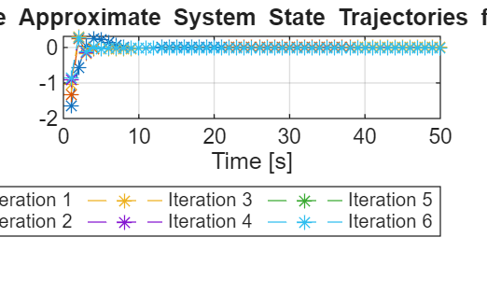

figure (5)
for i=1:Iter
Iname = sprintf('Iteration %d', i);
k=1:1:run_time;
for j=1:run_time
x(:,j)=((A-B*F{i})^k(j))*x0;
end
plot(k,x(4,:),'*--','DisplayName',Iname)
hold on
end
grid on
legend('NumColumns',5,'Location','southoutside'); xlabel('Time [s]'); % ylabel('State Variable x4')
title('Iteration-wise Approximate System State Trajectories for Variable x_4')
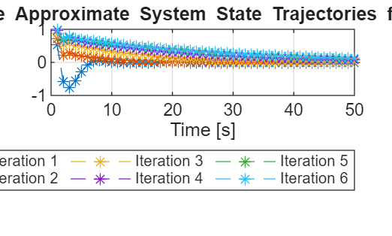
Further Study with RL toolbox:
Environment set-up:
env = myDiscreteEnv(A,B,Q,R);
'myDiscreteEnv' is used in Create and Train Custom LQR Agent.
rng(0);
LQR agent creation:
agent = LQRCustomAgent(Q,R,F0);
%getActionInfo(agent)

% Set-up future reward discount factor
agent.Gamma = 1

% Set-up the number of data point to be collected before updating the critic
agent.EstimateNum = 45
LQR agent training:
% Set-up training options
trainingOpts = rlTrainingOptions(...
MaxEpisodes=10, ...
MaxStepsPerEpisode=50, ...
Verbose=false);%, ...
% Plots="training-progress");
% Training the agent
trainingStats = train(agent,env,trainingOpts);
LQR agent perfromance evaluation:
simOptions = rlSimulationOptions(MaxSteps=Iter);
experience = sim(env,agent,simOptions);
totalReward = abs(sum(experience.Reward))
Performance comparison:
Hewer_reinforcer_error = Ji(Iter) - Jopt
LQR_agent_error = totalReward - Jopt
Plot iteration-wise difference of gains
figure (6)
% Plot the norm of the difference between the gains between the trained LQR agent and the optimal LQR solution
% Number of gain updates
len = agent.KUpdate;

% Initialize error vector
err = zeros(len,1);

% Fill elements
for i = 1:len
err(i) = norm(agent.KBuffer{i}-Fopt);
end

% Plot logarithm of the error vector
plot(log10(err),'b*-','DisplayName','LQR Agent')
grid on
hold on

% Plot the norm of the difference between the gains between the Hewer's reinforcer and the optimal LQR solution
err_h = zeros(Iter,1);
for i=1:Iter
err_h(i) = norm(F{i}-Fopt);
end
plot(log10(err_h),'rx-','DisplayName','Hewer reinforcer')
hold on
legend
title("Log of gain difference")
xlabel("Number of updates/iterations")

