Table of Contents

DigiLog — Application Flow & Handover Document
Audience: Client business team + client IT team Version: Phase 4 (as of 2026-04-20) Platform: DigiLog (21 CFR logbook) — Digital Filter Management System
All diagrams below use Mermaid. GitHub, GitLab, VS Code (with Markdown Preview), and most modern markdown renderers display them automatically.

1. Executive Summary
DigiLog is a 21 CFR Part 11–compliant digital logbook platform for pharmaceutical / cleanroom environments that automates:
- Filter cleaning-cycle tracking (wash → dry → storage)
- Preventive-maintenance (PM) scheduling
- Electronic signatures + hash-chained audit trails
- Multi-tenant organization isolation
- Offline-capable tablet operations with automatic sync
- Reporting (Audit Trail, Cleaning Cycles, Filter Traceability)

Delivered surfaces
Surface | Users | Access
Web dashboard | Admins, supervisors, QA, approvers | Browser → Nginx → API
Mobile Web (tablet) | Operators on shop floor | Browser → same API, responsive layout
Android APK (Capacitor) | Operators with RFID-scanner tablets | Packaged app → same API
REST API | Programmatic integrations | Swagger at /docs

2. System Architecture
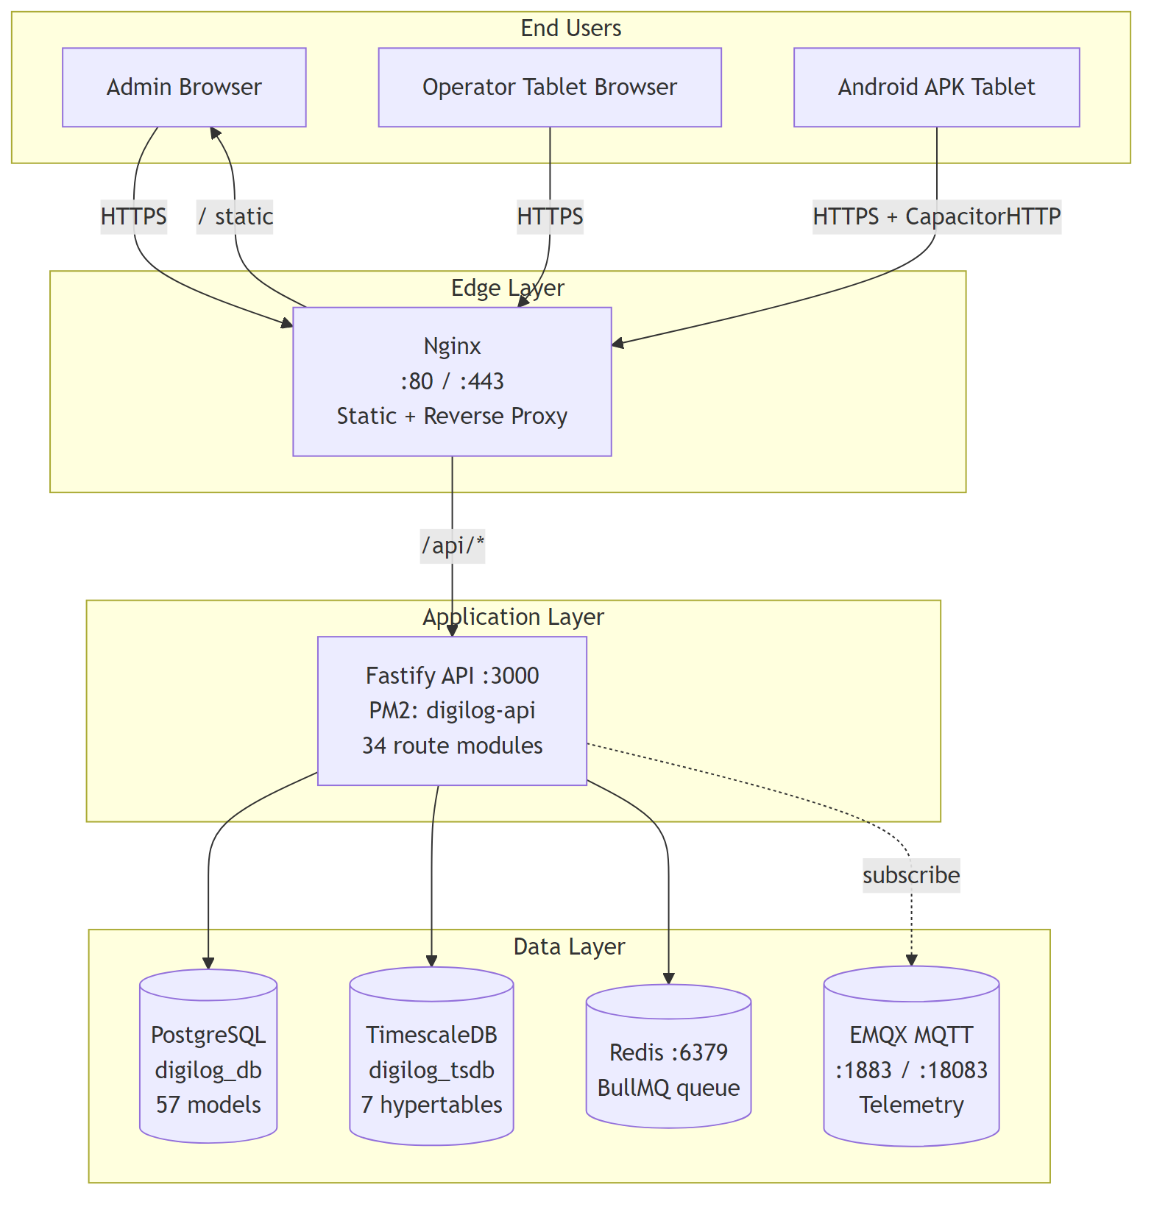

Tech summary
- Frontend: React 18, Vite, Tailwind CSS (unified light theme), SWR data-fetching, ReactFlow for pipeline editors, React Router v6
- Backend: Fastify + Prisma ORM, PostgreSQL 18 (app data), TimescaleDB (time-series), Redis (BullMQ job queue)
- Mobile: Capacitor wraps the same React SPA into an Android APK. KC-series UHF RFID scanners integrated via rfid_scan_app/ (Reader_Usb.jar SDK)
- Offline: IndexedDB queue + background sync engine (auto-syncs on reconnect)
- Messaging: EMQX MQTT broker (for device telemetry ingestion)

3. User Roles & Access Model

Built-in roles
Role | Scope | Typical use
Admin | Full tenant administration — manages users, config, roles, integrations | IT admin / platform owner
Supervisor | Org-scoped; approves deviations, reviews reports, signs off cycles | Shift lead / QA
Operator | Org-scoped; performs cleaning + scanning only | Shop-floor worker
Custom roles | Configurable granularly via the Roles page | Any bespoke job function
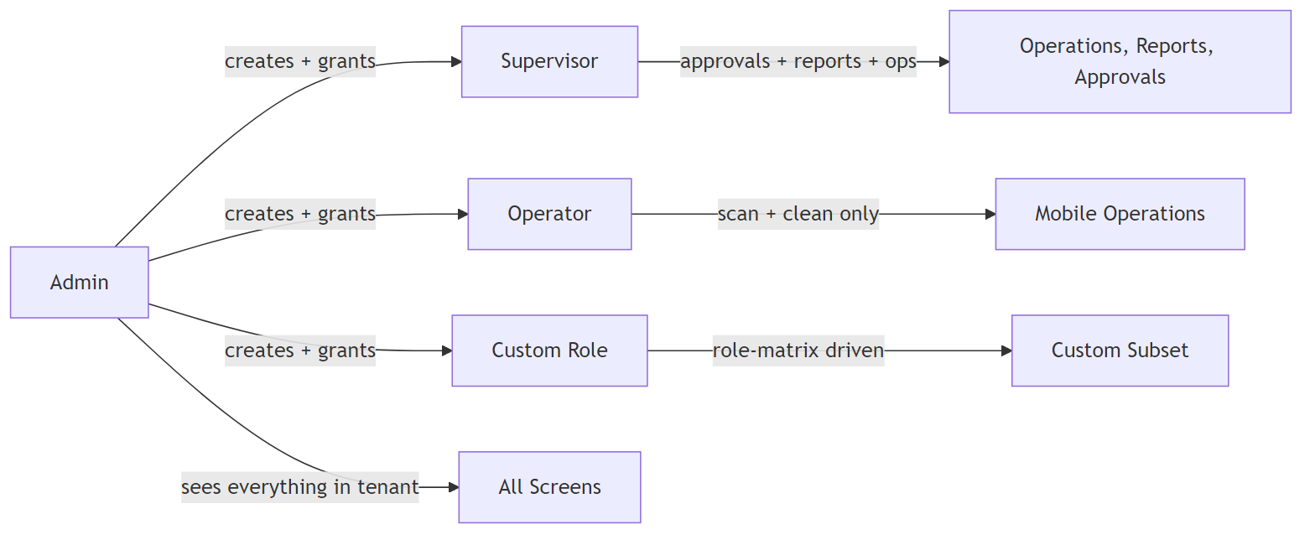

Permission system
- 95 permission constants (e.g. FILTER_OPERATE, CONFIG_UPDATE, AUDIT_READ)
- 82 feature privileges — UI toggles that each map to one or more backend permissions
- Backend routes protected by requirePermission(X) or requireAnyPermission(A, B) middleware
- Frontend elements gated by <RequireRole permissions={[X]}> or perms.includes(X)
- Organization scoping is enforced on all filter / cycle / PM queries — users see only data for their tenant

69 reauth actions
Sensitive operations (start cycle, bypass stage, submit checklist with signature, update credentials, etc.) require a fresh password re-authentication before execution. Password is cached on the server for 10 seconds to avoid dialog fatigue.
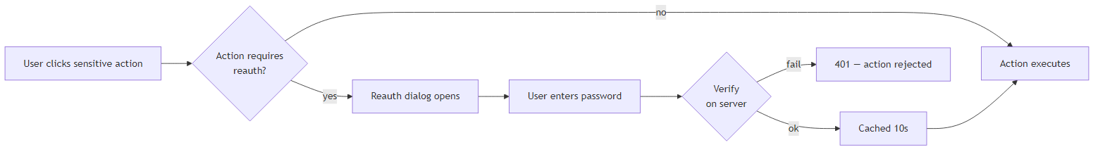

4. Core Workflows

4.1 Login & Session
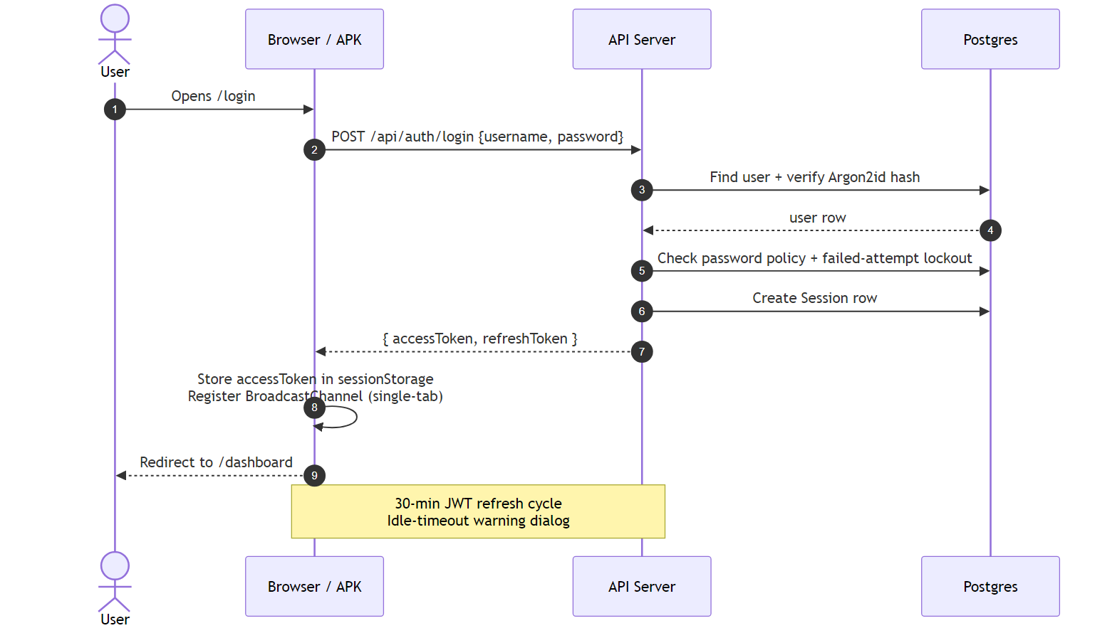
Key properties
- Passwords hashed with Argon2id
- LDAP integration optional (checked before local auth if configured)
- accessToken in sessionStorage (NOT localStorage) for shared-workstation safety
- Single-tab enforcement per user (via BroadcastChannel)
- Session conflict (same user / different user on same machine) → force-login dialog
- Multiple active sessions rejected — server-side Session table revokes old ones

4.2 Admin — Initial tenant setup
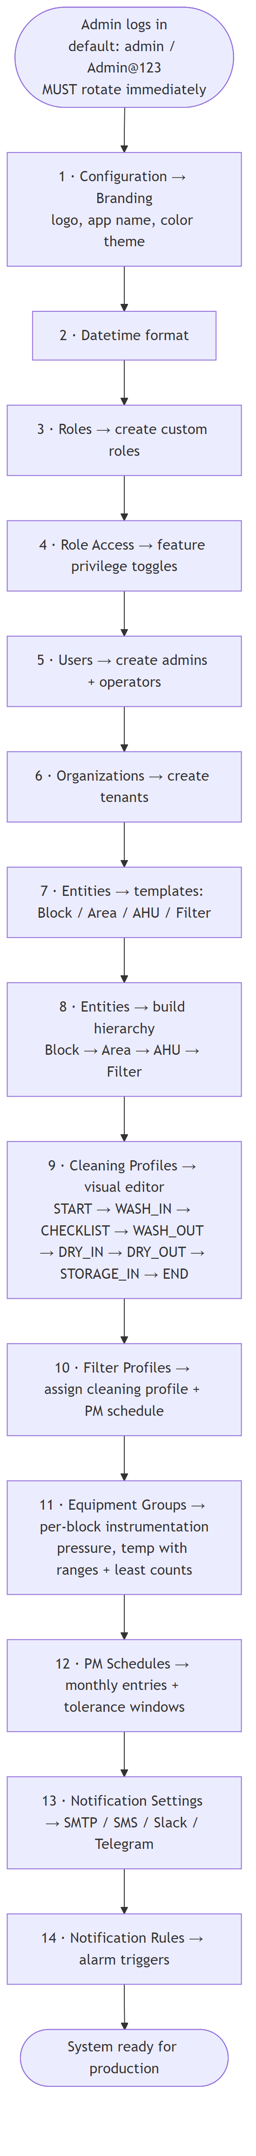

4.3 Operator — Day-to-Day Cleaning Cycle (happy path)
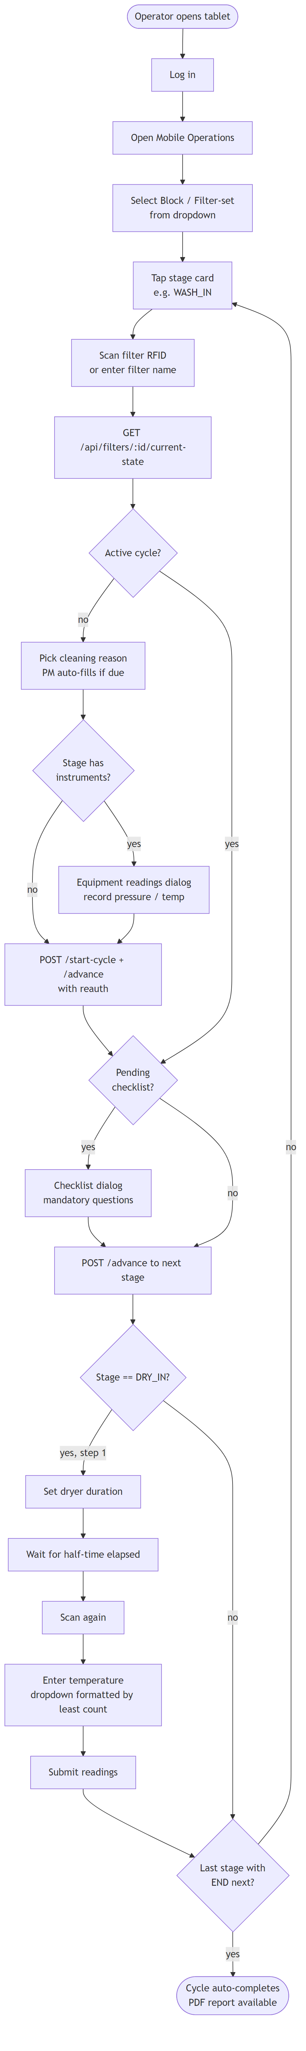
Special DRY_IN flow is the only two-step stage: first set duration (starts timer), then after half-time elapsed record the temperature.

4.4 Offline Operations (Tablet)
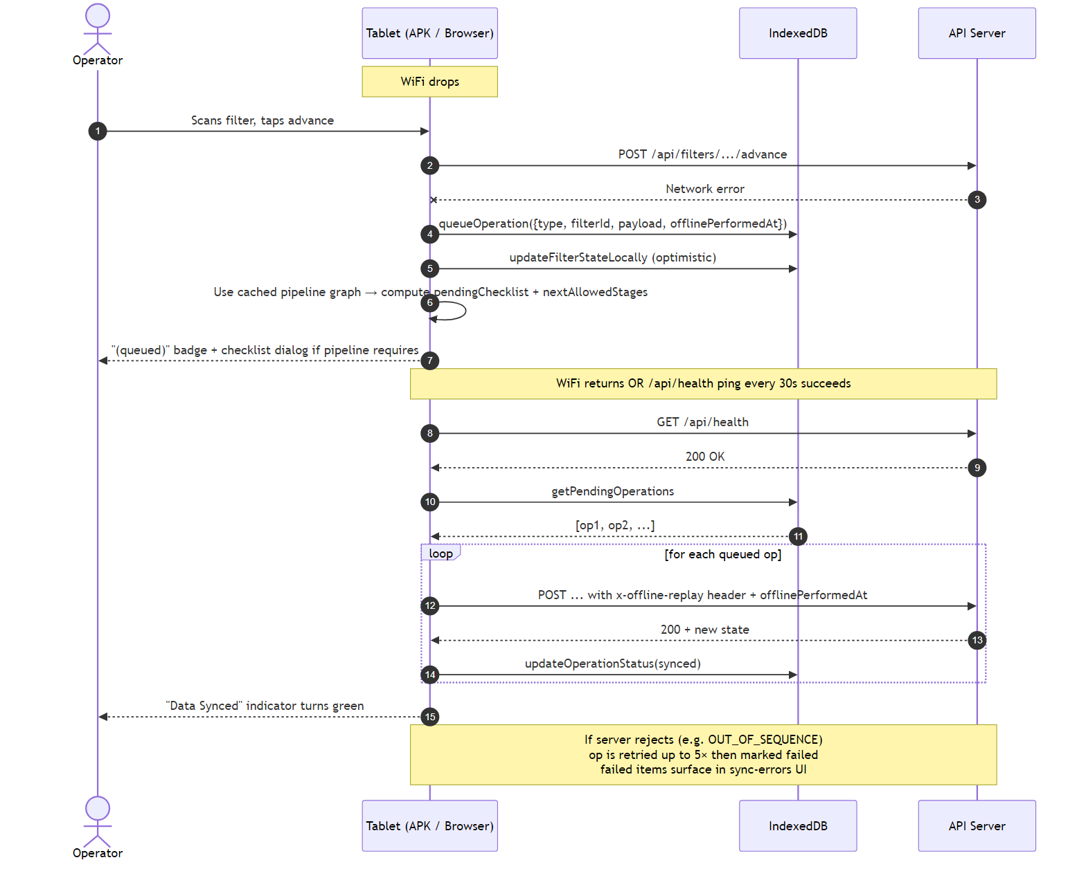
Offline cache warming happens during online sessions:
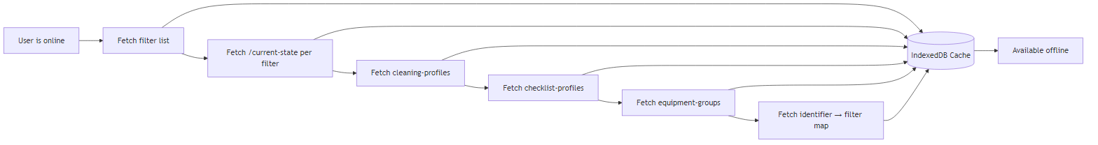

4.5 Admin Requests & Approvals
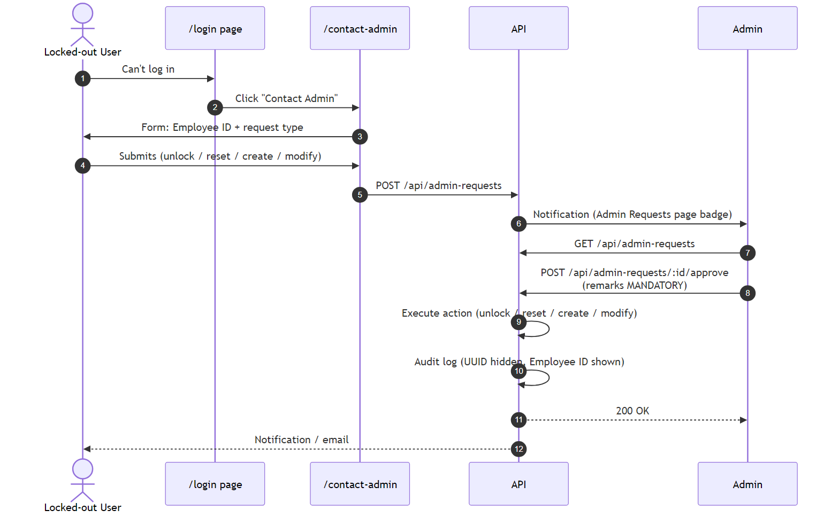

4.6 Block Change Approval (cross-block cleaning)
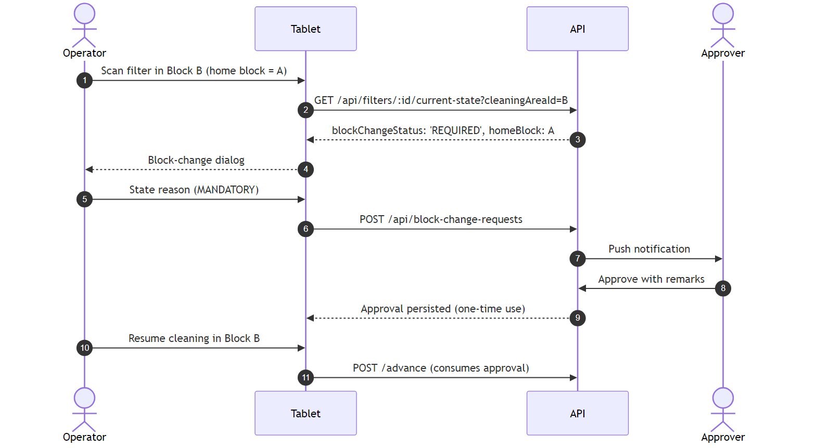

4.7 Reporting & Audit
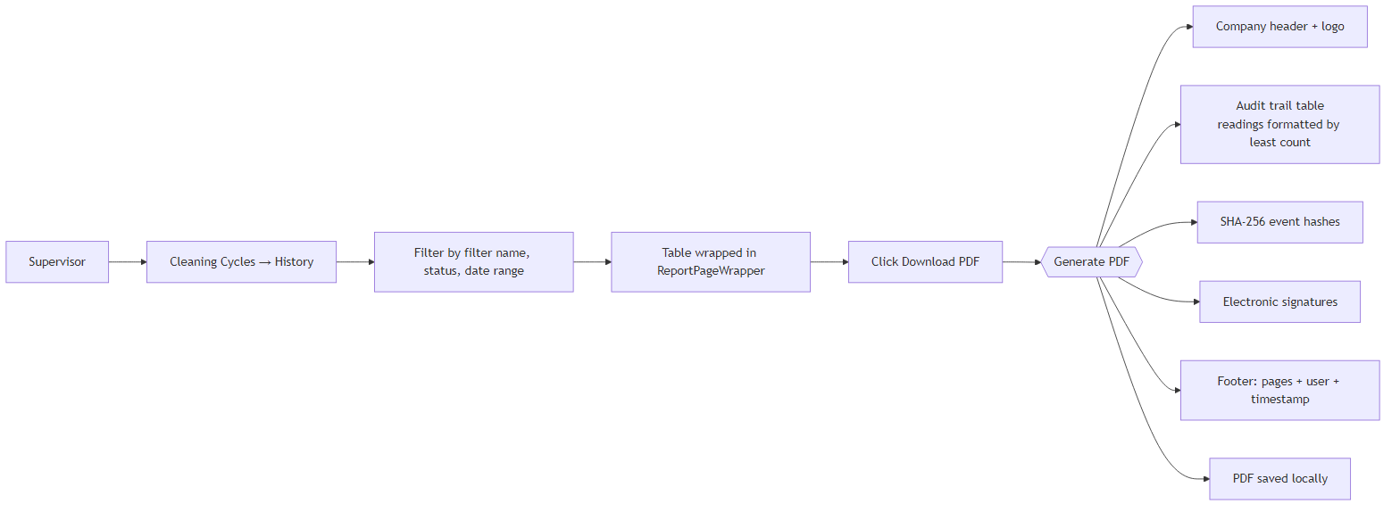
Other report surfaces: Audit Trail (system-wide), Filter Traceability (per-filter), Generated Reports (Reports module, phases A–F complete).

4.8 Checklist Enforcement (compliance critical)
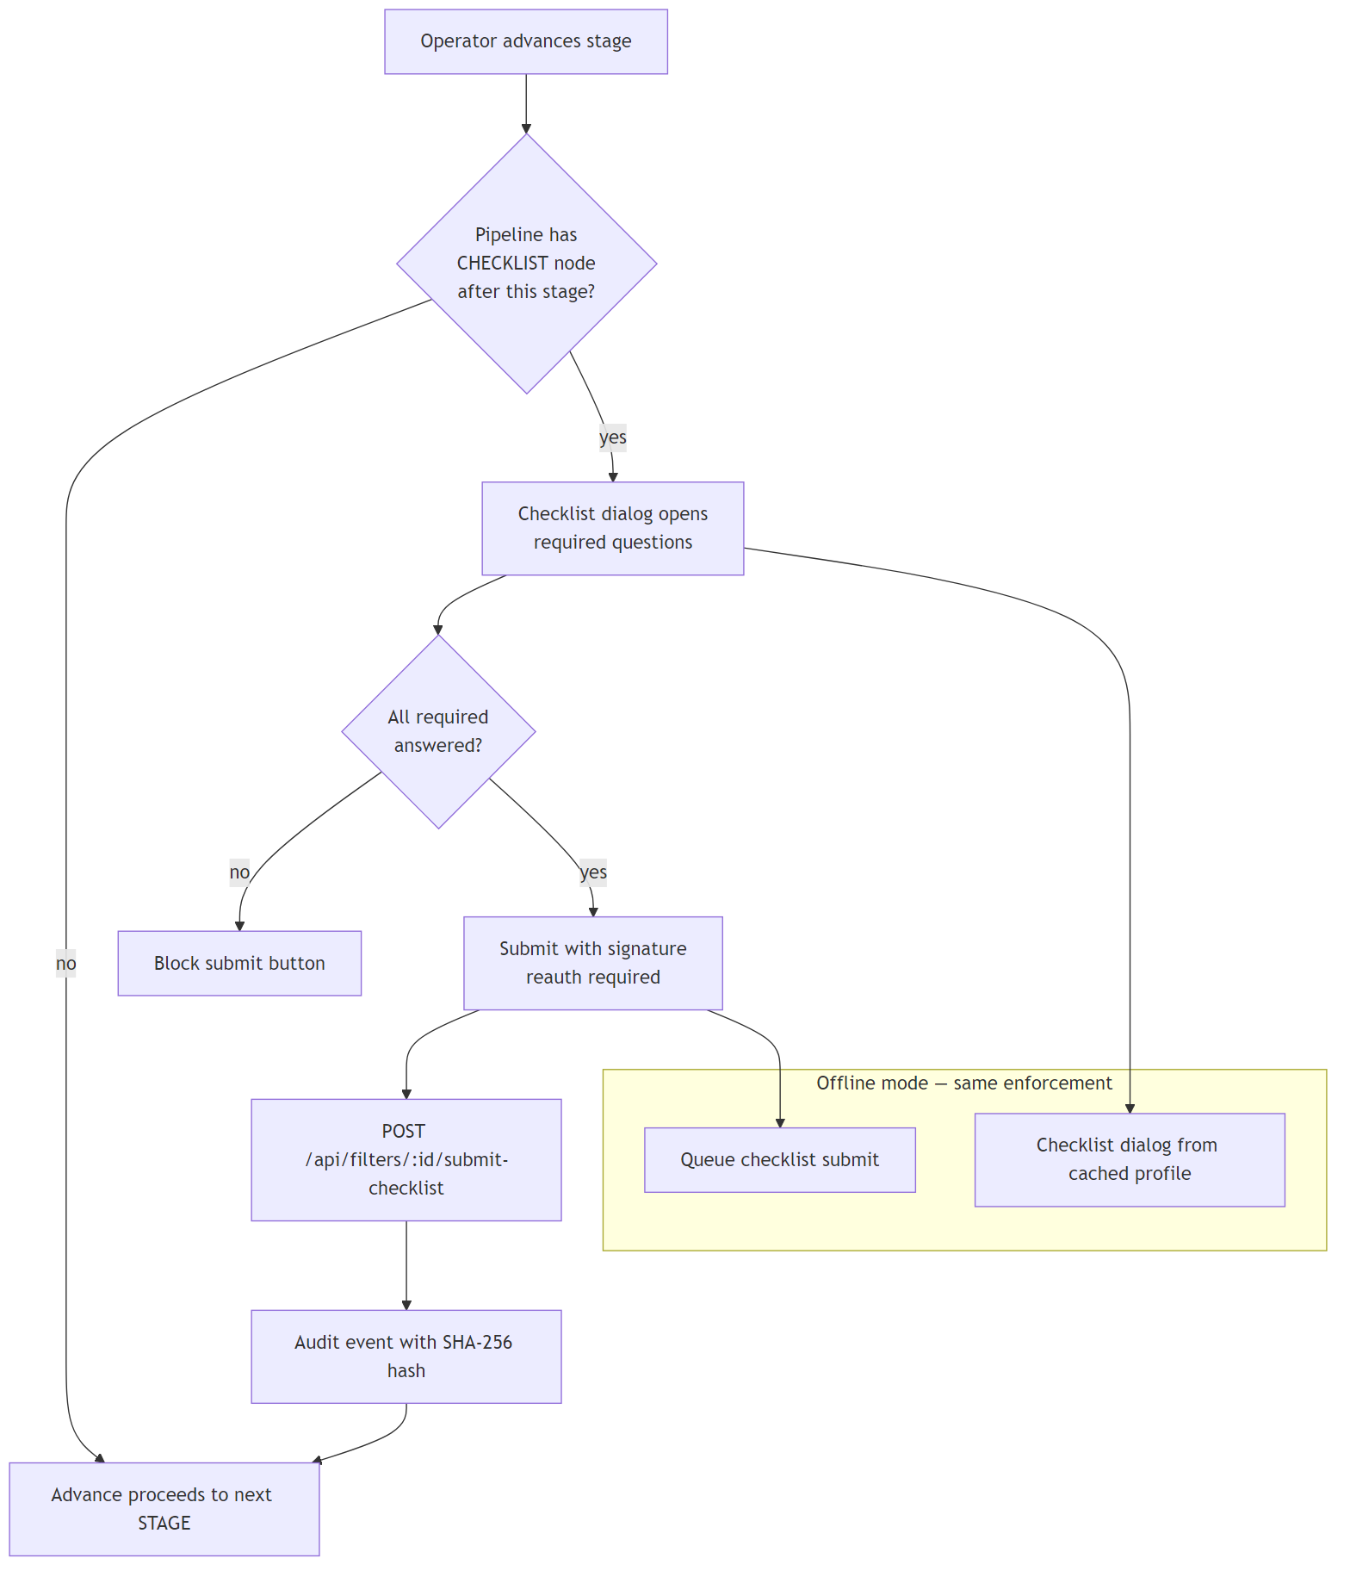
Offline checklist enforcement was hardened in the current release — the web offline path now computes pendingChecklist from the cached pipeline graph just like the tablet, preventing any cycle from skipping a required checklist.

5. Data Flow per Feature
Feature | Frontend Page | Primary API routes | DB Tables
Login | /auth/login.tsx | POST /api/auth/login, /refresh, /logout | User, Session
Dashboard | /dashboard.tsx | /api/filters/dashboard-stats, /api/users/stats, /api/audit, /api/notifications | Multiple
Filter Operations | /filter-management/filter-operations.tsx | /api/filters/:id/start-cycle, /advance, /submit-checklist, /bypass, /current-state | AssetInstance, CleaningCycle, FilterEvent
Mobile Operations | /mobile/mobile-operations.tsx | Same as above | Same + offline queue
Cleaning Profiles | /filter-management/cleaning-profile-editor.tsx | /api/filter-cleaning-profiles/* | FilterCleaningProfile, PipelineStage, PipelineConnection
Equipment Groups | /config/equipment-groups.tsx | /api/equipment-groups/* | EquipmentGroup, EquipmentGroupInstrument
PM Schedules | /pm-schedules/index.tsx | /api/pm-schedules/* | PmSchedule, PmScheduleEntry, PmExecution
Users | /users/*.tsx | /api/users/* | User, Session
Admin Requests | /admin-requests/index.tsx | /api/admin-requests/* | AdminRequest
Alarms | /alarms/index.tsx | /api/alarms/*, /api/rule-chain/* | Alarm, RuleChain
Audit Trail | /audit/index.tsx | /api/audit?* | AuditLog (hash-chained)
Configuration hub | /config/*.tsx | /api/config/:moduleKey/current + PUT /api/config/:moduleKey | SystemConfig
Notifications | /notifications/index.tsx | /api/notifications/* | Notification
Backup/Restore | /config/backup.tsx | /api/backup/* | All (dynamic export of 64 tables)
Reports | /reports/*.tsx, /report-templates/*.tsx | /api/reports/*, /api/report-templates/* | ReportTemplate, GeneratedReport

6. Infrastructure & Deployment (IT Team)

6.1 Environments
Env | Host | Purpose
Production | On-premises Windows Server (2019 / 2022 recommended) on the client network | Live system
Local Dev | Developer Windows / macOS | Feature development

6.2 Production service map
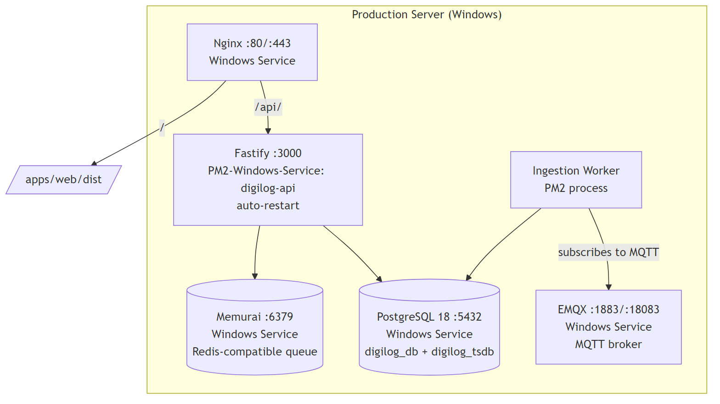
Server access (Windows)
The client IT team provisions access via one of the following:
# Option A — Remote Desktop (most common on Windows Server)
# Use the Remote Desktop Connection client with the provisioned admin account.
# Option B — OpenSSH for Windows (if enabled)
ssh <admin-user>@<server-hostname-or-ip>
# Option C — Windows Remote Management (WinRM / PowerShell Remoting)
Enter-PSSession -ComputerName <server-hostname-or-ip> -Credential (Get-Credential)
Key URLs (replace <host> with the production hostname or LAN IP)
- App: http://<host>/ (or https://<host>/ once TLS is installed)
- Swagger API docs: http://<host>/docs
- EMQX dashboard: http://<host>:18083/ (default admin/public — rotate on install)
Default login (ROTATE IMMEDIATELY on first deploy)
- Username: admin
- Password: Admin@123

6.3 Build & Deploy
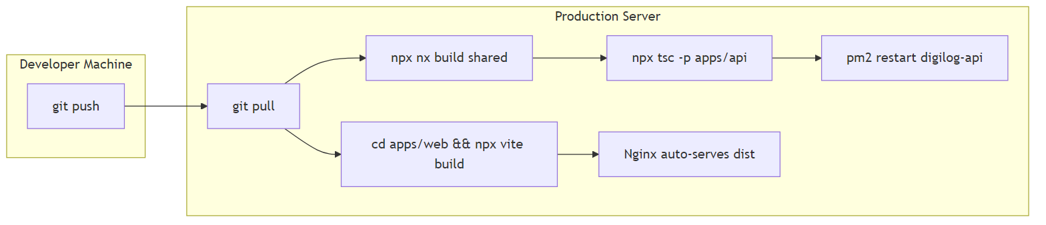
Commands (PowerShell on the production Windows server)
# On the production server (installed path is set by IT at deploy time — e.g. C:\DigiLog)
cd C:\DigiLog\21cfrlogbook
git pull
# Shared packages first (when their source changes)
npx nx build shared; npx nx build db; npx nx build queue
# Backend — compile then restart via pm2-windows-service
npx tsc -p apps/api/tsconfig.json
pm2 restart digilog-api
# Frontend
cd apps\web
npx vite build
# (Nginx picks up the dist\ folder automatically — no restart needed)
Note: PM2 runs as a Windows Service via pm2-windows-service so digilog-api survives reboots. If PM2 isn't registered yet: npm i -g pm2 pm2-windows-service then pm2-service-install -n DigiLogPM2.

6.4 Local dev setup (Windows)
Prerequisites:
- Node.js 20+
- Memurai ≥ 5 (Redis substitute for Windows — older Redis 3 crashes API via BullMQ)
- PostgreSQL 18 with digilog_db + digilog_tsdb databases
- EMQX broker (optional for most dev flows)
- .bat files in repo root to start each service
Start order:
# Terminal 1 — API (no compile needed locally)
cd apps/api && npx tsx src/server.ts
# Terminal 2 — Web dev server (port 5175 via HTTPS with mkcert)
cd apps/web && npx vite
APK development:
- Capacitor WebView rejects self-signed certs for fetch
- Use CapacitorHttp plugin or install the rootCA.pem in tablet system certs
- APK bakes in https://<dev-ip>:3000 — set API_HTTPS=true when starting the dev API

6.5 Android APK build
apps/android/ # Capacitor project
Prereqs: JDK 21, Android SDK. See reference_android_build.md for version matrix.

6.6 RFID Scanner Android app
Separate codebase at rfid_scan_app/ using KC-series UHF reader's Reader_Usb.jar SDK. Emits RFID tag IDs as keyboard input (UKB mode) or via USB serial.
Web-side RFID guard (apps/web/src/hooks/use-rfid-guard.ts) blocks tag bursts from landing in wrong input fields — only fields marked data-rfid="true" accept RFID input.

7. Security & 21 CFR Part 11 Compliance

7.1 Request security chain
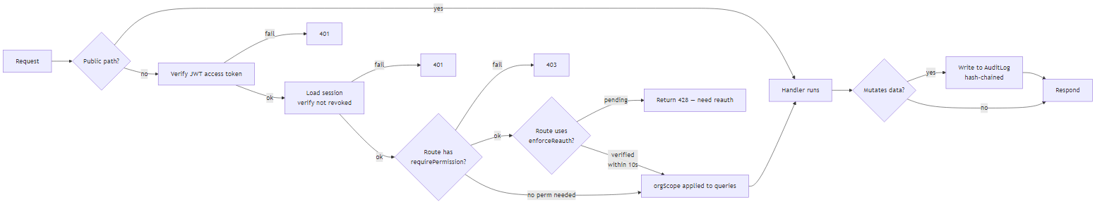

7.2 Authentication
- Argon2id password hashing
- JWT access tokens (short-lived) + refresh tokens
- Session stored server-side (Session table); revocable
- Single-tab enforcement (BroadcastChannel)
- Session conflict detection: same-user / different-user with force-login dialog
- LDAP integration optional

7.3 Authorization
- 95 granular permissions, 82 feature toggles
- Per-route requirePermission() / requireAnyPermission() on every mutating endpoint
- Organization-scoped queries (multi-tenant isolation)
- Reauth (10s cached) required for 69 sensitive actions

7.4 Audit trail (21 CFR Part 11 specific)
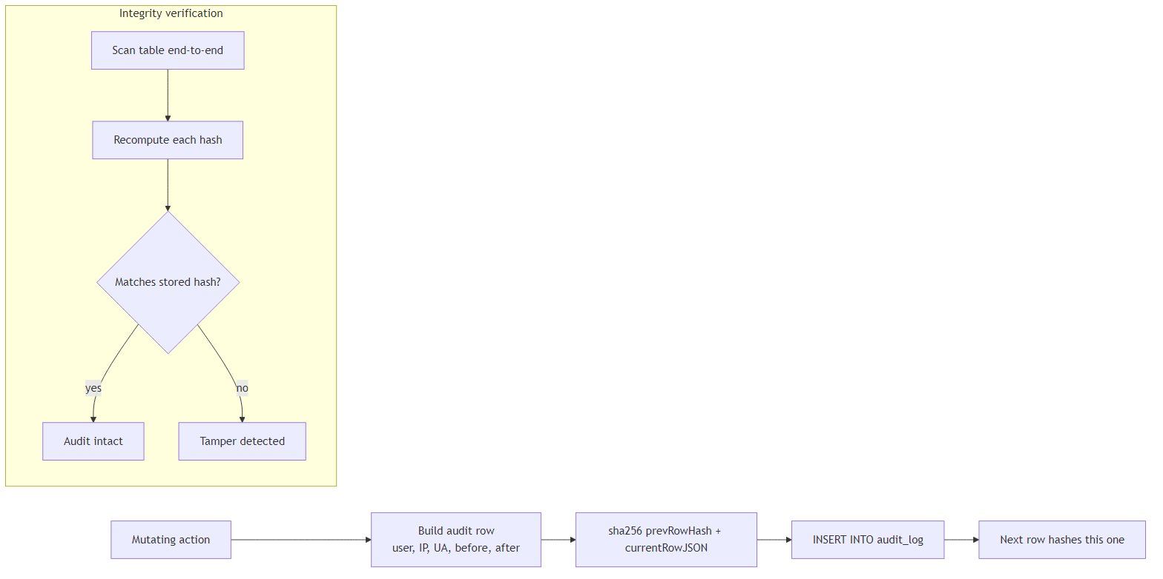
- Every mutating action writes to AuditLog
- Hash-chained: each row contains sha256(prevHash + currentRowJSON) so tampering is detectable
- User identity, IP, user agent, before/after values captured
- Electronic signatures on checklist submissions (password re-entry)
- Immutable by design — no DELETE path from UI

7.5 Data integrity
- Input sanitization strips HTML from all text fields (lib/sanitize.ts)
- Prisma ORM prevents SQL injection
- Checksum verification on cycle event reads
- Instrument readings validated against operating range before persist

7.6 Compliance checklist
- ☑ Electronic signatures (reauth-backed)
- ☑ Audit trail (hash-chained, immutable)
- ☑ User access controls (95 perms, 69 reauth actions)
- ☑ Data integrity (sanitization, checksums)
- ☑ Versioning (cleaning profiles + help articles + templates versioned)
- ☑ Backup + restore (64 tables, dynamic export)
- ☑ Time stamps (offlinePerformedAt for accurate offline replay)

8. Monitoring, Backup & Restore
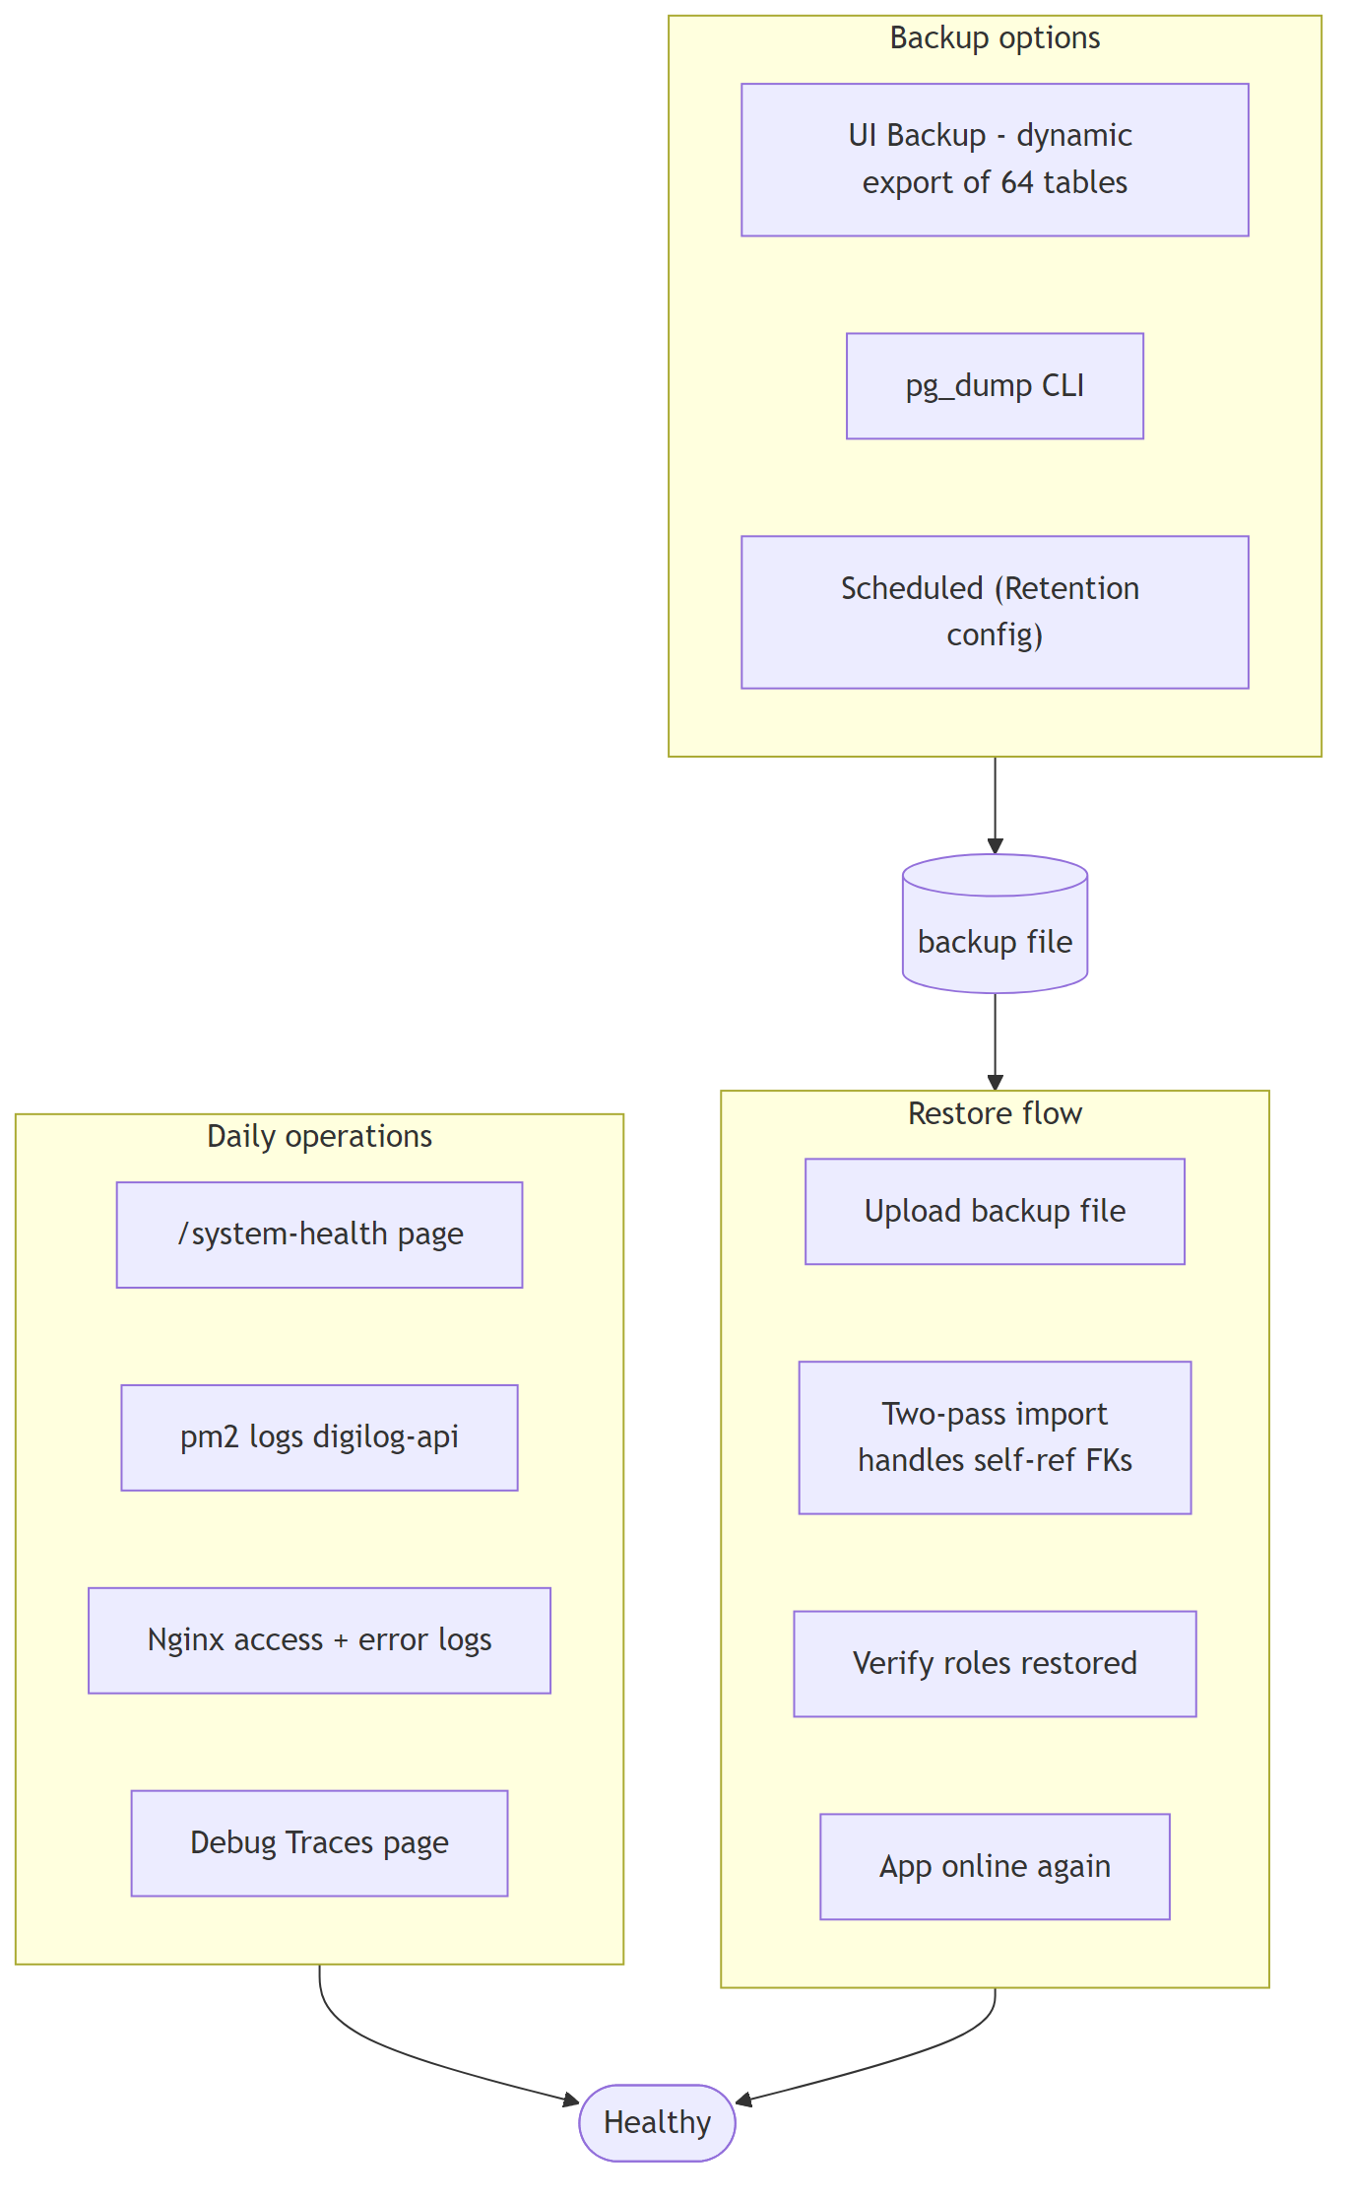

8.1 Monitoring
- PM2: pm2 logs digilog-api, pm2 status — or check the DigiLogPM2 service in services.msc
- Nginx (Windows): default log path C:\nginx\logs\access.log and C:\nginx\logs\error.log (or wherever Nginx was installed)
- PostgreSQL (Windows): C:\Program Files\PostgreSQL\18\data\log\*.log
- EMQX (Windows): C:\Program Files\emqx\log\ plus the web dashboard at :18083
- Windows Event Viewer → Windows Logs → Application captures service start/stop + uncaught crashes for all four services
- System Health page (/system-health): live DB + Redis + EMQX status
- Debug Traces page (/debug/traces): per-request pipeline trace

8.2 Backup
- Dynamic backup at Configuration → Backup — exports all 64 tables via pg_tables + jsonb_populate_recordset; works without superuser DB privileges
- Manual (PowerShell):
- & "C:\Program Files\PostgreSQL\18\bin\pg_dump.exe" -h localhost -U digilog -d digilog_db -F c -f C:\DigiLog\backups\digilog_db_$(Get-Date -Format yyyyMMdd).dump
- Scheduled backups: either set up via Windows Task Scheduler running the PowerShell command above, or configure in the Retention config page

8.3 Restore
- UI at Configuration → Backup → "Restore from file"
- Two-pass fixup handles self-referential foreign keys (e.g., user.supervisorId pointing to another user)
- IMPORTANT: DB restore rewrites the roles table — if roles lose access after restore, sync from seed.ts or UPDATE directly

8.4 Log rotation
- PM2 auto-rotates digilog-api logs (install pm2-logrotate if not already: pm2 install pm2-logrotate)
- Nginx (Windows) has no built-in log rotation — use either a scheduled task that renames access.log / error.log daily and sends nginx -s reopen, OR a tool like LogRotateWin / nginx-logrotate-windows

9. Integrations

9.1 Notifications (outbound)
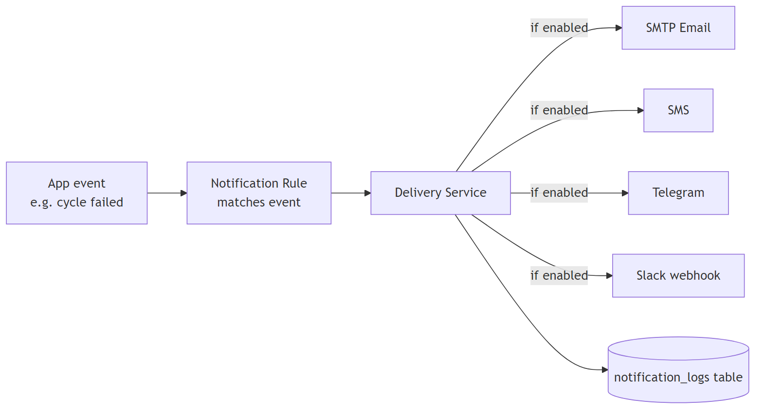
- Email: SMTP (Gmail, Outlook, custom); OAuth2 (Microsoft, Google) optional
- SMS: Twilio, AWS SNS, Vonage, custom HTTP gateway
- Telegram: Bot API
- Slack: Webhook URL
- Configured at Configuration → Notification Settings
- Rules at Configuration → Notification Rules

9.2 Telemetry ingestion (MQTT)
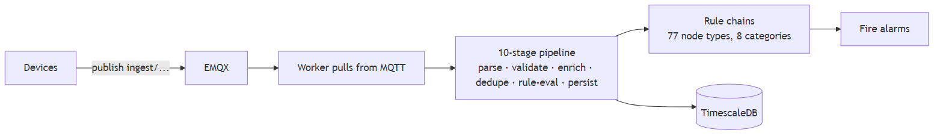

9.3 REST API
- Swagger docs at /docs
- All endpoints documented with request/response schemas
- Use service-account tokens for integrations
- Device-specific token auth for /api/data/* endpoints

10. Troubleshooting Common Issues
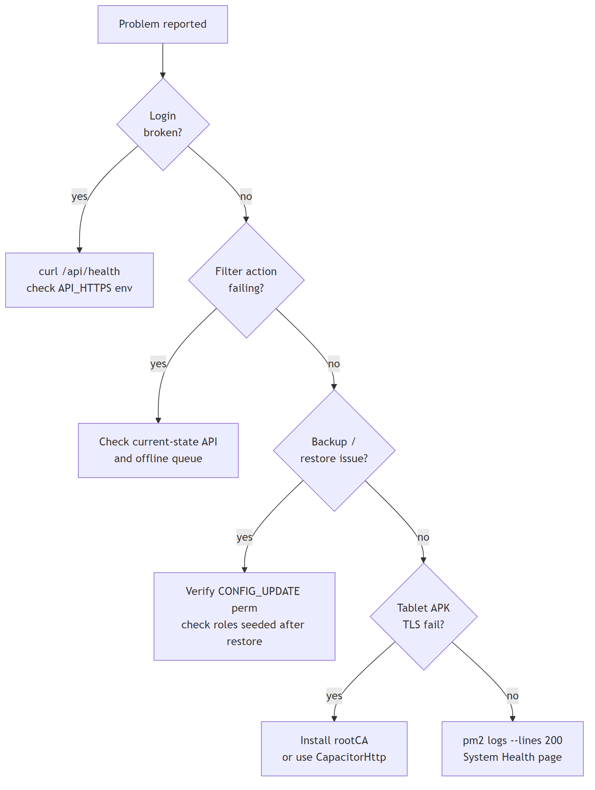
Symptom | Likely cause | Fix
Login returns "parse error" | API on HTTP but frontend calling HTTPS (or vice versa) | Check API_HTTPS env var matches frontend VITE_API_URL
API crashes on startup | Redis/Memurai version <5 | Install Memurai ≥5
APK login fails with TLS parse error | APK bakes HTTPS URL; API on HTTP | Set API_HTTPS=true + point APK to HTTPS URL
Sidebar items missing for admin | Role missing permissions after restore | UPDATE roles table from seed.ts
Backup export fails as non-admin | Missing CONFIG_UPDATE perm | Grant permission via Role Access
Offline temp submitted, filter won't advance | dryerReadingsSubmitted cache flag set; pipeline still says DRY_IN | Scan on Dry Out stage — friendly message now directs operator
Self-signed cert blocks APK fetch | Capacitor WebView rejects fetch on self-signed | Install rootCA.pem in system certs OR use CapacitorHttp
Sync stuck | Hit max 5 retries; op marked failed | Open sync-errors UI, operator manually re-does filter
navigator.onLine wrong on Android | WebView reports stale online status | /api/health polled every 15s (already implemented)

11. A Day in the Life of an Operator
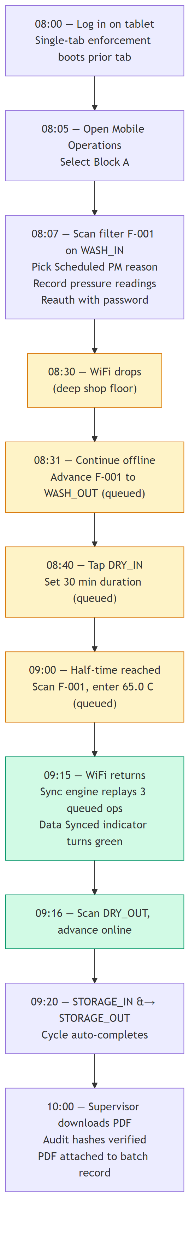

12. Key Configuration Touchpoints
Everything below is editable at Configuration → <page>:
- Branding (logo, app name, color theme — 10 presets)
- Datetime (format, timezone)
- Pagination (default records per page)
- Password Policy (min length, complexity, age, reuse window)
- Session (timeout, single-tab, force-login behavior)
- Login Security (lockout attempts, lockout duration)
- User ID (format for new user IDs)
- Action Reauth (69 actions: on/off per action)
- Access Matrix (admin-level role → screen mapping)
- Audit Templates (audit trail report layout)
- Alarm Columns (visible alarm table columns per role)
- Field IDs (78 renameable field identifiers)
- Retention (audit / notification log retention policies)
- Report Settings (header, footer, records/page)
- Dashboard Cards (which cards each role sees)
- Filter Cleaning Reasons (dropdown values)
- PM Schedule Settings (tolerance window, auto-start)
- Block Change Approval (approver role for cross-block)
- PM Schedule Approval (QA approver role)
- AHU Filter Set Config (SET_A / SET_B mode per AHU)
- Equipment Groups (per-block instrumentation)
- Backup (manual export / restore)
- Notification Email / SMS (provider credentials)
- Notification Rules (alarm triggers)
- Notification Logs (delivery history)
- Help (28 context-help articles, versioned)
- LDAP (directory integration)
- Tablet Access (restrict mobile features per role)
- Roles (create/edit roles + permissions)
- UNS (unified namespace for telemetry)

13. Known Gaps & Future Enhancements
- Cleaning-profile version pinning in offline cache — if an admin edits a profile mid-shift, an offline operator's replay could be rejected as out-of-sequence; today surfaced as a sync error for manual remediation. Full version pinning pending.
- AHU dashboard pagination at >1000 filters (currently shows a warning badge)
- Multi-filter batch offline checklist dialog pops for the first filter only — a batch-level UX improvement is planned
- Reports module (phases A–F complete); additional custom-report designer in roadmap

14. Handover Checklist

Business team
- Log in with default admin / Admin@123 works
- Admin password rotated to a strong value
- Client admin users created
- Cleaning profiles built and tested end-to-end
- PM schedules populated for active filters
- Notification SMTP/SMS tested (Test button on settings page)
- Operator training completed (all 8 stages + offline mode)
- First test cleaning cycle completed + PDF report downloaded + verified
- Backup/restore rehearsed

IT team (Windows Server)
- Remote Desktop / OpenSSH / WinRM access provisioned for app-admin account
- Windows Services verified running + set to Automatic start: Nginx, PostgreSQL, EMQX, Memurai, DigiLogPM2
- PM2 digilog-api healthy (pm2 status) and registered as a Windows Service (pm2-windows-service)
- Scheduled daily backup — Windows Task Scheduler job running pg_dump.exe OR the in-app Backup UI
- Nginx TLS cert installed (org-issued or internal CA) and bound to port 443
- Internal DNS / hosts entry pointing to the production server IP (optional if users connect by IP)
- Windows Firewall inbound rules for 80, 443 (LAN), 3000 (loopback only), 1883/18083 (if MQTT in use)
- Monitoring subscribed to PM2 crashes + disk-space alerts
- APK signed with production keystore + deployed to tablets
- RFID scanners tested end-to-end with production API
- Log retention policy configured in Retention config
- Swagger docs URL shared with integration developers
- Emergency contact + escalation matrix documented

15. Support & Contacts
- Repository: github.com/pankajexa/21cfrlogbook
- Primary branch: DigitalFMS
- Current active branch: RFID
- Swagger API docs: http://<host>/docs
- Project handover folder: PROJECT_HANDOVER/ (this document)
First diagnostic steps for any issue:
- pm2 logs digilog-api --lines 200
- Open /system-health in the app
- Check /docs to validate the failing API endpoint's expected shape
- For offline issues: browser DevTools → Application → IndexedDB → digilog-offline

End of document.

