Table of Contents

DigiLog — Application Overview & Flow Diagrams
Audience: Client business team + IT team Version: Phase 4 (2026-04-20)

1. What is DigiLog
A 21 CFR Part 11–compliant digital logbook for pharmaceutical / cleanroom environments. It replaces paper logs for:
- Filter cleaning-cycle tracking (wash → dry → storage)
- Preventive-maintenance scheduling
- Electronic signatures and tamper-evident audit trails
- Offline-capable tablet operations with automatic sync once connectivity returns
Used on a web browser (admins, supervisors, QA) and on Android tablets (shop-floor operators with RFID scanners).

2. System at a Glance
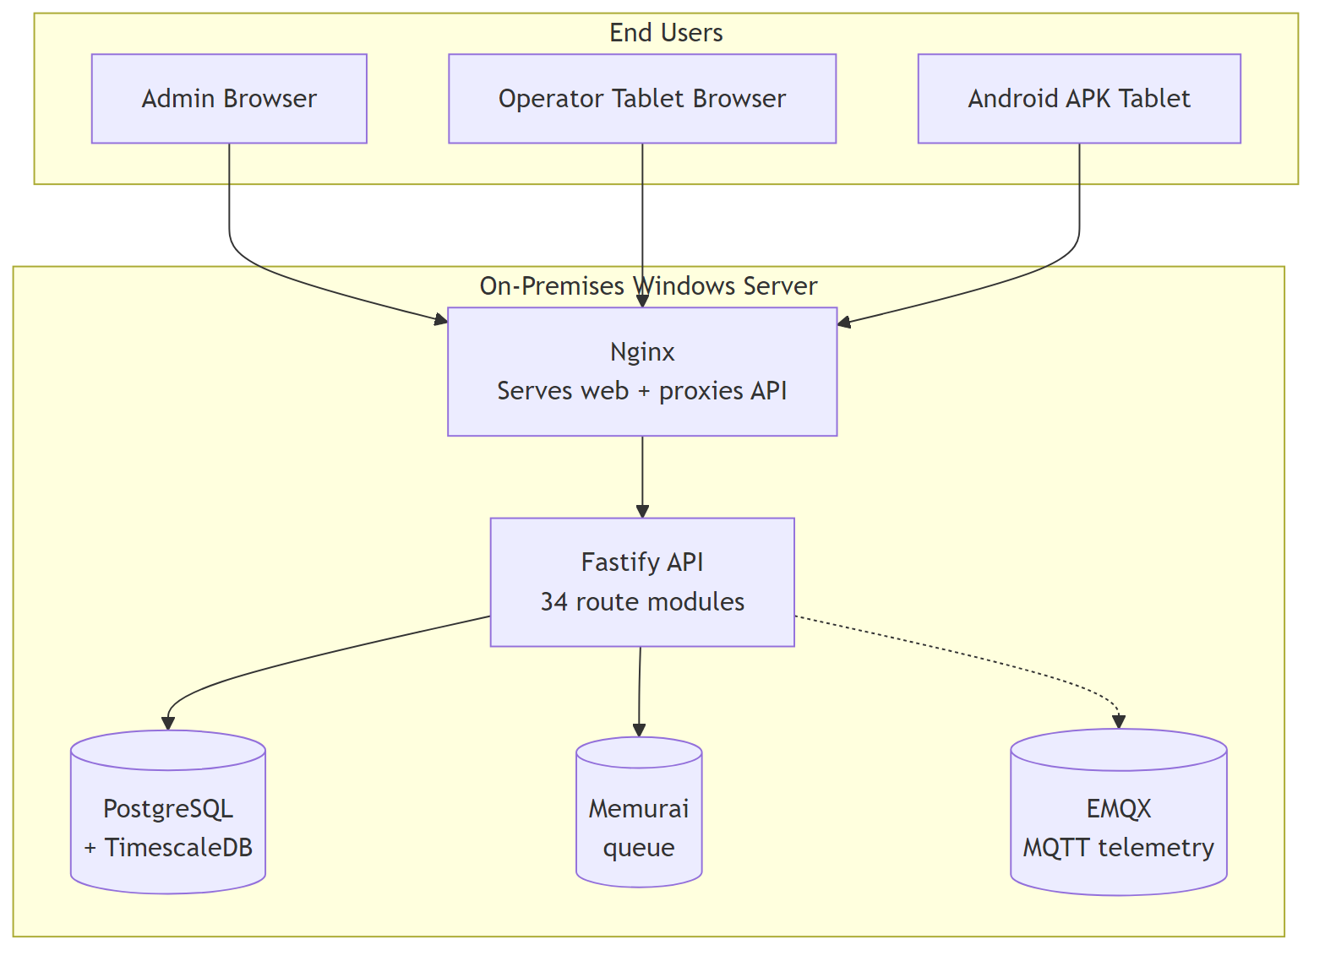
All DigiLog components run on one on-premises Windows server inside the client network.

3. Who Uses It
Role | Does what
Admin | Sets up the system, creates users, defines cleaning profiles, manages configuration
Supervisor | Approves deviations (bypass / block-change), reviews reports, signs off cycles
Operator | Scans filters, performs cleaning steps, records readings
Custom roles | Any bespoke role created by Admin with a custom permission matrix
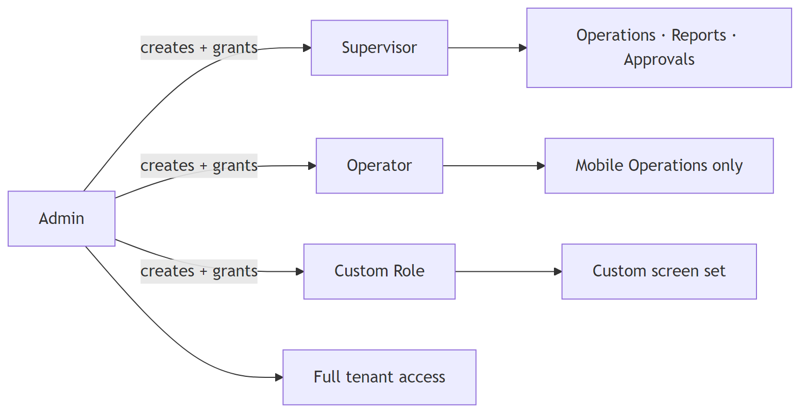

4. Login
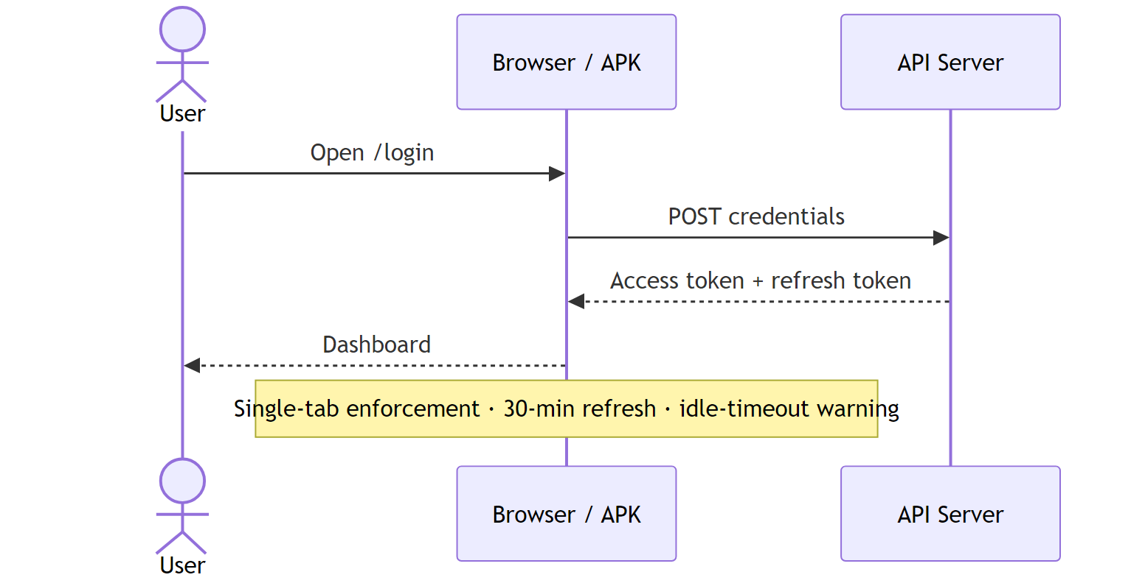
Argon2id password hashing. Optional LDAP. Session tokens in sessionStorage (not localStorage) for shared-workstation safety.

5. Admin — Initial Setup
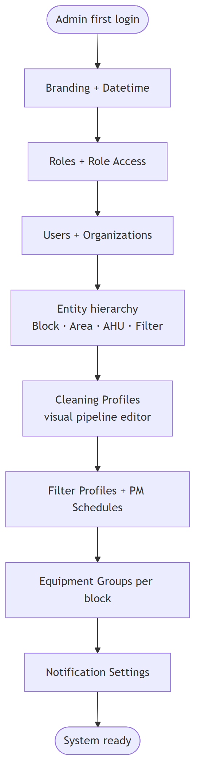
All these are configured through the Configuration section of the web UI — no coding needed.

6. Operator — Day-to-Day Cleaning Cycle
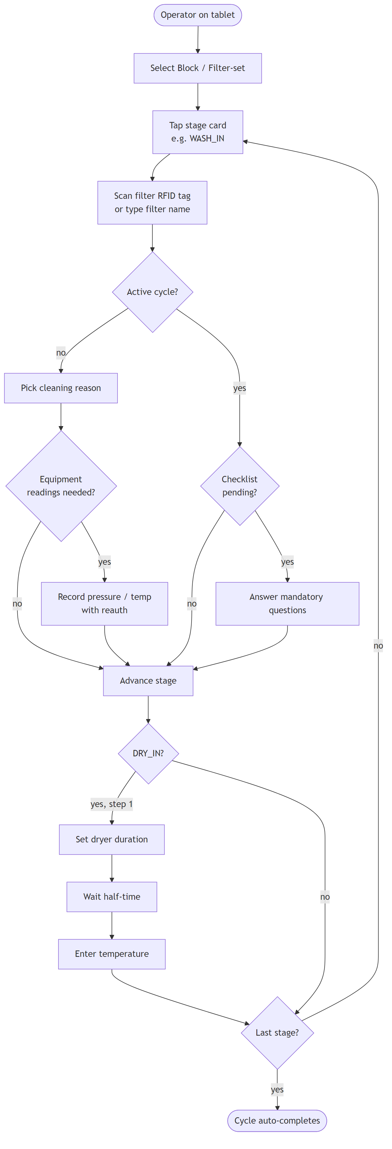
Every action writes a tamper-evident audit event. Sensitive steps require the operator to re-enter their password.

7. Offline Mode
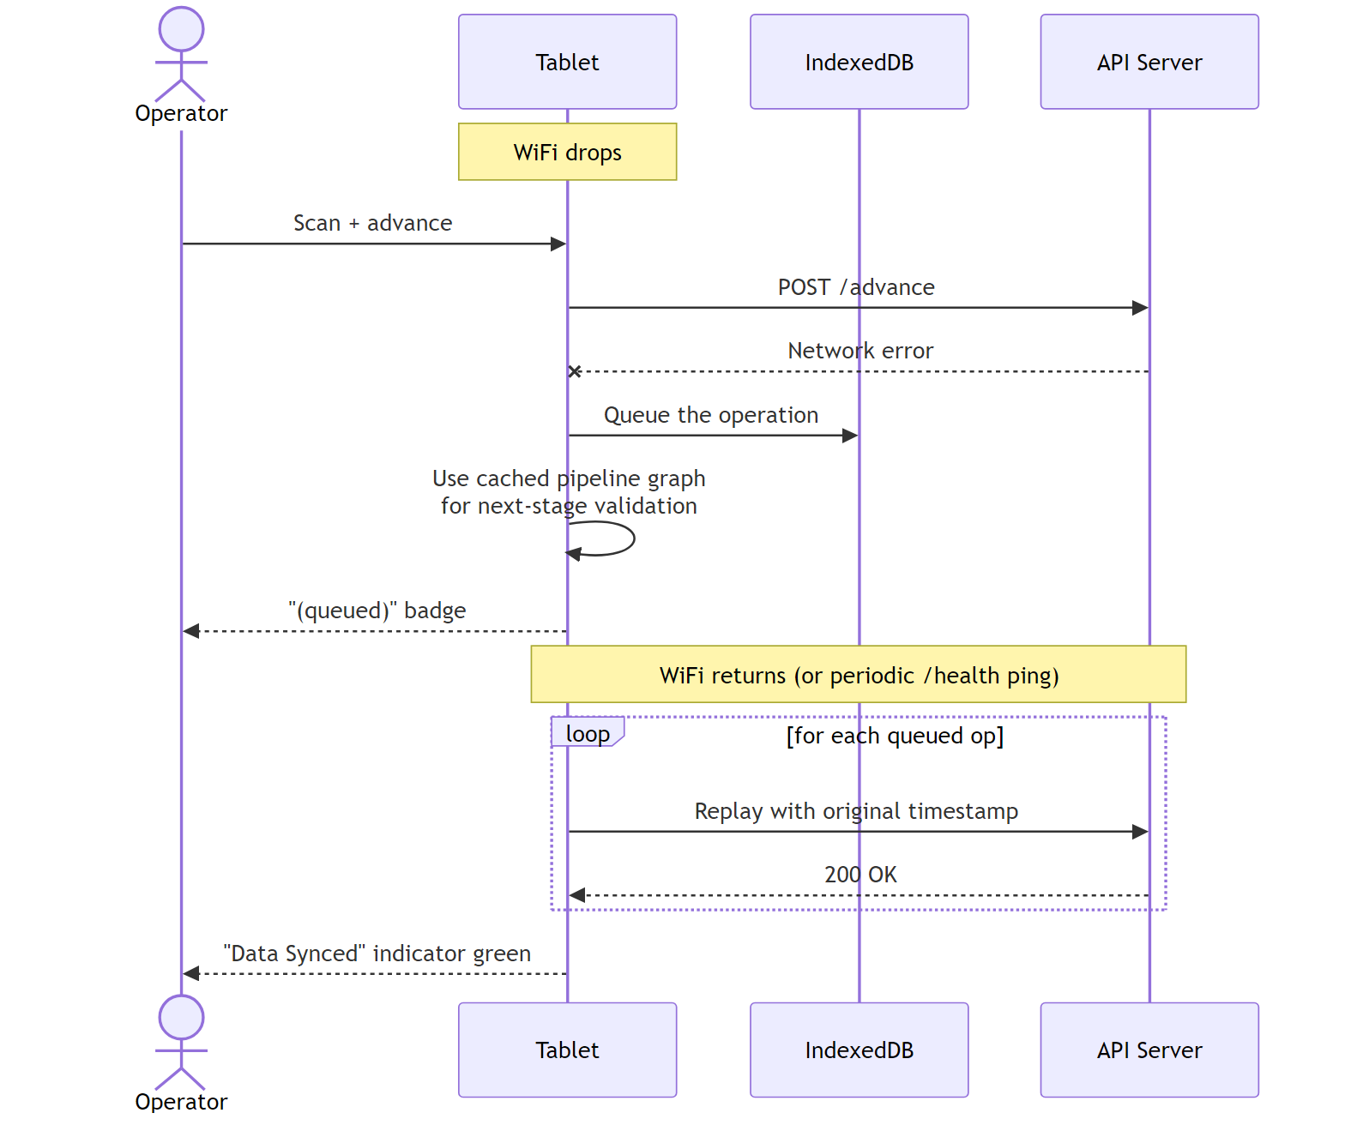
All cached data (filters, pipeline graphs, checklists, equipment groups, RFID map) is pre-loaded while online so the tablet stays fully functional on the shop floor.

8. Admin Requests & Approvals
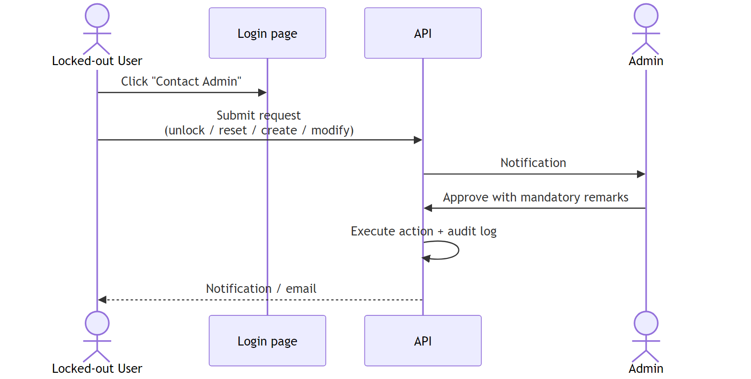

9. Block-Change Approval (cross-block cleaning)
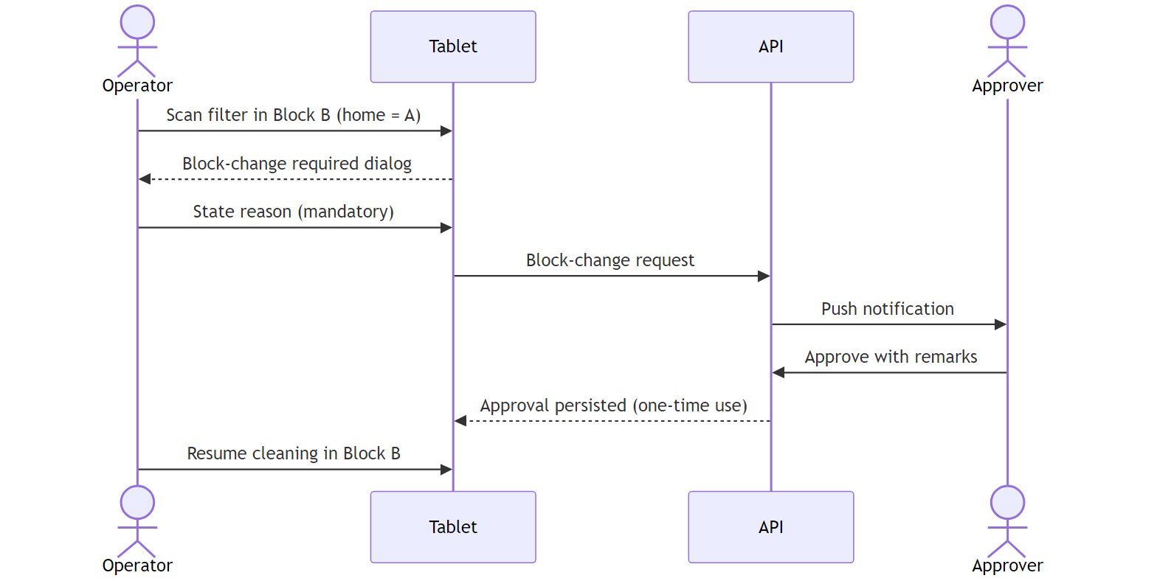

10. Checklist Enforcement (compliance critical)
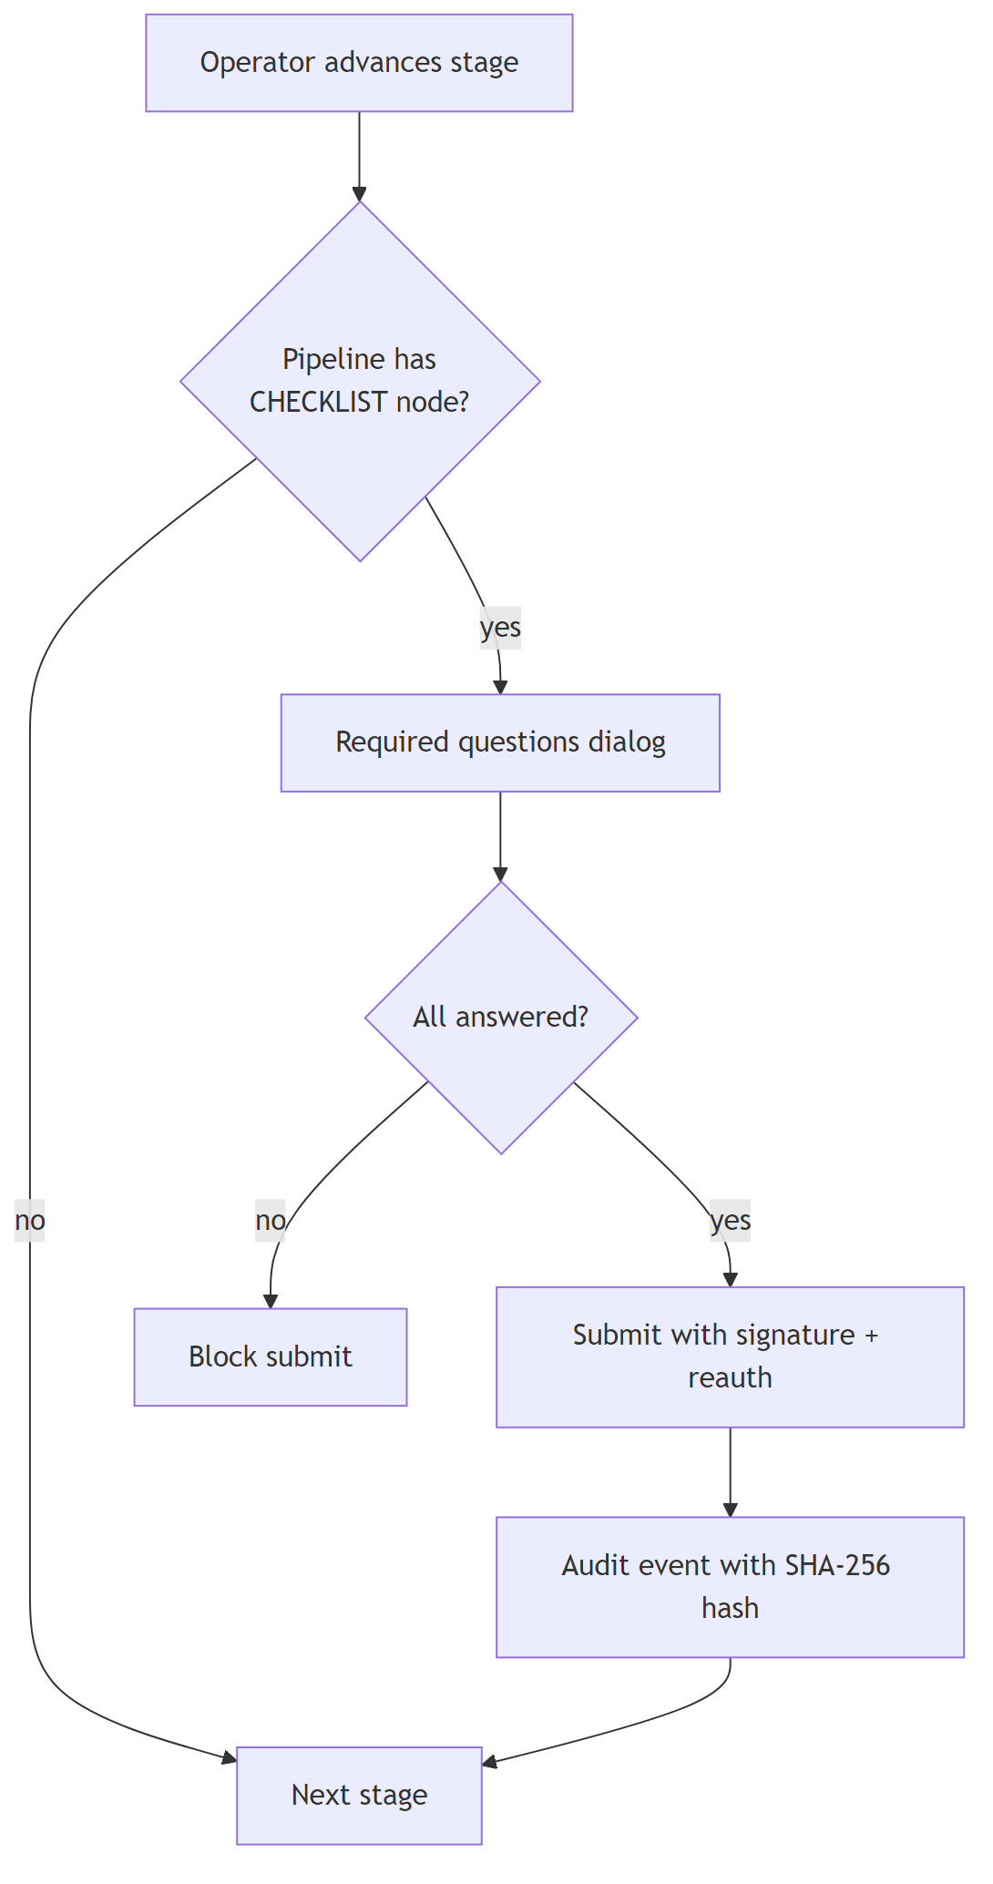
Same enforcement applies offline — required checklists are never skipped.

11. Reporting
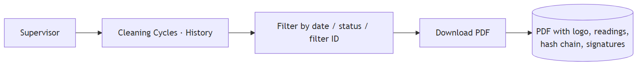
Report layouts (header, footer, records per page) are editable in Configuration → Report Settings.

12. Security & Compliance at a Glance
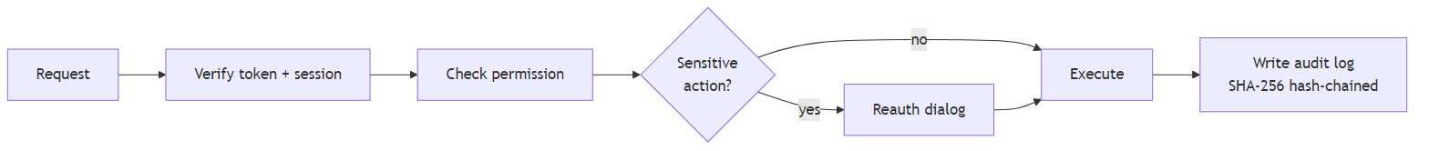
- 95 permissions, 82 feature toggles, 69 reauth actions
- Every mutating action audited — each audit row hashes the previous one, so tampering is detectable end-to-end
- Organization scoping on all queries — tenants cannot see each other's data
- Electronic signatures on checklist submissions

13. Backup & Restore
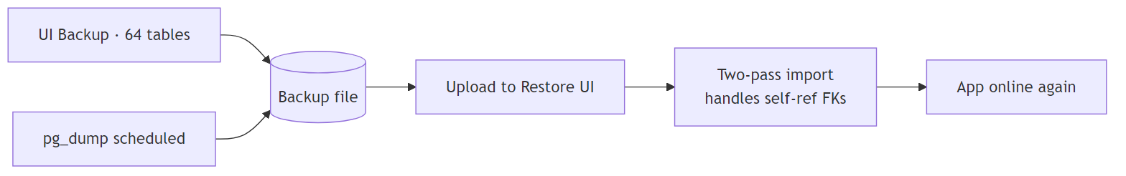
One-click dynamic backup covers all 64 database tables. Restore is two-pass to correctly rehydrate self-referential relationships.

14. Notifications
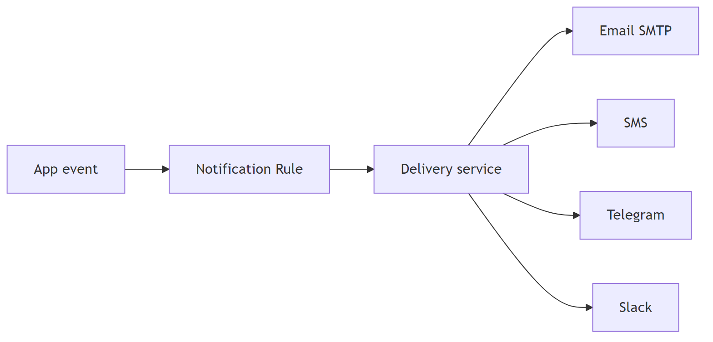
Email, SMS, Telegram, and Slack channels are all configurable per rule. OAuth2 supported for Microsoft / Google email.

15. A Day in the Life of an Operator
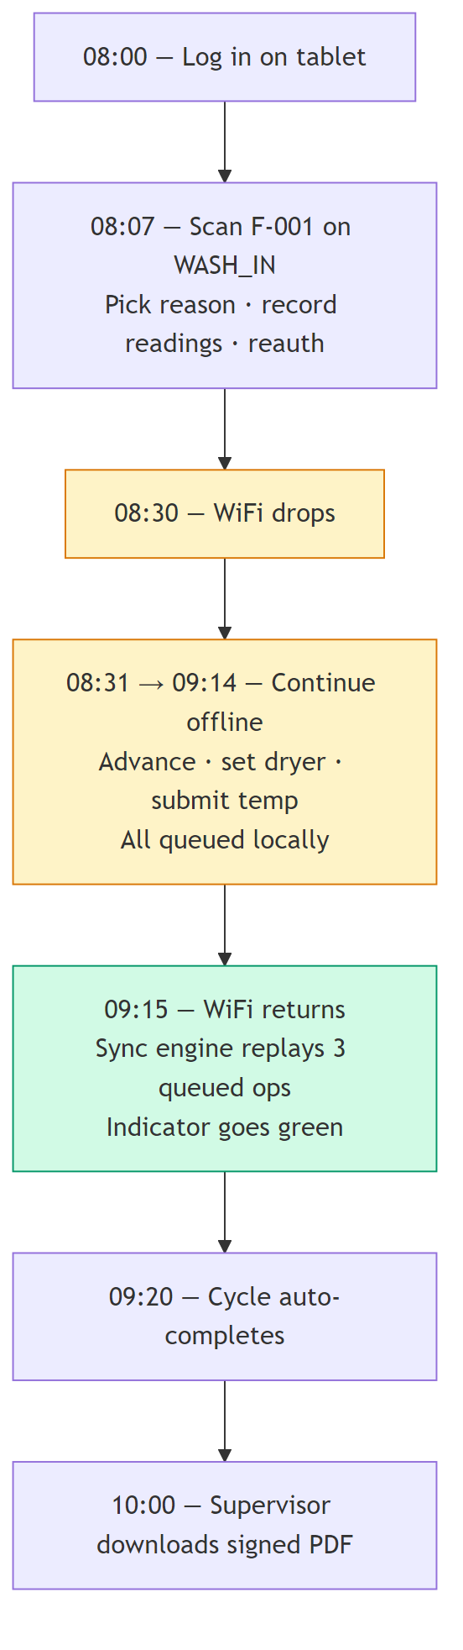

16. Key Facts for IT
Item | Value
Server | On-premises Windows Server (2019+)
Application runtime | Node.js 20+, PostgreSQL 18, Memurai (Redis), EMQX
Web access | HTTPS via Nginx (port 443)
Default URL | http://<server>/
Default admin login | admin / Admin@123 (rotate on first install)
Backup | Daily — scheduled via Windows Task Scheduler or in-app
Logs | PM2 logs + Windows Event Viewer
Mobile tablets | Signed Android APK distributed by IT

End of overview. Full technical detail is available in the development team's internal docs.

