How to implement DHCP
in W5200

Version 0.9βeta

`


© 2011 WIZnet Co., Inc. All Rights Reserved.
For more information, visit our website at http://www.wiznet.co.kr

Table of Contents
1 Introduction 3
2 DHCP 3
3 DHCP Client 4
3.1 Demonstration 4
4 Software 5
4.1 Socket 5
4.1.1 OPEN 5
4.1.2 SEND 5
4.1.3 RECEIVE 6
4.1.4 DHCP Message Format 6
4.2 DHCP Functions 7
Document History Information 11

- Introduction
DHCP server uses DHCP to assign details like IP address or settings to the client that uses the DHCP. This application note will explain how to implement DHCP client by using W5200.

- DHCP
DHCP uses UDP (User Datagram Protocol) through Transport Layer, and communicates with the DHCP server using UDP broadcast. Fig.1 describes the communication between the DHCP server and client.
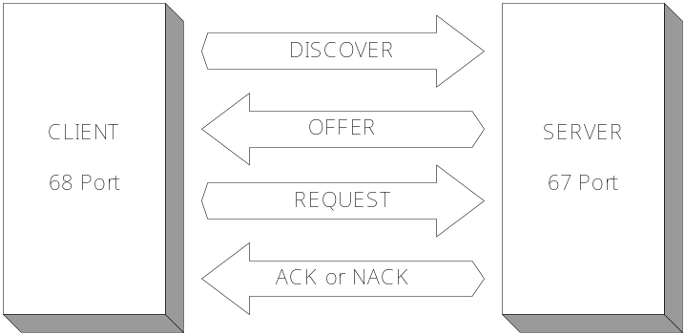
Fig. 1 DHCP Message
DHCP Client broadcasts the ‘DISCOVERY message’ on the connected network. If a DHCP Server exists on the computer network, the DHCP Server will receive the ‘DISCOVERY message’ and send the ‘OFFER message’ to the DHCP client. ‘OFFER message’ consists of an IP that can be used by DHCP client, Gateway(G/W), network information that is the same as the DNS server IP, and information like lease time. DHCP Client can acknowledge the DHCP Server by receiving the ‘OFFER message,’ and send the ‘REQEUST message’ to use the information suggested by the server. Then after the ‘REQUEST message’ is received, the DHCP Server decides whether the Lease duration (the period of time where the DHCP client IP address can be used) and Network configuration can be used or not. If the above information can be used, the DHCP Server will send an ACK message to the DHCP Client; or a NACK message if the information can’t be used.

- DHCP Client
  - Demonstration
Fig.2 shows the result of DHCP Client Test by connecting W5200E01-M3 and network gear. The DISCOVER/OFFER/REQUEST/ACK messages can be checked. The DHCP Client network configuration assigned by the DHCP Server can be checked also.

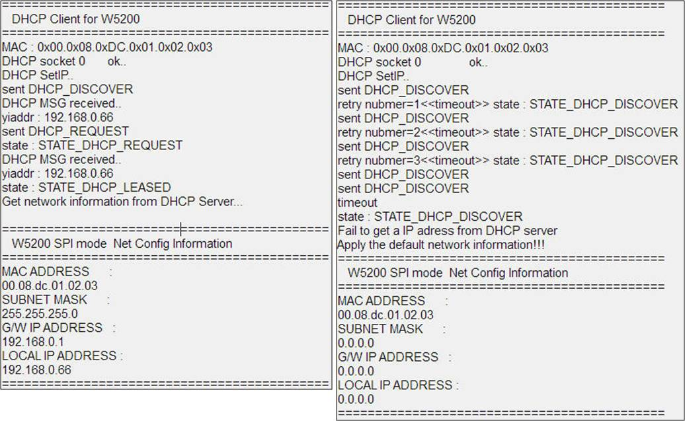
Figure 2 DHCP processing (Left:success & Right:timeout)

If there is no DHCP server in you network, DHCP processing will time out (See Figure 2, right). By default, W5200 will retry 3 times until the response of DHCP_DISCOVER (Offer) is received, otherwise W5200 will use zero as network parameters (IP: 0.0.0.0, subnet: 0.0.0.0, G/W: 0.0.0.0)
4. Software
  - Socket
    - OPEN
Since the internet connection is not required between the DHCP Server and DHCP Client, DHCP needs to be opened by UDP. Use Sn_MR_UDP as shown below to OPEN the socket (line886).
dhcp.h
/* UDP port numbers for DHCP */
- #define DHCP_SERVER_PORT 67 /* from server to client */
26 #define DHCP_CLIENT_PORT 68 /* from client to server */

dhcp.c

886：socket(SOCK_DHCP, Sn_MR_UDP, DHCP_CLIENT_PORT, 0x0)

4.1.2 SEND
The user must set the other user’s IP address and port before sending the DHCP data. The DHCP_SERVER_PORT is fixed to 67. When DISCOVER or REQUEST is operated, The IP address uses the BROADCAST address (255.255.255.255) to send data. After receiving the DHCP Server IP from the DHCP message, use the parsed DHCP Server IP (DHCP_SIP[]) to send data (line287).
dhcp.c
/* DST IP : BroadCasting*/

270: if(dhcp_state < STATE_DHCP_LEASED)
{
ip[0] = 255;
ip[1] = 255;
ip[2] = 255;
ip[3] = 255;
}
else
{
ip[0] = DHCP_SIP[0];
ip[1] = DHCP_SIP[1];
ip[2] = DHCP_SIP[2];
ip[3] = DHCP_SIP[3];
}

// send MSG to Broadcasting
285: sendto(s, (u_char*)pRIPMSG, sizeof(RIP_MSG), ip, DHCP_SERVER_PORT)

    - RECEIVE
This section is identical with the RECEIVE section of UDP. Please refer to ‘How to implement UDP in W5200.’
dhcp.c
415: len = recvfrom(s, (u_char *)pRIPMSG, length, svr_addr, &svr_port);

    - DHCP Message Format
The structure below is composed of codes that work with the DHCP message. (Please refer to the RFC1541 document for more details on DHCP Message Format and each Field). The fileds below the ciaddr field are used to send network information; and the options field is used to send message type and information like client identifier.
dhcp.h
128 : /**
* @brief for the DHCP message
*/
typedef struct _RIP_MSG
{
u_char op;
u_char htype;
u_char hlen;
u_char hops;
u_long xid;
u_int secs;
u_int flags;
u_char ciaddr[4];
u_char yiaddr[4];
u_char siaddr[4];
u_char giaddr[4];
u_char chaddr[16];
u_char sname[64];
u_char file[128];
u_char OPT[312];
}RIP_MSG;

  - DHCP Functions
The functions for implementing the DHCP client are listed under dhcp.h and dhcp.c below.
dhcp.h
void init_dhcp_client(SOCKET s, void (*ip_update)(void),void (*ip_conflict)(void)); // Initialize the DHCP client
u_int init_dhcpc_ch(SOCKET s); // Initialize the socket for DHCP client
u_int getIP_DHCPS(void); //Get the network configuration from the DHCP server
void check_DHCP_state(SOCKET s); // Check the DHCP state
dhcp.c
static void send_DHCP_DISCOVER(SOCKET s); /* Send the discovery message to the DHCP server */
static void send_DHCP_REQUEST(SOCKET s); /* Send the request message to the DHCP server */
static char parseDHCPMSG(SOCKET s, u_int length); /* Receive the message from DHCP server and parse it. */
static void reset_DHCP_time(void); /* Initialize DHCP Timer */
static void check_DHCP_Timeout(void); /* Check DHCP Timeout */
static void set_DHCP_network(void); /* Apply the leased IP address to LP-NetCAM II */
static void proc_ip_conflict(void); /* called when the leased IP address is conflict */

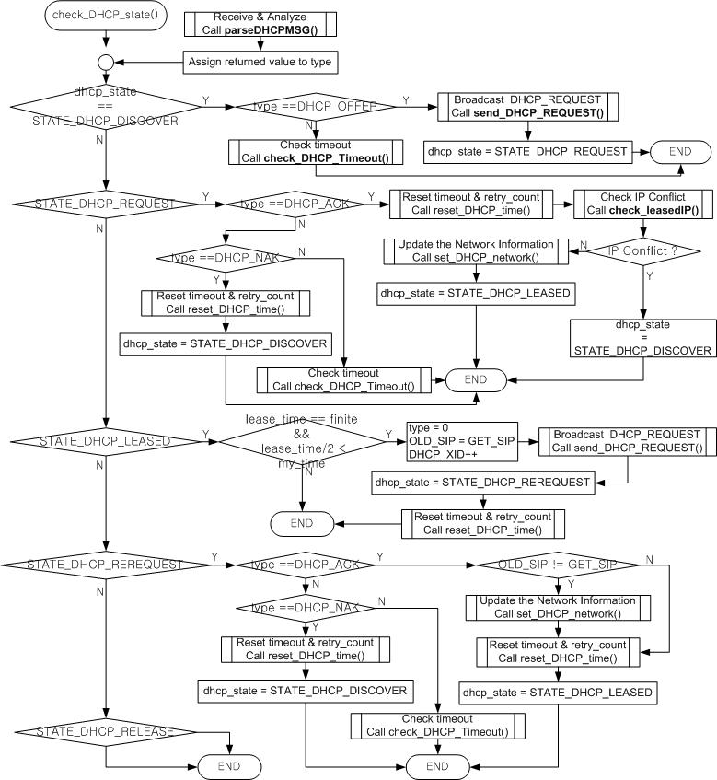
Fig. 2 check_dhcp function
Fig.3 shows the flowchart of check_dhcp(). DHCP_OFFER, DHCP_ACK, and DHCP_REQUEST are operated depending on the change (transition) of dhcp_state. Fig.4 shows the flowchart of parseDHCPMSG(). parseDHCPMSG() is used to phishing (parsing) DHCP messages. Fig.5 shows the flowchart of check_LeaseIP() and send_DHCP_REQUEST().

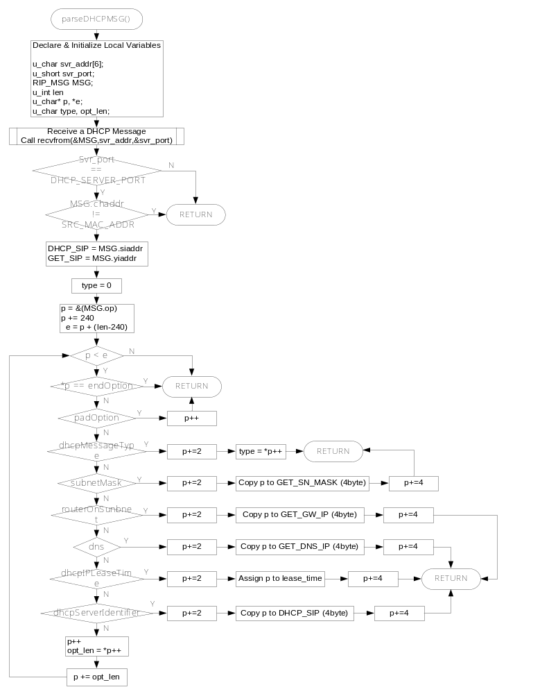Fig. 3 parseDHCPMSG() function flowchart
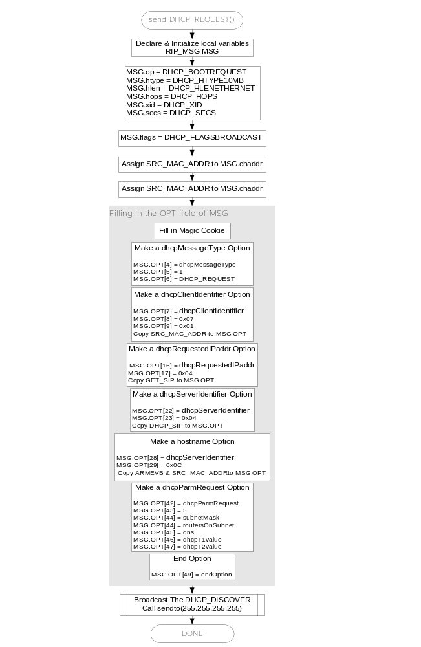
Fig. 4 send_DHCP_REQUEST() funciton flowchart

Document History Information
Version | Date | Descriptions
Ver. 0.9βeta | Sep, 2011

Copyright Notice

Copyright 2011 WIZnet, Inc. All Rights Reserved.

Technical Support: support@wiznet.co.kr
Sales & Distribution: sales@wiznet.co.kr

For more detailed information, visit our website at http://www.wiznet.co.kr

