**Assignment: File and folder exercise**

The purpose of this assignment is to establish, refine, and demonstrate your ability to manage directories and files.

**The Assignment**

In this assignment, you will create a file and directory structure, record it using a listing command, and then change the structure and record its change with another listing command.

* In your home directory, create a directory called "filefun".
* Inside this directory "filefun", create set of directories and files as shown in the following diagram. Use the Unix command **mkdir** to create a directory. Use whatever means you would like to make the files, such as output redirection or the Unix **touch** command. The contents of the files can be anything (or empty), but they must be plain text files, and you must use the exact names as shown in the diagram.

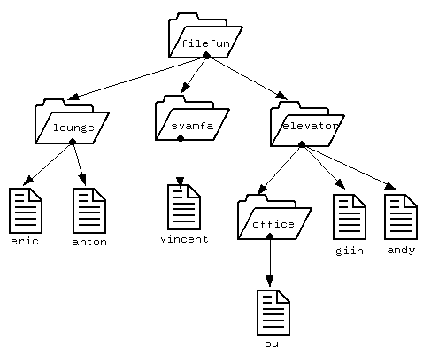

In this diagram, there are three directories under filefun: lounge, svamfa, and elevator. In lounge, there are two files: eric and anton. In svamfa, there is one file: vincent. In elevator, there are two files--giin and andy--and one directory, office. In office, there is one file, su.

* In the filefun directory, look at the directory structure you have created by using the Unix list command ls -lR.

Here is an example that I did and how it looked. I did a pwd command at the start to show the present working directory when I did the ls -lR command.

$ pwd

/home/andyd/filefun

$ ls -lR

total 3

drwxr-xr-x 3 andyd andyd 512 Sep 18 12:29 elevator/

drwxr-xr-x 2 andyd andyd 512 Sep 18 12:29 lounge/

drwxr-xr-x 2 andyd andyd 512 Sep 18 12:29 svamfa/

filefun/elevator:

total 1

-rw-r--r-- 1 andyd andyd 0 Sep 18 12:29 andy

-rw-r--r-- 1 andyd andyd 0 Sep 18 12:29 gin

drwxr-xr-x 2 andyd andyd 512 Sep 18 12:29 office/

filefun/elevator/office:

total 0

-rw-r--r-- 1 andyd andyd 0 Sep 18 12:29 su

filefun/lounge:

total 0

-rw-r--r-- 1 andyd andyd 0 Sep 18 12:29 eric

-rw-r--r-- 1 andyd andyd 0 Sep 18 12:29 anton

filefun/svamfa:

total 0

-rw-r--r-- 1 andyd andyd 0 Sep 18 12:29 vincent

* Still in the filefun directory, do the ls -lR command again, but this time **redirect the output** of this ls -lR command to a file called listing.txt.
* Now move all the files in the directories lounge (eric and anton), office (su), and elevator (giin andy) to svamfa.
* Now delete the directories lounge, office, and elevator. Once you have moved the files and deleted the directories, you would have this structure:

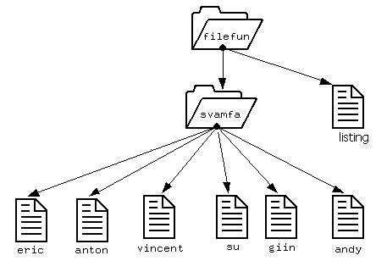

* Still in the "filefun" directory, use the ls -lR again to look at the new file structure you have.
* Still in the "filefun" directory, **append the output** of this ls -lR command to the file listing.txt.
* Your assignment is to email the contents of the file listing(s) that you created. This will show your directory and file structure "before" and "after" moving the files and deleting the directories. **Use the file redirection technique demonstrated in class to produce the file "listing.txt"**.
* Write a command to list all the files inside a folder i.e. if there is a folder inside a folder then it should list all files inside the sub-folder which is inside the folder to be listed.
* Search all the files which contains a particular string, say “include” within a folder.
* Rename all the files within a folder with suffix “Unix_” i.e. suppose a folder has two files a.txt and b.pdf than they both should be renamed from a single command to Unix_a.txt and Unix_b.pdf
* Rename all files within a folder with the first word of their content(remember all the files should be text files. For example if a.txt contains “Unix is an OS” in its first line then a.txt should be renamed to Unix.txt >>>

for fname in *.txt

do

mv $fname $(head -1 -q $fname|awk '{print $1}')

* Suppose you have a C project in a folder called “project”, it contains .c and .h files, it also contains some other .txt files and .pdf files. Write a Linux command that will count the number of lines of your text files. That means total line count of every file. (remember you have to count the lines in .txt files only)
* Rename all files which contain the sub-string 'foo', replacing it with 'bar' within a given folder.
* Show the most commonly used commands from “history”. [hint: remember the history command, use cut, and sort it.
* Create a tree structure named ‘training’ in which there are 3 subdirectories – ‘level 1’,’ level2’ and ‘cep’. Each one is again further divided into 3. The ‘level 1’ is divided into ‘sdp’, ‘re’ and ‘se’. From the subdirectory ‘se’ how can one reach the home directory in one step and also how to navigate to the subdirectory ‘sdp’ in one step? Give the commands, which do the above actions?
* How will you copy a directory structure dir1 to dir2 ? (with all the subdirectories)
* What is the command for printing the current time in 24-hour format?
* What is the command for printing the year, month, and date with a horizontal tab between the fields?