**1.5 Setup Password-less SSH on Servers**

First of all we need to protect our keypair files, if the file permissions are too open (see below) you will get an error

$ chmod 644 authorized_keys

**Quick Tip:** If you set the permissions to ‘chmod 644’, you get a file that can be written by you, but can only be read by the rest of the world.

$ chmod 400 HadoopAdmin.pem

[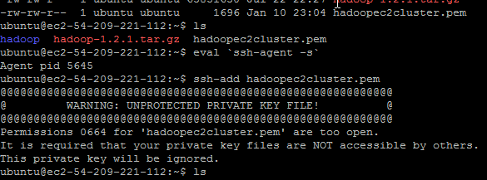](https://letsdobigdata.files.wordpress.com/2014/01/ssh_error1.png)

To fix this problem, we need to issue following commands

**Quick Tip**: chmod 400 is a very restrictive setting giving only the file onwer read-only access. No write / execute capabilities for the owner, and no permissions what-so-ever for anyone else.

To use ssh-agent and ssh-add, follow the steps below:

1. At the Unix prompt, enter: eval `ssh-agent`

**Note:**Make sure you use the backquote ( ` ), located under the tilde ( ~ ), rather than the single quote ( ' ).

1. $ ssh-agent /bin/sh
2. $ ssh-add $yourkey (HadoopAdmin.pem)

[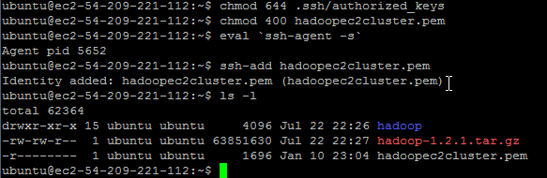](https://letsdobigdata.files.wordpress.com/2014/01/ssh_success.png)

Keep in mind ssh session will be lost upon shell exit and you have repeat ssh-agent and ssh-add commands.