***Single-node Hadoop cluster step by step instruction***

**1. Installing Cygwin**

a) Cygwin comes with a normal setup.exe to install in Windows, but there are a few steps you need to pay attention, I would like to walk you through the step by step installation. [Click her to download Cygwin setup](http://cygwin.com/install.html)

b)Once you start installing the first screen which appears this

[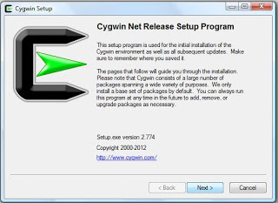](https://sundersinghc.files.wordpress.com/2013/04/cygwin12.jpg)

**SSH Installation**

c) After 4 steps from the above screen you will be getting a screen to select packages, in this step you can choose OpenSSH installation along with Cygwin

[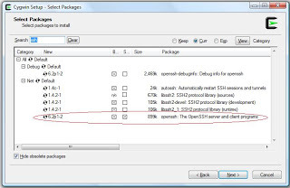](https://sundersinghc.files.wordpress.com/2013/04/cygwin22.jpg)

d) Cygwin installer proceeds with including all dependent packages which are required for the installation.

***Now you installed Cygwin with OpenSSH*2. Set Environment Variable in Window**

a) Find “*My Computer*” icon either on the desktop, right-click on it and select *Properties* item from the menu.   
b) When you see the *Properties dialog box*, click on the *Environment Variables* button which you see under the *Advance Tab*.  
c) When you click *Environment Variables* dialog shows up, click on the *Path* variable located in the *System Variables* box and then click the Edit button.  
d) Edit dialog appears append you cygwin path end of the Variable value field

(I installed Cygwin under C: drive – c:\cygwin\bin;)

***Now you are down with Cygwin environmental setup***

**3. Setup SSH daemon**a) Open the Cygwin command prompt.  
b) Execute the following command:

**$ ssh-host-config**

c) When asked if privilege separation should be used, answer **no**.

d) When asked if sshd should be installed as a service, answer **yes**.

*(If it prompts with CYGWIN environment variable, enter* ***ntsec****)*

**4.** **Start SSH daemon**

a) Find *My Computer* icon either on your desktop, right-click on it and select ***Manage*** from the context menu.

b) Open ***Services and Applications*** in the left-hand panel then select the *Services*item.

c) Find the ***CYGWIN sshd*** item in the main section and right-click on it.

d) On the property popup you can select “Start up :” **Automatic.** So that it will start up when windows starts

[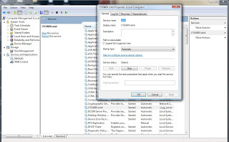](https://sundersinghc.files.wordpress.com/2013/04/cygwin32.jpg)

**5.** **Setup authorization keys**

a) Open Cygwin Terminal and exectute the command

**$ ssh-keygen**

*(Since we are generating keys without password, so press enter. Below is the sequence* *of text which appears in the terminal prompt)*

b) Once the command completed generating the key

**$ cd ~/.ssh**

*(.ssh folder will be under $ <user> directory, eg:- please find he screen shot below .ssh is under my user profile installed in my system is “sunder”*)  
[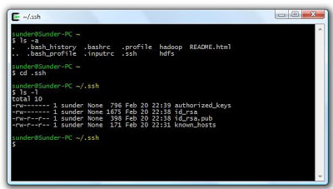](https://sundersinghc.files.wordpress.com/2013/04/cygwin-ssh2.jpg)c) Next step is to create an RSA key pair with an empty password. You have to enable SSH access to your local machine with this newly created key.

**$ cat id_rsa.pub >> authorized_keys**

***Now you created RSA key pair***

To test SSH installed, from a terminal prompt enter:

**$** **ssh localhost**

*( You will get a similar notification in the terminal)*

|  |  |
| --- | --- |
| 1 | $ ssh localhost |
| 2 | Last login: Mon Apr 8 21:36:45 2013 from sunder-pc |

***Now you SSH successfully running with keys generated***

[](https://sundersinghc.files.wordpress.com/2013/04/java5.jpg)

**6.** **JAVA Installation**

a) Installing JAVA in windows system is a easy step up step process

b) You can download .exe for Windows installation file from the [*Oracle JDK download page*](http://www.oracle.com/technetwork/java/javase/downloads/jdk6downloads-1902814.html)

c) Choose your JAVA installation folder (eg :- C:\Java\jdk1.6.0_41) and install JAVA

***Now you successfully installed JAVA***

**7.** **Setting JAVA_HOME in Windows**

a) Set environmental variable for JAVA_HOME, as we already did for **Cygwin** in the above instruction – the same steps to be followed for setting JAVA_HOME

b) You may need to create a new variable under the User Variable / System Variable. Please find the reference screen shot below

[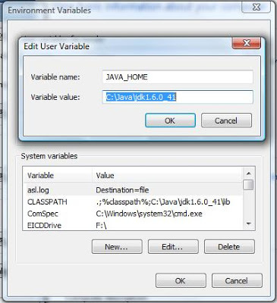](https://sundersinghc.files.wordpress.com/2013/04/java-env-setup2.jpg)

**8.** **Setting JAVA_HOME in Cygwin**

a. To set JAVA_HOME in **Cgwin** have to update Java home directory in /etc/bash.bashrc

b. edit **$HOME/.bashrc** file to set JAVA home directory

**$** **vi bashrc**

c. Set Java home, you can see export JAVA_HOME line in the file been commented using #. Remove # (uncomment it) and you have to key in by giving your Java installed path

d. *export JAVA_HOME=* c:\\java\\jdk1.6.0_41

*(to recognize your windows folder you have give 2 backward slash****”\\”*** *for each folder, since I installed java under* ***c:\java\jdk1.6.0_41*** *in my windows path)*

**Please Note:**

Since you are using Windows you can also edit file through windows explorer whenever you are editing any files inside **Cgwin** through Windows either with notepad or wordpad, after saving the files in windows ensure you get into **Cgywin**terminal and locate the file and execute a UNIX command **“$ dos2unix <filename>”**. This is more important in all stages of execution

e. Exit any terminal and open a new terminal

f. To check the variable is set, type the command in a terminal

**$ echo $JAVA_HOME**

*(The above command will display the java directory path you se or you can also type $ java –version or simply $ java to see execution of java commands in the terminal )*

***Now you set environment variable in Cygwin ie. JAVA_HOME***

[](https://sundersinghc.files.wordpress.com/2013/04/hadoop25.jpg)

**9.** **Hadoop Installation**

Below step by step instruction will help you to setup a single-node Hadoop cluster. Before we move on know about the [*HDFS*](http://hadoop.apache.org/docs/r1.0.4/hdfs_user_guide.html) (Hadoop Distributed File System) [*Architecture Guide*](http://hadoop.apache.org/docs/r1.0.4/hdfs_design.html)

a) Download a recent stable release from one of the [*Apache Download Mirrors.*](http://www.apache.org/dyn/closer.cgi/hadoop/core)

b) Download “hadoop-<version>.tar.gz” to your desired directory

c) From the terminal type this command where you download your hadoop-< version>.tar.gz file

**$ tar -xvf hadoop-<**version**>.tar.gz**

d) The above command will extract the hadoop files and folder

e) Once you extracted all the files, you may have to edit few configuration files inside <Hadoop Home> directory

**Feel free to edit any file through windows with wordpad but don’t forget to execute the UNIX command “$ dos2unix <filename>” for all the files you open up in windows.**

f) Now edit <Hadoop Home>/conf/hadoop-env.sh to set Java home as you did it before for environmental variable setup

*(Since I already set my JAVA_HOME in .bashrc so I gave JAVA_HOME*=$JAVA_HOME)

g) And then update <Hadoop Home>/conf/core-site.xml. with the below xml tag to setup hadoop file system property

<configuration>

<property>

<name>fs.default.name</name>

<value>hdfs://localhost:50000</value>

</property>

</configuration>

h) Now update<Hadoop Home>/conf/ mapred -site.xml with the below xml tag

<configuration>

<property>

<name>mapred.job.tracker</name>

<value>localhost:50001</value>

</property>

</configuration>

i) Now update<Hadoop Home>/conf/ hdfs -site.xml with the below xml tag

<configuration>

<property>

<name>dfs.data.dir</name>

<value>/home/<user>/hadoop-dir/datadir</value>

</property>

<property>

<name>dfs.name.dir</name>

<value>/home/<user>/hadoop-dir/namedir</value>

</property>

</configuration>

Assume you created your directory in your user profile, so user your user name after /home otherwise you can also check your folder by executing *pwd* command after you get into your terminal inside your created folder

Assuming create “data” and “name” directory from your home directory, I created a directory hadoop-dir and inside that I have created 2 directories one for name node and other for data node

ensure your data and name directory created and accessed by hadoop, execute the command to change the directory permission by

**$ chmod 755 data**

as well as

**$ chmod 755 name**

**i.e.** if you *$ ls -l* your directory you data and name directory should be in this mode “drwxr-xr-x” which means owner has three permissions, and group and other have only read and execute permissions

**10.** **HDFS Format**

Before starting your cluster you may need to format your HDFS by running the below command from <Hadoop-Home-Dir>/bin

**$ ./hadoop namenode -format**

**11.** **Copy File to HDFS**

To copy local file to HDFS execute this command from <Hadoop-Home-Dir>/bin from the terminal

**$ ./hadoop dfs -copyFromLocal <localsrc> URI**

**Eg: –** If I have a sample.txt file in the path /home/<user>/Example

Then I have to executing the command from<Hadoop-Home-Dir>/bin

**$ ./hadoop dfs –copyFromLocal /home/<user>/Example/sample.txt /**

This command will copy the local fin into HDFS home directory

**12.** **Browse HDFS through web interface**

Starting hadoop cluster is by executing a command from<Hadoop-Home-Dir>/bin

**$ ./start-all.sh**

This will startup a Namenode, Datanode, Jobtracker and a Tasktracker on your machine

To stop the cluster

**$ ./stop-all.sh**

to stop all the daemons running on your machine.

To understand more on [*Getting Started With Hadoop*](http://wiki.apache.org/hadoop/GettingStartedWithHadoop)

Browse the web interface for the NameNode and the JobTracker; by default they are available at:

NameNode – <http://localhost:50070/>

JobTracker – <http://localhost:50030/>

If you face problem running your Cluster, especially with data node daemon not starting up

* 1. Stop the cluster ($./stop-all.sh)