**E-WASTE MANAGEMENT IN INDIA**

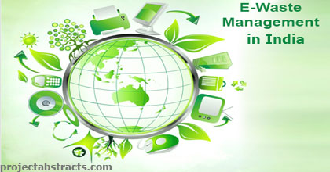

**Name-Lilesh Patil**

**Roll No-39**

**FYBSCIT-A**

**INDIVIDUAL**

**CERTIFICATE**

**ACKNOWLEDGEMENT**

I would like to express my special thanks of gratitude to my teacher Dhanraj Jadhav who gave me the golden opportunity to do this wonderful project on the topic E-Waste Management in India, which also helped me in doing a lot of Research and i came to know about so many new things I am really thankful to them.Secondly i would also like to thank my parents and friends who helped me a lot in giving responses for survey of project.

Lilesh Patil

FYBScIT- A

**INDEX**

|  |  |  |
| --- | --- | --- |
| S.NO | TOPICS | PAGE NO |
| 1. | Introduction | 5. |
| 2. | Review of Literature | 14. |
| 4. | Methodology | 24. |
| 5. | Findings | 32. |
| 6. | Discussion | 42. |
| 7. | Conclusion | 47. |
| 8. | References | 49. |

**INTRODUCTION**

**AIM**

The programme aims to create effective awareness in various levels (of society) to reduce the adverse impact on environment and health arising out of the polluting technologies used in recyclinge-waste in the unorganized sector E-waste is a growing concern and there has been a rapid increase in health hazards because of discharging the toxic materials into the environment. The goal of e-waste recycling providers is to help businesses and organizations in getting rid of obsolete electronics and safeguard the environment. The E-waste management market is experiencing exponential growth as more and more businesses are hiring the electronic recycling providers that are well-acquainted with efficient e-waste management techniques. Electronic recycling can help in saving unnecessary dumps and landfills, furthermore reduces greenhouse gas emissions, and save natural resources. Giving away the old electronics is important in the provision of refurbished products including mobile phones and computers. The Ministry of Environment, Forest and Climate Change rolled out the E-Waste (Management) Rules in 2016 to reduce e-waste production and increase recycling. Under these rules, the government introduced EPR which makes producers liable to collect 30 per cent to 70 per cent (over seven years) of the e-waste they produce, said the study. The integration of the informal sector into a transparent recycling system is crucial for a better control on environmental and human health impacts. There have been some attempts towards integrating the existing informal sector in the emerging scenario. Organizations such as GIZ have developed alternative business models in guiding the informal sector association towards authorization. The E-Waste Management Rules, 2016 were amended by the government in March 2018 to facilitate and effectively implement the environmentally sound management of e-waste in India. The amended Rules revise the collection targets under the provision of EPR with effect from October 1, 2017. By way of revised targets and monitoring under the Central Pollution Control Board (CPCB), effective and improved management of e-waste would be ensured. India is among the top five e-waste producing countries in the world with estimated annual production of 2 million tons. Like some of the other developing countries, e-waste management in India is dominated by the informal sector with estimates of more than 90 per cent of the waste being processed in this sector.

**TOPIC**

Electronic waste or e-waste is generated when electronic and electrical equipment become unfit for their originally intended use or have crossed the expiry date. Computers, servers, mainframes, monitors, compact discs (CDs), printers, scanners, copiers, calculators, fax machines, battery cells, cellular phones, transceivers, TVs, iPods, medical apparatus, washing machines, refrigerators, and air conditioners are examples of e-waste (when unfit for use). These electronic equipment’s get fast replaced with newer models due to the rapid technology advancements and production of newer electronic equipment. This has led to an exponential increase in e-waste generation. People tend to switch over to the newer models and the life of products has also decreased .The discarded and end-of-life electronics products ranging from computers, equipment used in Information and Communication Technology (ICT), home appliances, audio and video products and all of their peripherals are popularly known as Electronic waste (E-waste). There is, however, no standard or generally accepted definition of e-waste in the world. In most cases, e-waste comprises of the relatively expensive and essentially durable products used for data processing, telecommunications or entertainment in private households and businesses. E-waste is not hazardous if it is stocked in safe storage or recycled by scientific methods or transported from one place to the other in parts or in totality in the formal sector. The e-waste can, however, be considered hazardous if recycled by primitive methods. E-waste contains several substances such as heavy metals, plastics, glass etc., which can be potentially toxic and hazardous to the environment and human health, if not handled in an environmentally sound manner. E-waste recycling in the informal sector by primitive methods can damage the environment. The ill effects of e-waste could be on soil through leaching of hazardous contents from landfills; in water due to contamination of rivers, wells and other water sources; in air due to emission of gases and burning of e-waste. The recycling process, if not carried out properly, can cause damage to human being through inhalation of gases during recycling, contact of the skin of the workers with hazardous substances and contact during acid treatment used in recovery process. Actual data on generation or import of e-waste is not currently available in India. Several studies have been conducted by various agencies to find out the inventory of e-waste in the country. Most of these studies are based on the model of obsolescence of electronic products, which needs to be validated with the field data. A survey was carried out by the Central Pollution Control Board (CPCB) during 2005.

**METHODS**

The current e-waste disposal techniques in India have operated mostly in an informal manner due to the lack of enforcement laws and regulations. This has created a new area of economic gain for the country, especially among the urban and rural poor. Though it helps many make a living, those that are disposing of e-waste are usually not aware of the risks and health hazards that result from certain disposal techniques. There are two sectors that handle e-waste disposal and they can be divided into Informal or Formal Sectors.[[21]](https://en.wikipedia.org/wiki/Electronic_waste_in_India#cite_note-ReferenceA-21)

**Formal sector**

The formal sector includes two facilities authorized to deconstruct electronics for the entire country of India and are at capacity with five tons being disposed each day. These facilities primarily receive electronic waste from the producers of "service centres or take-back schemes" or companies that follow the environmental policies on disposing electronic waste. These facilities, though reaching capacity daily, are not the mainstream method of disposal. The formal sector only follows procedure of dismantling and segregating parts. They do not physically dispose of the electronic waste. The informal sector has made it difficult to compete.

**Informal sector**

The informal sector handles electronic waste by recycling or final disposal. Much of electronics that reach India are out of date to more developed countries. Then, within India, these electronics are passed around until no longer of use. There is a whole economic market for electronic waste because the parts can be dismantled and the scrap metals can be recycled. There are recycling techniques that are not following any type of environmental or health standards. Some of the methods used are acid baths, burning cables, and disposing in nature which can be detrimental to the health of those participating in these disposal techniques

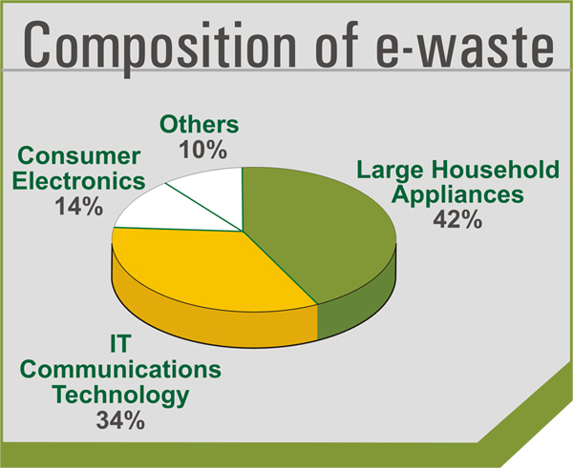

In the recent scenario, the electronic waste recycling business is in all the areas of the developed countries. By properly disposing or reusing electronics, we can prevent health problems, reduce greenhouse gas emissions and create jobs. The recycling is done by sorting, dismantling, and recovery of valuable materials and this is achieved through refurbishing and reuse. The social and environmental benefits of reuse of electronics include diminished demand for new products. Recycling the printed circuit boards from the electronic wastes is one of the major challenges. The circuit board contains some of the precious metals such as silver, gold, platinum, etc. and base metals such as iron, copper, aluminium, etc. The best way to process e-waste is by melting circuit boards, burning the cable sheathing to recover copper wire and open-pit acid hang on for separating metals of value. In order to reclaim a waste material such as electrolysis, osmosis, electrolytic recovery, condensation, filtration, centrifugation, etc.

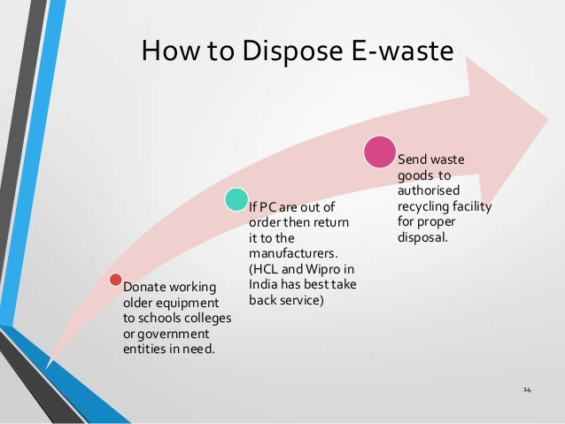

CONSUMER AWARENESS EFFORTS:

The prevention of e-waste is more preferred to any other waste management option and e-waste recycling. By donating the electronics for reuse, we extend the lives of valuable products and keep them out of the waste management system for a longer period of time. While donating the items, it should be confirmed that it is in good working condition. This reuse process also benefits the society. By donating the electronics, the lower income families can be able to use electronics that they could not afford. The e-waste should be segregated at the site and sold or donated to various organizations; it should never be disposed with garbage and other household wastes.

While buying electronic products, preference should be made to those that:

• Use recycled content

• Are energy efficient

• Are made with fewer toxic constituents

• Utilize minimal packaging

• Are designed for easy disassembly or upgrading

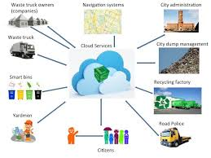

**SENARIO IN INDIA**

In India, the amount of e-waste generated differs by state. The three states that produce the most e-waste are as follows: Maharashtra, Tamil Nadu and [Andhra Pradesh](https://en.wikipedia.org/wiki/Andhra_Pradesh). Other states that produce significant e-waste are [Uttar Pradesh](https://en.wikipedia.org/wiki/Uttar_Pradesh), West Bengal, [Delhi](https://en.wikipedia.org/wiki/Delhi), [Karnataka](https://en.wikipedia.org/wiki/Karnataka), [Gujarat](https://en.wikipedia.org/wiki/Gujarat), [Madhya Pradesh](https://en.wikipedia.org/wiki/Madhya_Pradesh) and [Punjab](https://en.wikipedia.org/wiki/Punjab).

Additionally, e-waste is disproportionately generated in urban areas—65 Indian cities generate more than 60% of India's total e-waste. [Mumbai](https://en.wikipedia.org/wiki/Mumbai) is the top e-waste producer followed by [Delhi](https://en.wikipedia.org/wiki/Delhi), [Bengaluru](https://en.wikipedia.org/wiki/Bangalore), Chennai, and [Kolkata](https://en.wikipedia.org/wiki/Kolkata).

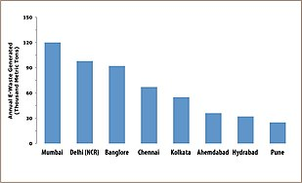

The Ministry of Environment, Forests, and Climate Change (MoEFCC) is primarily responsible for regulations regarding electronic waste. Additionally, the Central Pollution Control Board (CPCB) and State Pollution Control Board (SPCB) produce implementation procedures to ensure proper management of rules set forth by the MoEFCC.

**E-Waste Management and Handling Rules, 2011**

An addition to the Environmental Protection Act of 1986, the E-Waste (Management and Handling) Rules of 2011 came into effect in May 2012. The rules stated that all manufacturers and importers of electronic goods were required to come up with a plan to manage their electronic waste. Producers or importers had to establish e-waste collection centers or employ take back systems. These rules also mandated that sellers of electronic goods must provide consumers with information on how to properly dispose of the electronics in order to prevent people from dumping their electronics with domestic waste. Further, companies that produce electronics which have the potential to become e-waste must make the consumer aware of the hazardous materials in their product. These rules established and placed specific responsibilities for each party involved in the production, disposal, and management of electronic waste. Specific responsibilities were given to the producer, collection centers, consumer or bulk consumer, dismantlers, and recyclers. These rules also mandated that commercial consumers and government departments must keep records of their electronic waste and make them available to state and federal Pollution Control Boards.

**E-Waste Management Rules, 2016**

E- Waste (Management) Rules, 2016 In October 2016, the E-Waste (Management) Rules, 2016 replaced the E-Waste (Management and Handling) Rules, 2016. This set of rules clarifies duties of responsible parties, enacts more stringent regulations on e-waste production, as well as clarifies the general definition of e-waste. In these rules, e-waste is defined as "electrical and electronic equipment, whole or in part discarded as waste by the consumer or bulk consumer as well as rejects from manufacturing, refurbishment and repair processes. ‘Electrical and electronic equipment’ in turn has been defined to mean equipment which are dependent on electric current or electro-magnetic field in order to become functional."[[23]](https://en.wikipedia.org/wiki/Electronic_waste_in_India#cite_note-23) A major concept presented in these rules is the idea of Extended Producer Responsibility (EPR). Producers of electronic products must implement EPR in order to ensure that their electronic waste is delivered to authorized recyclers or dismantlers. These rules establish and place specific responsibilities for each party involved in the production, disposal, and management of electronic waste. Specific responsibilities were given to the manufacturer, producer, collection centers, dealers, refurbished, consumer or bulk consumer, recycler, and the state government. These rules also stated target goals for certain industries to drastically reduce their collection of electronic waste.

**Amendment to the E-Waste Management Rules, 2018**

This amendment relaxes certain aspects of the strict E- Waste (Management Rules of 2016). Specifically, the amendment focusses on the e-waste collection targets by 10% during 2017–2018, 20% during 2018–2019, 30% during 2019–2020, and so on. This amendment also gives the Central Pollution Control Board power to randomly select electronic equipment on the market to test for compliance of rules.

The financial cost associated with this testing shall be the responsibility of the government, whereas previously, this responsibility was of the producer.

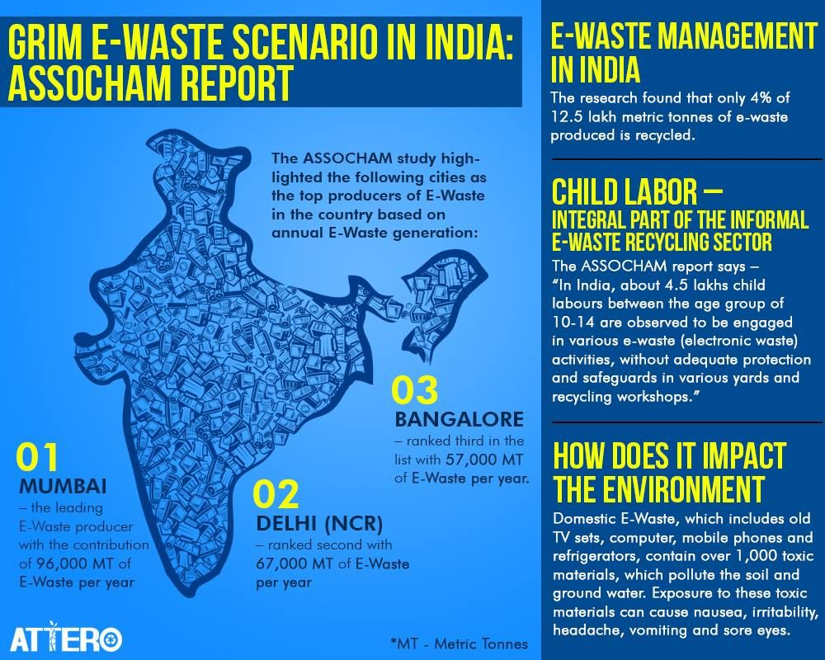

**REVIEW OF LITERATURE**

**1. Title:** E-Waste Management and its Consequences: A Literature Review

Research by: Prof. Arnav Chowdhury, Prof. Jitendra Patel.

Link: <https://www.pimrindore.ac.in/Volume%204,issue1/E-WASTE%20MANAGEMENT%20AND%20ITS%20CONSEQUENCES%20A%20LITERATURE%20REVIEW.pdf>

New Abstract:

Central issue of the present study is electronic-waste (e-waste) that is rising as a brand new environmental challenge for twenty-first century. The rapid rise in electronics and IT trade, the culture of gift customers, and the increase in consumption rates of electronic products have led to major environmental consequences. E-waste, while recycling, is also risky due to toxicity of a number of the substances which contains several cancer-causing agents. The implications and toxicity is thanks to discharge of lead, mercury, cadmium, metallic element and alternative virulent substances. Developed countries dump this waste in developing countries by giving them some money for it. China and some Asian nations, where environmental standards are low, are the most important recipients of e-waste which, in most cases, is processed illicitly. The environmental burden of e-waste is born by people that sleep in developing countries. Despite varied laws and directives in developed countries, the e-waste management is uncontrollable. The current study focuses on the effect of usage, marketing and use of the electronic waste on the natural setting.

**2. Title: A Review on E-waste Management and**

**Recycling Challenges in India**

Research by: Ms. Neethu Lukose

Link: <https://www.ijser.org/paper/A-Review-on-E-waste-Management-and-Recycling-Challenges-in-India.html>

**New Abstract:**

Electronics industry is the world’s largest and fastest growing manufacturing industry. But the increase in sales of electronic equipments and their rapid obsolescence such as advancement in technology, change in fashion, style and status has resulted in generation of electronic waste which is popularly known as E-waste. E-waste contains many hazardous components that may negatively impact the environment and adversely affect human health if not properly managed. E-waste problem is of global concern due to the production and disposal of waste in a globalized world. In India, e-waste management has greater significance not only due to the generation of its own e-waste but also because of the dumping of e-waste from developed countries. This is coupled with India’s lack of appropriate infrastructure and procedures for its disposal and recycling. The challenge is to develop innovative and cost- effective solutions to decontaminate polluted environments due to E-waste, to make them safe for human habitation and consumption, and to protect the functioning of the ecosystems which support life. This paper discusses the different categories of E-waste, categorization of different hazardous components present in e-waste, methods of E-waste management and an innovative bioremediation technologies which have become an eco-friendly and fruitful method to conventional clean up technologies to decontaminate e-waste from the soil-water environment, the challenges in which India is facing for the management of E-waste and suggestion for a formal method of E-waste recycling in India.

**3. Title: Electronic Waste - A Literature Review**

Research by: Swati A. Patil, Neetu M. Sharma

Link: <https://www.ijsr.net/archive/v4i4/SUB153374.pdf>

**New Abstract:**

Electronic waste is informally known as e-waste for the electronic products nearing the end of their useful life. The e- waste products contain materials that are hazardous to the human beings, depending on their condition & density. The hazardous content of these materials pose a threat to human health and environment. In India electronic waste is producing in a huge quantity, since it has emerged as an it giant and due to modernization of lifestyle. Fridge, cell phones, discarded computers, mobiles & batteries etc., if not disposed properly, can leach lead & other substances to soil & underground water. This paper highlights the issues related to e-waste disposal methods & management of e-waste.

##### 4. Title: Strategies for E-Waste Management: A Literature Review

Research by:  Linh Thi Truc Doan, Yousef Amer, Sang-Heon Lee, Phan Nguyen Ky Phuc

Link: <https://publications.waset.org/10010153/strategies-for-e-waste-management-a-literature-review>

**New Abstract:**

During the last few decades, with the high-speed upgrade of electronic products, electronic waste (e-waste) has become one of the fastest growing wastes of the waste stream. In this context, more efforts and concerns have already been placed on the treatment and management of this waste. To mitigate their negative influences on the environment and society, it is Necessary to establish appropriate strategies for e-waste management. Hence, this paper aims to review and analysis some useful strategies which have been applied in several countries to handle e-waste. Future perspectives on e-waste management are also suggested. The key findings found that, to manage e-waste successfully, it is necessary to establish effective reverse supply chains for e-waste, and raise public awareness towards the detrimental impacts of e-waste. The result of the research provides valuable insights to governments, policymakers in establishing e-waste management in a safe and sustainable manner

##### 5. Title: Waste Management and Research

Research by:  V Preze-Bells, MD Bovea,

Link: <https://journals.sagepub.com/doi/abs/10.1177/0734242X14557382>

**New Abstract:**

The consumption of electrical and electronic equipment (EEE) is continuously increasing worldwide and, consequently, so is the amount of waste electrical and electronic equipment it generates at its end-of-life. In parallel to this growth, legislation related to this issue has been passed in different countries with the aim of improving the management of EEE. In order to raise awareness about the situation in which the generation, composition, management or final treatment of this kind of waste currently finds itself, an extensive number of articles have been published around the world. The aim of this paper is to define and analyse the main areas of research on EEE by offering a broader analysis of the relevant literature in this field published between 1992 and August 2014. The literature researched comprises 307 articles, which are analysed according to the topic they focus on. In addition, a deeper analysis is also presented, which takes into account the temporal evolution (globally and by topic), location of the study, categories and subcategories analysed, etc.

# **6. Title: E-Waste Management: As a Challenge to Public Health in India**

 Research by:  Monika and Jugal Kishore

Link: <https://www.ncbi.nlm.nih.gov/pmc/articles/PMC2963874/>

**New Abstract:**

In India, the quantity of “e-waste” or electronic waste has now become a major problem. Disposal of e-waste is an emerging global environmental and public health issue, as this waste has become the most rapidly growing segment of the formal municipal waste stream in the world. E-waste or Waste Electrical and Electronic Equipment (WEEE) are loosely discarded, surplus, obsolete, broken, electrical or electronic devices. In India most of the waste electronic items are stored at households as people do not know how to discard them. This ever-increasing waste is very complex in nature and is also a rich source of metals such as gold, silver, and copper, which can be recovered and brought back into the production cycle. So e-waste trade and recycling alliances provide employment to many groups of people in India. Around 25,000 workers including children are involved in crude dismantling units in Delhi alone where 10,000–20,000 tonnes of e-waste is handled every year by bare hands. Improper dismantling and processing of e-waste render it perilous to human health and our ecosystem. Therefore, the need of proper e-waste management has been realized. It is necessary to review the public health risks and strategies to combat this growing menace

# **7. Title: Knowledge and Attitude towards E-Waste**

 Research by:  Dr.Brijesh Sivathnu

Link: <https://www.ripublication.com/ijaes16/ijaesv11n2_06.pdf>

**New Abstract:**

The world's largest and fastest growing manufacturing industry today is the electronics industry. The rapid growth in this sector combined with rapid product obsolescence due to the advent of latest technologies and discarded electronics is now the fastest growing concern in the entire industrialized world. The growing quantity of waste from the electronics industry that is “Waste” is beginning to reach disastrous proportions not only globally but also in most of the cities in India. In this paper, the author discusses the consumers’ awareness and preference towards the disposal of e-waste. A primary survey was conducted using a structured questionnaire among 600 consumers in Pune city. The exploratory factor analysis technique was deployed to identify the awareness factors contributing to the consumer’s preference towards the proper disposal and management of e-waste. The findings show that five important factors contribute to the consumer’s preference during the disposal of e-waste. These antecedents are Awareness of toxic effects on human health, Awareness of Environmental Hazards, Awareness of proper disposal of E-waste, Awareness of E-waste Management by various stakeholders and Awareness of Convenience of Recycling. This paper suggests the various pathways to create awareness so that the attitude of the consumers towards disposal of e-waste can be changed which would be helpful to the society to handle E-waste properly and focus towards efficient and effective E-waste management.

# **8. Title: A Study on the Attitude towards e-Waste Collection and Safe Management**

 Research by:  Lakshmi Shankar Iyer

Link: <https://papers.ssrn.com/sol3/papers.cfm?abstract_id=2480323>

**New Abstract:**

Electronic and electrical products which are discarded or reaching their end of life are called e-waste or electronic waste. With the booming Indian economy and changing technology at a faster pace, product life cycles have become shorter. Due to the presence of toxic materials in these products, recycling them or disposing them off in a safe and environmentally friendly manner becomes essential. Lack of organised segregation processes has created more harm to the people involved in the process. Constitution of India says that every individual has got the right to live a pollution free life. This study would help us understand the awareness level and attitude of students and faculties towards e-waste segregation in academic institutions in Bangalore as they are one of the major producers of e-waste due to implementation of Information and Communication Technology (ICT) in Higher Education

# **9. Title: Management of Electronic Waste by Bulk Consumers**

 Research by: Logakanthi Subramanian

Link: <https://www.research.manchester.ac.uk/portal/files/54553713/FULL_TEXT.PDF>

**New Abstract:**

The global ICT revolution is adding a new stream of waste, known as electronic waste or ‘e-waste’: electrical and electronic equipment that has ceased to be of value to its owners. The recyclability of e-waste together with the presence of pollutants poses a waste management challenge. Developed countries have systems in place to address this challenge, but developing countries have only recently recognised the need to develop appropriate systems for e-waste management. ICT consumers are key stakeholders in e-waste: it is they who decide whether and when an item is e-waste, and they form the link between producers and recyclers. Yet not much attention has been paid to their role. The limited research to date has focused on household consumers in developed countries, leaving a knowledge gap around bulk, organisational consumers in developing countries, despite their often being the largest single contributor to e-waste. Acknowledging the growing challenge of e-waste management in developing countries and lack of research on bulk consumer response to this challenge, the present research aimed to understand e-waste material flows, management strategies and determinants relating to bulk consumers of IT in India. It focused on bulk consumers in India’s IT service sector because that sector depends on electronic equipment for its operation and has been recognised to generate nearly 30% of the total e-waste in the country. The data for this research was collected between 2010 and 2011, at a time when preparations were underway for implementation of separate e-waste regulations in the country. Therefore, the findings of the research here draw attention to the practice for e-waste management in India before implementation of the new regulations. In order to achieve the overall aims, a qualitative research approach based on multiple case studies was adopted. In all, 20 IT service organisations belonging to three different groups based on size namely, very large (VL), large (L) and small and medium (SM) were studied via multiple semi-structured interviews, direct observations and document analysis. Further source triangulation was achieved through interviews with representatives from other stakeholder groups: IT equipment producers, formal recyclers, regulators, industry association representatives, and representatives of various national and international organisations working on e-waste management.

# **10. Title: Electronic Waste Management Approaches**

 Research by: Somvir Arya , Dr. Ajay Gupta and Dr. Arvind Bhardwaj

Link: <https://www.longdom.org/open-access/electronic-waste-management-approaches--a-pilot-study-in-northern-indian-states-2252-5211-1000346.pdf>

**New Abstract:**

The electronics industry is the one of the world's largest and fastest growing manufacturing industry. Discarded electronic and electrical equipment with all of their peripherals at the end of its useful life is termed as E-waste. But nowadays the main problem with the electronics products is that we generally don't consider the lifespan of it, mainly in case of mobile phones, laptops/PC, we frequently buys new products ultimately leading to an increased E-waste. Also, we don't know what to do with the discarded electronics items. We generally store them in our home as we are not aware of the hazardous effect of these E-devices on human health as well as on the environment. This paper projects a pilot study conducted in northern Indian states to find out the awareness level among the Consumer (Individual and Organizational) and recycler about the hazardous effect of E-waste. Punjab, Haryana, Himachal Pradesh, Uttar Pradesh, Delhi, Chandigarh are selected for the pilot study.

# **11. Title: Assessing enablers of e-waste management in circular economy using DEMATEL method**

 Research by: Manu Sharma, Sudanshu Joshi and Ashwini Kumar

Link: <https://link.springer.com/article/10.1007/s11356-020-07765-w>

**New Abstract:**

With increasing population, excessive use of electrical and electronic products and extreme demand of resources have compelled the linear economy to transform into Circular Economy (CE). In the current scenario, e-waste management has become the top priority of all the developed and developing nations especially those in the transition phase. The generation of e-waste has increased proportionally across the world and created an intense pressure on the firms to implement sustainable practices to redesign and recycle the products. The current status of the developing countries like India confronts number of challenges to manage e-waste produced, and the only possible solution is to minimize the waste generation and practicing recycling processes. For transforming into CEs, there is a need to identify the most influencing key enablers through which an effective and robust e-waste management (e-WM) system can be developed. An extensive literature review and expert judgments are expended to identify the most influencing key enablers of e-WM in circular economies, and, being the highest producer of e-waste, Mumbai (Maharashtra) has been chosen as the case location. To explore the strength of causal and effect enablers, the DEMATEL method is applied. This study has shown that ‘Environmental management system’ (EMS) is the most significant and important driving enabler to influence all the other existing enablers. This study has also highlighted that e-WM can be efficient if it focuses on producing eco-friendly products, developing strict legislations, building green image and supporting the producers to implement CE practices. This study helps stakeholders and policy makers to reduce the burden from the environment and focus on developing an efficient e-WM system on the basis of identified key enablers like EMS and collaboration with environmental partners to contribute towards CE transition

**METHODOLOGY**

**E-Waste Problem in India**

India ranks 177 amongst 180 countries and is amongst the bottom five countries on the Environmental Performance Index 2018, as per a report released at the World Economic Forum 2018. This was linked to poor performance in the environment health policy and deaths due to air pollution categories. Also, India is ranked fifth in the world amongst top e-waste producing countries after the USA, China, Japan, and Germany and recycles less than 2 per cent of the total e-waste it produces annually formally. Since 2018, India generates more than two million tons of e-waste annually, and also imports huge amounts of e-waste from other countries around the world. Dumping in open dumpsites is a common sight which gives rise to issues such as groundwater contamination, poor health, and more. The Associated Chambers of Commerce and Industry of India (ASSOCHAM) and KPMG study, Electronic Waste Management in India identified that computer equipment account for almost 70 per cent of e-waste, followed by telecommunication equipment phones (12 per cent), electrical equipment (8 per cent), and medical equipment (7 per cent) with remaining from household .E-waste collection, transportation, processing, and recycling is dominated by the informal sector. The sector is well networked and unregulated. Often, all the materials and value that could be potentially recovered is not recovered. In addition, there are serious issues regarding leakages of toxins into the environment and workers’ safety and health. Seelampur in Delhi is the largest e-waste dismantling center of India. Adults as well as children spend 8–10 hours daily extracting reusable components and precious metals like copper, gold and various functional parts from the devices. E-waste recyclers use processes such as open incineration and acid-leeching. This situation could be improved by creating awareness and improving the infrastructure of recycling units along with the prevalent policies. The majority of the e-waste collected in India is managed by an unorganized sector .Also, informal channels of recycling/reuse of electronics such as repair shops, used product dealers, e-commerce portal vendors collect a significant proportion of the discarded electronics for reuse and cannibalization of parts and components.

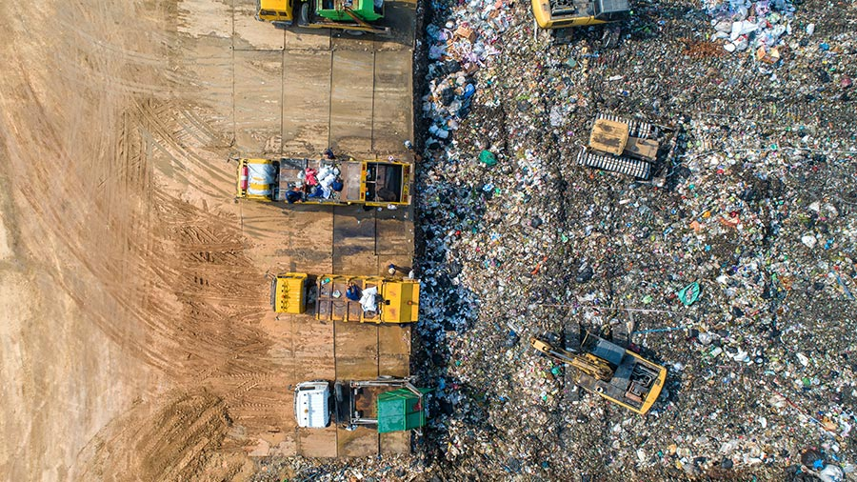

#### Opportunities of E-Waste Management in India

The Ministry of Environment, Forest and Climate Change rolled out the E-Waste (Management) Rules in 2016 to reduce e-waste production and increase recycling. Under these rules, the government introduced EPR which makes producers liable to collect 30 per cent to 70 per cent (over seven years) of the e-waste they produce, said the study.

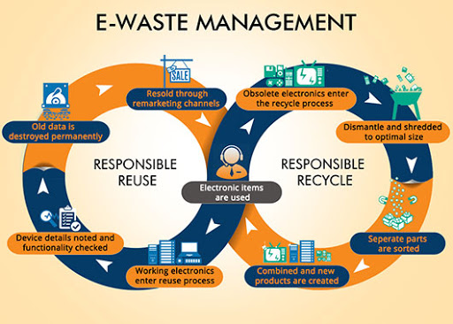

The integration of the informal sector into a transparent recycling system is crucial for a better control on environmental and human health impacts. There have been some attempts towards integrating the existing informal sector in the emerging scenario. Organizations such as GIZ have developed alternative business models in guiding the informal sector association towards authorization. These business models promote a city-wide collection system feeding the manual dismantling facility and a strategy towards best available technology facilities to yield higher revenue from printed circuit boards. By replacing the traditional wet chemical leaching process for the recovery of gold with the export to integrated smelters and refineries, safer practices and a higher revenue per unit of e-waste collected are generated-waste is a rich source of metals such as gold, silver, and copper, which can be recovered and brought back into the production cycle. There is significant economic potential in the efficient recovery of valuable materials in e-waste and can provide income-generating opportunities for both individuals and enterprises. The E-Waste Management Rules, 2016 were amended by the government in March 2018 to facilitate and effectively implement the environmentally sound management of e-waste in India. The amended Rules revise the collection targets under the provision of EPR with effect from October 1, 2017. By way of revised targets and monitoring under the Central Pollution Control Board (CPCB), effective and improved management of e-waste would be ensured.

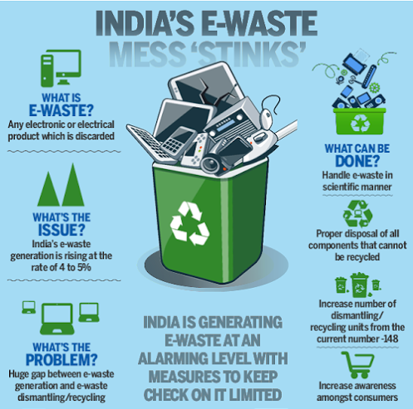

#### How Can Governments, City Administration, and Citizens Help?

The ASSOCHAM report (2017) suggests that the government may look at collaborating with the industry to draw out formal/standard operating procedures and a phased approach towards the agenda of reducing e-wastes to the lowest. Alternatively, the government may also refer methods adopted by other countries for efficient collection and recycling of e-wastes. For example, South Korea, one of the largest producers of electronics managed to recycle 21 per cent of the total 0.8 million tonnes of e-waste that it produced in 2015, said the study .Considering the adverse impacts caused by untreated e-waste on land, water, and air; the government should encourage the new entrepreneurs by providing the necessary financial support and technological guidance. Establishment of start-ups connected with e-waste recycling and disposal should be encouraged by giving special concessions. The unorganized sector has a well-established collection network. But it is capital-intensive in case of organized sector. Therefore, if both the sectors coordinate and work in a harmonious manner, the materials collected by the unorganized sector may be handed over to the organized sector to be processed in an environment-friendly way. In this kind of scenario, the government can play a crucial role between the two sectors for successful processing of the e-waste. It is high time that the government takes a proactive initiative to recycle and dispose of e-waste safely to protect the environment and ensure the well-being of the general public and other living organisms.

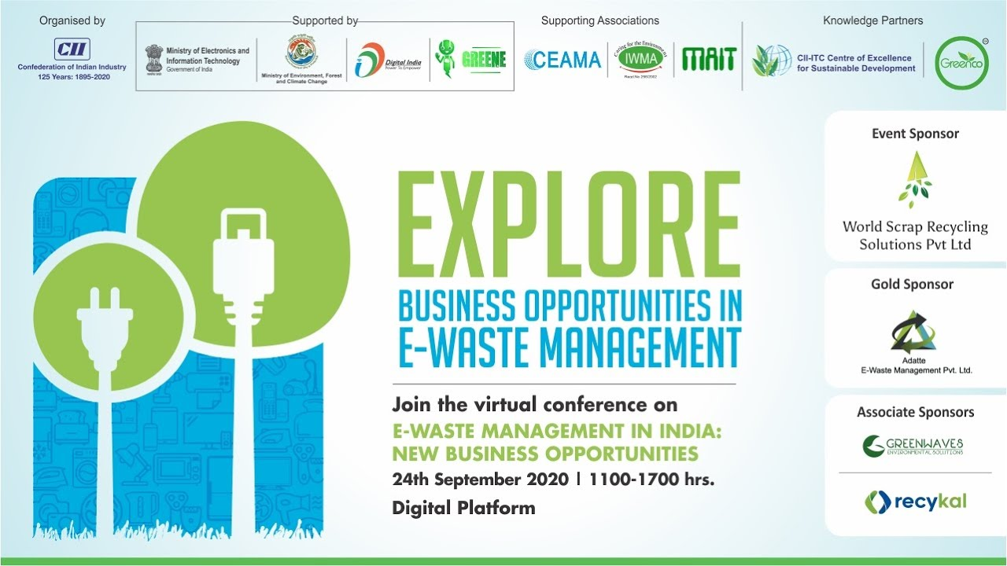

At present, Design for Environment (DfE) is attracting much attention in the world as a new method to solve environmental pollution. DfE principle in the product design is a process to significantly reduce the environmental impact of products being put into the market. It is often seen that the robust rules in India are ineffective due to slack implementation.

The citizens have a very important role to play in e-waste management. We casually throw many small gadgets along with dumped waste and many people openly burn those accumulated waste. A number of hazardous substances such as dioxins and furans are released in the process which we breathe. This is a very unhealthy practice, which we should immediately stop. Some of the very progressive Resident Welfare Associations (RWAs) have separate bins clearly marked for collecting e-wastes. All the other residential societies should follow this practice. Students and Women SHGs can be mobilized for this activity in their respective RWAs.

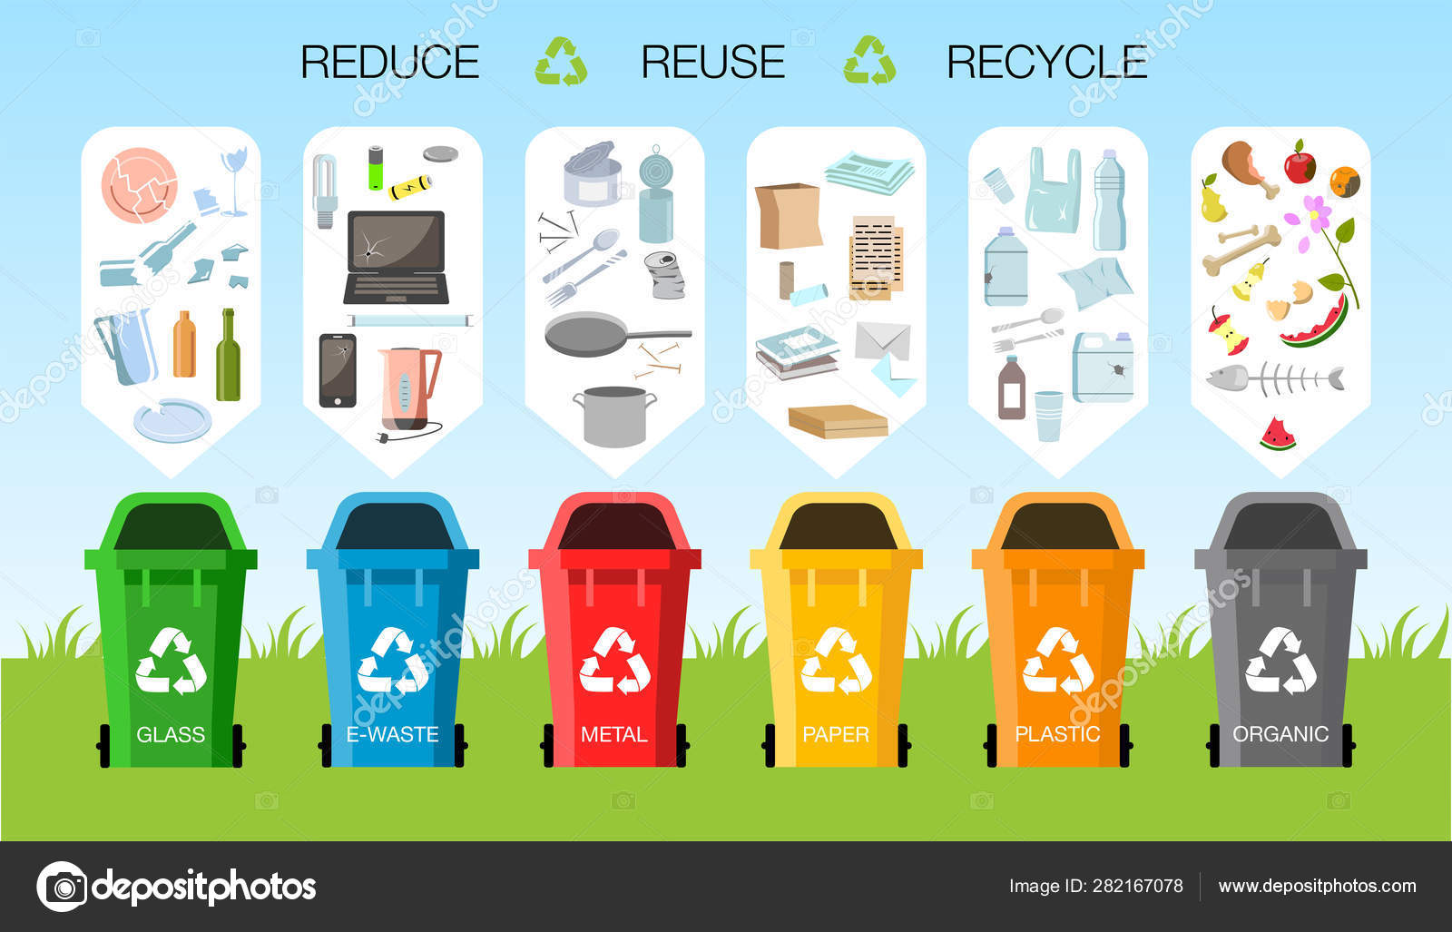

**There are five key components that need to be linked together for improving e-waste management. These are: 1) providing market information regarding e-waste prices; 2) incentivising formal e-waste recycling; 3) up skilling informal sector players; 4) deploying readily available and mature recycling technologies; and 5) developing innovative methods and technologies for processing new forms of e-waste.**

1. Providing market information regarding e-waste prices

Electronic waste (e-waste) typically includes discarded computer monitors, motherboards, mobile phones and chargers, compact discs, headphones, television sets, air conditioners and refrigerators. According to the Global E-Waste Monitor 2017, India generates about 2 million tones (MT) of e-waste annually and ranks fifth among e-waste producing countries, after the US, China, Japan and Germany. In 2016-17, India treated only 0.036 MT of its e-waste.

.

1. Incentivizing formal e-waste recycling

The Indian Government could introduce a point-based reward system of E-waste Recycling Credits (ERCs) for formal organizations to incentivize them to channel their e-waste through government-approved recycling centers. Depending on the volume and type of e-waste supplied, organizations would earn the requisite ERCs which could be used to offset energy utility bills. Such an initiative would also provide a strong incentive for informal sector e-waste businesses to formalize their operations and establish supply chain links with approved recycling centers.

1. Up skilling informal sector players

The majority of the informal e-waste recycling workforce needs up skilling, particularly for handling and dismantling hazardous materials, ensuring environmental and occupational health and safety of their work, and linking supply to formal sector processors. This could be pursued through the Indian government’s National Skill Development Mission.

1. Deploying readily available and mature recycling technologies

There is urgent need for deploying mature recycling technologies alongside existing manual techniques to improve recycling efficiency of the large volumes of e-waste being generated in India. Global e-waste recycling companies such as Umicore and Glencore have mature technologies and well-tested systems for dismantling, sorting and resource recovery. India also has a very large and mature plastics processing sector that can recycle plastic material from e-waste.

1. Developing innovative methods and technologies for processing new forms of e-waste

The composition of e-waste is changing rapidly as new electrical and electronics devices enter the market. This requires significant investment in research and development for innovative recycling methods and technologies for future-proofing India’s e-waste policies and management.

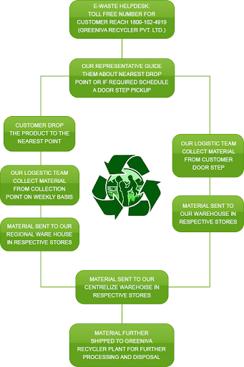

**FINDINGS**

**Story:**

The alleys of Mustafabad are dotted with hole-in-the-wall workshops that are crammed full of discarded PCs and tech gear from another era. Bits and pieces of electronic waste are piled high, precariously balanced atop each other as if they were Jenga blocks. A visit to this shanty town and others like it in north-east New Delhi is like wandering into a scene from *Wall-E*, albeit with humans.

Now an ambitious start-up is working hard to clean it up by taking on the seemingly impossible task of formalizing India’s murky e-waste economy.

Karo Sambhav means “make it possible” in Hindi. It sees itself as “a movement” to get multiple players—manufacturers, distributors, recyclers—to act sustainably and create a circular economy with the help of new digital solutions.

“The whole ecosystem, right from collection channels to dismantling and recycling companies to organizations that utilize secondary materials for new product creation, has to collaborate,” says founder Pranshu Singhal. “Only then we can solve the problem at scale, because it is not possible to tackle this problem alone.”

India, with its rising middle class and zooming technology penetration, is one of the largest electronics markets in the world. And it’s also one of the world’s most prolific e-waste generators—ranking third with 3.2 million metric tons annually according to Global E-waste Monitor. It has a poor track record of disposing of used and unwanted electronics with only two percent being recycled.

Roughly 7,200 tons of e-waste lands in India’s capital city from across the country and abroad every day. Most of it ends up in hundreds of small undocumented shops where bands of low-paid men and women dismantle junked desktops, laptops, monitors, smart phones, and all sorts of old gadgets by hand. Salvaged circuit boards and pulled out cables are sold on to crude recycling operations where workers with little or no protective gear use acid baths to extract valuable metals.

**I have made a small survey of 20 question. I have shared this question with 81 participants and the responses of them is shown below in the form of graph**

**.** 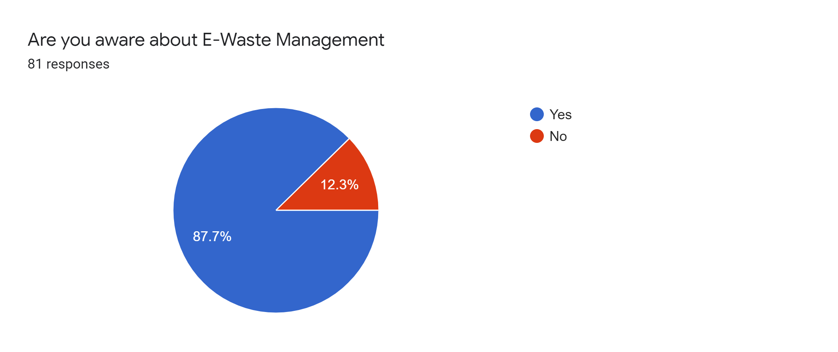

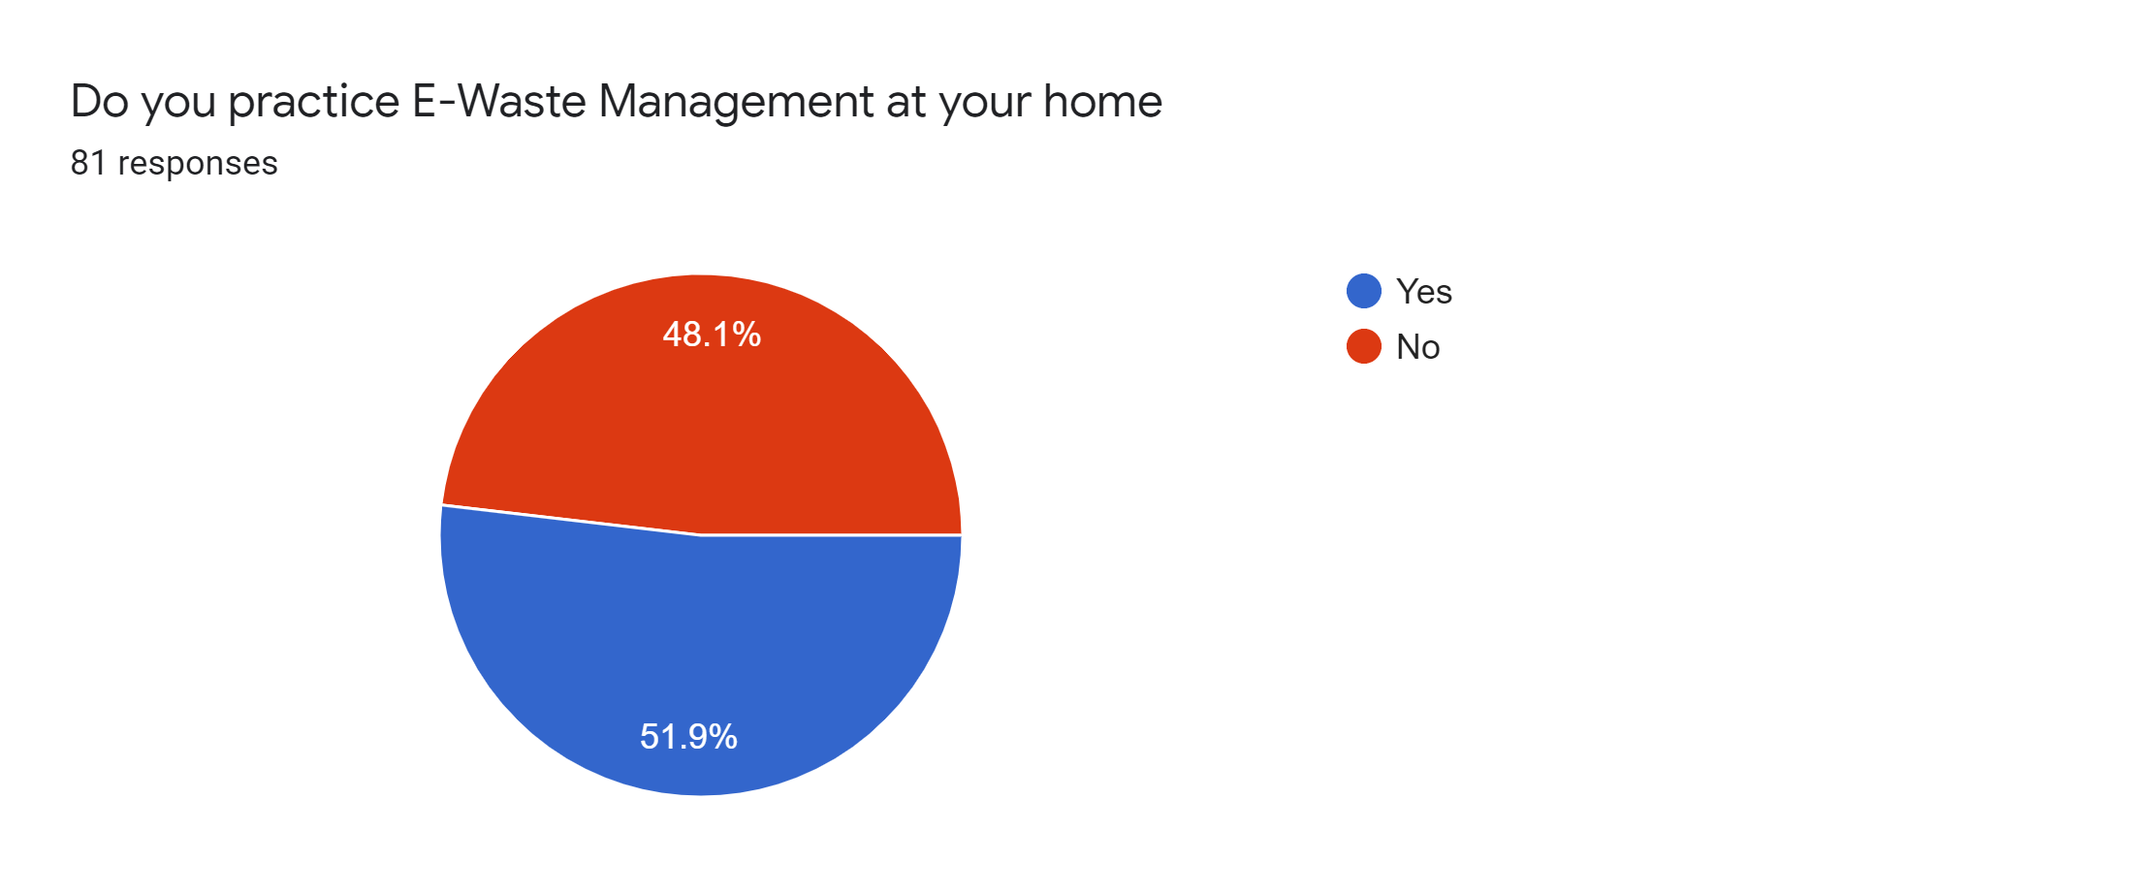

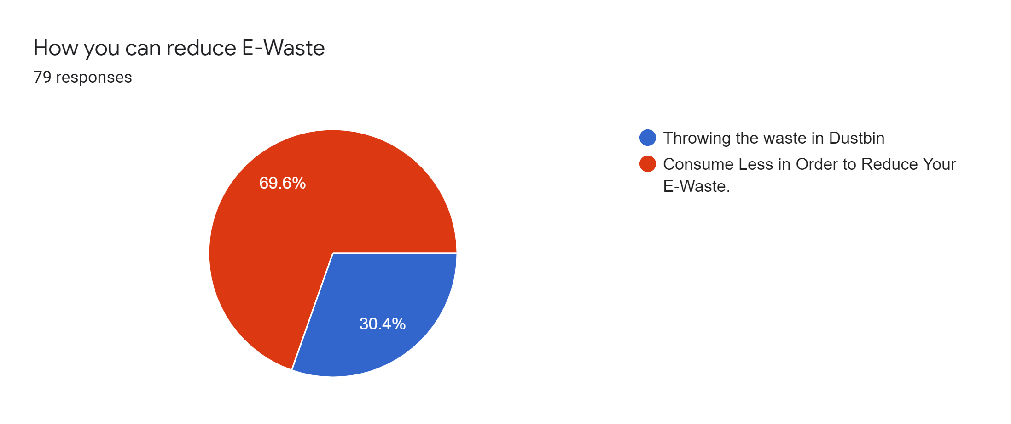

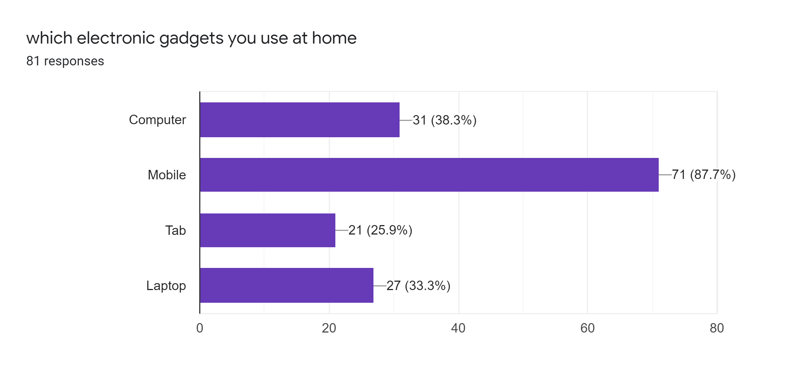

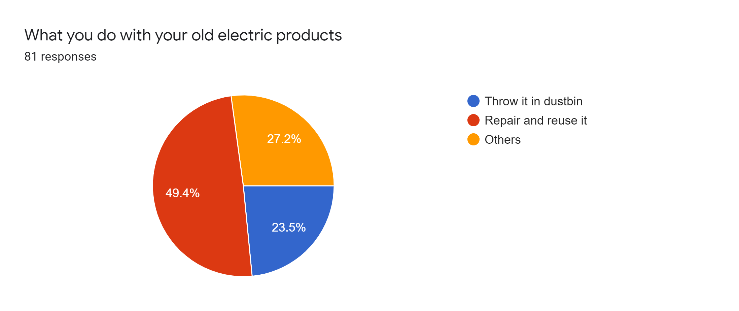

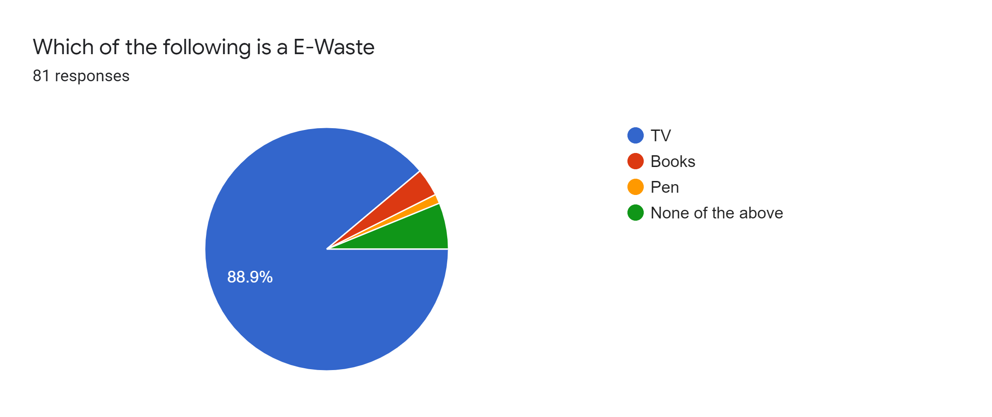

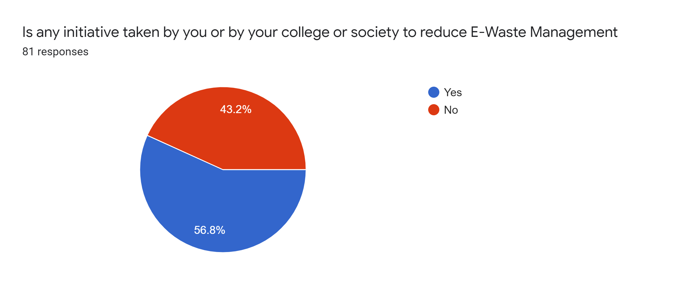

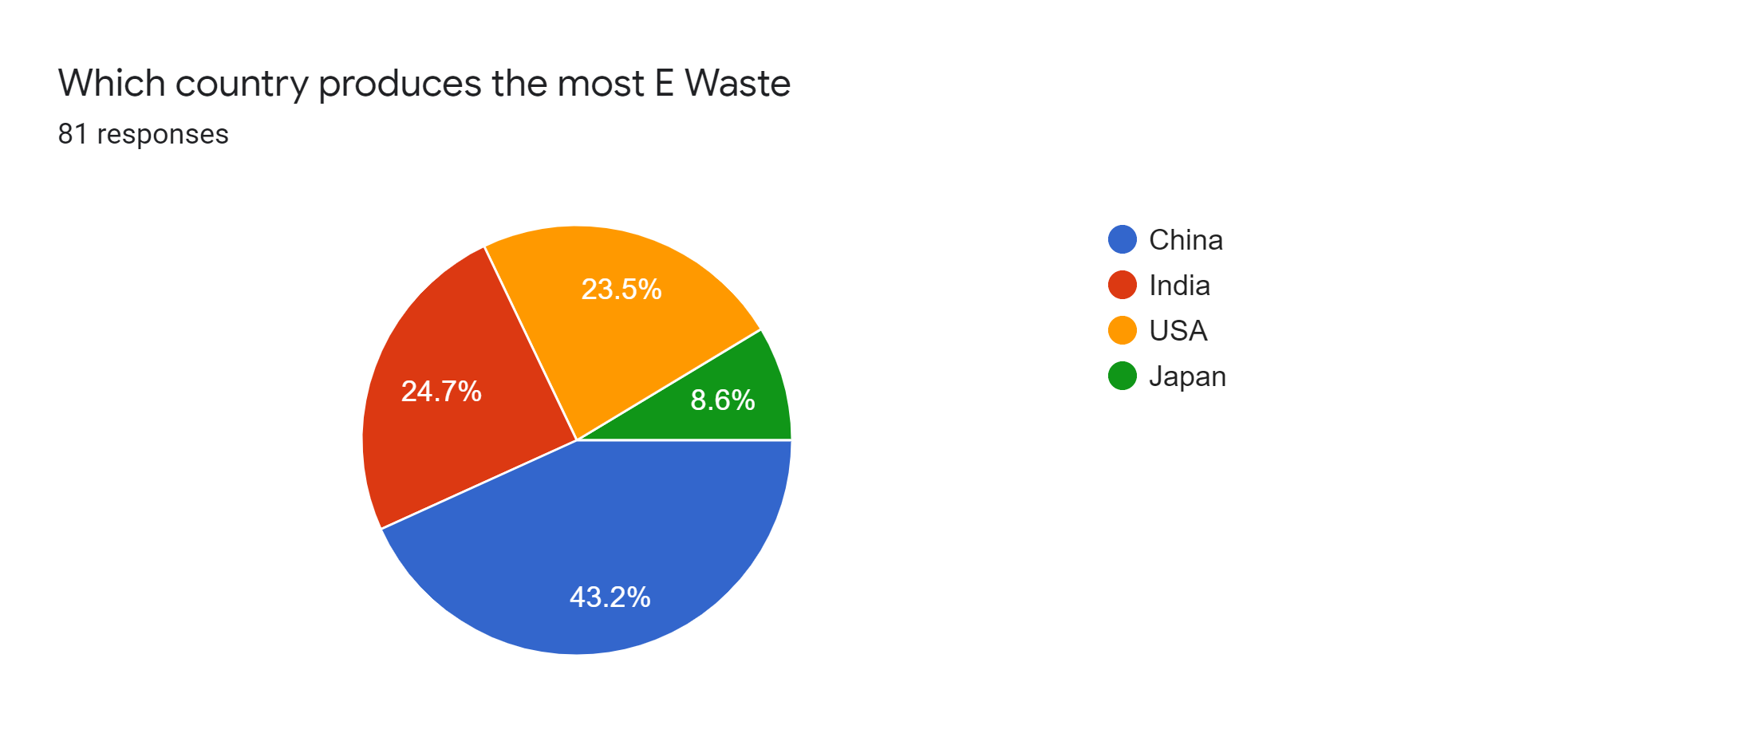

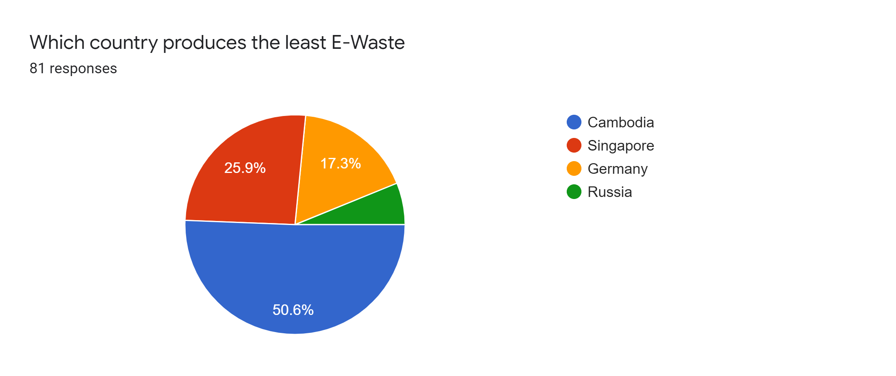

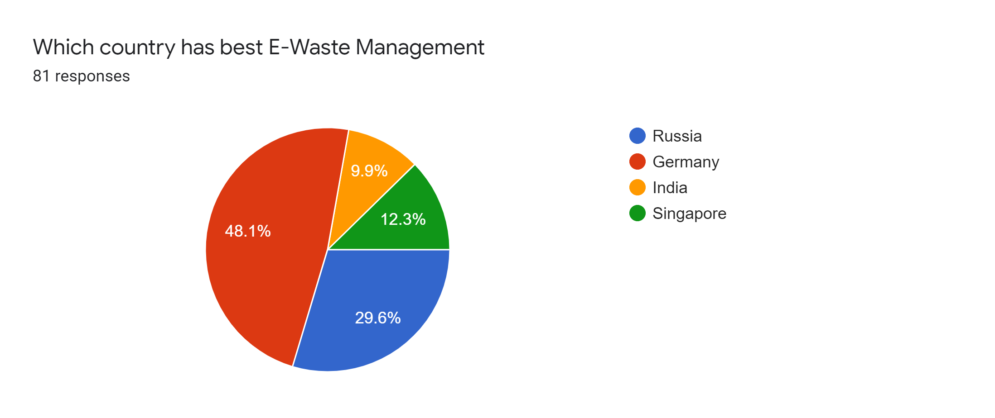

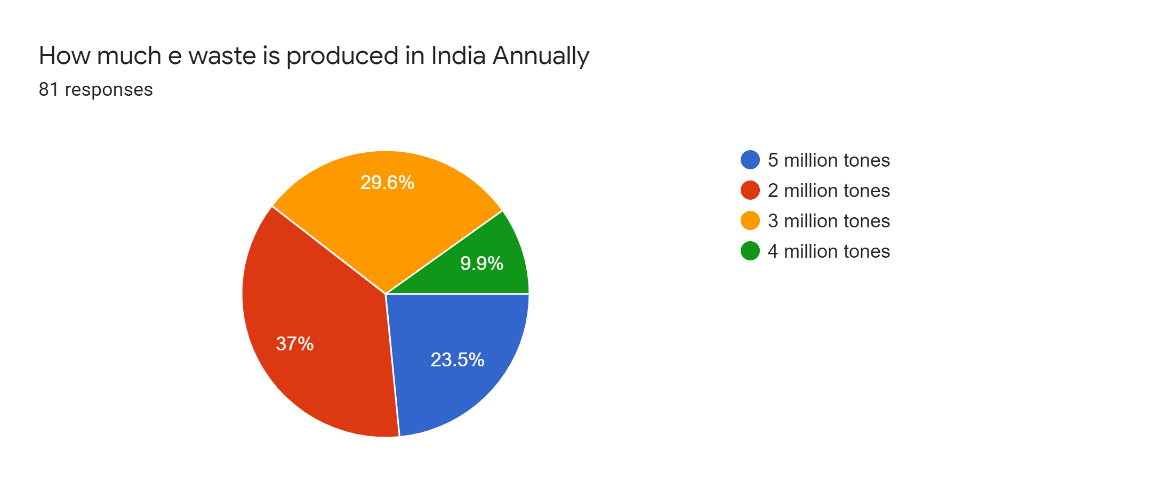

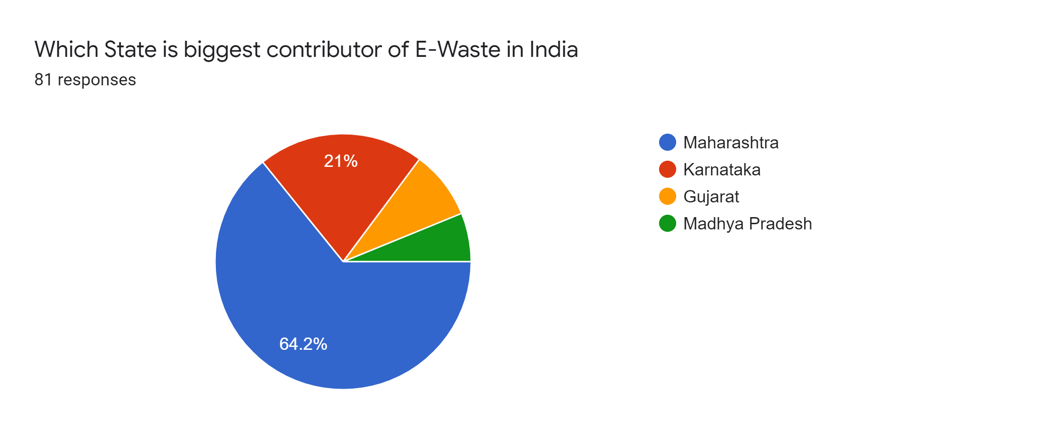

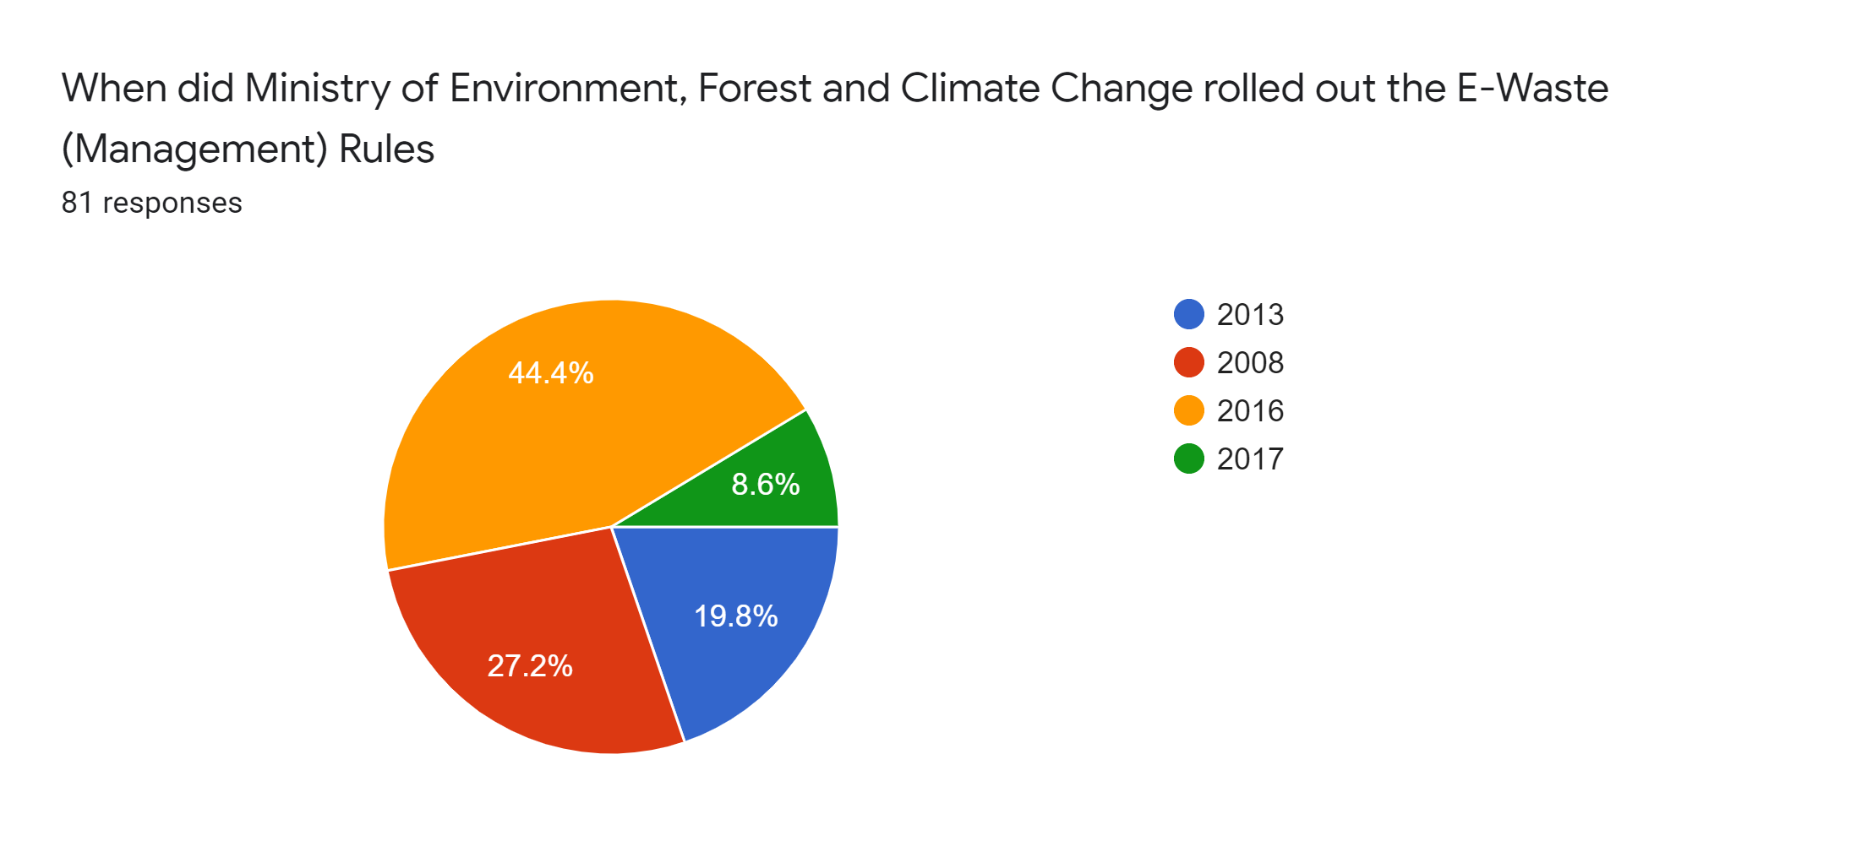

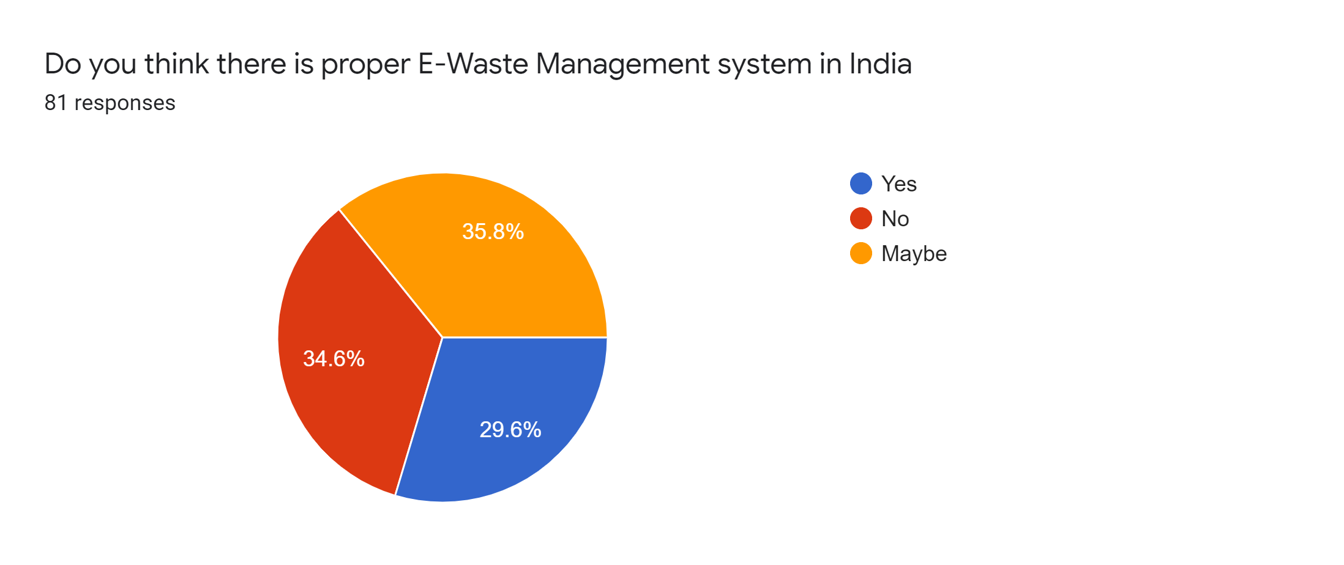

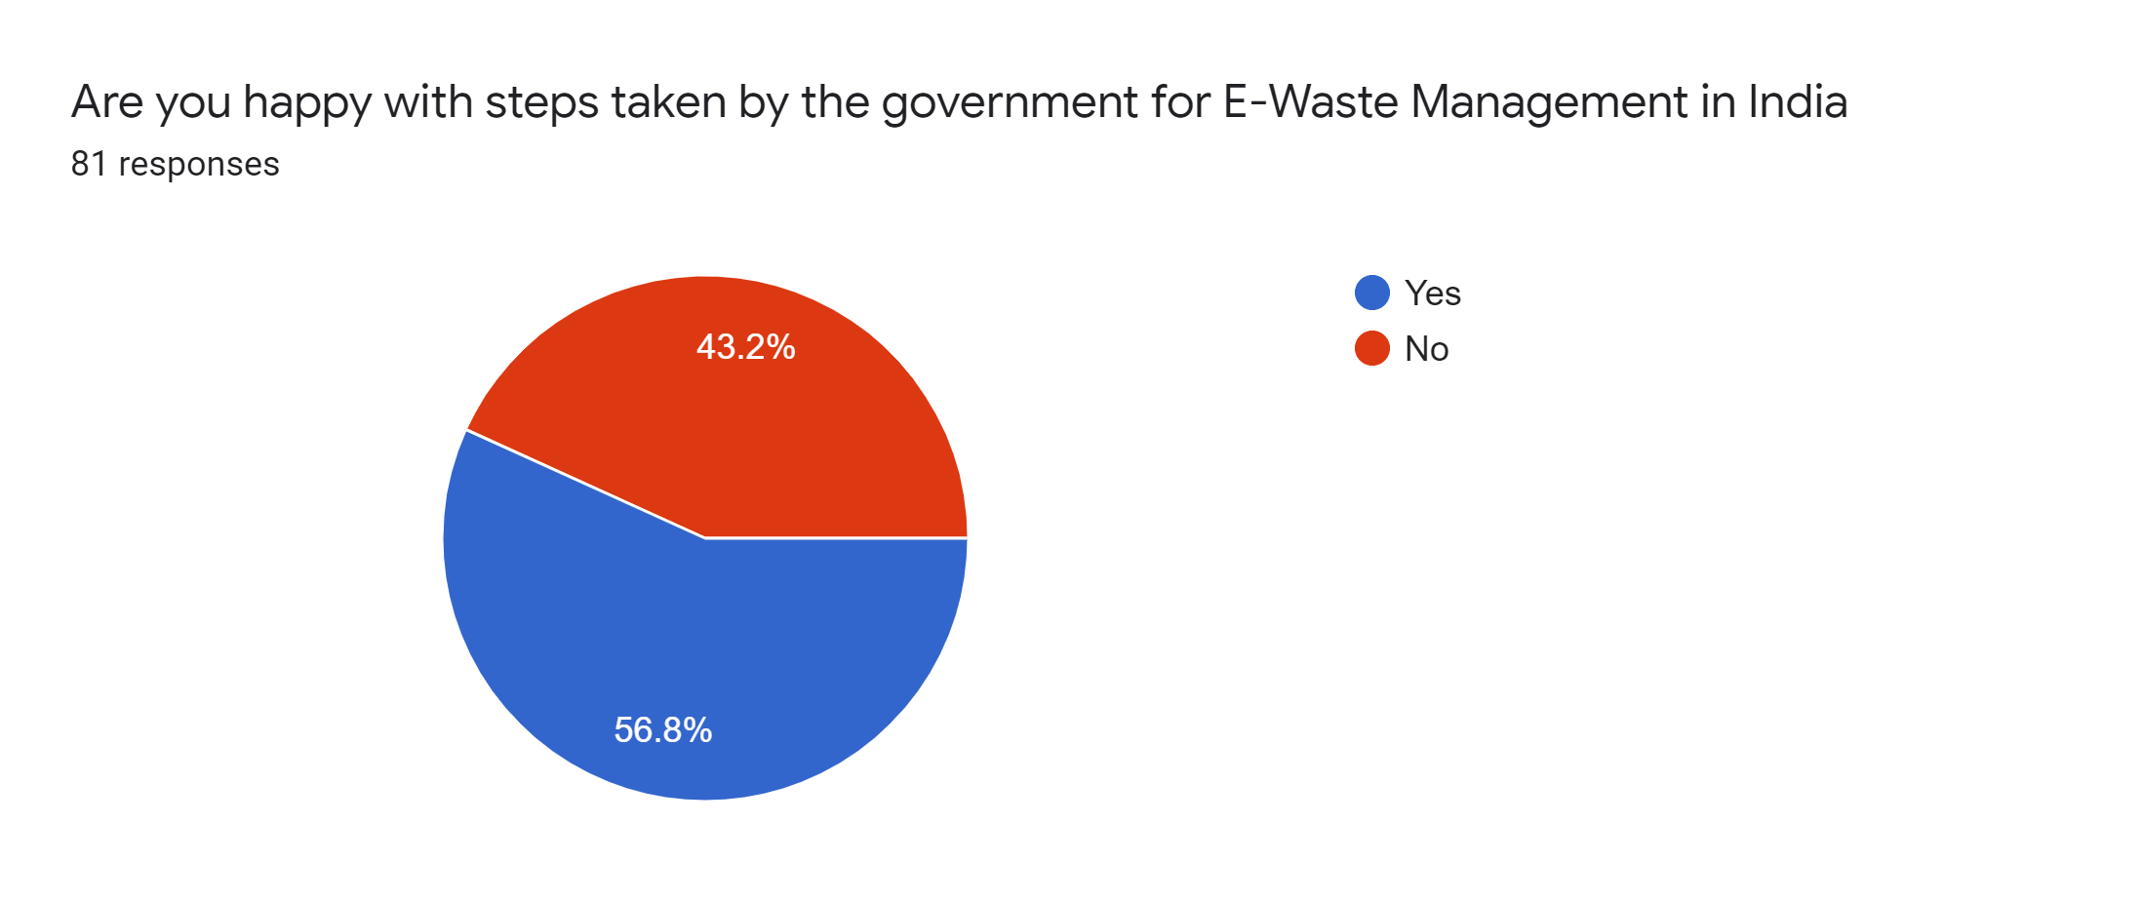

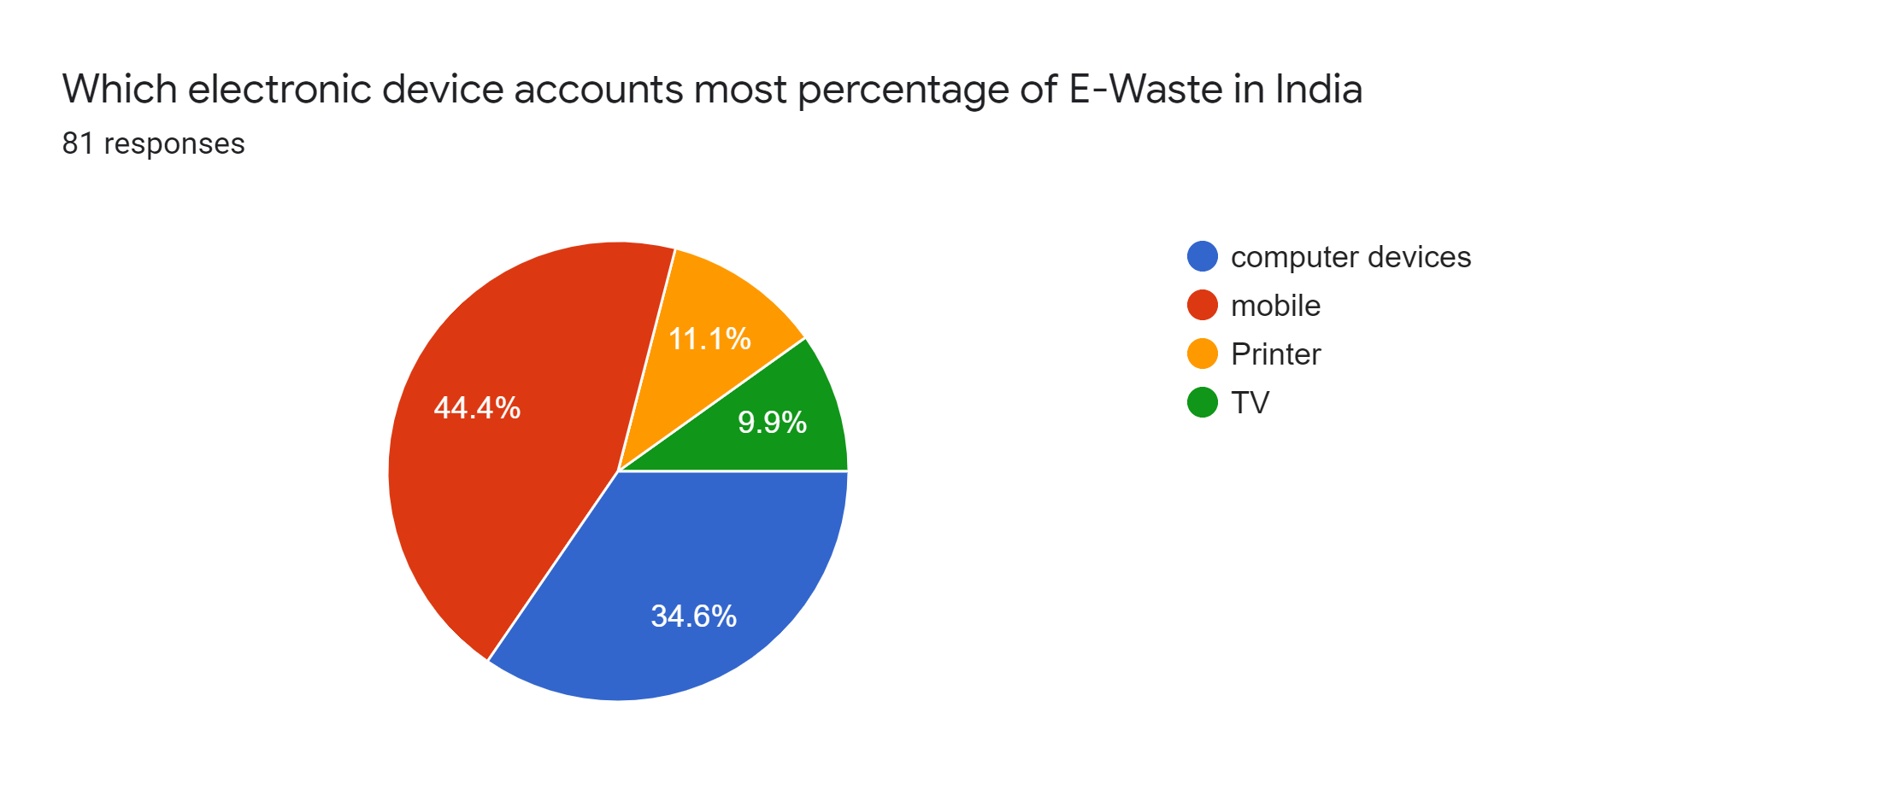

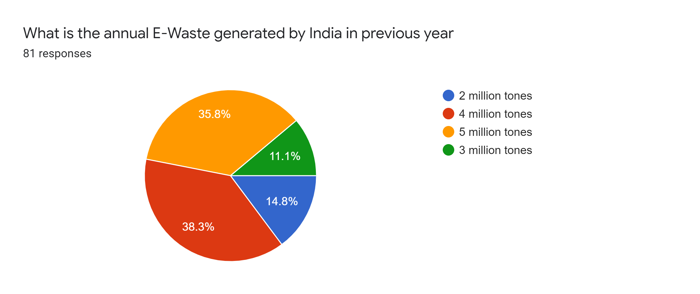

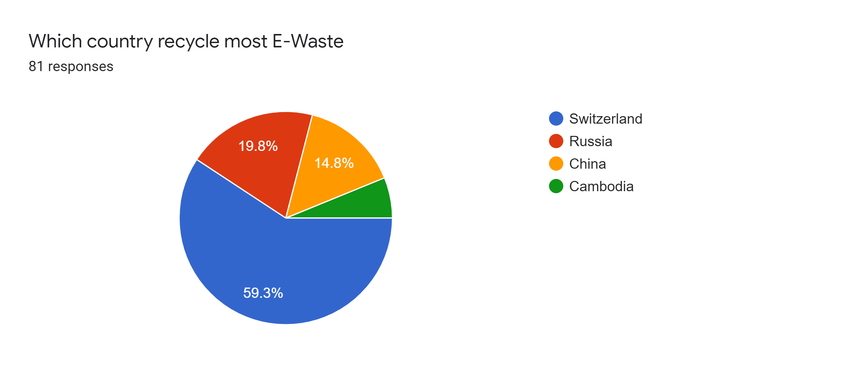

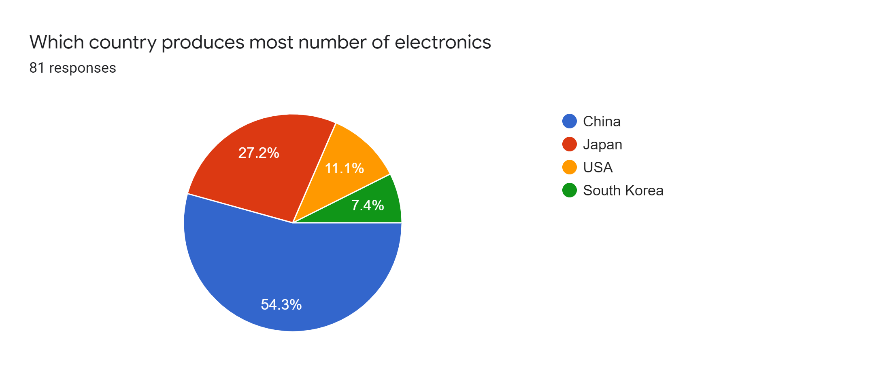

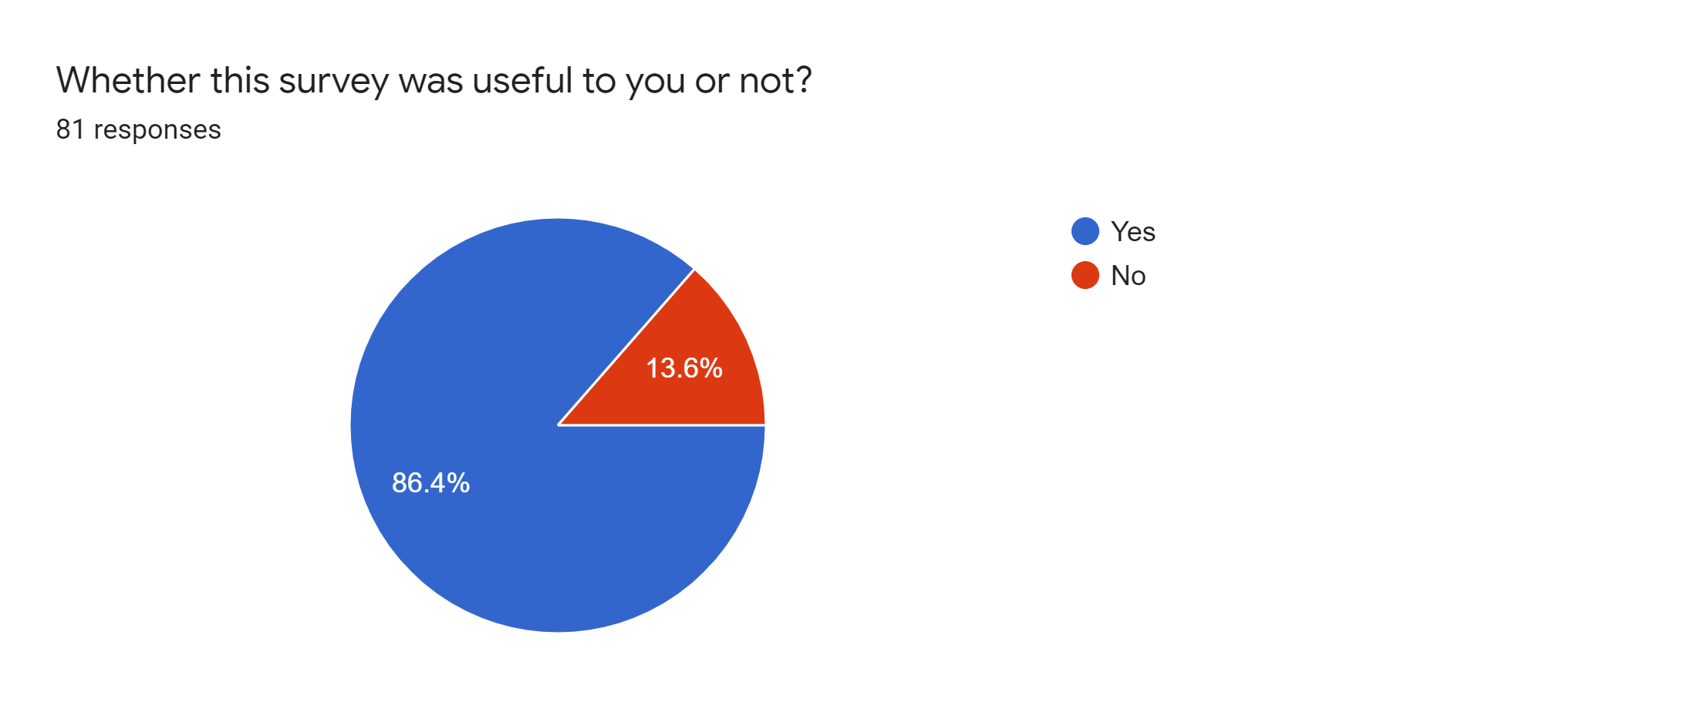

**DISCUSSION**

With the rapid development of economy, the lifespan of electronic products has been shortened, leading to the generation of more and more electronic waste (E-waste). E-waste that is composed of metals and metalloids has been paid much attention by researchers from all over the world. Methods including physical, chemical, and biological technologies are adopted to dispose of E-waste. Considering energy consumption and environmentally friendly advantages, biological methods are regarded as the most suitable technology for disposing of E-waste. This chapter discusses the generation of E-waste in the world, the introduction of multiple technologies in disposing E-waste, especially the biological method, and the specific applications of the biological method in E-waste, which using microorganisms to extract precious metals, heavy metals, and metalloids. The mechanisms and influencing factors of the biological method are introduced. An example of the biological method in recycling of E-waste is also investigated. The applications of biological method in E-waste relevant areas are also discussed. Finally, the prospects for applications of the biological method for E-waste are also highlighted

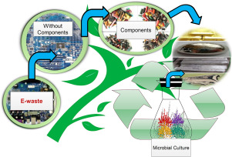

Electronic waste (E-waste) has been increasing rapidly with the impact of economic and population growth, technological developments, industrialization, and urbanization. E-waste has hazardous substances with damaging effects on human health and the environment. It also contains a considerable amount of valuable materials such as precious metals. Hence, recovering E-waste is crucially important within the framework of social, economic, and environmental incentives. Due to regulations, specified recovery targets and responsibilities of stakeholders such as producers, distributors, consumers, municipalities, and waste treatment plants should be considered in order to ensure sustainable E-waste management. Therefore, stakeholders need to design and optimally manage their E-waste management networks. This chapter aims to guide stakeholders how to design and manage their networks, according to regulations for the fulfilment of obligations and process efficiency.



Electronic waste (e-waste) typically includes discarded computer monitors, motherboards, mobile phones and chargers, compact discs, headphones, television sets, air conditioners and refrigerators. According to the Global E-Waste Monitor 2017, India generates about 2 million tonnes (MT) of e-waste annually and ranks fifth among e-waste producing countries, after the US, China, Japan and Germany. In 2016-17, India treated only 0.036 MT of its e-waste.

About 95 per cent of India’s e-waste is recycled in the informal sector and in a crude manner. A report on e-waste presented by the United Nations (UN) in World Economic Forum on January 24, 2019 points out that the waste stream reached 48.5 MT in 2018 and the figure is expected to double if nothing changes.

Only 20 per cent of global e-waste is recycled. The UN report indicates that due to poor extraction techniques, the total recovery rate of cobalt (the metal which is in great demand for laptop, smart phone and electric car batteries) from e-waste is only 30 per cent.

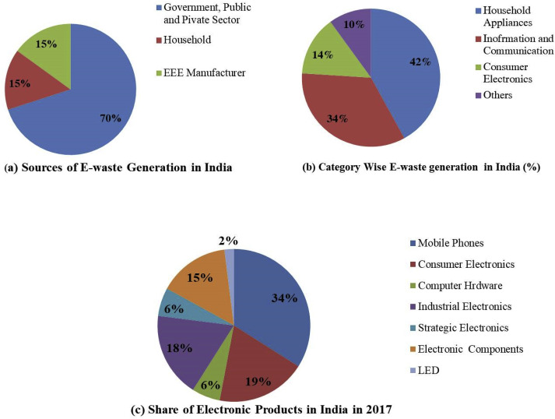

The study was conducted for the awareness levels and practices of people regarding e-waste management. The survey conducted revealed that significant fraction of middle-class population is still unaware of the issue; however, on getting the information they were able to link the impacts of improper management of e-waste with detrimental health outcomes. For those who knew about it, the main sources of information to them were found to be internet, and print media. However, despite some awareness about the issue, most respondents were totally unaware about correct ways of its recycling and management. An important finding of the study was that 12-26 per cent people replace their major electronic goods like refrigerators, food processors, personal computers and music systems within the first three years of purchase. Discarding products within their periods of useful lives leads to enhanced generation of e-wastes. Along with e-waste generation, this also puts additional stress over the resources used for manufacturing of these products. On management of e-waste, most of the respondents opined of need of having efficient recycling units and effective mass awareness programmes. The survey also revealed the willingness of users to pay extra cost for proper management of e-waste provided that there is proper cost sharing between consumers and producers. This also raises an important aspect of extended producer responsibility (EPR). EPR puts additional responsibility and onus on the manufacturer of the product to not only produce durable quality of products but also take back the obsolete products and manage the e-waste. This also means that the manufacturers will have to use recyclable material in manufacturing of new products for economic management of e-waste at the later stage. Although, in Indian context it would be a challenge to implement the concept of EPR, especially with the active informal sector. The respondents quite adequately put equal responsibilities on the government, consumers and producers for effective e-waste management. The study clearly highlights the issues perceived by the middle-class population of Delhi and can be replicated in other major cities for re-authentication of the facts. The study could prove to be important in designing awareness programme related to the issue.

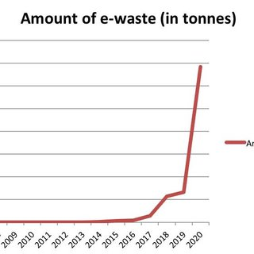

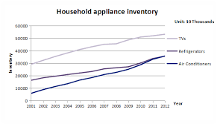

**CONCLUSION**

E-waste management is a great challenge for governments of many developing countries such as India. This is becoming a huge public health issue and is exponentially increasing by the day. In order to separately collect, effectively treat, and dispose of e-waste, as well as divert it from conventional landfills and open burning, it is essential to integrate the informal sector with the formal sector. The competent authorities in developing and transition countries need to establish mechanisms for handling and treatment of e-waste in a safe and sustainable manner.

Increasing information campaigns, capacity building, and awareness is critical to promote environment friendly e-waste management programmes. Increasing efforts are urgently required on improvement of the current practices such as collection schemes and management practices to reduce the illegal trade of e-waste. Reducing the amount of hazardous substances in e-products will also have a positive effect in dealing with the specific e-waste streams since it will support the prevention process.

Mobile phone manufacturer Nokia is one of the very few companies that seem to have made serious effort in this direction since 2008. The companies were made responsible for creating channels for proper collection and disposal of e-waste in accordance with a Central Pollution Control Board (CPCB) approved EPR Authorization plan in India. Recently, the import license of some of the big companies were suspended for violation of E-waste rules. Such measures have a great impact on effective implementation of e-waste management in India. Any task undertaken must have its share of incentives which attract stakeholders. In the field of e-waste management, the government must announce incentives, which could be in the form of tax concessions or rebates, to ensure compliance across the electronics industry. Additionally, the e-waste collection targets need to be regularly reviewed and renewed to ensure compliance across India on collection of e-waste.

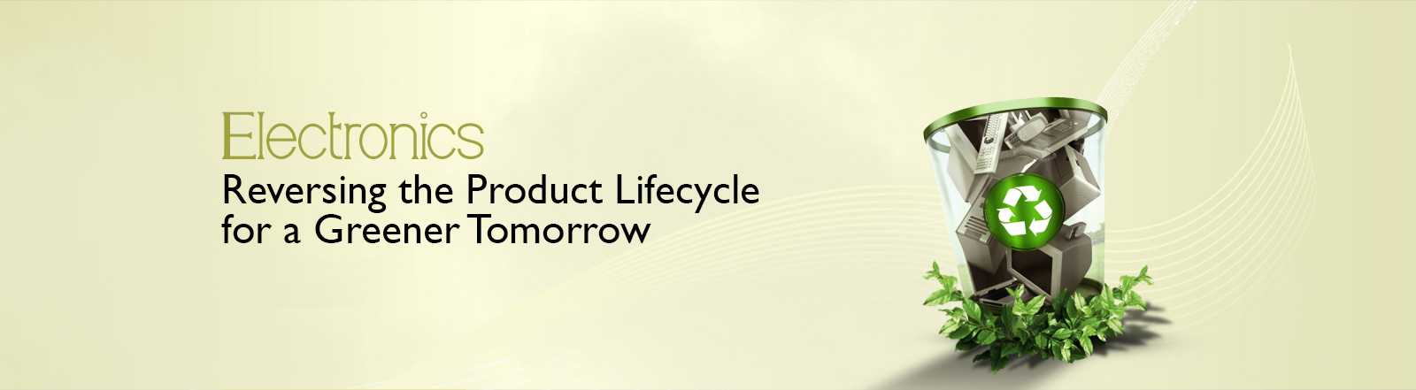

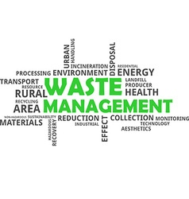

**REFERENCES**

1. **Journal References**
2. Baldé, C. P., Forti V., Gray, V., Kuehr, R., & Stegmann, P. (2017). *Global E-waste monitor 2017*
3. *Quantities, flows, and resources*. Bonn/Geneva/Vienna: United Nations University (UNU),
4. Toxics Links. (2014). *on the edge: Potential hotspots in Delhi*. New Delhi Retrieved
5. Bhaskar, K., & Turaga, R. M. R. (2018). India’s e-waste rules and their impact on e-waste management practices: A case study. *Journal of Industrial Ecology, 22*(4), 930–942
6. Raghupathy, L., Krüger, C., Chaturvedi, A., Aroa, R., & Henzler, M. P. (2007). E-waste recycling in India: Bridging the gap between the informal and formal sector.
7. Chatterjee, S., & Kumar, K. (2009). Effective electronic waste management and recycling process involving formal and non-formal sectors. *International Journal of Physical Sciences, 4*(13), 893–905
8. Parthasarathy, P., Chatterjee, S., Reddy, M. R. P., & Bulbule, K. A. (2018). Environmentally sound recycling technology of scrap printed circuit boards for developing countries. *International Journal of Scientific & Engineering Research 9*(3), 1713–1725
9. **Book References**
10. Hand book of electronic Waste Management(2009).E-Waste management: From Bangalore
11. Mallick, R. B., & El-Korchi, T. (2013). *Pavement engineering: Principles and practice*. Boca Raton,: CRC Press.
12. *E-WASTE RECYCLING AND MANAGEMENT: Present scenarios and environmental issues*. (2020). S.l.: SPRINGER NATURE.
13. E-Waste in Transition: From Pollution to Resource(2016).New Delhi IIM Institute
14. Kahhat, R., Hieronymi, K., & Williams, E. (2013). *E-waste management: From waste to resource*. London: Routledge.
15. Blackman, W. C. (2001). *Basic hazardous waste management*. Boca Raton: Lewis.
16. Johri, R. (2009). *E-waste: Implications, regulations, and management in India and current global best practices*. New Delhi: Energy and Resources Institute.
17. **Website references**
18. Mishra, ✍. (2021, January 13). E Waste in India: Issues and Management. Retrieved from <https://www.dailyissues3.com/2021/01/e-waste-in-india-issues-and-management.html>
19. E-Waste Management in India. (n.d.). Retrieved from <https://www.cseindia.org/e-waste-management-in-india-10693>
20. ByHrBiz, P. (2020, October 15). E-Waste Management in India: Challenges and Opportunities. Retrieved from <https://cleantogreen751389608.wordpress.com/2020/10/09/e-waste-management-in-india-challenges-and-opportunities/>
21. ByHrBiz, P. (2020, October 15). E-Waste Management in India: Challenges and Opportunities. Retrieved from <https://cleantogreen751389608.wordpress.com/2020/10/09/e-waste-management-in-india-challenges-and-opportunities/>
22. The Future of E-waste in India. (-0001, November 30). Retrieved from <https://www.dqindia.com/the-future-e-waste-india/>
23. E-waste management in India, Policies and Best Practices. (n.d.). Retrieved from <https://www.itu.int/dms_pub/itu-d/oth/07/15/D07150000060001PDFE.pdf>
24. Admin. (2021, January 20). Electronic Waste - E-waste Management Rules, Integrated E-waste Management System for UPSC. Retrieved from <https://byjus.com/free-ias-prep/electronic-waste/>