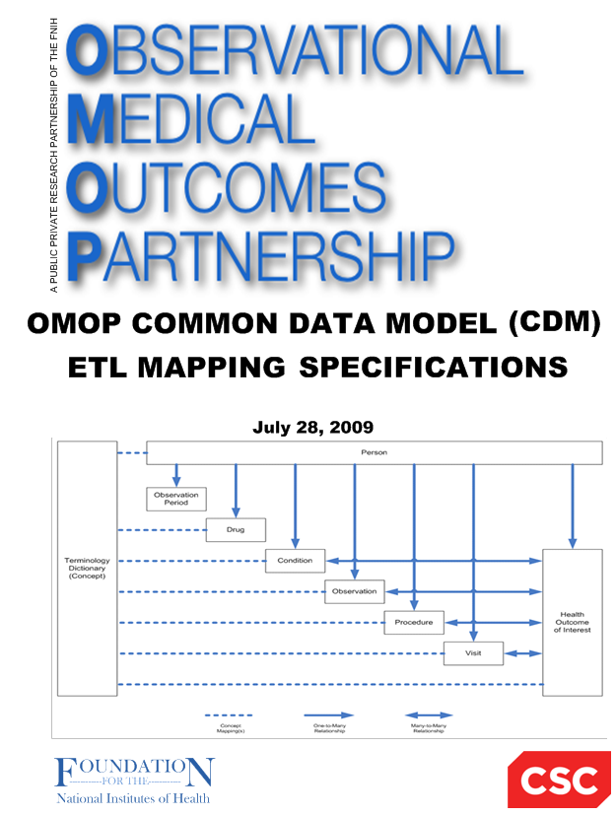

**OMOP Common Data Model (CDM V4.0)**

**Health Cost and Utilization Project (HCUP) – Nationwide Inpatient Sample (NIS)**

**Mapping Specification**

**Version 1.1**

**8-January-2015**

Martijn Schuemie

Erica Voss

Patrick Ryan

Chris Knoll

Source Data Mapping Approach

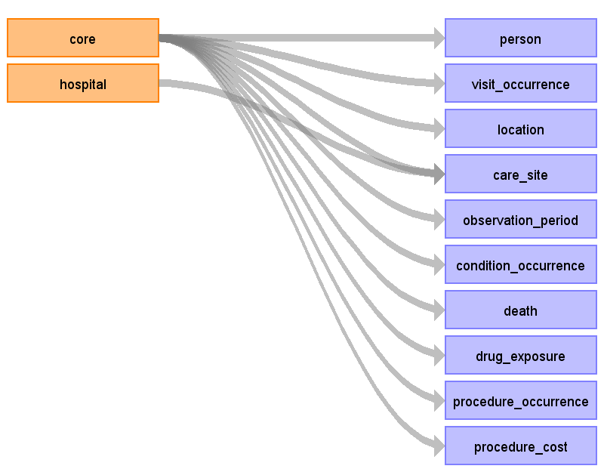

Table name: person

Reading from core

Contains hospital discharges, not persons. But every row can be considered one person

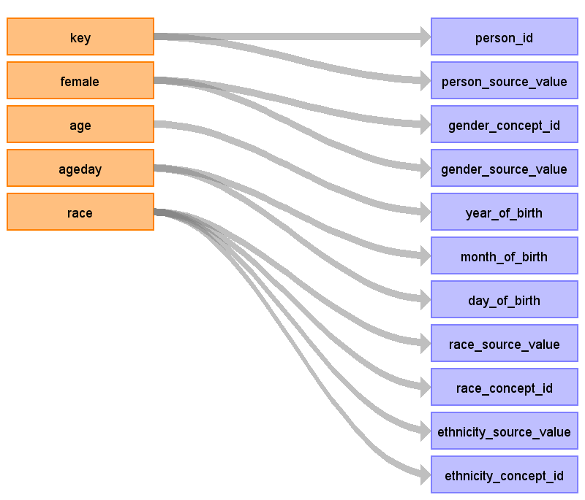

|  |  |  |  |
| --- | --- | --- | --- |
| Destination Field | Source Field | Logic | Comment |
| person_id | key |  | One-on-one copy |
| person_source_value | key |  |  |
| gender_concept_id | female | 1 = female (8532) 0 = male (8507) else = unknown (8551) |  |
| gender_source_value | female |  |  |
| year_of_birth | age | if age > 0 year_of_birth = visit_start_date year - age else year_of_birth + month_of_birth + day_of_birth = visit_start_date - ageday |  |
| month_of_birth | ageday | see year_of_birth logic. Only filled if age = 0, else NULL |  |
| day_of_birth | ageday | see year_of_birth logic. Only filled if age = 0, else NULL |  |
| race_source_value | race |  |  |
| race_concept_id | race | See mapping table:  source_value label concept_id  1 White 8527  2 Black 8516  3 Other 8522  4 Pacific Islander 8557  5 Native American 8657  6 Other 8522 |  |
| ethnicity_source_value | race | if race = 3, put that value here, else 0 (note: will be stored in race_source_value) |  |
| ethnicity_concept_id | race | if race = 3, set to 38003563 (Hispanic), else 0 |  |
| location_id |  | not used |  |
| provider_id |  | not used |  |
| care_site_id |  | not used |  |

**Sample code for transformation:**

Row person = **new** Row();

person.add("person_id", row.get("KEY"));

person.add("person_source_value", row.get("KEY"));

person.add("gender_source_value", row.get("FEMALE"));

person.add("gender_concept_id", row.get("FEMALE").equals("1") ? "8532" : row.get("FEMALE").equals("0") ? "8507" : "8551");

**if** (row.getInt("AGE") > 0) {

**int** yearOfBirth = Integer.*parseInt*(StringUtilities.*daysToCalendarYear*(visitStartDate)) - row.getInt("AGE");

person.add("year_of_birth", yearOfBirth);

person.add("month_of_birth", "");

person.add("day_of_birth", "");

} **else** **if** (row.getInt("AGEDAY") >= 0) {

**long** dateOfBirth = visitStartDate - row.getInt("AGEDAY");

person.add("year_of_birth", StringUtilities.*daysToCalendarYear*(dateOfBirth));

person.add("month_of_birth", StringUtilities.*daysToCalendarMonth*(dateOfBirth));

person.add("day_of_birth", StringUtilities.*daysToCalendarDayOfMonth*(dateOfBirth));

} **else** {

person.add("year_of_birth", "");

person.add("month_of_birth", "");

person.add("day_of_birth", "");

}

person.add("race_source_value", row.get("RACE"));

**if** (row.get("RACE").equals("1")) // White

person.add("race_concept_id", "8527");

**else** **if** (row.get("RACE").equals("2")) // Black

person.add("race_concept_id", "8516");

**else** **if** (row.get("RACE").equals("4")) // Pacific islander

person.add("race_concept_id", "8557");

**else** **if** (row.get("RACE").equals("5")) // Native American

person.add("race_concept_id", "8657");

**else** **if** (row.get("RACE").equals("3")) // Hispanic, should be coded as 'other'

person.add("race_concept_id", "8522");

**else** **if** (row.get("RACE").equals("6")) // Other

person.add("race_concept_id", "8522");

**else**

person.add("race_concept_id", "");

**if** (row.get("RACE").equals("3")) {// Hispanic

person.add("ethnicity_source_value", "3");

person.add("ethnicity_concept_id", "38003563");

} **else** {

person.add("ethnicity_source_value", "");

person.add("ethnicity_concept_id", "0");

}

Table name: visit_occurrence

Reading from core

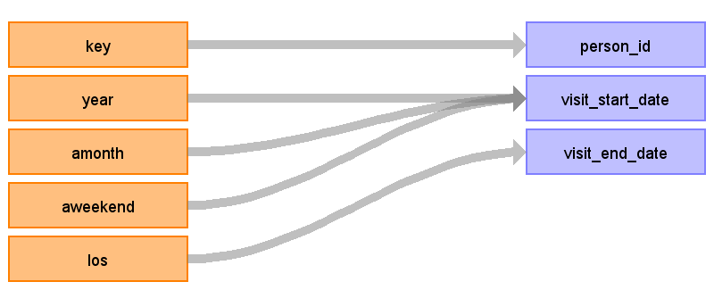

|  |  |  |  |
| --- | --- | --- | --- |
| Destination Field | Source Field | Logic | Comment |
| person_id | key |  |  |
| visit_occurrence_id |  | Auto generate |  |
| place_of_service_source_value |  |  |  |
| place_of_service_concept_id |  | 9201 |  |
| visit_start_date | year amonth aweekend | visit date = year + amonth + ? (first day of month that is correct weekday (weekday or weekend))  if amonth < 1 then amonth = 1  if aweekend < 0 then aweekend = 0 |  |
| visit_end_date | los | if los < 1 set to 0 (same day stay): start_date = end_date | There are some bogus values, but they are very infrequent. |
| care_site_id | hospid |  |  |

**Sample code for computing visit start date**

**if** (Integer.*parseInt*(amonth) < 1)

amonth = Integer.*toString*(Math.*abs*(hash(key) % 12) + 1);

**boolean** isWeekend = aweekend.equals("1");

Calendar calendar = Calendar.*getInstance*();

calendar.set(Integer.*parseInt*(year), Integer.*parseInt*(amonth) - 1, 1);

**while** (isWeekend(calendar) != isWeekend)

calendar.add(Calendar.*DATE*, 1);

**long** time = calendar.getTimeInMillis();

time += calendar.getTimeZone().getOffset(time);

// Millenium is added because for negative numbers, integer division truncates upwards! (-8/10 = 0). This is reversed in the daysToDatabaseDateString function

visitStartDate = (((StringUtilities.*MILLENIUM* + time) / StringUtilities.*DAY*) - (1000 * 365));

**Sample code for transformation:**

Row visitOccurrence = **new** Row();

visitOccurrence.add("person_id", row.get("KEY"));

visitOccurrence.add("visit_occurrence_id", visitOccurrenceId);

visitOccurrence.add("visit_start_date", StringUtilities.*daysToDatabaseDateString*(visitStartDate));

visitOccurrence.add("visit_end_date", StringUtilities.*daysToDatabaseDateString*(visitEndDate));

visitOccurrence.add("care_site_id", row.get("HOSPID"));

visitOccurrence.add("place_of_service_concept_id", 9201); // Inpatient visitTable name: location

Reading from core

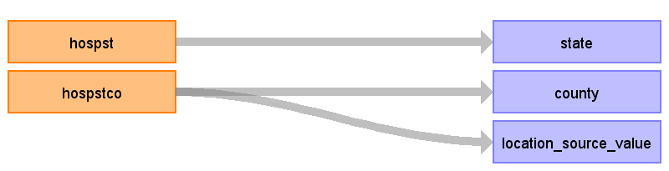

|  |  |  |  |
| --- | --- | --- | --- |
| Destination Field | Source Field | Logic | Comment |
| location_id |  | For every combination of hospst + hospstco, a new location_id is generated. hoststco = NULL and hospstco = -9999 are considered to be the same. |  |
| address_1 |  |  |  |
| address_2 |  |  |  |
| city |  |  |  |
| state | hospst |  |  |
| zip |  |  |  |
| county | hospstco | Lookup in FIPS table <http://www.census.gov/geo/reference/docs/codes/national_county.txt> County name is truncated to 20 characters (note: the truncation has been verified to not create duplicate county names) |  |
| location_source_value | hospstco |  |  |

**Sample code for transformation:**

String stateCounty = row.get("HOSPST") + "\t" + (row.get("HOSPSTCO").equals("-9999") ? "" : row.get("HOSPSTCO"));

locationId = stateCountyToLocationId.get(stateCounty);

**if** (locationId == **null**) {

locationId = stateCountyToLocationId.size() + 1;

stateCountyToLocationId.put(stateCounty, locationId);

Row location = **new** Row();

location.add("location_id", locationId);

location.add("state", row.get("HOSPST"));

String county = codeToCounty.get(row.get("HOSPSTCO"));

**if** (county == **null**)

county = "";

**if** (county.length() > 20)

county = county.substring(0,20); //County field in CDM limited to 20 chars

location.add("county", county);

location.add("location_source_value", row.get("HOSPSTCO"));

}Table name: care_site

Reading from core

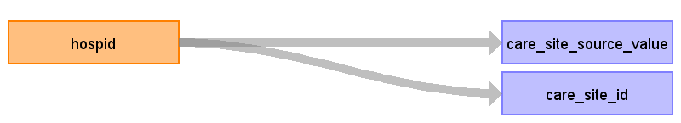

|  |  |  |  |
| --- | --- | --- | --- |
| Destination Field | Source Field | Logic | Comment |
| location_id |  | From location table based on hospst + hospstco |  |
| organization_id |  |  |  |
| place_of_service_concept_id |  |  |  |
| place_of_service_source_value |  |  |  |
| care_site_source_value | hospid |  |  |
| care_site_id | hospid |  |  |

**Sample code for transformation:**

**if** (careSiteIds.add(row.getInt("HOSPID"))) {

Row careSite = **new** Row();

careSite.add("care_site_id", row.get("HOSPID"));

careSite.add("care_site_source_value", row.get("HOSPID"));

careSite.add("location_id", locationId);

}

Reading from hospital

Lots of nice data, but no place to put it in the CDM.

Table name: observation_period

Reading from core

Same logic as visit_occurrence table (visit = observation_period)

Generated

|  |  |  |  |
| --- | --- | --- | --- |
| Destination Field | Source Field | Logic | Comment |
| observation_period_id |  |  |  |
| person_id |  |  |  |
| observation_period_start_date |  |  |  |
| observation_period_end_date |  |  |  |

**Sample code for transformation:**

Row observationPeriod = **new** Row();

observationPeriod.add("observation_period_id", observationPeriodId);

observationPeriod.add("person_id", row.get("KEY"));

observationPeriod.add("observation_period_start_date", StringUtilities.*daysToDatabaseDateString*(visitStartDate));

observationPeriod.add("observation_period_end_date", StringUtilities.*daysToDatabaseDateString*(visitEndDate));Table name: provider

Table name: condition_occurrence

Reading from core

If any of the diagnose fields maps to concept 4014295 (Single live birth) and the patient is either male or younger than 12, the code is discarted.

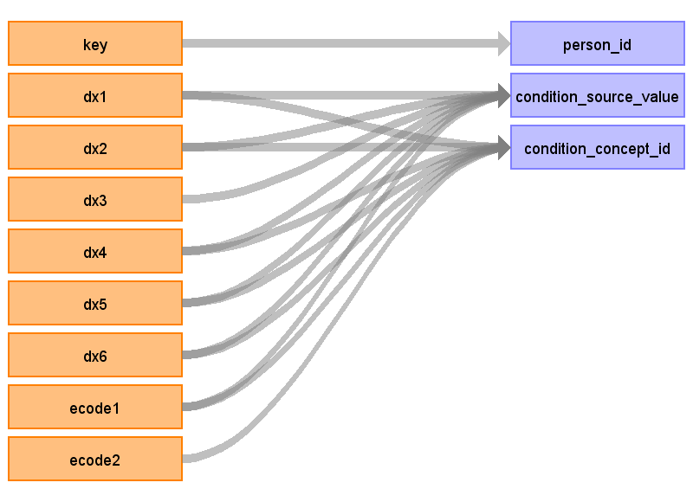

|  |  |  |  |
| --- | --- | --- | --- |
| Destination Field | Source Field | Logic | Comment |
| person_id | key |  |  |
| condition_occurrence_id |  |  |  |
| condition_start_date | visit_start_date |  |  |
| condition_end_date |  |  |  |
| condition_type_concept_id | 38000184 – 38000198 for dx1-dx15, respectively  if ecode then 38000184-38000185 |  |  |
| stop_reason |  |  |  |
| associated_provider_id |  |  |  |
| visit_occurrence_id | From visit_occurrence table |  |  |
| condition_source_value | dx1 dx2 dx3 dx4 dx5 dx6 ecode1 |  |  |
| condition_concept_id | dx1 dx2 dx4 dx5 dx6 ecode2 ecode1 |  |  |

**Sample code for transformation:**

*diagnoseFields* = **new** String[] { "DX1", "DX2", "DX3", "DX4", "DX5", "DX6", "DX7", "DX8", "DX9", "DX10", "DX11", "DX12", "DX13", "DX14", "DX15", "DX16", "DX17", "DX18", "DX19", "DX20", "DX21", "DX22", "DX23", "DX24", "DX25", "ECODE1", "ECODE2" };

*diagnoseFieldConceptIds* = **new** **int**[] { 38000184, 38000185, 38000186, 38000187, 38000188, 38000189, 38000190, 38000191, 38000192, 38000193, 38000194, 38000195, 38000196, 38000197, 38000198, 38000198, 38000198, 38000198, 38000198, 38000198, 38000198, 38000198, 38000198, 38000198, 38000198, 38000184, 38000185 };

**for** (**int** i = 0; i < *diagnoseFields*.length; i++)

**if** (row.get(*diagnoseFields*[i]).trim().length() != 0) {

**if** (conceptId == 4014295 && row.getInt("AGE") < 12) { // 4014295 = Single live birth

etlReport.reportProblem("Condition_occurrence", "Person < 12 years old with live birth. Removing condition_occurrence", row.get("KEY"));

**continue**;

}

**if** (conceptId == 4014295 && row.get("FEMALE").equals("0")) { // 4014295 = Single live birth

etlReport.reportProblem("Condition_occurrence", "Male with live birth. Removing condition_occurrence", row.get("KEY"));

**continue**;

}

Row conditionOccurrence = **new** Row();

conditionOccurrence.add("person_id", row.get("KEY"));

conditionOccurrence.add("condition_occurrence_id", ++conditionOccurrenceId);

conditionOccurrence.add("condition_source_value", row.get(*diagnoseFields*[i]));

conditionOccurrence.add("condition_concept_id", conceptId);

conditionOccurrence.add("condition_type_concept_id", *diagnoseFieldConceptIds*[i]);

conditionOccurrence.add("condition_start_date", StringUtilities.*daysToDatabaseDateString*(visitStartDate));

conditionOccurrence.add("visit_occurrence_id", visitOccurrenceId);

tableToRows.put("condition_occurrence", conditionOccurrence);

}Table name: death

Reading from core

Only create a record if died = 1

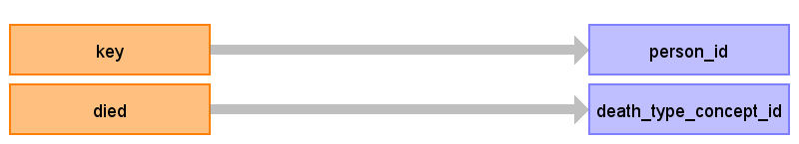

|  |  |  |  |
| --- | --- | --- | --- |
| Destination Field | Source Field | Logic | Comment |
| person_id | key |  |  |
| death_date |  | visit_end_date |  |
| death_type_concept_id |  | 38003566 Medical claim discharge status "Died" |  |
| cause_of_death_concept_id |  |  |  |
| cause_of_death_source_value |  |  |  |

**Sample code for transformation:**

**if** (row.get("DIED").equals("1")) {

Row death = **new** Row();

death.add("person_id", row.get("KEY"));

death.add("death_date", StringUtilities.*daysToDatabaseDateString*(visitEndDate));

death.add("death_type_concept_id", 38003566); // EHR record patient status "Deceased"

}

Table name: drug_exposure

Reading from core

A record is created only if procedure implies drug.

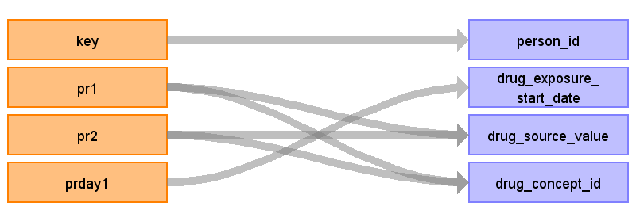

|  |  |  |  |
| --- | --- | --- | --- |
| Destination Field | Source Field | Logic | Comment |
| person_id | key |  |  |
| drug_exposure_start_date | prday1 prday2  ... | If prdayx < 1 then visit_start_date, else (visit_start_date + prdayx) |  |
| drug_exposure_end_date |  |  |  |
| drug_type_concept_id |  | 38000179 (Physician administered drug (identified as procedure)) |  |
| stop_reason |  |  |  |
| refills |  |  |  |
| quantity |  |  |  |
| days_supply |  |  |  |
| sig |  |  |  |
| prescribing_provider_id |  |  |  |
| visit_occurrence_id |  | From visit_occurrence table |  |
| relevant_condition_concept_id |  |  |  |
| drug_exposure_id |  | auto generate |  |
| drug_source_value | pr1  pr2  ... |  |  |
| drug_concept_id | pr1  pr2  ... | Lookup in mapping table |  |

**Sample SQL code for finding procedures that map to drugs:**

SELECT DISTINCT source_code, source_code_description, target_concept_id, concept_code, concept_name FROM source_to_concept_map INNER JOIN concept ON target_concept_id = concept_id WHERE target_vocabulary_id = 8 AND source_vocabulary_id in (3,4,5) AND primary_map = 'Y' AND COALESCE(source_to_concept_map.invalid_reason,’’) != 'D'

**Sample code for transformation:**

*procedureFields* = **new** String[] { "PR1", "PR2", "PR3", "PR4", "PR5", "PR6", "PR7", "PR8", "PR9", "PR10", "PR11", "PR12", "PR13", "PR14", "PR15"};

*procedureDayFields* = **new** String[] { "PRDAY1", "PRDAY2", "PRDAY3", "PRDAY4", "PRDAY5", "PRDAY6", "PRDAY7", "PRDAY8", "PRDAY9", "PRDAY10", "PRDAY11", "PRDAY12", "PRDAY13", "PRDAY14", "PRDAY15" };

**for** (**int** i = 0; i < *procedureFields*.length; i++)

**if** (row.get(*procedureFields*[i]).trim().length() != 0) {

**int** conceptId = icd9ToRxNorm.getConceptId(row.get(*procedureFields*[i]).trim());

**if** (conceptId != 0) {

Row drugExposure = **new** Row();

drugExposure.add("drug_exposure_id", ++drugExposureId);

drugExposure.add("person_id", row.get("KEY"));

**int** day = row.getInt(*procedureDayFields*[i]);

**if** (day < 0)

day = 0;

**if** (day > visitEndDate - visitStartDate) {

etlReport.reportProblem("Drug_exposure", "Drug exposure date beyond length of stay, removing drug exposure", row.get("KEY"));

**continue**;

}

drugExposure.add("drug_exposure_start_date", StringUtilities.*daysToDatabaseDateString*(visitStartDate + day));

drugExposure.add("drug_source_value", row.get(*procedureFields*[i]));

drugExposure.add("drug_concept_id", conceptId);

drugExposure.add("drug_type_concept_id", 38000179); // Physician administered drug (identified as procedure)

drugExposure.add("visit_occurrence_id", visitOccurrenceId);

tableToRows.put("drug_exposure", drugExposure);

}

}Table name: procedure_occurrence

Reading from core

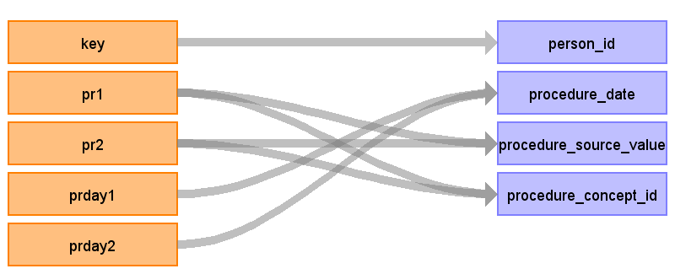

|  |  |  |  |
| --- | --- | --- | --- |
| Destination Field | Source Field | Logic | Comment |
| person_id | key |  |  |
| procedure_occurrence_id |  | Auto generate |  |
| procedure_type_concept_id |  | 38000251 to 38000265, for pr1 through pr15 |  |
| procedure_date | prday1 prday2  ... | If prdayx < 1 then visit_start_date, else (visit_start_date + prdayx) |  |
| associated_provider_id |  |  |  |
| visit_occurrence_id |  | from visit occurrence table |  |
| relevant_condition_concept_id |  |  |  |
| procedure_source_value | pr1  pr2  ... |  |  |
| procedure_concept_id | pr1  pr2  ... | Lookup in source_to_concept_map |  |

**Sample code for transformation:**

*procedureFields* = **new** String[] { "PR1", "PR2", "PR3", "PR4", "PR5", "PR6", "PR7", "PR8", "PR9", "PR10", "PR11", "PR12", "PR13", "PR14", "PR15"};

*procedureDayFields* = **new** String[] { "PRDAY1", "PRDAY2", "PRDAY3", "PRDAY4", "PRDAY5", "PRDAY6", "PRDAY7", "PRDAY8", "PRDAY9", "PRDAY10", "PRDAY11", "PRDAY12", "PRDAY13", "PRDAY14", "PRDAY15" };

*procedureFieldConceptIds* = **new** **int**[] { 38000251, 38000252, 38000253, 38000254, 38000255, 38000256, 38000257, 38000258, 38000259, 38000260, 38000261, 38000262, 38000263, 38000264, 38000265 };

**for** (**int** i = 0; i < *procedureFields*.length; i++)

**if** (row.get(*procedureFields*[i]).trim().length() != 0) {

**int** day = row.getInt(*procedureDayFields*[i]);

**if** (day < 0)

day = 0;

**if** (day > visitEndDate-visitStartDate){

etlReport.reportProblem("Procedure_occurrence", "Procedure date beyond length of stay, removing procedure", row.get("KEY"));

**continue**;

}

Row procedureOccurrence = **new** Row();

procedureOccurrence.add("procedure_occurrence_id", ++procedureOccurrenceId);

procedureOccurrence.add("person_id", row.get("KEY"));

procedureOccurrence.add("procedure_date", StringUtilities.*daysToDatabaseDateString*(visitStartDate + day));

procedureOccurrence.add("procedure_source_value", row.get(*procedureFields*[i]));

procedureOccurrence.add("procedure_concept_id", icd9ProcToConcept.getConceptId(row.get(*procedureFields*[i]).trim()));

procedureOccurrence.add("procedure_type_concept_id", *procedureFieldConceptIds*[i]);

procedureOccurrence.add("visit_occurrence_id", visitOccurrenceId);

tableToRows.put("procedure_occurrence", procedureOccurrence);

**if** (*procedureFields*[i].equals("PR1"))

primaryProcedureOccurrenceId = procedureOccurrenceId;

}Table name: procedure_cost

Reading from core

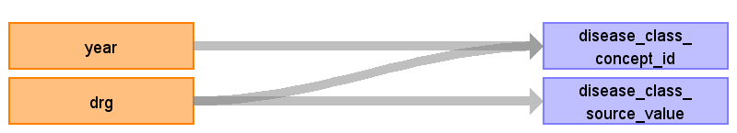

|  |  |  |  |
| --- | --- | --- | --- |
| Destination Field | Source Field | Logic | Comment |
| procedure_cost_id |  | Autogenerate, starts at value 1 |  |
| procedure_occurrence_id |  | procedure_occurrence_id corresponding to PR1 |  |
| paid_copay |  |  |  |
| paid_coinsurance |  |  |  |
| paid_toward_deductible |  |  |  |
| paid_by_payer |  |  |  |
| paid_by_coordination_benefits |  |  |  |
| total_out_of_pocket |  |  |  |
| total_paid |  |  |  |
| revenue_code_concept_id |  |  |  |
| payer_plan_period_id |  |  |  |
| revenue_code_source_value |  |  |  |
| disease_class_concept_id | drg year | Use year to select only the DRG code in the vocab that was valid that year |  |
| disease_class_source_value | drg |  |  |

**Sample code for transformation:**

**if** (primaryProcedureOccurrenceId != -1) {

String drg = row.get("DRG").trim();

**int** conceptId;

**if** (StringUtilities.*isInteger*(drg)) {

conceptId = drgYearToConcept.getConceptId(String.*format*("%03d", Integer.*parseInt*(drg)) + "_" + row.get("YEAR"));

} **else**

conceptId = drgYearToConcept.getConceptId(drg + "_" + row.get("YEAR"));

procedureCostId++;

Row procedureCost = **new** Row();

procedureCost.add("procedure_cost_id", procedureCostId);

procedureCost.add("procedure_occurrence_id", primaryProcedureOccurrenceId);

procedureCost.add("disease_class_source_value", row.get("DRG"));

procedureCost.add("disease_class_concept_id", conceptId);

}Table name: observation

Table name: condition_era

Table name: drug_era

Table name: organization

Table name: payer_plan_period

Table name: drug_cost

Table name: cohort

Appendix: source tables

Table: core

|  |  |  |  |
| --- | --- | --- | --- |
| Field | Type | Most freq. value | Comment |
| key | Integer | List truncated... |  |
| female | Integer | 1 |  |
| year | Integer | 2006 |  |
| amonth | Integer | -9 |  |
| aweekend | Integer | 0 |  |
| age | Integer | 0 |  |
| ageday | Integer | -99 |  |
| race | Integer | 1 |  |
| hospst | VarChar | CA |  |
| hospstco | Integer |  | Indicates the five (or four) digits of zip code for hospital |
| hospid | Integer | 51043 |  |
| los | Integer | 2 |  |
| los_x | Integer | 2 |  |
| asource | Integer | 5 |  |
| asource_x | VarChar |  |  |
| atype | Integer | 1 |  |
| died | Integer | 0 |  |
| discwt | Real | 4.6286 |  |
| dispub92 | Integer |  |  |
| dispuniform | Integer | 1 |  |
| dqtr | Integer | 1 |  |
| drg | Integer | 391 | DRG |
| drgver | Integer | 22 |  |
| drg18 | Integer |  | DRG 18 |
| drg24 | Integer |  | DRG 24 |
| dshospid | VarChar |  |  |
| dx1 | VarChar | V3000 |  |
| dx2 | VarChar |  |  |
| dx3 | VarChar |  |  |
| dx4 | VarChar |  |  |
| dx5 | VarChar |  |  |
| dx6 | VarChar |  |  |
| dx7 | VarChar |  |  |
| dx8 | VarChar |  |  |
| dx9 | VarChar |  |  |
| dx10 | Free text | 4019 |  |
| dx11 | Free text | 4019 |  |
| dx12 | VarChar |  |  |
| dx13 | VarChar |  |  |
| dx14 | VarChar |  |  |
| dx15 | VarChar |  |  |
| dxccs1 | Integer | 218 | CCS = clinical classification systems |
| dxccs2 | Integer | -999 |  |
| dxccs3 | Integer | -999 |  |
| dxccs4 | Integer | -999 |  |
| dxccs5 | Integer | -999 |  |
| dxccs6 | Integer | -999 |  |
| dxccs7 | Integer | -999 |  |
| dxccs8 | Integer | -999 |  |
| dxccs9 | Integer | -999 |  |
| dxccs10 | Integer | -999 |  |
| dxccs11 | Integer | -999 |  |
| dxccs12 | Integer | -999 |  |
| dxccs13 | Integer | -999 |  |
| dxccs14 | Integer | -999 |  |
| dxccs15 | Integer | -999 |  |
| mdc | Integer | 5 |  |
| mdc18 | Integer |  |  |
| mdnum1_s | VarChar |  |  |
| mdnum2_s | VarChar |  |  |
| ndx | Integer | 9 |  |
| neomat | Integer | 0 |  |
| nis_stratum | Integer | 3033 |  |
| npr | Integer | 0 |  |
| pay1 | Integer | 1 |  |
| pay1_x | VarChar | C |  |
| pay2 | Integer | -9 |  |
| pay2_x | VarChar |  |  |
| pr1 | VarChar |  |  |
| pr2 | VarChar |  |  |
| pr3 | VarChar |  |  |
| pr4 | VarChar |  |  |
| pr5 | VarChar |  |  |
| pr6 | Free text | 8853 |  |
| pr7 | VarChar |  |  |
| pr8 | VarChar |  |  |
| pr9 | VarChar |  |  |
| pr10 | VarChar |  |  |
| pr11 | VarChar |  |  |
| pr12 | VarChar |  |  |
| pr13 | VarChar |  |  |
| pr14 | VarChar |  |  |
| pr15 | Integer |  |  |
| prccs1 | Integer | -99 |  |
| prccs2 | Integer | -99 |  |
| prccs3 | Integer | -99 |  |
| prccs4 | Integer | -99 |  |
| prccs5 | Integer | -99 |  |
| prccs6 | Integer | -99 |  |
| prccs7 | Integer | -99 |  |
| prccs8 | Integer | -99 |  |
| prccs9 | Integer | -99 |  |
| prccs10 | Integer | -99 |  |
| prccs11 | Integer | -99 |  |
| prccs12 | Integer | -99 |  |
| prccs13 | Integer | -99 |  |
| prccs14 | Integer | -99 |  |
| prccs15 | Integer | -99 |  |
| prday1 | Integer | -99 |  |
| prday2 | Integer | -99 |  |
| prday3 | Integer | -99 |  |
| prday4 | Integer | -99 |  |
| prday5 | Integer | -99 |  |
| prday6 | Integer | -99 |  |
| prday7 | Integer | -99 |  |
| prday8 | Integer | -99 |  |
| prday9 | Integer | -99 |  |
| prday10 | Integer | -99 |  |
| prday11 | Integer | -99 |  |
| prday12 | Integer | -99 |  |
| prday13 | Integer | -99 |  |
| prday14 | Integer | -99 |  |
| prday15 | Integer | -99 |  |
| totchg | Integer | -999999999 |  |
| totchg_x | Real | -99999999999.99 |  |
| zipinc | Integer |  |  |
| discwtcharge | Real |  |  |
| mdid_s | VarChar |  |  |
| surgid_s | VarChar |  |  |
| asourceub92 | VarChar |  |  |
| dispub04 | Integer |  |  |
| dqtr_x | Integer |  |  |
| drg_nopoa | Integer |  |  |
| dx16 | VarChar |  |  |
| dx17 | VarChar |  |  |
| dx18 | VarChar |  |  |
| dx19 | VarChar |  |  |
| dx20 | VarChar |  |  |
| dx21 | VarChar |  |  |
| dx22 | VarChar |  |  |
| dx23 | VarChar |  |  |
| dx24 | VarChar |  |  |
| dx25 | VarChar |  |  |
| dxccs16 | Integer |  |  |
| dxccs17 | Integer |  |  |
| dxccs18 | Integer |  |  |
| dxccs19 | Integer |  |  |
| dxccs20 | Integer |  |  |
| dxccs21 | Integer |  |  |
| dxccs22 | Integer |  |  |
| dxccs23 | Integer |  |  |
| dxccs24 | Integer |  |  |
| dxccs25 | Integer |  |  |
| ecode1 | VarChar |  |  |
| ecode2 | VarChar |  |  |
| ecode3 | VarChar |  |  |
| ecode4 | VarChar |  |  |
| elective | Integer | 0 |  |
| e_ccs1 | Integer | -999 |  |
| e_ccs2 | Integer | -999 |  |
| e_ccs3 | Integer | -999 |  |
| e_ccs4 | Integer | -999 |  |
| hcup_ed | Integer |  |  |
| hospbrth | Integer |  |  |
| mdc24 | Integer |  |  |
| mdc_nopoa | Integer |  |  |
| nchronic | Integer |  |  |
| necode | Integer | 0 |  |
| orproc | Integer |  |  |
| pl_nchs2006 | Integer |  |  |
| pointoforiginub04 | VarChar |  |  |
| pointoforigin_x | VarChar |  |  |
| tran_in | Integer |  |  |
| tran_out | Integer |  |  |
| zipinc_qrtl | Integer |  |  |
| mdnum1_r | Integer |  |  |
| mdnum2_r | Integer |  |  |
| pl_ur_cat4 | Integer |  |  |

Table: dx_pr_grps

|  |  |  |  |
| --- | --- | --- | --- |
| Field | Type | Most freq. value | Comment |
| hospid | Integer | 12320 |  |
| key | Integer | List truncated... |  |
| chron1 | Integer | 0 |  |
| chron2 | Integer | 0 |  |
| chron3 | Integer | 1 |  |
| chron4 | Integer | 1 |  |
| chron5 | Integer | 1 |  |
| chron6 | Integer | -99 |  |
| chron7 | Integer | -99 |  |
| chron8 | Integer | -99 |  |
| chron9 | Integer | -99 |  |
| chron10 | Integer | -99 |  |
| chron11 | Integer | -99 |  |
| chron12 | Integer | -99 |  |
| chron13 | Integer | -99 |  |
| chron14 | Integer | -99 |  |
| chron15 | Integer | -99 |  |
| chron16 | Integer |  |  |
| chron17 | Integer |  |  |
| chron18 | Integer |  |  |
| chron19 | Integer |  |  |
| chron20 | Integer |  |  |
| chron21 | Integer |  |  |
| chron22 | Integer |  |  |
| chron23 | Integer |  |  |
| chron24 | Integer |  |  |
| chron25 | Integer |  |  |
| chronb1 | Integer | 7 |  |
| chronb2 | Integer | 7 |  |
| chronb3 | Integer | 7 |  |
| chronb4 | Integer | -99 |  |
| chronb5 | Integer | -99 |  |
| chronb6 | Integer | -99 |  |
| chronb7 | Integer | -99 |  |
| chronb8 | Integer | -99 |  |
| chronb9 | Integer | -99 |  |
| chronb10 | Integer | -99 |  |
| chronb11 | Integer | -99 |  |
| chronb12 | Integer | -99 |  |
| chronb13 | Integer | -99 |  |
| chronb14 | Integer | -99 |  |
| chronb15 | Integer | -99 |  |
| chronb16 | Integer |  |  |
| chronb17 | Integer |  |  |
| chronb18 | Integer |  |  |
| chronb19 | Integer |  |  |
| chronb20 | Integer |  |  |
| chronb21 | Integer |  |  |
| chronb22 | Integer |  |  |
| chronb23 | Integer |  |  |
| chronb24 | Integer |  |  |
| chronb25 | Integer |  |  |
| dxmccs1 | VarChar |  |  |
| e_mccs1 | VarChar |  |  |
| pclass1 | Integer | -99 |  |
| pclass2 | Integer | -99 |  |
| pclass3 | Integer | -99 |  |
| pclass4 | Integer | -99 |  |
| pclass5 | Integer | -99 |  |
| pclass6 | Integer | -99 |  |
| pclass7 | Integer | -99 |  |
| pclass8 | Integer | -99 |  |
| pclass9 | Integer | -99 |  |
| pclass10 | Integer | -99 |  |
| pclass11 | Integer | -99 |  |
| pclass12 | Integer | -99 |  |
| pclass13 | Integer | -99 |  |
| pclass14 | Integer | -99 |  |
| pclass15 | Integer | -99 |  |
| prmccs1 | VarChar |  |  |
| ccsmgn1 | Integer |  |  |
| ccsmgn2 | Integer |  |  |
| ccsmgn3 | Integer |  |  |
| ccsmgn4 | Integer |  |  |
| ccsmgn5 | Integer |  |  |
| ccsmgn6 | Integer |  |  |
| ccsmgn7 | Integer |  |  |
| ccsmgn8 | Integer |  |  |
| ccsmgn9 | Integer |  |  |
| ccsmgn10 | Integer |  |  |
| ccsmgn11 | Integer |  |  |
| ccsmgn12 | Integer |  |  |
| ccsmgn13 | Integer |  |  |
| ccsmgn14 | Integer |  |  |
| ccsmgn15 | Integer |  |  |
| ccsmsp1 | Integer |  |  |
| ccsmsp2 | Integer |  |  |
| ccsmsp3 | Integer |  |  |
| ccsmsp4 | Integer |  |  |
| ccsmsp5 | Integer |  |  |
| ccsmsp6 | Integer |  |  |
| ccsmsp7 | Integer |  |  |
| ccsmsp8 | Integer |  |  |
| ccsmsp9 | Integer |  |  |
| ccsmsp10 | Integer |  |  |
| ccsmsp11 | Integer |  |  |
| ccsmsp12 | Integer |  |  |
| ccsmsp13 | Integer |  |  |
| ccsmsp14 | Integer |  |  |
| ccsmsp15 | Integer |  |  |
| eccsmgn1 | Integer |  |  |
| eccsmgn2 | Integer |  |  |
| eccsmgn3 | Integer |  |  |
| eccsmgn4 | Integer |  |  |

Table: hospital

|  |  |  |  |
| --- | --- | --- | --- |
| Field | Type | Most freq. value | Comment |
| ahaid | VarChar |  |  |
| discwt | Real | 4.4322 |  |
| hospaddr | VarChar |  |  |
| hospcity | VarChar |  |  |
| hospid | Integer | List truncated... |  |
| hospname | VarChar |  |  |
| hospst | VarChar | TX |  |
| hospwt | Real | 5.0000 |  |
| hospzip | Integer |  |  |
| hosp_bedsize | Integer | 1 |  |
| hosp_control | Integer | 0 |  |
| hosp_location | Integer | 1 |  |
| hosp_locteach | Integer | 2 |  |
| hosp_region | Integer | 3 |  |
| hosp_teach | Integer | 0 |  |
| idnumber | VarChar |  |  |
| nis_stratum | Integer | 2411 |  |
| n_disc_u | Integer | 133443 |  |
| n_hosp_u | Integer | 78 |  |
| s_disc_u | Integer | 84786 |  |
| s_hosp_u | Integer | 16 |  |
| total_disc | Integer | List truncated... |  |
| year | Integer | 2008 |  |
| discwtcharge | Real |  |  |
| hfipsstco | Integer |  |  |
| h_contrl | Integer |  |  |
| hospstco | Integer | -9999 |  |
| hosp_rnpct | Integer |  |  |
| hosp_rnfteapd | Real |  |  |
| hosp_lpnfteapd | Real |  |  |
| hosp_nafteapd | Real |  |  |
| hosp_opsurgpct | Integer |  |  |
| hosp_mhsmember | Integer |  |  |
| hosp_mhscluster | Integer |  |  |

Table: severity

|  |  |  |  |
| --- | --- | --- | --- |
| Field | Type | Most freq. value | Comment |
| hospid | Integer | 51043 |  |
| key | Integer | List truncated... |  |
| aprdrg | Integer | 640 |  |
| aprdrg_risk_mortality | Integer | 1 |  |
| aprdrg_severity | Integer | 1 |  |
| cm_aids | Integer | 0 |  |
| cm_alcohol | Integer | 0 |  |
| cm_anemdef | Integer | 0 |  |
| cm_arth | Integer | 0 |  |
| cm_bldloss | Integer | 0 |  |
| cm_chf | Integer | 0 |  |
| cm_chrnlung | Integer | 0 |  |
| cm_coag | Integer | 0 |  |
| cm_depress | Integer | 0 |  |
| cm_dm | Integer | 0 |  |
| cm_dmcx | Integer | 0 |  |
| cm_drug | Integer | 0 |  |
| cm_htn_c | Integer | 0 |  |
| cm_hypothy | Integer | 0 |  |
| cm_liver | Integer | 0 |  |
| cm_lymph | Integer | 0 |  |
| cm_lytes | Integer | 0 |  |
| cm_mets | Integer | 0 |  |
| cm_neuro | Integer | 0 |  |
| cm_obese | Integer | 0 |  |
| cm_para | Integer | 0 |  |
| cm_perivasc | Integer | 0 |  |
| cm_psych | Integer | 0 |  |
| cm_pulmcirc | Integer | 0 |  |
| cm_renlfail | Integer | 0 |  |
| cm_tumor | Integer | 0 |  |
| cm_ulcer | Integer | 0 |  |
| cm_valve | Integer | 0 |  |
| cm_wghtloss | Integer | 0 |  |
| ds_dx_category1 | VarChar |  |  |
| ds_stage1 | Real | 1.01 |  |
| apsdrg | Integer |  |  |
| apsdrg_charge_weight | Real |  |  |
| apsdrg_los_weight | Real |  |  |
| apsdrg_mortality_weight | Real |  |  |
| ds_los_level | Integer |  |  |
| ds_los_scale | Real |  |  |
| ds_mrt_level | Integer |  |  |
| ds_mrt_scale | Real |  |  |
| ds_rd_level | Integer |  |  |
| ds_rd_scale | Real |  |  |