Q.1.1.1

What properties do each of the filter functions pick up?

-Gaussian filters pick up low frequencies.

-Laplacian of Gaussian filters pick up edges.

-Derivative of Gaussian filters pick up edges perpendicular to derivative directions.

Why do we need multiple scales of filter responses?

Multiple scales of filter responses allow for detecting different sizes of edges.

Q1.1.2

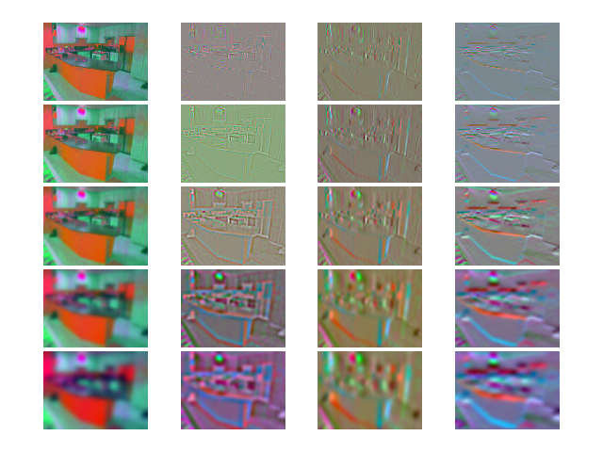

Q1.3



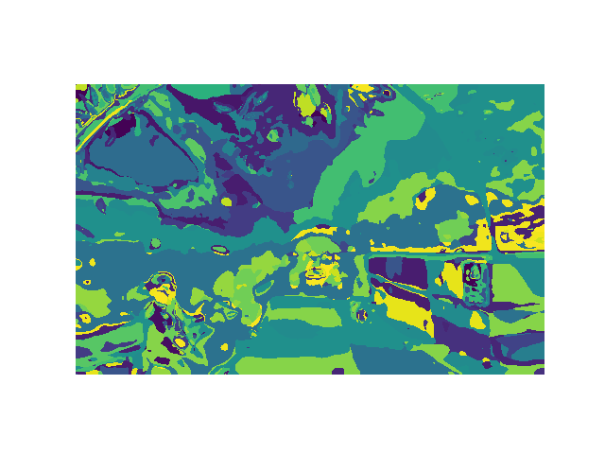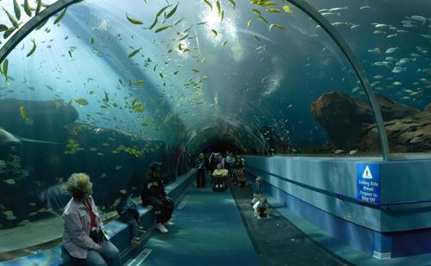

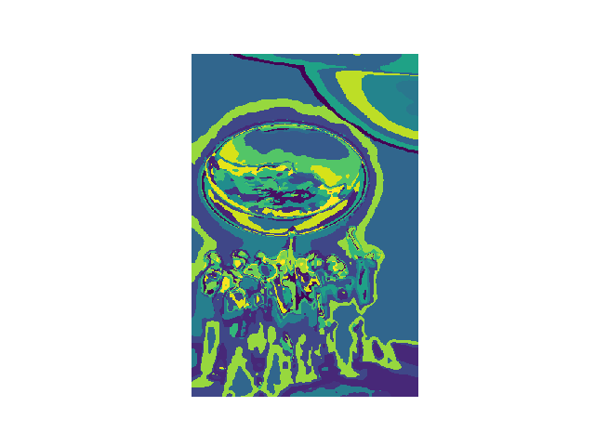

Q2.5

Confusion Matrix:

[46. 3. 2. 2. 2. 2. 2. 2.]

[ 2. 49. 3. 3. 2. 2. 3. 3.]

[ 2. 0. 55. 15. 2. 4. 3. 6.]

[ 2. 9. 10. 34. 2. 1. 3. 11.]

[ 7. 1. 2. 0. 41. 7. 1. 1.]

[11. 6. 2. 2. 19. 39. 2. 0.]

[ 7. 10. 3. 1. 4. 12. 42. 4.]

[ 1. 5. 8. 20. 3. 3. 1. 25.]

Accuracy:

0.5736568457538995

~57.4%

Q2.6

Laundromats, Waterfalls, and Windmills have high miss-classification rates compared to the other labels.

Laundromats vary in shape and color, and seem to have a lot of shadows that create problems for classification.

Waterfalls seem to have issue with how much of a waterfall is framed in the picture, and how much the surrounding environment plays into the classification algorithm.

Windmills have a similar problem to waterfalls; the surroundings can vary drastically. For example, most windmills are in open areas with fields or trees, but this one is in a city setting:

