Q1.1

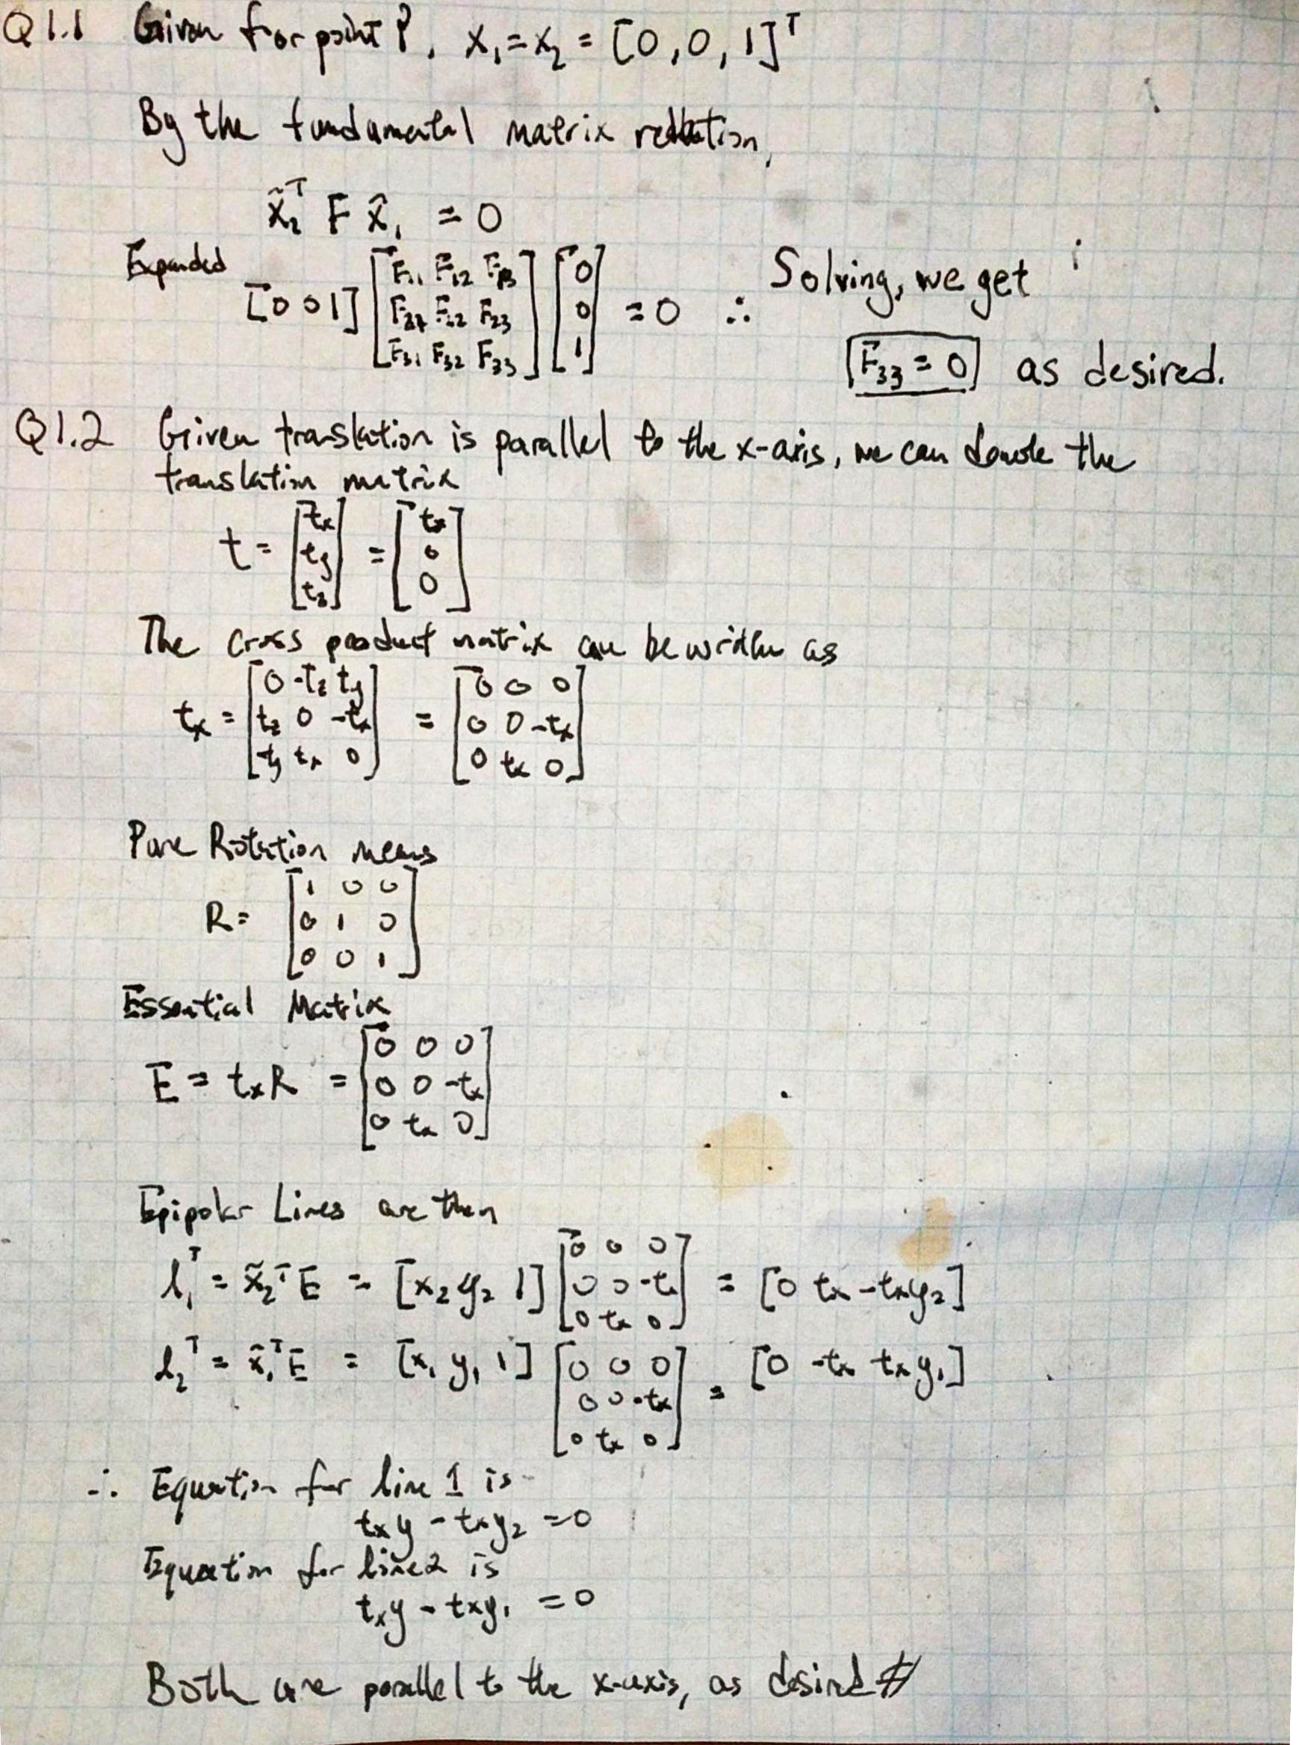

Q1.2



Q1.3

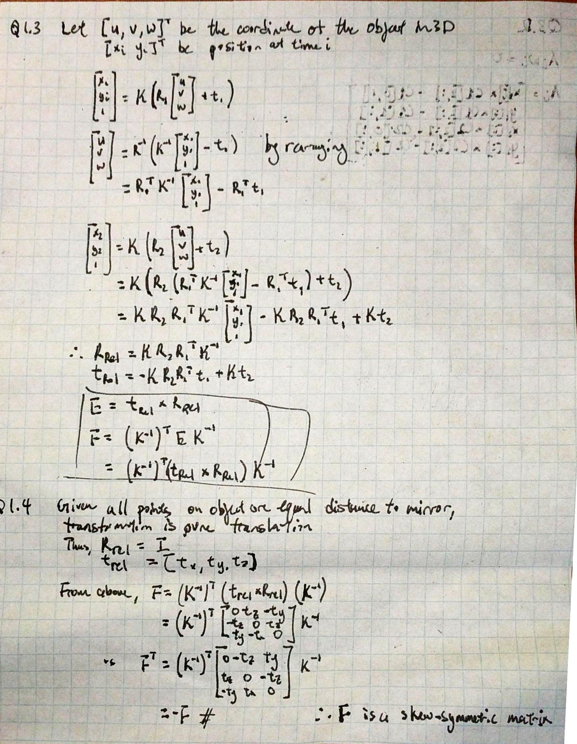

Q1.4



Q 2.1

F8 =

[[ 9.78833286e-10 -1.32135929e-07 1.12585666e-03]

[-5.73843315e-08 2.96800276e-09 -1.17611996e-05]

[-1.08269003e-03 3.04846703e-05 -4.47032655e-03]]

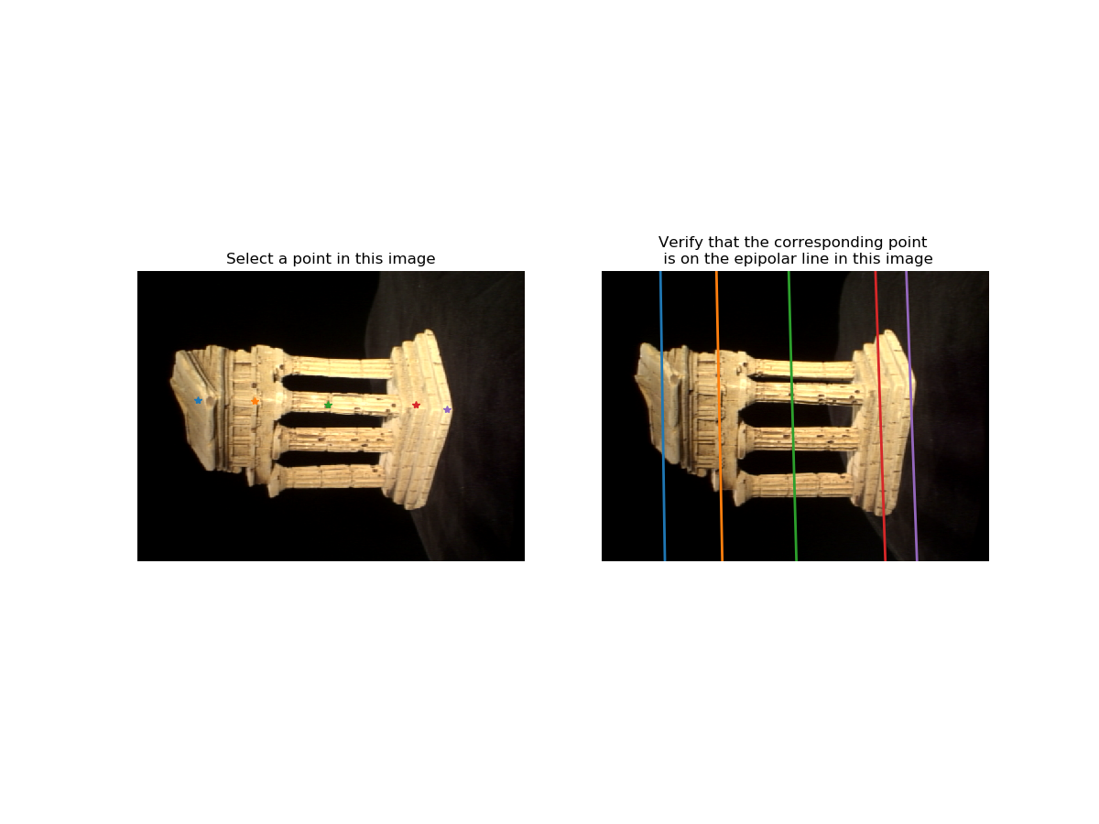

Q 2.2

F7 =

[[-1.94078149e-07 7.96477251e-07 6.97294189e-04]

[-7.90268545e-07 -9.25318810e-09 1.34406658e-04]

[-6.14775991e-04 -1.40855499e-04 -6.59754289e-03]]

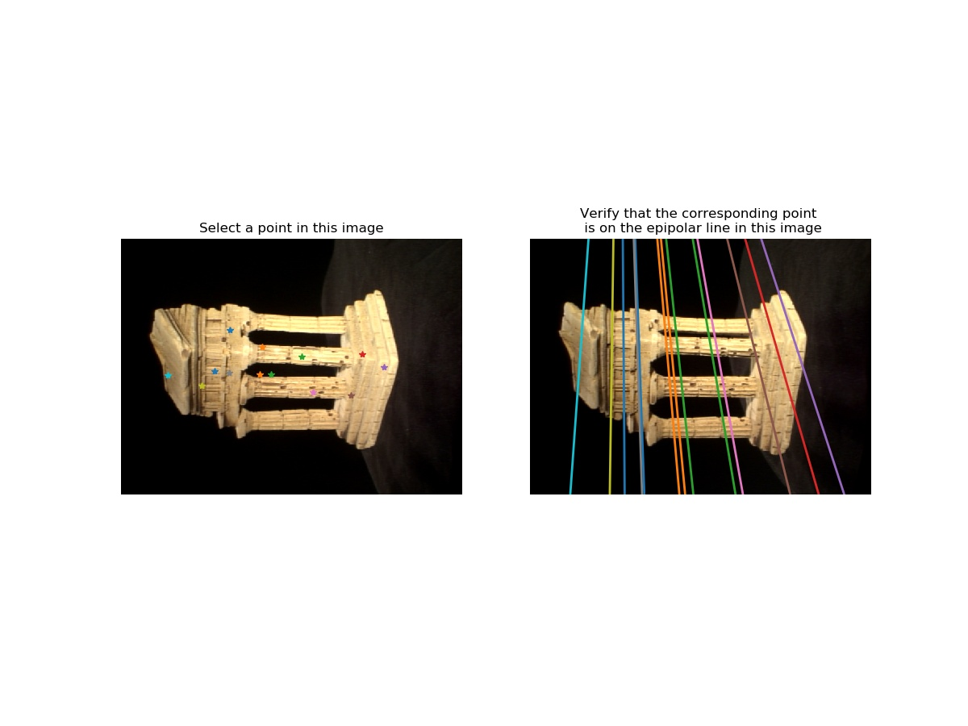

Q 3.1

Using F8 from eight point algorithm, K1 & K2 from intrinsics.npz

E=

[[ 2.26268684e-03 -3.06552495e-01 1.66260633e+00]

[-1.33130407e-01 6.91061098e-03 -4.33003420e-02]

[-1.66721070e+00 -1.33210351e-02 -6.72186431e-04]]

Q 3.2

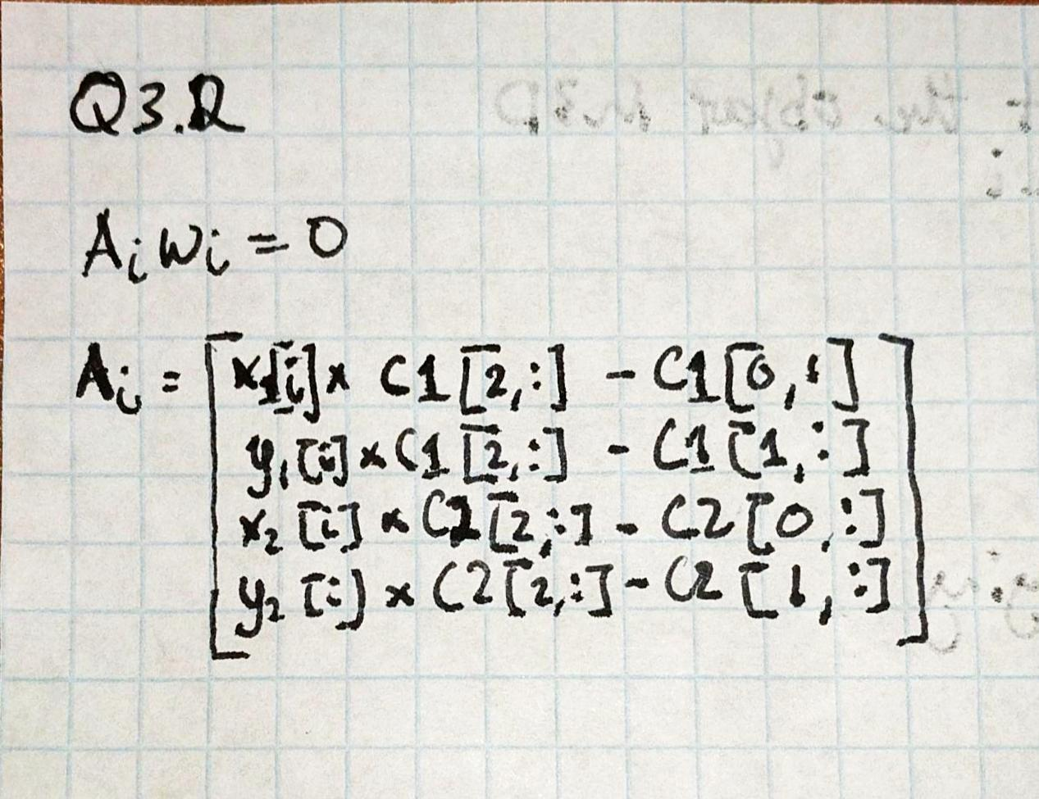

Q 4.1

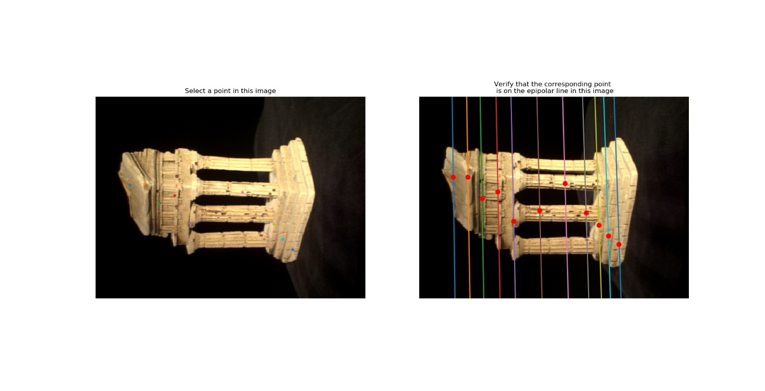

Q 4.2

