PLAN FOR 2026:

- To move towards more workshop jobs (paint correction, machine polishing, wheels off services, coatings, sale prep and my own car flipping) - better skill development long term
- To keep mobile customer base closer for travel and time reasons allowing growth
- Going to build more of a brand on social media and focus on local leads
- To upsell local customers into workshop services so it’s easy travel for them
- Want to move into jet skis and boats at the workshop for example

You could state on the website something like: “We are based near Loch Lomond”

WORKING AREA FOR MOBILE:

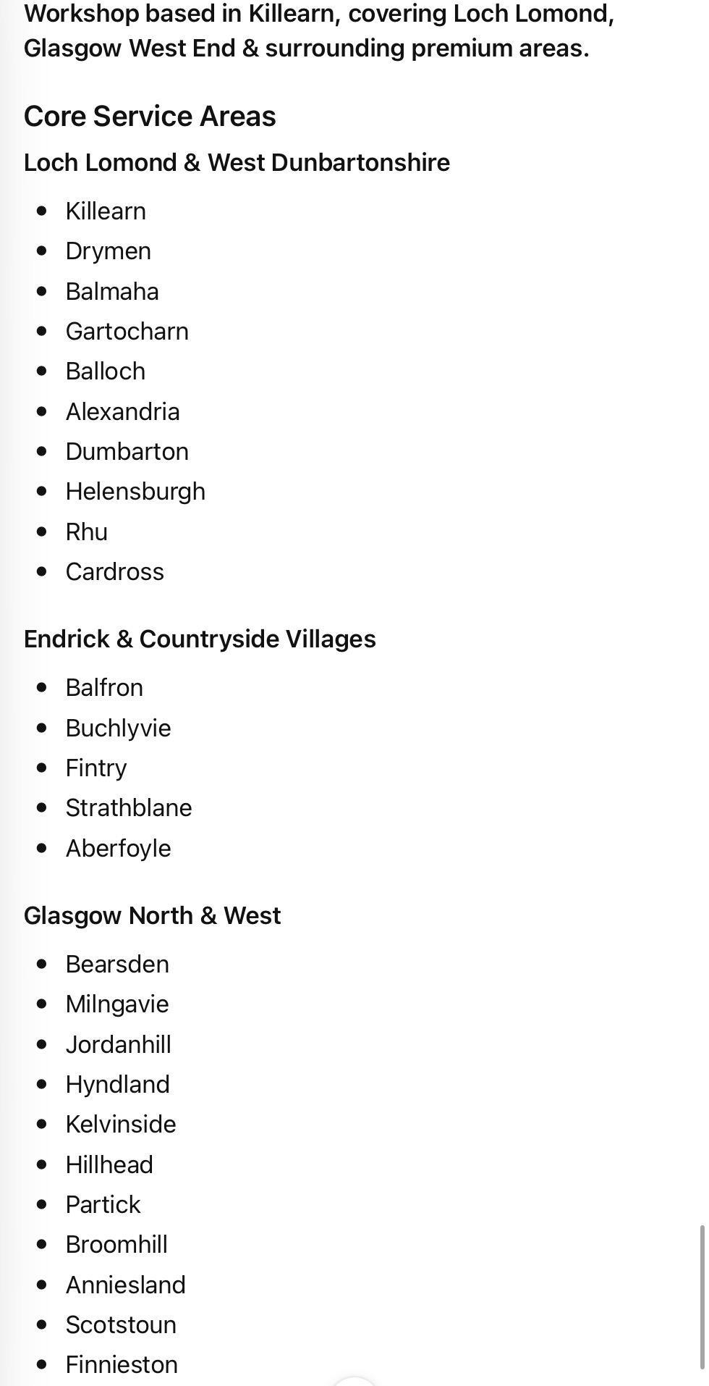
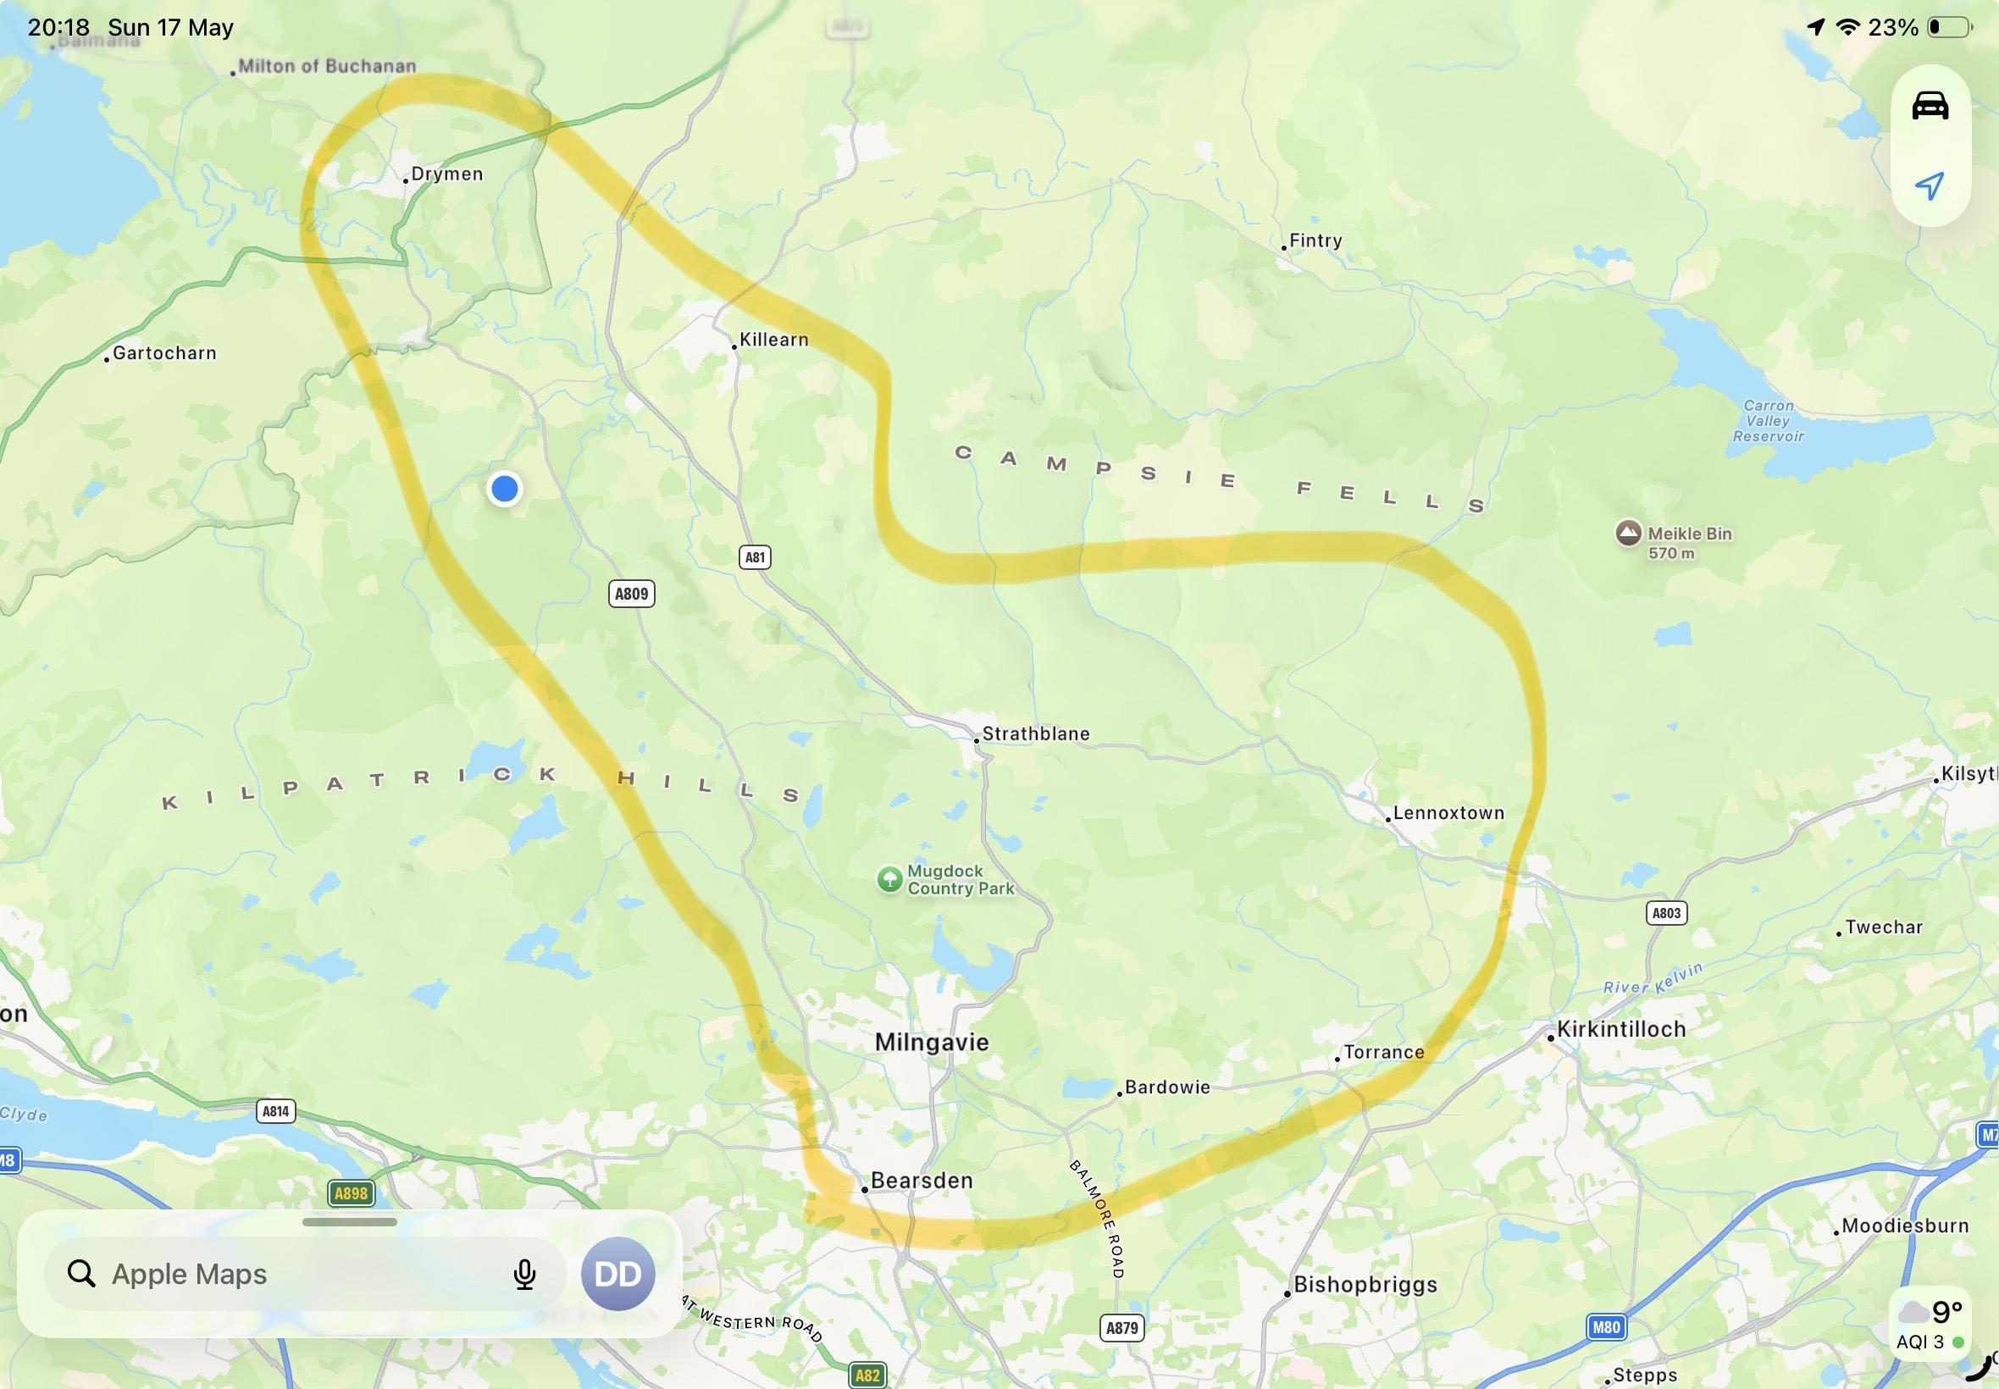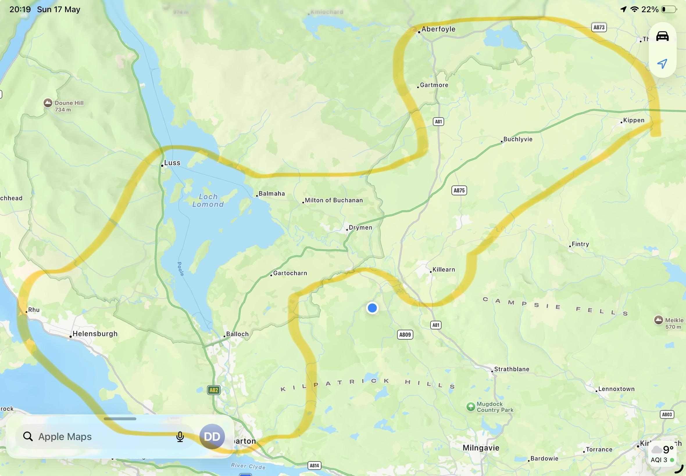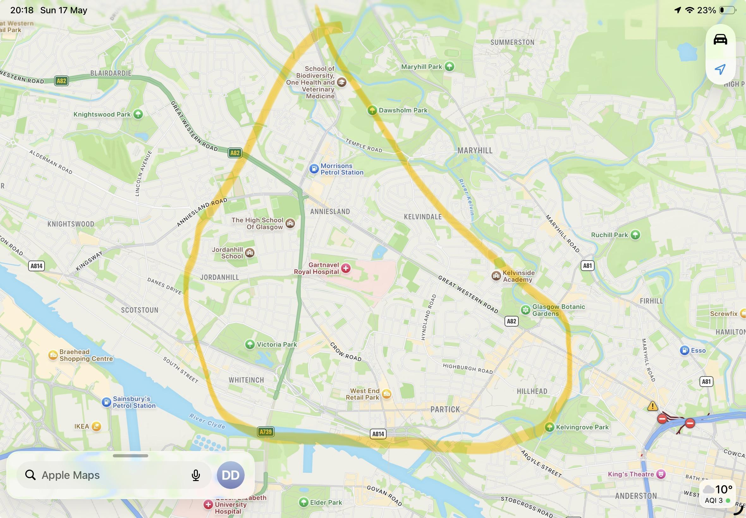

SOME CHANGES TO WEBSITE:

- Need locations obviously edited please

- If any location specific wording changes needed just do them please

- Couple of pics for website to add

- Sent 3 for “Casino Royale” photos
- Sent more for gallery in general

- Package/Service specific changes to simplify

- So I will have 5 main and easy packages to follow now!
heres the details below:

GLOSS ENHANCEMENT + 12 MONTH PROTECTION
“No Time To Die”

From £275
Approx. 7 - 8 Hours

A machine polishing package designed to dramatically improve gloss, depth and paint clarity while adding durable long-term protection.

EXTERIOR PREPARATION INCLUDES
· Safe wash & decontamination process
· Wheels, arches & exhaust tips deep cleaned
· Iron, tar & sap removal
· Clay treatment
· Spot-free drying process

ENHANCEMENT INCLUDES
· Single-stage machine polish
· Oxidation & haze reduction
· Increased gloss, clarity & depth
· Paintwork refined for a sharper finish

PROTECTION INCLUDES
· 12-month ceramic paint protection
· Glass sealed
· Tyres & trims dressed

IDEAL FOR
· Dull or lightly swirled paintwork
· Enthusiast vehicles
· Vehicles needing a visual refresh
· Owners wanting high gloss without full correction

STAGE 1 PAINT CORRECTION + CERAMIC COATING
“Casino Royale”

Professional paint correction paired with durable ceramic protection for maximum gloss, easier maintenance, and long-lasting results.

2-YEAR CERAMIC COATING

From £375
Approx. 1 Full Day

INCLUDES
· Full safe wash & decontamination
· Clay bar treatment
· Stage 1 machine correction
· Swirl mark reduction
· Increased gloss & paint clarity
· Ceramic coating applied to paintwork
· Glass cleaned & protected
· Tyres & trims dressed

IDEAL FOR
· Daily driven enthusiast vehicles
· Long-term paint protection
· Easier ongoing maintenance

3-YEAR CERAMIC COATING (UNIT ONLY)

From £450
Approx. 1.5 - 2 Days (Cure time required)

A more durable ceramic coating package offering enhanced longevity, gloss and protection.

INCLUDES
· Everything included in the 2-Year Ceramic Package
· Upgraded long-term ceramic coating
· Enhanced chemical & environmental resistance
· Additional durability & gloss retention

UNIT ONLY SERVICE
This package is available exclusively at our detailing unit to ensure optimal coating conditions and curing time.

OPTIONAL ADD-ON

WHEELS-OFF CERAMIC PROTECTION (UNIT ONLY)

From £125

· Wheels safely removed
· Inner barrels deep cleaned & decontaminated
· Ceramic coating applied to wheels & calipers
· Easier maintenance & brake dust removal

DEEP CLEAN DETAIL
“Shaken, Not Stirred”

From £170
Approx. From 4 Hours

A comprehensive interior and exterior transformation designed to restore heavily used or neglected vehicles back to a high standard.

EXTERIOR INCLUDES:

· Safe multi-stage wash process
· Wheels, arches & exhaust tips deep cleaned
· Full chemical decontamination
· Tar, iron & sap removal
· 6-month paint protection applied
· Tyres, trims & arches dressed
· Spot-free drying process

INTERIOR INCLUDES:

· Full deep vacuum including boot
· Compressed air dust removal
· Detailed cleaning of all interior surfaces
· Carpets & mats shampooed & extracted
· Seats, vents, switches & consoles detailed
· UV-protective interior dressing applied
· Interior & exterior glass cleaned
· Door shuts & jambs deep cleaned

IDEAL FOR
· Neglected vehicles (Add-ons recommended)
· Seasonal resets
· End-of-lease returns

OPTIONAL ADD-ONS
· Engine Bay Detail — From £50
· Ozone Odour Treatment — POA
· Excessive Pet Hair Removal — POA

MAINTENANCE DETAIL
“Spectre”

From £90
Approx. 2.5 – 3 Hours

A more thorough interior and exterior reset designed to keep your vehicle consistently clean, protected, and easy to maintain.

EXTERIOR INCLUDES:

· Everything included in the Exterior Safe Wash
· Paintwork decontamination where necessary
· Additional protection top-up

INTERIOR INCLUDES:

· Full interior vacuum including boot
· Carpets & mats deep cleaned
· Interior surfaces detailed
· Vents, switches & consoles cleaned
· UV-protective interior dressing applied
· Interior & exterior glass cleaned
· Door shuts & jambs cleaned

IDEAL FOR
· 3-8 week maintenance
· Family vehicles
· Daily drivers
· Keeping vehicles at a consistently high standard

ELIGIBILITY
Vehicle must have received a Deep Clean, Maintenance Detail, or Paint Enhancement package within the last 2–8 weeks.

EXTERIOR SAFE WASH
“007”

From £50
Approx. 1.5 – 2 Hours

A safe, professional maintenance wash designed to preserve your vehicle’s finish using premium products and careful wash methods.

EXTERIOR INCLUDES:

· Safe pre-wash & snow foam
· Two-bucket contact wash
· Wheels, arches & exhaust tips cleaned
· Intricate areas cleaned with soft brushes
· 3-month paint protection applied
· Tyres & trims dressed
· Plush towel & air-assisted drying process

IDEAL FOR
· Well-maintained vehicles
· Weekly, fortnightly or monthly upkeep
· Enthusiast-maintained cars

IMPORTANT INFORMATION

All pricing is based on vehicles in average condition.
Larger vehicles, excessive contamination, pet hair, mould, or neglected interiors may require additional time and cost.

Mobile appointments available seasonally and weather permitting.
Unit-based services available year-round.

