**Resume** 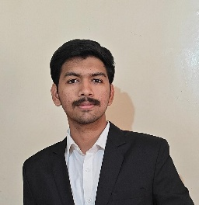

**1.Personal Information:**

Name: Athav Sanjay Sonawane [Nashik, Maharashtra]

Birth Date: 24/02/2006.

Birth Place : Dhule,(Maharashtra).

Nationality :Indian.

Blood group: B+.

Mobile Number: 9420208831.

Email id: atharv24sonawane@gmail.com

LinkedIn id: Atharv Sonawane.

GitHub : atharv24sonawane

**2.Educational Background :**

|  |  |
| --- | --- |
| **Class 10th (SSC) [2022]** | 93.80 % |
| **Class 12th (HSC)[2024]** | 79.00 % |
| **MHT-CET [2024]** | 97.32 ile |
| **Current College** | Vishwakrama Institute of Technology. |
| **Branch** | Artificial Intelligence And Machine Learnig (AIML). |
| **Current Cgpa** | 9.1 |

**3. Skills :**

* Programming: C / C++ / Python
* Tools: MS Word, PowerPoint, Excel
* Communication & Teamwork
* Presentation & Problem Solving

**4.Strengths:**

* Quick Learner
* Good at time management
* Strong focus and discipline
* Adaptable and curious

**5.Weaknesses**

* Sometimes face difficulty in time management
* Need to improve public speaking and presentation skills
* Limited hands-on industry experience
* Occasionally procrastinate on long tasks

**6.Opportunities**

* Active tech clubs and student communities at VIT Pune
* Regular hackathons and technical events to gain experience
* Access to online courses for upskilling in new technologies
* Internship options in Pune’s growing tech industry.

**7.Threats / Challenges**

* Time management during college + exam prep
* Need improvement in public speaking
* Balancing practical work with theory

**8.Short-Term Goals**

* Master core programming languages
* Complete at least 2 personal or team projects
* Get selected for a college tech team or club
* Start preparing for [CDS/AFCAT etc.]

**9.Achievements**

* Secured AIR 8 in Maths Olympiad Exam.
* Represented School in Chess Competitions.
* Scored Good marks in MHT-Cet.
* Participated in RTO Hackathon.

**Career Objective:**

Motivated and focused undergraduate student pursuing [Your Branch] with strong academic background and technical interests. Looking to develop skills through learning, projects, and internships that align with future goals in the tech/defence/engineering domain.