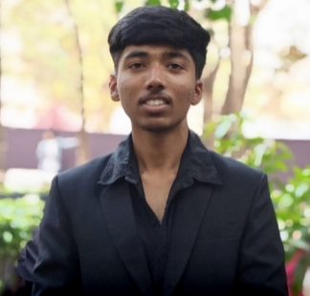**RESUME**

**1.Personal Information:**

Name – Shreyas Suresh Shinde

Birth Date: 21/03/2006

Mob.no – 8208035509

Birth Place : Gadhinglaj

Nationality :Indian.

Blood group: A+

Email Address – [shindeshreyas1314@gmail.com](mailto:shindeshreyas1314@gmail.com)

Linkedln id – Shreyas Shinde

**2.Current Education**

Course: B.TECH in CSE(AIML)

College : Vishwakarma Institute of Technology Pune

Year – First year (2024 – 2028)

**3.Education Background :**

HSC( 12th Standard )

|  |  |
| --- | --- |
| **School name** | Shraddha Junior college of sci. and com,ichalkaranji, dist.Kolhapur. |
| **Board** | HSE board |
| **Year** | 2024 |
| **Marks** | 72% |

**SSC ( 10TH Standard )**

|  |  |
| --- | --- |
| **School name** | New English School Nool, tal. Gadhinglaj , dist. Kolhapur. |
| **Board** | SSC board |
| **Year** | 2022 |
| **Marks** | 93% |

**4.Entrance Exam Score :** MHT-CET 2024 : 97.6

**5.Skills**

* Programming : C/C++ / Python
* Microsoft Word, Excel, PowerPoint
* Canva / Poster Designing
* Communication & Time Management
* Team Collaboration

**6.Stregnth:**

* Quick Learner
* Good Communication Skills
* Team Player
* Time Management
* Self-Motivated

**7.Weaknesses**

Public speaking

Taking on too many tasks

Lack of experience

Perfectionism

**8.Apportunity**

Internship programs in relevant fields

Online courses and certifications

Participation in hackathons and competitions

Building personal projects or portfolios

**9.Short-Term Goals:**

* Gain internship or part-time work experience in the tech/engineering field
* Improve coding and problem-solving skills
* Participate in technical workshops and college clubs
* Build a portfolio of mini-projects

**10.Threats / Challenges**

* Time management during college + exam prep
* Need improvement in public speaking
* Balancing practical work with theory

**11.Achievements :**

* Represent school at district level for hockey

• Represented School in Chess Competitions.

• Scored Good marks in MHT-Cet.

• Participated in RTO Hackathon**.**