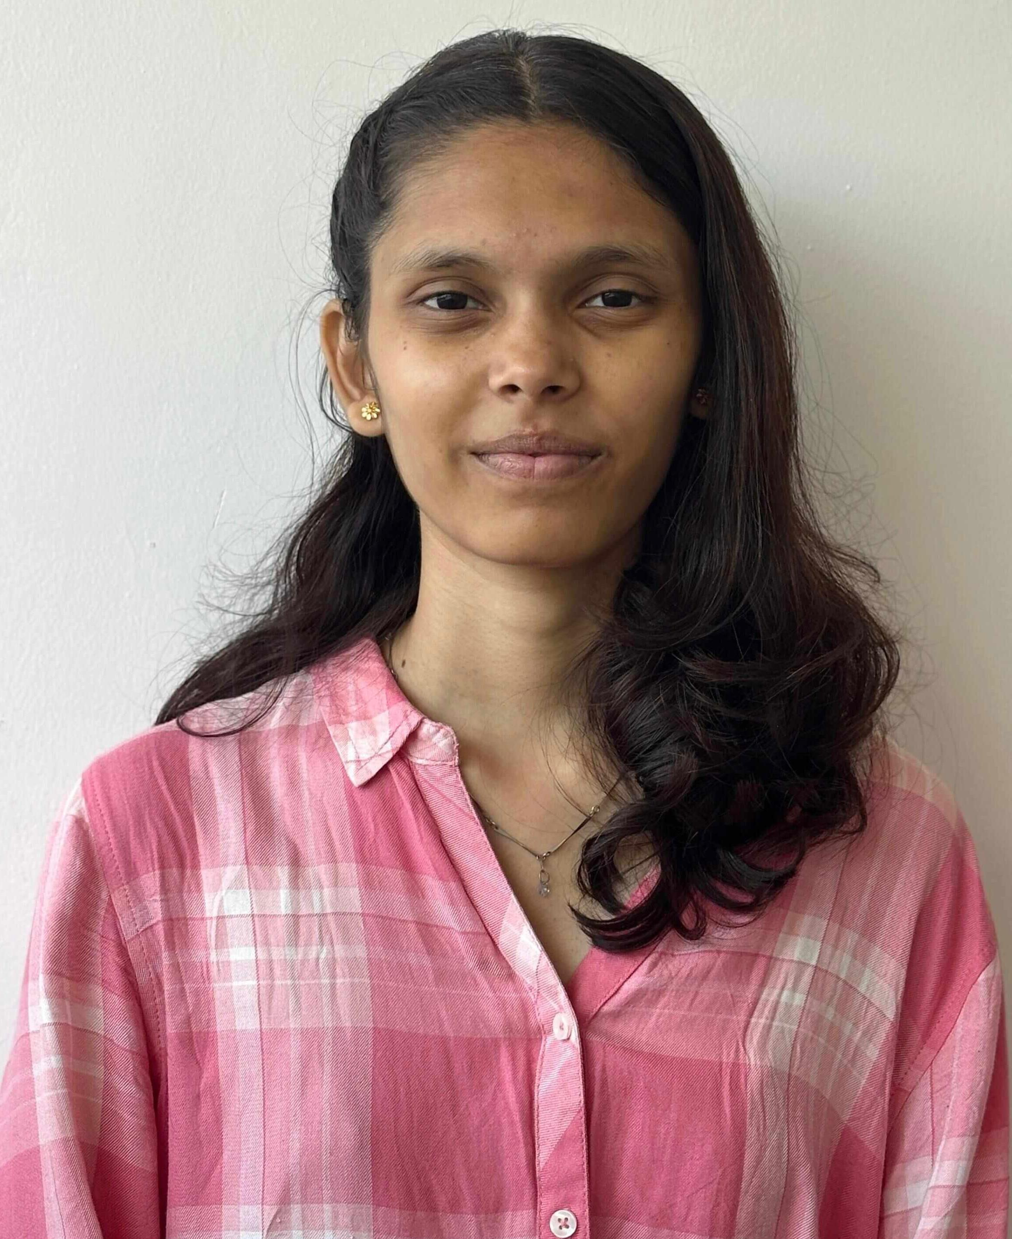GP ASSIGNMENT-6(RESUME BUILDING)

NAME: Akshata Shirsath

Gender: Female

Marital status: single

DOB: 29/10/2004

Birthplace: chh. Sambhajinagar

Nationality: Indian

📍 Maharashtra, India  
📞 [7822021400]

Email: [akshatashirsath2004@gmail.com]

**Introduction**

* Enthusiastic engineering student with a strong foundation in computer studies.
* Motivated by personal passion and family inspiration to excel in the tech field.
* Currently pursuing a degree in engineering with an interest in Artificial Intelligence and machine learning.
* Aiming to pursue higher education in Australia and contribute to the global tech community.
* Strong communication and teamwork abilities developed through academic projects and events.

# Career Objective

A passionate and dedicated engineering student with a strong foundation in computer studies and a growing interest in AI and machine learning. Motivated by family values and personal aspirations, I aim to pursue higher education and build an impactful career in the tech industry.

# Education

|  |  |  |  |  |
| --- | --- | --- | --- | --- |
| Qualification | Institute | Board/University | Year | Percentage |
| Bachelor of Engineering (Pursuing) | Vishwakarma institute of technology, Pune | Autonomous Savitribai Phule Pune university (SPPU) | [1ST year] | SGPA: 8.4 |
| HSC (12th Grade) | Vivekanand College of science and arts | Maharashtra State Board | [2023] | 70% |
| SSC (10th Grade) | Podar International School | ICSE | [2021] | 86% |

# SWOT Analysis

## Strengths:

- Strong interest and skills in computer studies  
- Hardworking and self-motivated  
- Excellent family support system  
- Passionate about learning new technologies

## Weaknesses:

- Initial indecision regarding career path  
- Tendency to overthink under pressure

## Opportunities:

- Aspiration to study in Australia  
- High demand for tech experts in global markets  
- Exposure to innovative family role models in science and engineering

## Threats:

- High expectations from family and self  
- Competitive academic and job environment

# Short-Term Goals

- Excel in my engineering academics  
- Strengthen coding and technical skills (Python, Web Development, etc.)  
- Complete impactful academic projects (e.g., smart parking system, inventory manager)  
- Participate in workshops and certifications in AI/ML

# Long-Term Goals

- Pursue higher education in Australia  
- Build a successful career in Artificial Intelligence and Machine Learning  
- Contribute to meaningful tech innovations  
- Make my family proud through personal and professional achievements

**Technical skills**

- Programming Languages: C, Python, Java

-Web Development: HTML, CSS, JavaScript

-Tools & Platforms: Arduino, Visual Studio Code, GitHub

**Soft Skills**

Communication

Teamwork

Leadership

Time management

Problem-solving

# Projects

- Smart Parking System (Ongoing): A web-based system with advanced features like pre-booking and real-time availability.  
- Pollution Detection in Cars: Arduino-based project using SIM module and MQ-7 gas sensor to monitor car exhaust pollution.  
- Warehouse Inventory Management System: Developed using C programming to log sales and manage inventory efficiently.

# Interests

-Dancing, Basketball, Badminton  
-Exploring new technologies  
-Inspired by research, innovation, and real-life problem solving

**Achievements**

* Received Certificate of Completion for Web Development Workshop
* Completed a successful speaker session at VIT Pune with positive feedback
* Earned Certificate of Achievement at an IEEE session
* Successfully implemented a pollution detection system as part of ASEP1 project
* Scored 86% in SSC Board Exams from Podar International School
* Achieved good marks in CET after repeating 12th and focused preparation