**Assignment 6 [GP]**

Personal Information:

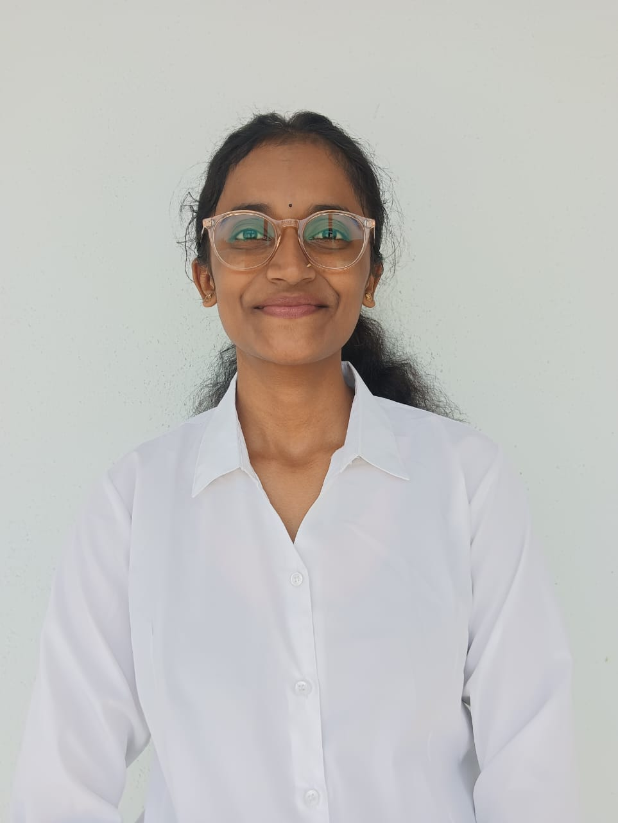

* **Full Name:** Tanvi Shinde
* **Date of Birth:** 20-10-2005
* **Gender:** Female
* **Nationality:** Indian
* **Languages Known:** [English, Hindi, Marathi, etc.]
* **Address:** Sukhsagar Nagar, Katraj, Pune
* **Contact Number:** +91-9561834675
* **Email ID:** tanvi.shinde@vit.edu
* **Blood Group: O+**

**Educational Background:**

|  |  |  |  |  |
| --- | --- | --- | --- | --- |
| **Qualification** | **Institution** | **Board/University** | **Year of Passing** | **Percentage/CGPA** |
| B. Tech  (CSE AIML) | Vishwakarma Institute of Technology, Pune | Vishwakarma University | 2025 | 8.8 |
| Class XII | SGM College Karad, Satara | MSBSHSE | 2024 | 91.73 |
| Class X | MGV Kadegaon , Sangli | MSBSHSE | 2022 | 81.17 |

**Technical Skills:**

* Programming Languages: C, Python, HTML, CSS, JavaScript, etc
* Tools & Platforms: Git, VS Code, Android Studio.
* Frameworks: GTK (for C GUI), Bootstrap, Tkinter .etc
* Databases: MySQL, MongoDB etc
* Others: Data Analysis with Pandas & NumPy, Matplotlib/Seaborn for Visualization.
* Microcontrollers: ATmega328p, Arduino Uno

**Extracurricular Activities:**

* Participated in various coding and hackathon events
* Volunteer at social drives and college cultural fest
* Anchored and organized inter-college tech talks

**Hobbies & Interests:**

* Coding and experimenting with new tech projects
* Reading about finance and cryptocurrency
* Listening to music and exploring new genres
* Sketching fictional Objects
* Playing badminton and Video Games

**Social Activities**

* Active volunteer in college and community cleanliness drives
* Helped organize fundraising events and donation drives
* Participated in tech awareness programs in rural schools
* Mentor/junior support in college coding and learning clubs

**Future Plans:**

* To pursue a career in **software development.**
* Contribute to impactful tech projects in health, education, or finance
* Plan to pursue higher studies or certifications in the field of AI/ML
* Looking forward to launching my own tech startup one day

**SWOT Analysis**

**Strengths**

* Strong foundation in C programming and embedded systems
* Hands-on experience with projects (pollution detection, warehouse systems)
* Quick learner with interests in AI/ML and full-stack development

**Weaknesses**

* Limited industrial internship experience .
* Early stage in advanced AI/ML technologies and frameworks.
* Need for more real-time exposure to deployment of software systems.

**Opportunities**

* Growing demand for AI-integrated embedded systems.
* Potential to contribute to socially impactful tech solutions.
* Opportunities to enhance full-stack and machine learning .
* Work in top tech company.

**Threats**

* Rapid technological evolution may require continuous upskilling.
* Competitive job market in software .
* Time management challenges while balancing project, exam prep, and skill learning.

**Contact Details:**

* **Phone:** +91-956193475
* **Email:** [tanvi.shinde24@vit.edu](mailto:tanvi.shinde24@vit.edu)
* **LinkedIn:** [linkedin.com/in/tanvishinde](https://linkedin.com/in/yourusername)
* **Portfolio/Website:** [Tanvi . shinde](mailto:github.com/Prathmesh1312)