This was the design that I wanted my website to be prior to creating any of the code, I wanted a simple two-column architecture with the right column being more as a side bar and the left column containing all the of the main important information. Using the side bar as an information holder for the main column kind of.

**Home – Latest News – Premier League Standings – Signing of the season – Contact us**

Side bar with information to backup main information or similar news stories

**Footer**

Main information

The initial designing of the website was pretty straight forward in the beginning until more pages were introduced, and the layout got a bit more trickier every time to abide by as there were some problems with closing divs resulting in a frustrating period of being stuck at the same point for a while.

As stated within the designing of the website, there would be a two-column system throughout to stick to a consistent base allowing me to progress faster as I didn’t need to constantly move around code as I previously had to before setting up the two-column system.

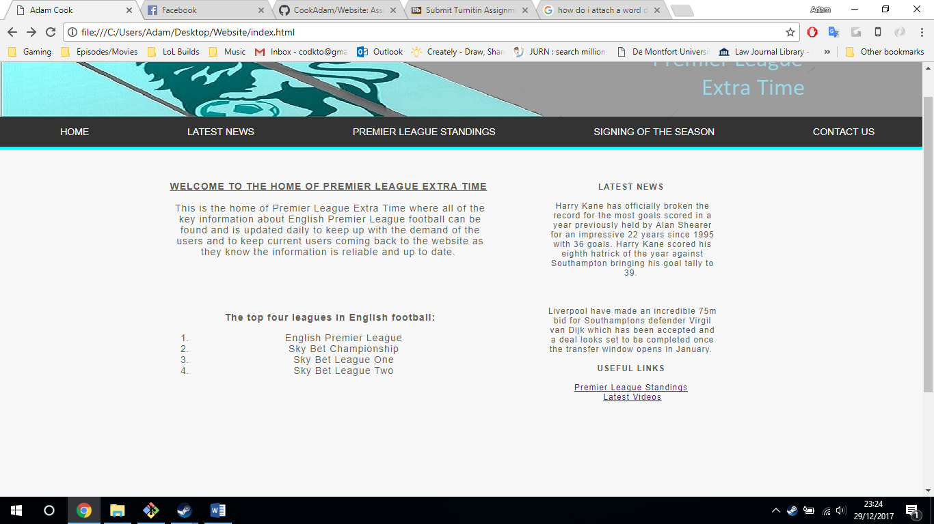

The banner of the website was originally created in Photoshop but after a frustrating period of trying to get the banner to fit the entire width of the page, I had to resize the banner resulting in quality loss and had to remove the original text I had due to this. I edited it in Photoshop and went over it in a grey colour and then added a text box with the new text to make it look less plain on the right side of the banner.

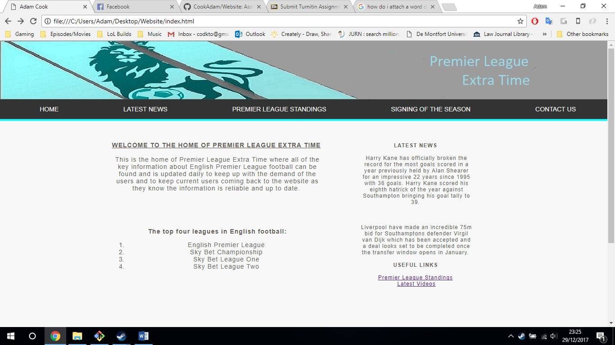

I added the google maps api to the website via the contact page to allow users to gain an understanding on where we’re located as an office and potentially increases the relations with current and potential users.

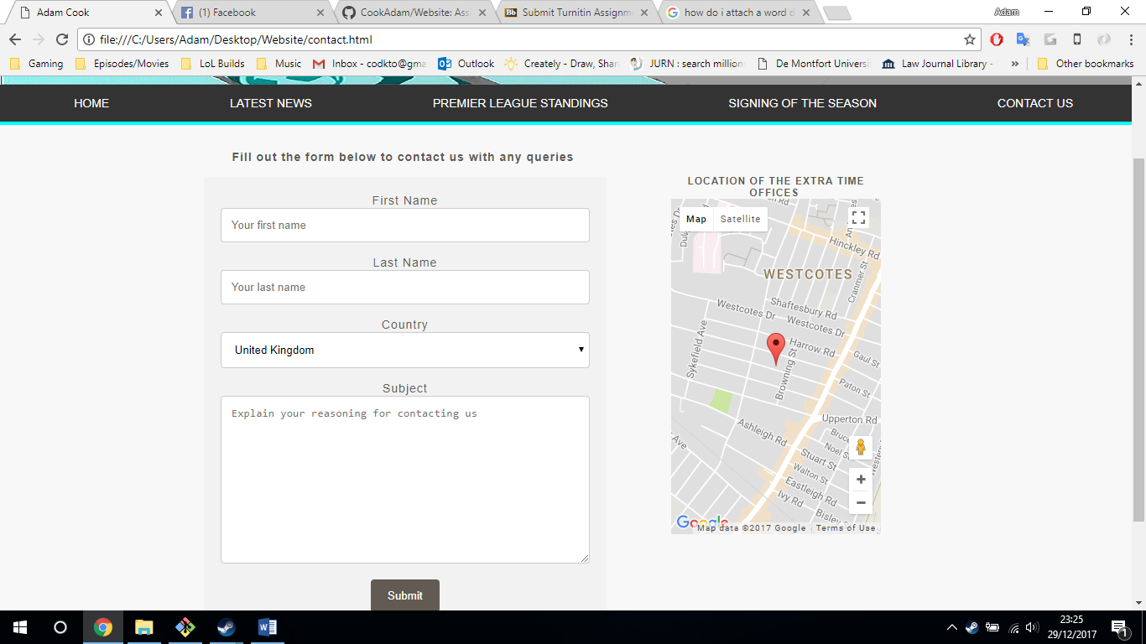

All the information used within the website is factual and based upon real events to gain a more professional looking website. The three main colours that I used were grey, black and a light blue which became the key part as I created my banner before creating the website and originally, I created a grey and green banner but later changed it to light blue as I didn’t like the overall feel with the green and can be found within the images folder.

I also added some code that required JavaScript by allowing the user to click on some text which will then reveal the real information behind it allowing the user to find out what was predicted by the company on the top four premier league standings come end of the 2017/18 football season.

The website consists of a simple but effective layout not using a lot of information to keep the site looking clean and eye catching to the user as they may think twice about visiting if each page was cluttered with un-needed information.

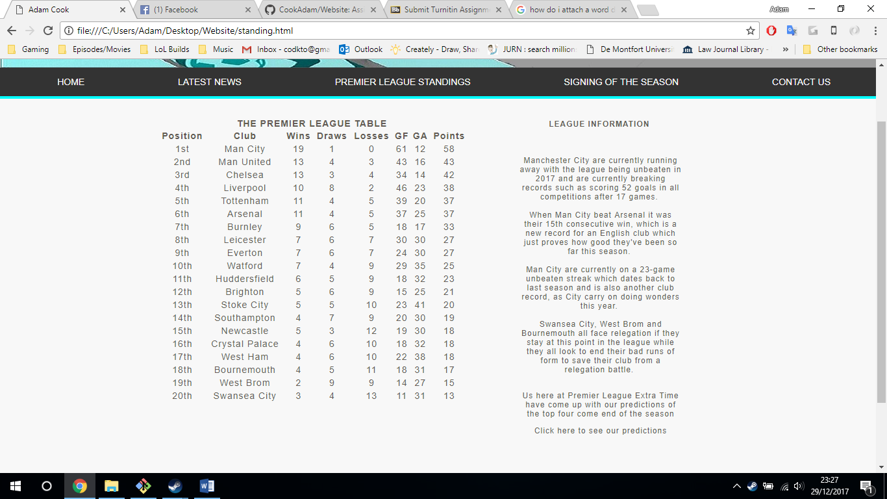

I found the responsiveness of my website was affected by some of the changes I made at the final stages of the website and could not fit them appropriately, if I could go back and improve on the website I would spend a lot more time trying to fix the little things like responsiveness and ensuring these got fixed early on within the website building process rather than at the end.

The wireframe

Side bar with information to backup main information or similar news stories

Main information

**Home – Latest News – Premier League Standings – Signing of the season – Contact us**

**Footer**