Software Requirements Specification
for
My Little Shop Project
Version 1.0 approved
Prepared by Hoang
Team A
5/3/2018

Table of Contents
Contents
Table of Contents
1. Introduction 1
1.1 Purpose 1
1.2 Document Conventions 1
1.3 Intended Audience and Reading Suggestions 1
1.4 Project Scope 1
1.5 References 2
2. Overall Description 2
2.1 Product Perspective 2
2.2 Product Features 2
2.3 User Classes and Characteristics 2
2.4 Operating Environment 2
2.5 Design and Implementation Constraints 3
2.6 User Documentation 3
2.7 Assumptions and Dependencies 3
3. System Features 3
3.1 Access control 3
3.2 Transaction management 3
3.3 Sales-Log View 4
3.4 Inventory 5
3.5 Modify inventory 5
3.6 Modify shop 5
4. External Interface Requirements 6
4.1 User Interfaces 6
4.2 Hardware Interfaces 9
4.3 Software Interfaces 9
4.4 Communications Interfaces 9
5. Other Nonfunctional Requirements 10
5.1 Performance Requirements 10
5.2 Security Requirements 10
5.3 Software Quality Attributes 10
6. Other Requirements 10

Revision History
Name | Date | Reason For Changes | Version

Introduction

Purpose
This SRS was created in an attempt to restructure and analyze the requirements of the My Little Shop project of the Programming Exercise course in the curriculum of the Vietnamese German University.

This SRS will cover the various functional and non-functional requirements of the software to be created by team A, including:
- Ha Anh Hoang - 11072
- Nguyen Le Thien Ha - 9481
- Phan Le Trong Nhan - 11094
- Zagitov Yerzhanovich Aldiyar - 9779
This document will also cover the team’s analyzation of the requirements and how that affects their choice of implementing a specific design.

Document Conventions
The document includes acronyms. The full writing of any acronym was provided right after its first use. A list of acronyms can be found here:
- POS: Point Of Sale
- JRE: Java Runtime Environment
- API: Application programming interface
- JDBC: Java database Connectivity

Intended Audience and Reading Suggestions
This document is intended for anyone who’s examining the project in anyway, such as the lecturer, the team themselves, the user of the system (if any) or anyone who wish to modify the source code of the project to make improvements or simply repurpose the software.

This SRS contains an overall description of the project, its features, and requirements both functional and non-functional. Other topics that covered are security model, database design and some known issues.

Project Scope
Small shops in Vietnam have been using very dated methods to keep track of sales and inventory. The most common methods range from using notebooks to Excel spreadsheets. This software aims to provide a centralized solution to this task by providing a system that can support many small shops at once through the utilization of the Internet. The end goal is to computerize and expand the capability of the inventory and sales control or POS system (Point of Sale), which doesn’t require extensive infrastructure upgrade for the client, on the premise that their business scale is small (typically 1 – 5 shops).

References
- www.exinfm.com/training/M2C3/srs_template.doc - Author: Karl Wiegers
- https://www.lucidchart.com/pages/uml-component-diagram .
- https://www.lucidchart.com/pages/uml-deployment-diagram .
- https://creately.com
- https://en.wikipedia.org
- https://www.globalsign.com/en/ssl-information-center/what-is-ssl/

Overall Description

Product Perspective
The My Little Shop Project aims to replace the old record book/spreadsheet system and unify all records from various outlets to a single destination.

Product Features
The new system should allow the user to perform all previously available tasks that the old system can fulfill:
- Look up for the details of a product that the user offers.
- Recording transactions of the shop
- Manage the inventory of the shop : Import, export the quantity for the available inventory
- Add details of new items in inventory
- Delete the unwanted products
- Add or remove shop information
- Scan barcode to search the appropriate products and store each of it in the sale list
- Calculate the total price of the sale list which will be exported
Two major improvements of the system over the old one are the usage of a barcode system, which in theory speed up the transaction speed at the POS; and access control of the records.

User Classes and Characteristics
- Manager: This user plays a role as an administrator of the system, the only one who can access to the database through a database password for adding and deleting the user accounts using for the project.
- Salesman: This user can access to the system and has the right to modify all available records as well as the items and managing function that the system provides.

Operating Environment
The client and server side application can operate in any machine that JRE (Java Runtime Environment) installed.

Design and Implementation Constraints
- The system cannot use any proprietary components or support any output from a proprietary source.
- The maintenance fee of the whole system must be in the range of 5 to 10 US dollars.
- The system must have the mean to send data securely through the Internets

User Documentation
This part is already included in project folder with the name README.md

Assumptions and Dependencies
The server relies on the API (Application Programming Interface) called JDBC (Java Database Connectivity) to fetch records from the database. Because of this, the user end implementation of the system will require a database that supports this API.

To fully utilize the functions of the software, the computer executing it must have a webcam.

System Features

Access control

3.1.1 Description and Priority
The user provides the credential to log in to the system. The system recognizes the privilege of the user based on prerecorded information on the database.
This function is of low priority.
3.1.2 Stimulus/Response Sequences
- The salesperson provides the system with his/her credential.
- The system provides the user the available domains (shops) that the user can operate in
- The user chooses one of the available domain
- The system prepares a menu of available functions that the user can perform

3.1.3 Functional Requirements

REQ-1: The client must have a form for the user to input his/her credential
REQ-2: The server must have a persistent storage mechanism for the credentials.

Transaction management

Description and priority
The user can use a webcam to capture a barcode on the product he/she’s selling. The user chooses to decode the barcode to look for the details of its product on the database or directly input the ID if the image cannot be decoded. The user then confirms the transaction and save these export event entries in the database. The import process works very much the same way. The export and import history is also recorded for the user to check. This function has high priority

3.2.2 Stimulus/Response Sequences
User scan the barcode of the product, this action can access to the export function.
These sequences of this action can be described as:
- User opens the “Sale” page to scan the barcode
- User chooses start button from Barcode box.
- System accesses the camera of user device
- User take an image of the bar code from the project and save it
- System save the image
- User choose decode to get the item’s ID.
- System provides product information on the sale list

3.2.3 Functional Requirements

REQ-1: The client must have a camera and the camera should work normally.
REQ-2: The client must have a clear image of item’s barcode before decoding.
REQ-3: The server must have the information of the item before the item’s ID was acknowledged.
REQ-4: The system will pop-up a warning screen if the barcode scanned is not available in the database.

Sales-Log View

3.3.1 Description and priority

The user gets the sales-log from database which records what have been sold (exported) from each store of the chain stores. This function has high priority.

3.3.2 Stimulus/Response Sequences

- The user request to get sales-log from a shop after input the shop ID with or without the interval of time of the transaction.
- System displays the sales-log of chosen shop and chosen time.

3.3.3 Functional Requirements

REQ-1: The user input a valid shop ID and appropriate format of date, month and year.
REQ-2: The system will pop-up a warning screen if user input invalid information.

Inventory
3.4.1 Description and priority

The user get the inventory table which consists of the information of all the products with their quantity. This function has high priority.

3.4.2 Stimulus/Response Sequences

- The user requests to get the inventory table after inputting the valid shop ID.
- System shows the inventory table of the chosen shop.
- The user makes adjustment to add or to remove products or quantity of available products.
- System can only updates the new information of the inventory table through the response from server, which directly connects with the database.

3.4.3 Functional Requirements

REQ-1: The user inputs a valid shop ID.
REQ-2: The system will pop-up a warning screen if user input invalid shop- ID.

Modify inventory
3.5.1 Description and priority

    - Import, export the quantity of the available products
    - Add or delete product.

3.5.2 Stimulus/Response Sequences

- The user makes decision to change the quantity of products in the inventory.
- System sends request to the server to adjust the database.

3.5.3 Functional Requirements

REQ-1: Import, Export functions need the available of item ID and shop ID in the database.

Modify shop
3.6.1 Description and priority

Add or remove shops.

3.6.2 Stimulus/Response Sequences

- The user makes decision to add or remove shops.
- System sends request to the server to adjust the database.

3.6.3 Functional Requirements

REQ-1: none.

External Interface Requirements

User Interfaces

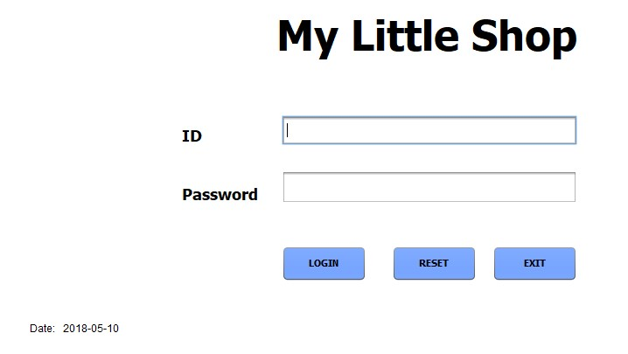
4.1a/ User Interface

- User must input given account ID and Password before pressing LOGIN button to access application function.
- RESET button for resetting ID and Password to re-input these information.
- EXIT button to exit the application.

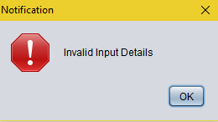
4.1b/ Notification

- Wrong ID or Password leads to the pop-up of notification and cannot access to the application program.

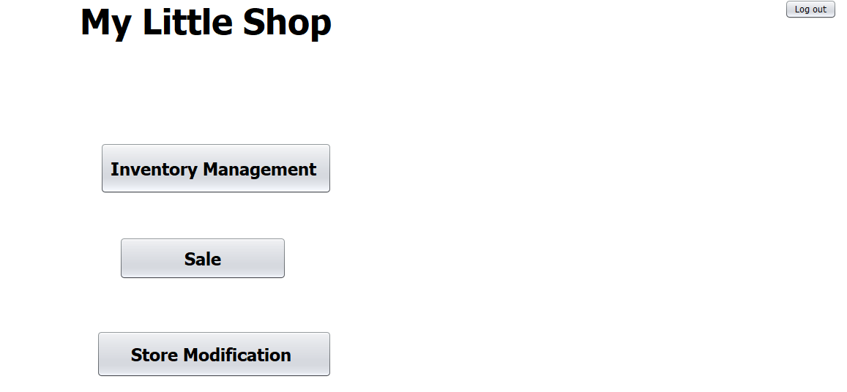
4.1c/ Domains interface

- Three main domains to access to further functions:
  - Inventory Management: inventory getting, sales log showing, items modification.
  - Sale: transaction management, barcode scanning
  - Store Modification: stores adding and removing
- Log out button: to back to login screen

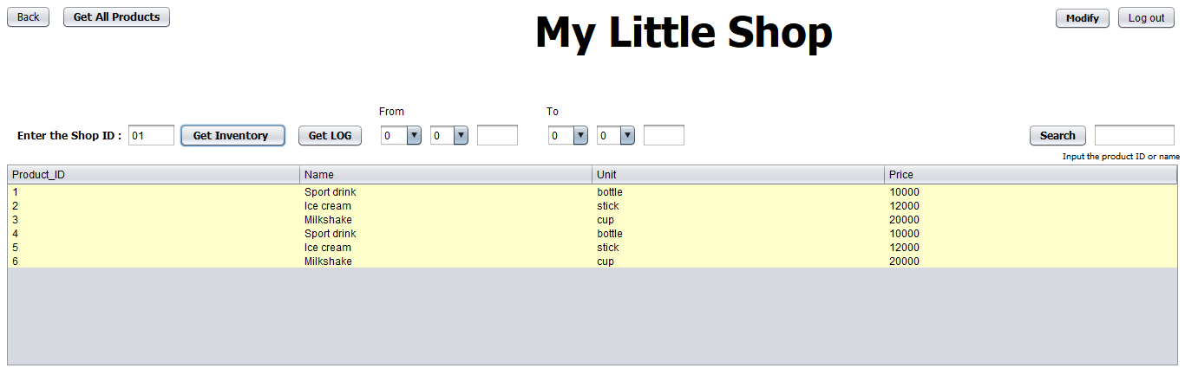

4.1d/ Inventory management
- Input shop ID then:
  - Press GET INVENTORY to take the chosen shop’s inventory.
  - Press GET LOG to take the chosen shop’s sales log
    - There is a tool for the user to modify sales log on the specific interval of time
- GET ALL PRODUCTS: to get the information of all items of the company.
- SEARCH: input item ID or name of the item to search.
- MODIFY: to import, export the available items and add new items
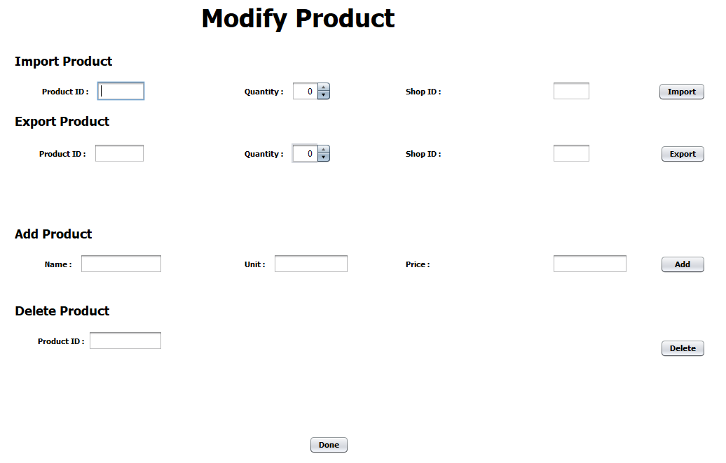
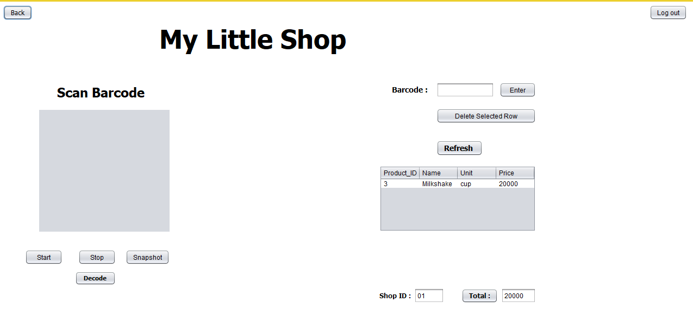
4.1e/ Modify items

4.1f/ Barcode scanner for sales function

- START, STOP: to start and stop the camera
- SNAPSHOT: to take image of item’s barcode
- DECODE: to search for the item’s information through the barcode
- BARCODE box: to input the barcode if image cannot be processed
- DELETE SELECTED ROW: selected the unwanted row then click this button to delete. After that clicking TOTAL button to refresh the recent price
- REFRESH: to clean the recent sale list and reset the total price to 0
- SHOP ID box: to show the salesman’s shop ID

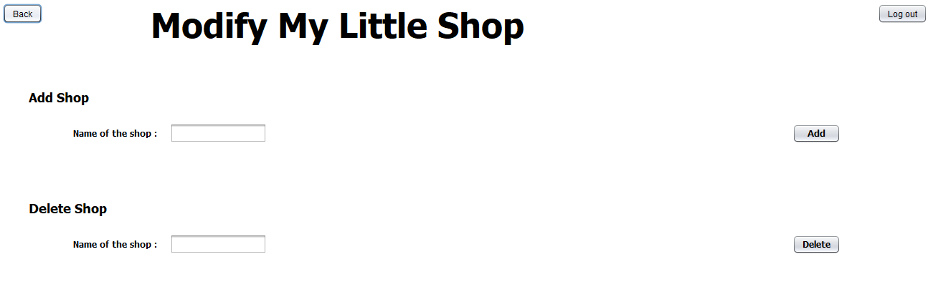
4.1g/ Modify shop

- ADD SHOP: input a new shop name and click ADD to add new shop
- DELETE SHOP: input shop name wanted to delete then click DELETE

Hardware Interfaces
- Device’s Camera or webcam: after the client log-in, in the Sales Reporting tag, there is a Scan barcode function which will access to the device’s camera to take images of item barcode. Start button need to be press to activate the camera.

Software Interfaces
- Server-database: JDBC API.
- Java SE as programming platform.
- NetBeans with Java Development Kit 8 as integrated development environment.
- Window as operating systems.
- Specifics Java library to connect database-server-client: derby.jar, derbyclient.jar, derbynet.jar.
- “Zebra Crossing” library for Barcode function.
- “OpenCV” library for camera function

Communications Interfaces
- Client-server: TCP connection with SSL

Other Nonfunctional Requirements

Performance Requirements
- The project will pop up a warning box
  - Wrong account when input.
  - Wrong shop ID or item’s ID during searching.
  - Invalid input of the interval of time.
    - Wrong input day or month
    - Missing any digits of year input (yyyy).
- The project will pop up a notification box when
  - Delete an item on the sale list.
  - Export an out of stock item.

Security Requirements
- SSL: provide a secure enhancement to the standard TCP/IP sockets protocol used for Internet communications.

Software Quality Attributes
- Adaptability: the application can adapts automatically to its users according to changing conditions on some functions.
- Availability: the product can operate at given time
- Correctness: the project is working normally with the functional has given
- Flexibility: adapt to possible or future change
- Interoperability: the product can work with other projects or system at present or in future.
- Maintainability: the projects can be easily maintain.
- Portability: the project functions perfectly in different operating systems.
- Reliability: the application has low probability of failure
- Reusability: the project code can be reuse for others project.
- Testability: fault or error can be detected easily.

Other Requirements
Appendix A: Glossary
- Transmission Control Protocol (TCP)
- Secure Socket Layer(SSL)
Appendix B: Analysis Models
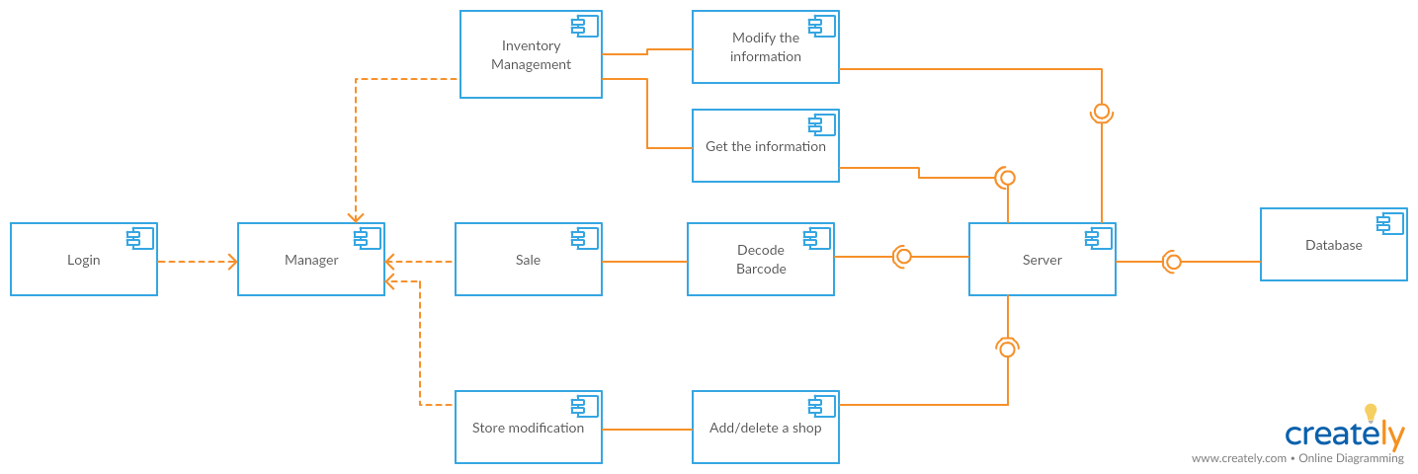
Image1: Component diagram
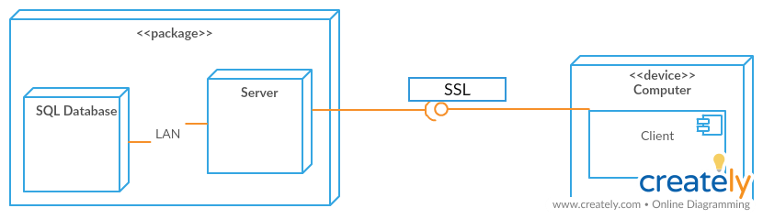
Image2: Deployment diagram
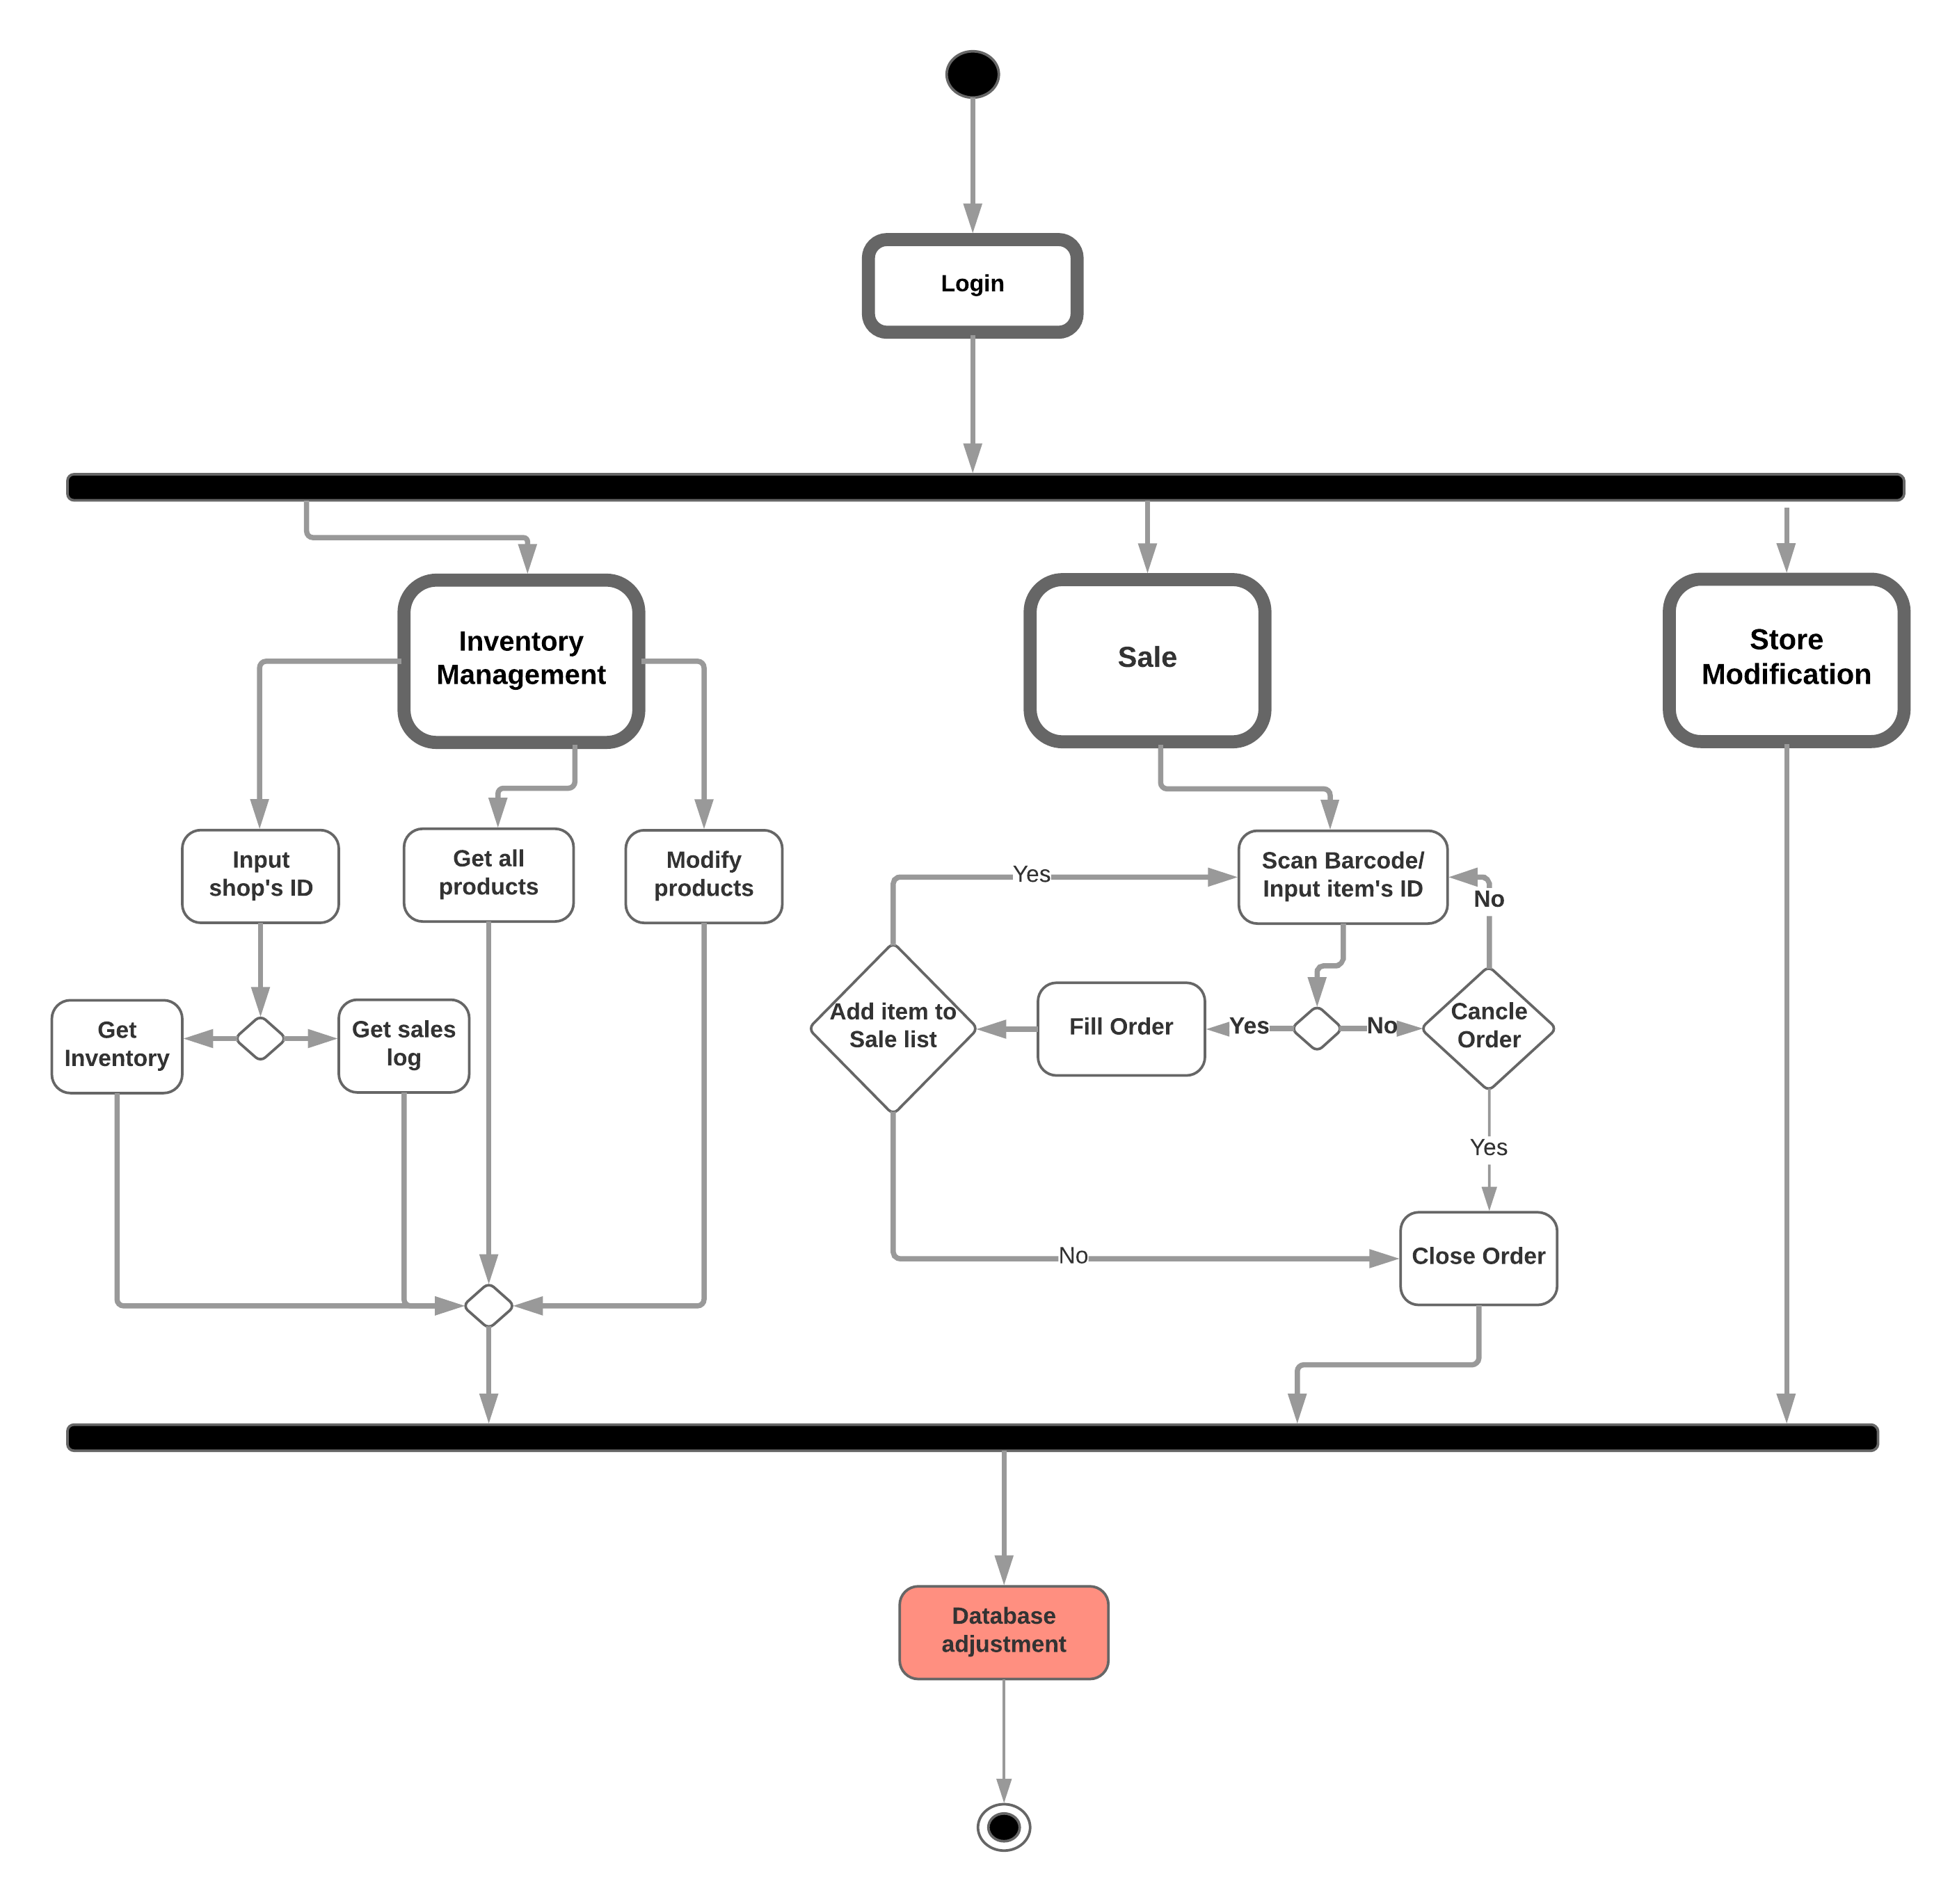
Image3: Activity diagram
Appendix C: Issues List
These are some functions that have not been implemented in the project.
- Access restriction
  - Restriction for salesman to only access some functions, instead of all the system like the manager.
  - Restriction for specific user for specific shop.
- Automatically decode the barcode.
- Input the quantity of the selling projects after scanning the barcode.

