Is there a “trick” to finding success in using crowdfunded platforms like Kickstarter or Indiegogo? Reviewing the data provided on world crowdfunding and its metrics should yield some insights. One of the conclusions we can draw from this data is that most projects (76%) are US-based. Upon filtering the original category-based pivot table to US only, the grand total of items is 763 out of the original 1,000 item dataset. The most frequent category worldwide is theater, at 344 total of the 1,000 projects (34%). The most successful month in which to have a crowdfunded project is June. Out of the 87 projects that took place in June, 55 campaigns were deemed successful. This was a success rate of 63% for the month of June. Based on these initial insights, if you were using a crowdfunding platform in June for a theater project in the US you would be successful. There’s more to analyzing this dataset than just these metrics though.

What we don’t know is which crowdfunding platforms were used for each project. Depending on platform popularity the campaign may not have gained enough notice or traction. Another factor depending on popularity is the realm of entertainment, which had the highest general numbers. The categories of theater, music, film & video could be easily influenced depending on celebrity backers and their popularity in these realms. Also, the component of trends within the entertainment industry could determine the interest in a project. Another thing we do not know is the composition of the backers. Was the group of backers always the same? Probably not. We have differing countries involved in this dataset. That indicates potential backers with varying cultures, interests, income, socioeconomic backgrounds.

Instead of focusing on what we don’t have, we can utilize other areas of our dataset to gain a more robust understanding of success within crowdfunding platform data. Here are a couple of other possible tables or graphs that would yield additional value from our dataset. A pivot table where you can see the rate of successful projects by country with additional filters for category and sub-category could help a person decide which type of project would be successful by country. By utilizing this pivot table data in a color formatted table, you can easily isolate outcome trends for any country (Figure 1).

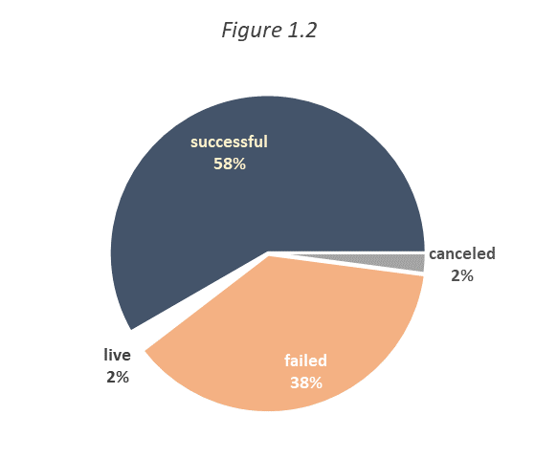

Based on the country with the most success, you would be able to create a pie chart showing the rates of failure, cancellation, and success (Figure 1.2). Tables that would give further insight would include rows of either sum pledged or sum of goal. You could filter to specific outcomes and add further filters such as currency, Sub-category, and percent funded. Data from these tables would enable you to find a successful goal per project based on outcomes. Note that before you start comparing amounts, you would have to ensure that the currency has been adjusted to whatever measure you are using as your standard (ex. GBP, USD, EUR, etc.). The following examples (Figure 2.1 and Figure 2.2) do not have a uniform currency applied and offer a vague insight of capabilities, and should not be considered accurate findings. Applying similar techniques mentioned for Figure 1.1 would lead to success or failure rate per category.



With the information we have available in this dataset there are still other variables that could contribute to success or failure. A survey geared toward potential project backers might offer further information when an individual is creating a project. Popularity alone would not be enough to determine success either. So, there aren’t any definitive “tricks” in finding success with crowdfunded platforms. I would suggest that if you are passionate about a particular project, research it and your variables of success. You can’t go wrong with following your passion.