The statistical analysis of both successful and failed outcomes by number of backers is best summarized by the mean of each dataset. This was verified by creating a box and whiskers chart for each outcome and comparing it against the product of Mode, Mean, and Median functions. Further comparison was conducted utilizing Variance, Standard Deviation, and Quartiles on the dataset. Charts and Tables included below.



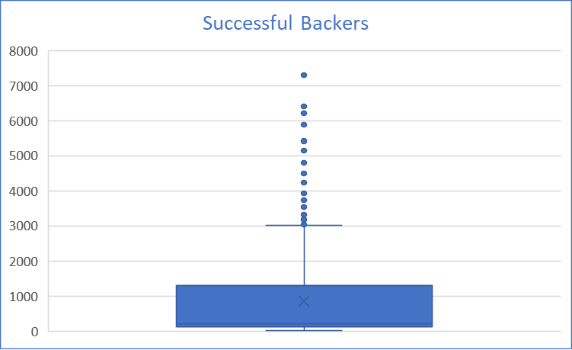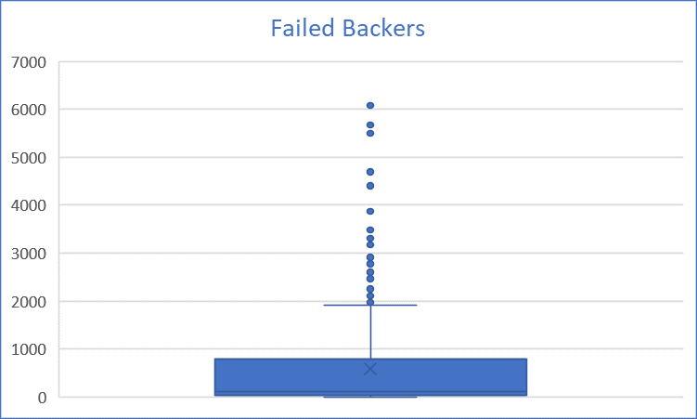

Review of each dataset revealed that there was more variance in the number of backers for successful projects. In some ways this makes sense as project goals vary as does the amount each backer can contribute. This is made even more apparent when you look at the disbursement of outcomes by goal amount. The table below shows a high concentration in ranges blank and then again at the end of the spectrum.

