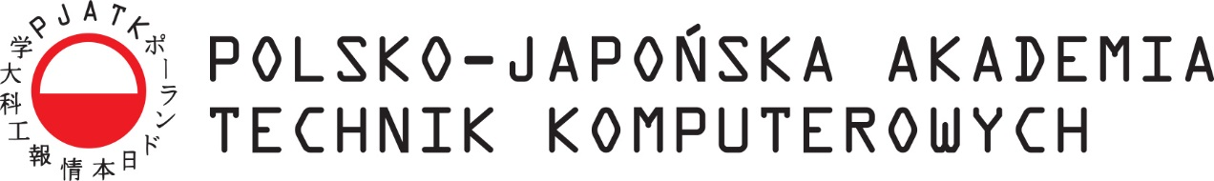

IT Department

Department of Software Engineering
Software and database engineering

Nazar Lytvyn
Album number s22673

Creation of a Leave Management System with Points-Based Approval
(Extension Approach for HR system)

Diploma
Written under the direction
Katarzyna Maciejewska

Warszawa 2025

Wydział Informatyki

Katedra Inżynierii Oprogramowania
Inżynieria Oprogramowania i Baz Danych

Nazar Lytvyn
Numer albumu s22673

Stworzenie systemu zarządzania urlopami z zatwierdzaniem opartym na punktach
(rozszerzenie systemu HR)

Diploma
Written under the direction
Katarzyna Maciejewska

Warszawa 2025
Abstract

In modern organizations, managers face increasing workloads that extend beyond strategic decision-making into repetitive administrative tasks such as leave approvals. This thesis proposes a points-based extension to existing HR systems that automates leave approvals under defined policies. Employees earn points monthly and through achievements, which can be spent to request paid leaves. The system automatically approves requests if staffing thresholds, project deadlines, and critical project flags are respected. Otherwise, managers intervene manually.
The system is implemented as a Spring Boot application with PostgreSQL persistence, Hibernate ORM, and Docker deployment. REST APIs expose all core entities (Department, Employee, Leave Request) for integration. Manual testing with Postman validates functionality. This approach reduces managerial overhead, ensures fairness, and introduces gamification into leave management.
Keywords: Leave Management, Points System, Spring Boot, PostgreSQL, Docker, REST API, HR Extension
Abstrakt

W nowoczesnych organizacjach menedżerowie stają wobec rosnących obciążeń, które obejmują nie tylko decyzje strategiczne, lecz także powtarzalne zadania administracyjne, takie jak zatwierdzanie urlopów. Niniejsza praca proponuje rozszerzenie istniejących systemów HR o mechanizm punktowy, który automatyzuje zatwierdzanie wniosków urlopowych zgodnie z określonymi zasadami. Pracownicy zdobywają punkty co miesiąc oraz za osiągnięcia, które mogą wykorzystać na płatne urlopy. System automatycznie zatwierdza wnioski, jeśli spełnione są progi kadrowe, terminy projektów i statusy krytyczne. W przeciwnym razie decyzję podejmuje menedżer.
System został zaimplementowany jako aplikacja Spring Boot z bazą danych PostgreSQL, wykorzystująca Hibernate ORM i wdrożenie w Dockerze. REST API udostępnia wszystkie główne encje (Dział, Pracownik, Wniosek urlopowy) w celu integracji. Funkcjonalność została zweryfikowana ręcznie przy użyciu Postmana. Podejście to zmniejsza obciążenie menedżerów, zapewnia sprawiedliwość i wprowadza element grywalizacji do zarządzania urlopami.
Słowa kluczowe: Zarządzanie urlopami, System punktowy, Spring Boot, PostgreSQL, Docker, REST API, Rozszerzenie HR

Introduction 6
The structure of the diploma 7
Dictionary of technical terms 8
1. Problem overview 9
2. New points system approach 10
2.1 Points as a measurable resource 10
2.2 Second principle. Automatic approval based on policy 11
2.3 Managerial control of exceptions 11
2.4 Approach comparison 12
3. Technologies used for the implementation of the project 13
3.1 Java 13
3.2 Spring Boot 13
3.3 Docker 14
3.4 PostgreSQL 14
3.5 Postman 15
4. Platform architecture 15
4.1 Java + Spring + RestAPI backbone 15
4.2 Leave management service architecture 16
4.3 Functionalities Use Cases Diagram 18
4.4 User use cases basic flow 20
5. Platform implementation 22
5.1 Open-source approach 22
5.2 Frontend 22
5.2.1 Account creation and login 23
5.2.2 Point-based system implementation 35
5.2.3 Leave request evaluation implementation 36
5.2.4 Automatic leave request evaluation implementation 39
6. Future of the platform 43
Bibliography 44

Introduction

Today, modern organizations are increasingly undergoing digital transformation (as shown on Figure 1), hence relying on digital tools to manage their day-to-day administrative processes as it speed ups delivery time for an actual product sale. With company growth, an increase in the number of employees and projects are creating an additional burden on managers, who have to juggle strategic tasks with a large amount of routine work. As a result, a significant portion of their working time is spent on operations that could be automated or optimized with technology.

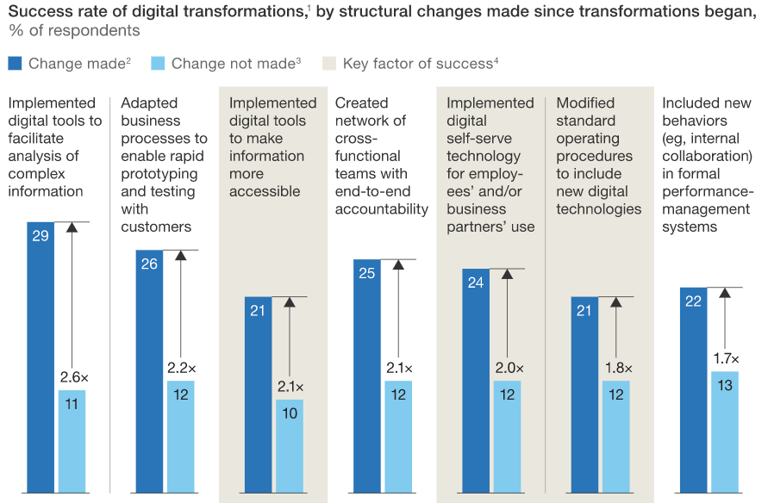
Figure 1. Sinequa rate of digital transformation [1]
One of the most telling areas where manual processes still dominate is leave management—managing vacations, sick leave, absences, and other types of employee absences. As teams grow, coordinating leave becomes a complex and labor-intensive task: managers spend time checking available days, coordinating plans, updating schedules, checking for overlaps in teams, and communicating with HR.
When these processes are performed manually—via email, spreadsheets, or disparate systems—there are delays in approval, risks of errors, and a lack of transparency. This affects not only the efficiency of managers, but also the overall impression employees have of the company. Delayed vacation approvals reduce satisfaction, and uncoordinated periods of absence can negatively impact workload distribution, task deadlines, and resource planning.
In addition, as a company scales, manual management of absences becomes virtually impossible: a serious need for a centralized, automated, and convenient system that allows you to quickly approve requests, monitor staff availability, ensure transparency, and maintain consistent rules arises. Therefore, leave management is becoming one of the key areas for the digital transformation of internal processes.

The structure of the diploma
The diploma thesis has been divided into four parts.
In the first part, the author identifies the problems associated with traditional leave management approach. This section also eximines how poor employee management affects final product delivery.
The second part introduces a new points system as a substitution for a normal approach with leave days calculated independently and compares them.
The third part contains a detailed analysis of the current state of the proposed solution. This chapter is devoted to a technical implementation of the author's solution with new points-based system approach, which provides justification for the implementation way and technologies use.
In the last, fourth part, the author reflects on potential future developments for the platform and discusses the incorporation of technologies that could be integrated into the code. The author lays out the motivation behind choosing specific technologies over others, establishing a foundation for introducing a list of promising technologies that could enhance the current tech stack in the foreseeable future

Dictionary of technical terms
Below is the dictionary describing technical terms used throughout the paper. Dictionary serves the purpose of briefly describing terms that some of the readers may not be familiar with but are willing to follow along with the paper.

Acronym | Full name | Definition
HTTP
API
RestAPI | Representational State Transfer
EJB
MVC
Java EE
SQL
PostgreSQL
ACID
VS Code
JWT

Problem overview

“HR teams across industries face a critical challenge: 71% of organizations struggle with tracking employee absences effectively, and unplanned leaves cost companies an average of 15% in lost productivity annually”[2]. In many organizations, the process of submitting and approving employee leave requests is still largely manual, fragmented, and dependent on individual oversight by management. While this approach may seem simple, it often leads to inefficiencies that accumulate over time and negatively impact both employee satisfaction and organizational productivity. Traditional leave management workflows rely heavily on managers manually reviewing each request, checking team availability, verifying project deadlines, and ensuring compliance with internal policies. This model places a disproportionate administrative burden on managers, whose primary responsibilities typically include strategic planning, project execution, and team leadership.
The main problem is not the existence of management control itself, but the lack of structured automation to support it. Without automated assessment mechanisms, managers are forced to repeat the same checks—team capacity, seniority distribution, project criticality, and employee vacation history—every time a request comes in. This repetitive workload becomes particularly problematic in large teams or during peak vacation periods when the volume of requests increases significantly. As a result, managers spend valuable time on routine administrative tasks rather than on activities that directly impact project outcomes.
In addition, traditional systems often lack transparency and consistency. Decisions may vary between managers or even within the same team depending on workload, stress levels, or subjective opinions. Employees may not fully understand why some requests are approved while others are postponed or rejected, leading to frustration and a sense of unfairness. The lack of clear, automated rules also makes it difficult to comply with organizational policies such as minimum staffing thresholds, seniority requirements, or no-termination periods during critical project phases.
Another significant drawback is the lack of integration between leave management tools and project management realities. In many organizations, leave decisions are made without considering project deadlines, release dates, or important milestones in real time. This disconnect can lead to the approval of leave that inadvertently jeopardizes project deadlines or reduces team productivity below sustainable levels. Conversely, overly cautious manual decision-making can result in unnecessary denials or delays, further reducing employee morale.
These inefficiencies have a direct impact on the final delivery of the product. When managers are overwhelmed with administrative tasks, their ability to focus on planning, risk mitigation, and technical oversight is diminished. Delays in vacation decision-making can also create uncertainty in resource planning, making it difficult to forecast team availability and allocate work effectively. During critical periods, such as pre-release stages, manual oversight becomes even more strained, increasing the likelihood of bottlenecks and misunderstandings.

New points system approach

The proposed system implements a structured, automated approach to leave management, combining a points-based incentive model with a rules-based approval mechanism. Rather than relying solely on management discretion, the system evaluates each leave request against a set of organizational policies, staffing constraints, and project constraints. This hybrid model maintains managerial control where necessary while automating routine decisions that meet predefined criteria. The system is based on three principles which will be explained next.

Points as a measurable resource
Employees accumulate points monthly and for achievements. These points act as
a transparent currency that employees can spend on vacation requests or unplanned leaves for a day. This mechanism ensures fairness and predictability: employees who make consistent contributions or achieve important results gain more flexibility in planning their vacations.

Second principle. Automatic approval based on policy
A scheduled evaluation process runs hourly, reviewing all pending requests. The system checks:
- the potential workload of the team after the employee's absence,
- distribution by seniority,
- the importance of the project and its deadlines,
- restrictions on the frequency of vacations,
- the employee's points balance.
If all conditions are met, the request is approved automatically. Otherwise, it is forwarded for manual review.

Managerial control of exceptions
Managers retain full authority over requests that fall outside safe operating boundaries. This ensures that human judgment is applied in cases where nuance is required, such as during critical releases or unusual circumstances involving employees.

Approach comparison
Aspect | Traditional | Points-based
Approval method | Manual, manager dependent | Automated when safe; manual for exception
Consistency | Varies by manager or a team | Uniform rule enforcement
Transparency | Often unclear to employees
  Clear point balances and policy rules
Manager workload | High administrative burden | Reduced; focused on critical cases
Integration with project status | Rare or manual | Built-in evaluation of deadlines and criticality
Scalability | Difficult as teams grow | Designed for scaling via RestAPIs
Impact on delivery | Risk of understaffing or delays | Protects team capacity and project timelines
Table 1. Comparison of traditional and points-based approaches

Technologies used for the implementation of the project

Java
Java is a high-level, class-based, object-oriented programming language designed to ensure minimal dependence on implementation. “James Gosling, Mike Sheridan, and Patrick Naughton initiated the Java language project in June 1991.”. “Sun Microsystems released the first public implementation as Java 1.0 in 1996.” [3][4] and is now supported by Oracle. Java solves the problem of platform dependency by following the “write once, run anywhere” (WORA) principle, allowing compiled Java code to run on all platforms that support Java without recompilation. Java is a statically typed language, which helps identify errors at compile time rather than at runtime. It features automatic memory management through garbage collection, which eliminates the need for manual memory management and reduces memory leaks. Java's robust standard library, extensive ecosystem of frameworks and tools, and strong community support make it ideal for enterprise applications. Its multithreading capabilities enable parallel execution, making it suitable for building scalable backend systems. In this diploma work, Java 25 is used as the primary programming language for implementing business logic, data models, and service layers.

Spring Boot
Spring Boot is an open-source Java-based framework that simplifies the creation of standalone Spring production applications. It solves the problem of complex Spring configuration by providing ready-made default settings and automatic configuration, allowing developers to focus on business logic rather than infrastructure configuration. Spring Boot is based on the principles of inversion of control (IoC) and dependency injection from the Spring Framework, offering an optimized approach to application development. It eliminates the need for extensive XML configuration by using Java-based configuration and configuration agreements. Built-in support for Spring Boot servers (Tomcat, Jetty, or Undertow) allows you to create standalone applications that do not require external application servers. Its extensive starter dependencies simplify dependency management by providing carefully curated sets of dependencies for common use cases. Spring Boot also includes production-ready features such as health checks, metrics, and external configuration. In this diploma work, Spring Boot 3.5.7 serves as the core framework, providing the foundation for the REST API, handling HTTP requests, managing database connections via JPA/Hibernate, and implementing security features via Spring Security.

Docker
Docker is an open-source platform that automates the deployment, scaling, and management of applications within lightweight, portable containers. It solves the problem of environment inconsistency during development, testing, and production by encapsulating applications and their dependencies into standardized units. Docker containers use the host operating system kernel, making them lighter and more efficient than traditional virtual machines while still providing isolation. Docker's approach to containerization ensures that applications run the same regardless of where they are deployed, eliminating the “it works on my machine” problem. Docker Compose, a tool for defining and running multi-container Docker applications, simplifies the orchestration of interconnected services. In this diploma work, Docker is used to deploy PostgreSQL and a database management tool Adminer as containers, providing a consistent database environment that is easy to set up and remove. This approach simplifies database management and eliminates the need to manually install PostgreSQL.

PostgreSQL
PostgreSQL is a powerful open-source object-relational database management system (ORDBMS) with a focus on extensibility and SQL compatibility. “Originally developed at the University of California, Berkeley”[5], PostgreSQL has evolved to support advanced data types and performance optimization, making it suitable for complex, large-scale applications. It addresses data integrity concerns by providing a reliable, ACID-compliant database that can handle complex queries, transactions, and concurrent access. PostgreSQL supports both relational (SQL) and non-relational (JSON) data structures, providing flexibility in data modeling. Its advanced indexing capabilities, including a large variety of indexes, ensuring efficient query performance even with large data sets. PostgreSQL's extensibility allows users to define custom functions, operators, and even data types, making it adaptable to specific application requirements. In this project, PostgreSQL serves as the primary database storing all application data, including information about employees, departments, projects, and vacation requests, while Hibernate ORM facilitates object-relational mapping.

Postman
Postman is a collaborative API development platform that simplifies the process of creating, testing, and documenting APIs. It solves the problem of API testing by providing a convenient interface for sending HTTP requests and checking responses, eliminating the need for command-line tools or custom scripts. Postman supports all HTTP methods (GET, POST, PUT, DELETE, PATCH, etc.) and makes it easy to manage headers, request parameters, request bodies, and authentication. Its collection feature allows you to organize related API requests that can be saved, shared, and run as test suites. Postman environment variables allow you to seamlessly switch between different deployment environments (development, testing, production) without changing requests. The tool also supports automated testing with JavaScript-based test scripts, allowing you to check response status codes, headers, and body content. Postman's code generation feature can generate API client code in various programming languages, making it easier to develop integrations. In this diploma work, Postman is used to test REST API endpoints, verify request/response formats, and ensure that the application handles various HTTP operations, authentication, and error scenarios correctly.

Platform architecture

Java + Spring + RestAPI backbone
In 2002, Rod Johnson introduced the Spring Framework as a response to the complexity of Enterprise JavaBeans (EJB)[6]. Spring provided an easier alternative through dependency injection and aspect-oriented programming, making the development of enterprise Java applications simpler and more testable. Unlike traditional Java EE applications, which required powerful application servers, Spring offered a more flexible approach that could run in a variety of environments.
In 2014, the Spring team released Spring Boot, which revolutionized Spring development by providing conventions over configuration and auto-configuration [7]. This approach significantly reduced the amount of boilerplate code and configuration required to set up a Spring application. Spring Boot made it possible to create production-ready applications with minimal configuration, including built-in web servers.
With the rise in popularity of web services and the need for interoperability between different systems, REST became the dominant architectural style for creating web APIs. The integration of Spring Boot with Spring MVC made it the ideal choice for creating RESTful APIs, providing seamless support for HTTP methods, content negotiation, and error handling.
Today, technology stacks such as Spring Boot with REST API allow developers to create reliable and scalable backend services using strong typing and the extensive Java ecosystem combined with Spring's dependency injection and auto-configuration capabilities. This combination has become the standard for enterprise application development, especially for microservices architecture.

Leave management service architecture
To facilitate access, it was decided to make the platform a web application. The backend was implemented using Java and Spring Boot, a widely used framework for building enterprise applications. PostgreSQL was chosen as the database.
The primary focus was on microservice approach and ease of deploying. Hence, the database and Java application were containerized using Docker. Docker allows applications to be packaged and deployed regardless of host specifications.
By using Docker for isolated environments for applications, developers can run them on any host without additional configuration. Because Docker under the hood uses images—an application or environment with its dependencies pre-defined—setting up any system becomes very. Author uses a docker-compose.yml file which allows to deploy more than one service using only one script, whereas that compose file uses regular Dockerfile that builds and deploys Java application explicitly.
As presented on Figure 2 the project directory structure of the project contains only source code and deployment files for Docker with corresponding database initialization script.
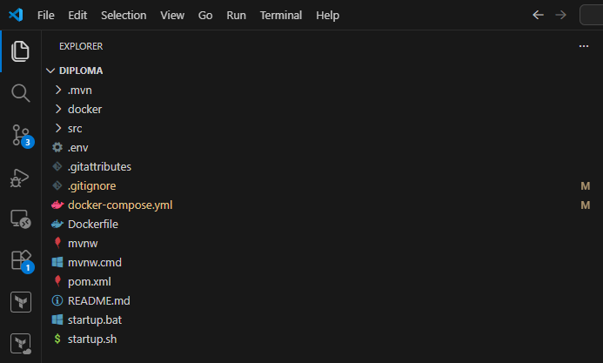
Figure 2. Directory structure (presented with VS Code - source: author's work)

Functionalities Use Cases Diagram

The following diagram describes usage options for different user roles.
There are three roles: employee, manager, and administrator. After logging in or registering, a JWT token will be assigned to each of them. Their access varies depending on their role in the company. For example, only the administrator is allowed to delete a department.
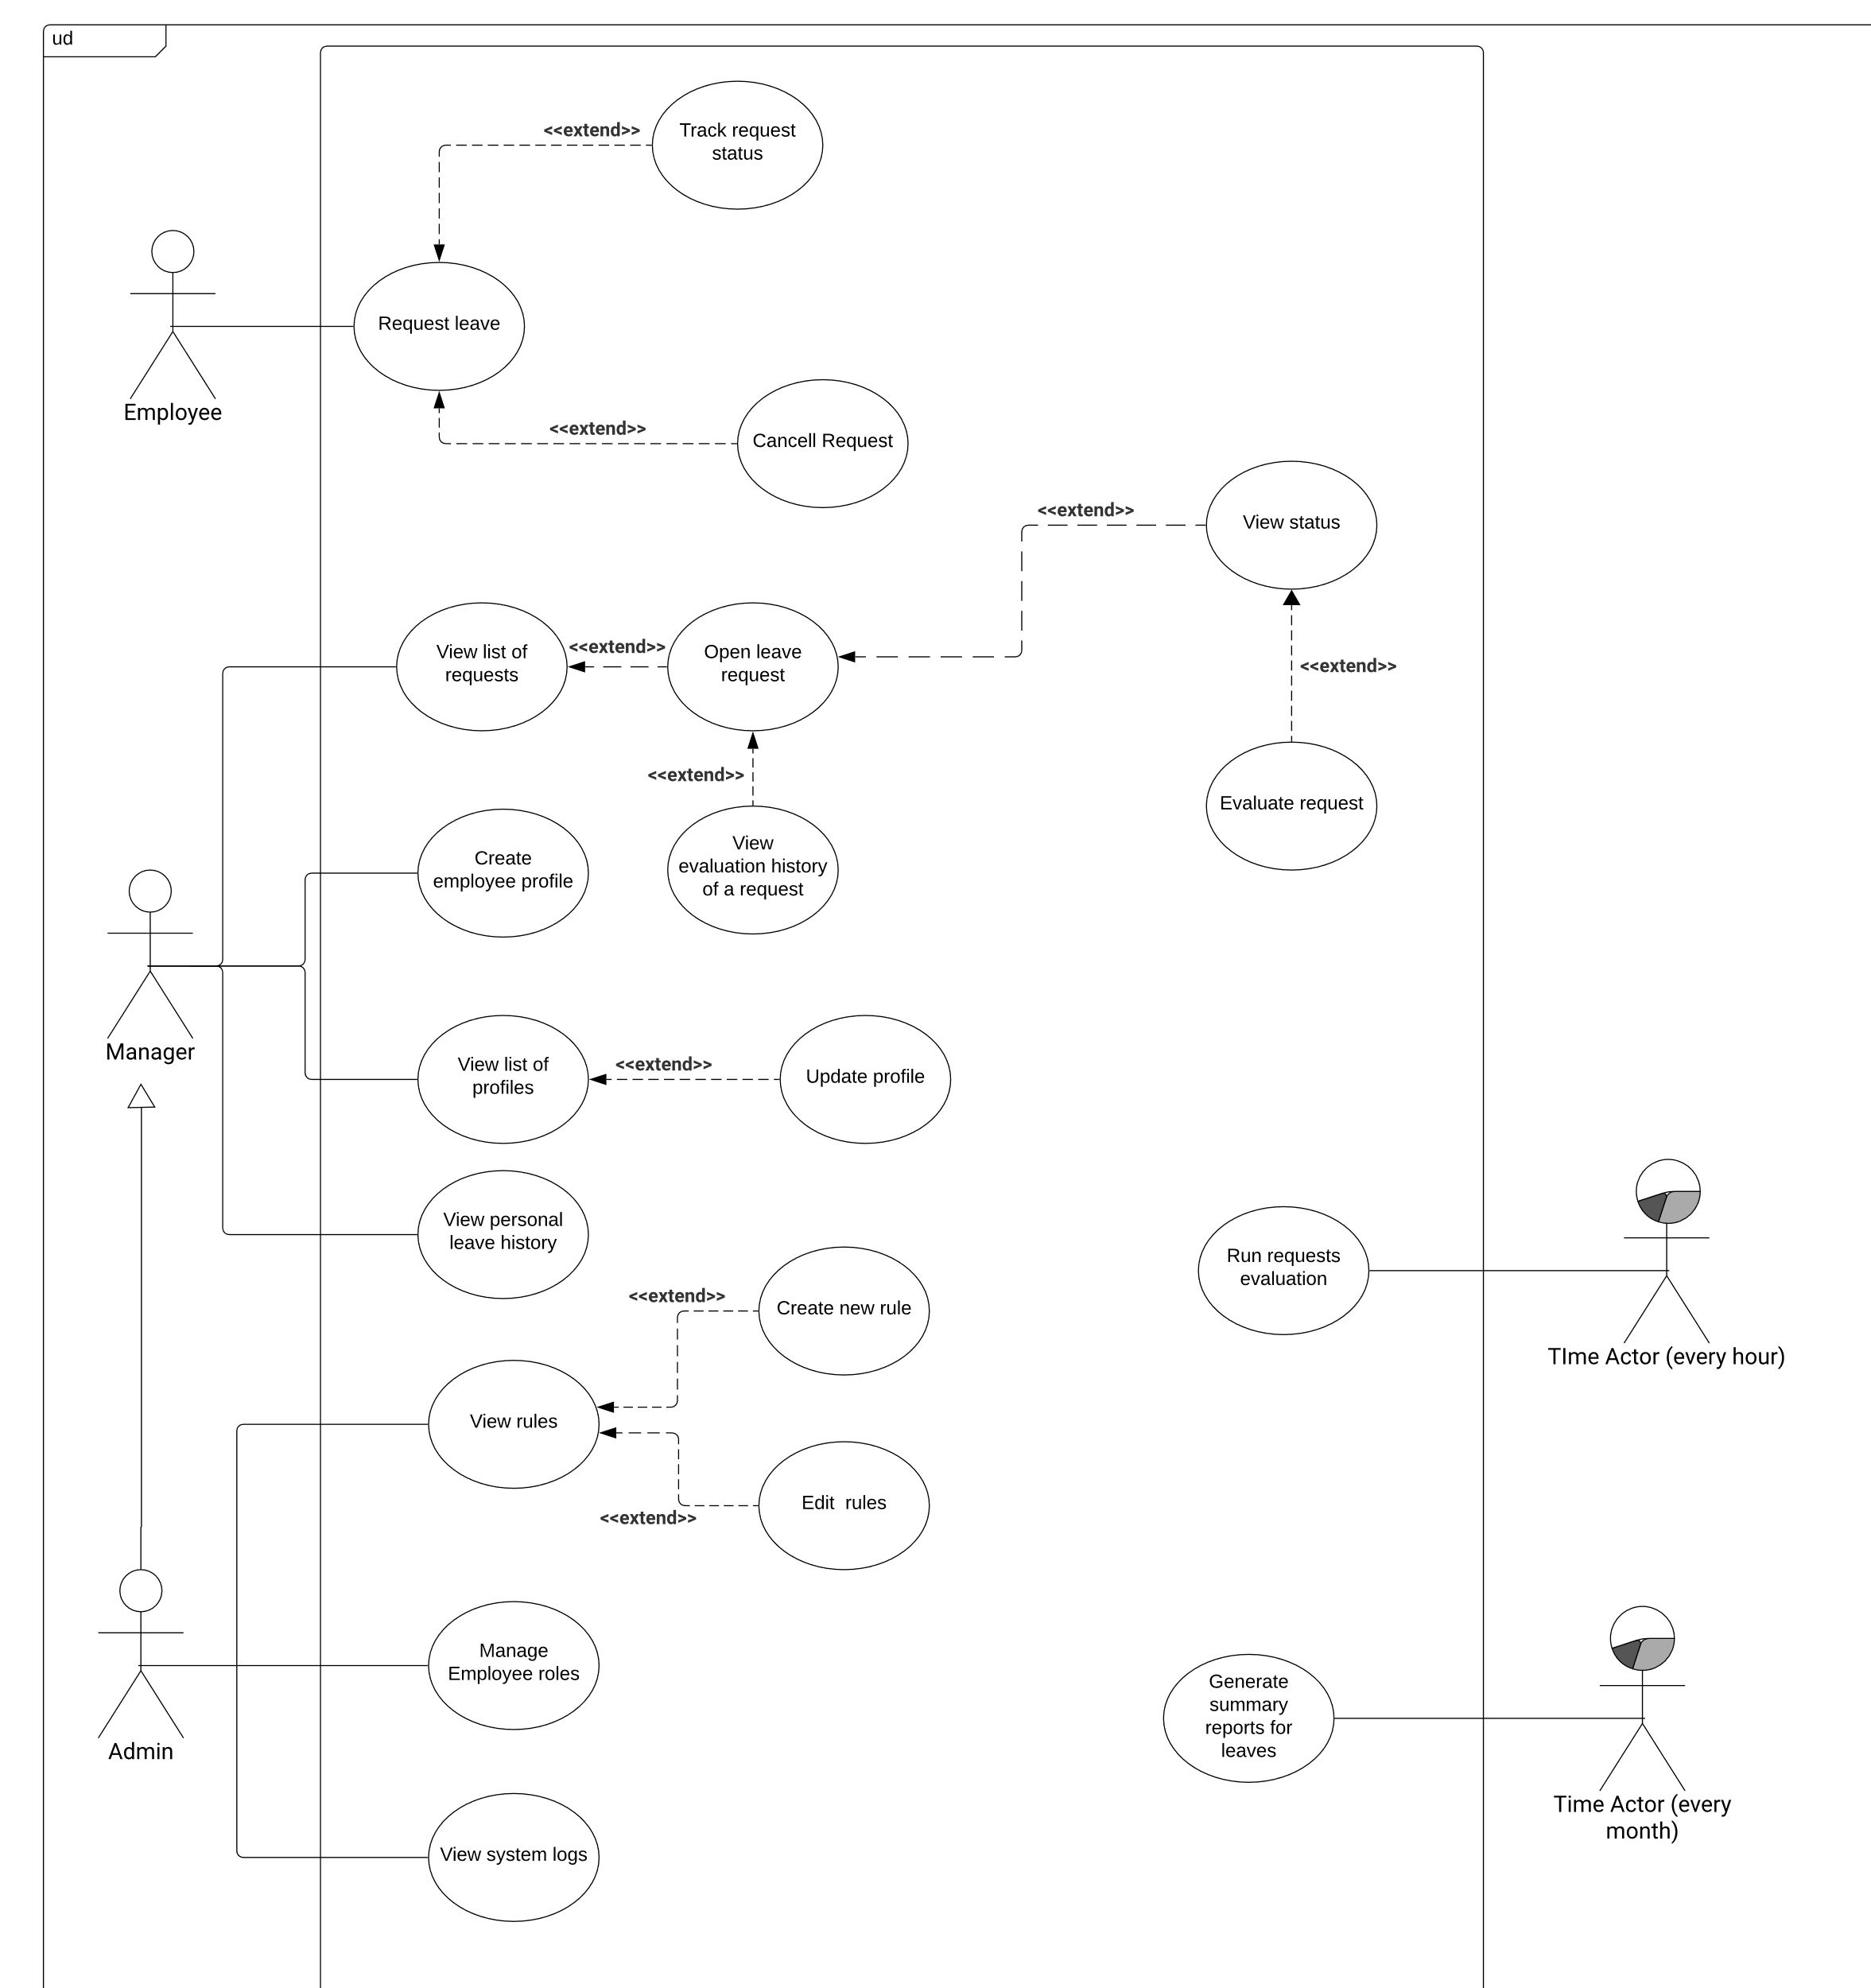
Figure 3. Functionalities use case diagram (visualized with LucidChart - source: author’s work)

Focus was made on implementation of crucial functionality and previously mentioned new points system approach. On a Figure 4, presented below, author’s implemented functionality is marked in red.
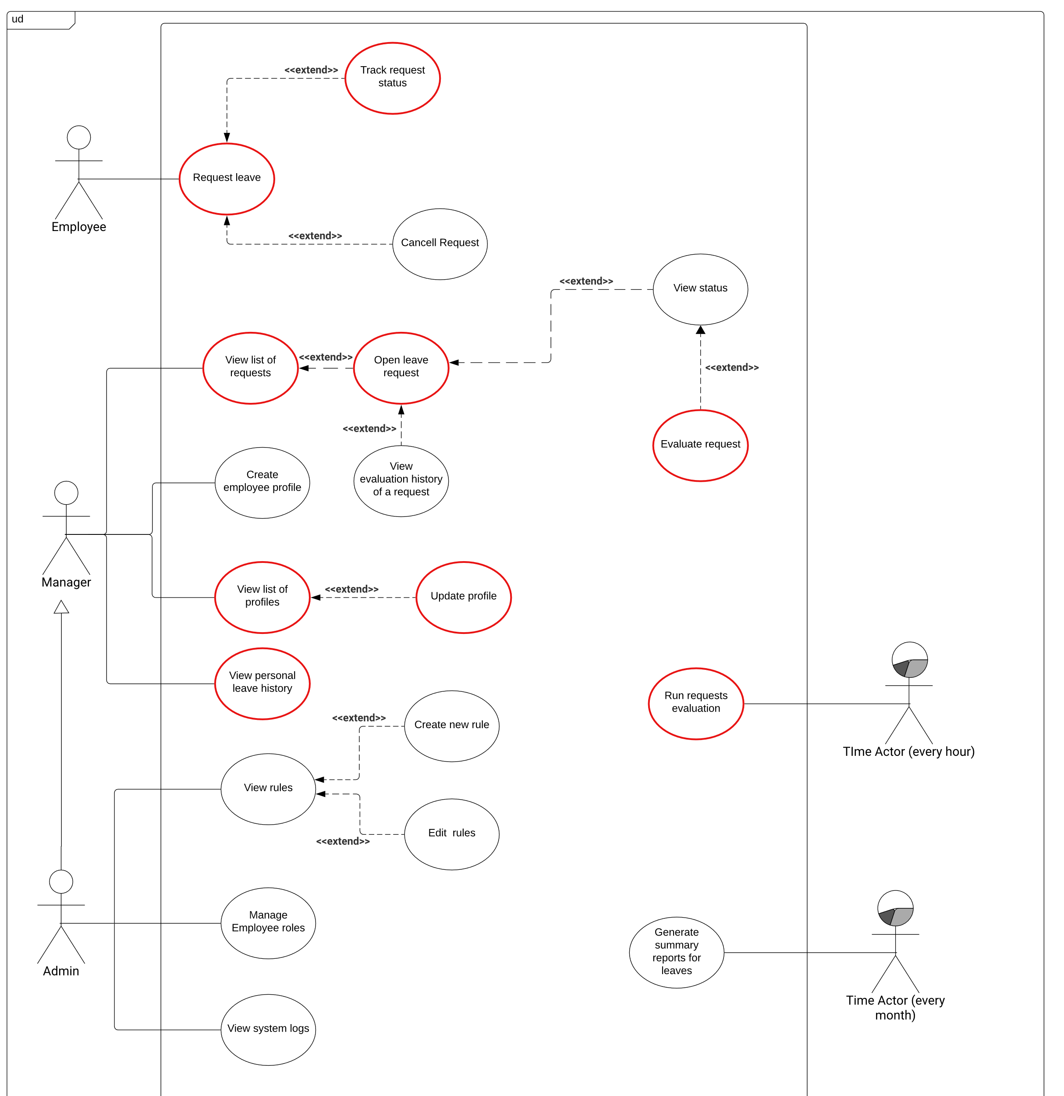
Figure 4. Functionalities use case diagram implemented by author (visualized with LucidChart - source: author’s work)

User use cases basic flow
In this section author’s describes use cases for two main functionalities: Request leave from Employee perspective and Evaluate request from Manager perspective. Both are presented on Figure 3.

- Employee leave request creation basic flow:

Use case | Create a leave request
Description | User wants to create a leave request
Actors | User
Goals | New leave request is created and saved to database
Pre-conditions | User is logged in and system is working
Post-conditions | User creates new leave request and can see it in list of requests
Basic flow | - User clicks on “Create new” button  - System redirects user to a leave request creation form page  - User fulfills all fields and presses “Request”  - System saves leave request in the database
Table 2. Employee leave request basic flow

- Manager leave request evaluation basic flow:

Use case | Evaluate a leave request
Description | User wants to evaluate a leave request
Actors | User
Goals | Leave request is evaluated and its record is updated in database
Pre-conditions | User is logged in and system is working
Post-conditions | User evaluates leave request and can see its updated status
Basic flow | - User clicks one the leave request in the list of requests  - System redirects user to a leave request page  - User enters a comment  - User presses Approve or reject  - System updates leave request in the database
Table 3. Manager leave request evaluation basic flow

Platform implementation

Open-source approach
The application implementation is open-source and is published to github. However, a code should be adapted for every system and become more generic in order to suit every system. This will be discussed in one of the next sections about possible future complete development. Figure 5 shows github repository with author’s source code published.
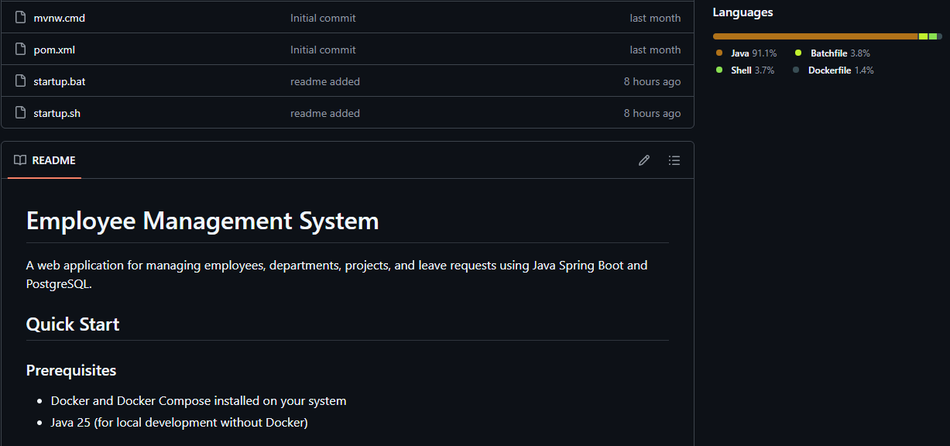
Figure 5. Project repository on github (source: author's github)

Frontend
This application was intentionally designed using a REST API-first approach, without a dedicated frontend implementation. This decision was made to create a more universal and generic solution that can serve multiple client types.
The application provides a comprehensive REST API that follows RESTful principles, making it accessible to any client capable of making HTTP requests. This approach offers several advantages over a traditional application that combines a frontend and a backend.
By implementing only the backend API, the application remains completely independent of client-side technologies. Any frontend framework (React, Angular, Vue.js), mobile app (iOS, Android), or even other services can use the API without modifying the backend.
The Spring Boot framework provides excellent support for REST API development thanks to the @RestController annotation and automatic JSON serialization. This allows for a clear separation of business and presentation logic, where the backend handles data validation, business rules, and persistence, while clients only handle user interaction and presentation.
This API-centric approach makes the application future-proof, as frontend technologies change rapidly, while well-designed APIs remain stable. New frontend frameworks can be implemented without backend modifications, and the same API can simultaneously serve multiple different clients—web applications, native mobile apps, desktop applications, or other microservices.
The REST API serves as the foundation upon which any number of different frontends can be built, making the application truly versatile and adaptable to the changing technological landscape.
Despite the information provided earlier, Figma mock-ups were created for workflow understanding from user perspective.

Account creation and login

Account creation is possible only for Manager and Administrator, for that they would need their account to be created directly in the database. Although, this way is not ideal possible improvement will be discussed at the future development section. When logged in as two of previously mentioned roles, a button on employee’s page is available as shown on Figure 6.
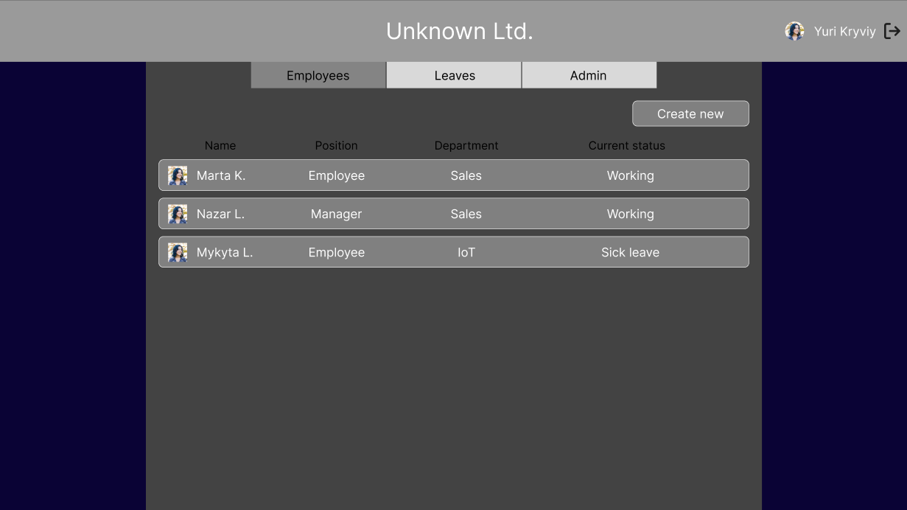
Figure 6. Manager employee list page (source: author's Figma mock-up)

On the Figure 7 presented possible account creation page. Worth to mention, to maintain concept of the least privilege only Administrator can create account of the same type and all others. Since we are logged in as one of the Administrators – Yuri Kryviy, this account type is displayed and selected by default. Managers, on the other hand, cannot see Administrator option, but they still are able to create other Manager account. To be specific, implementation can differ basing on company policy.

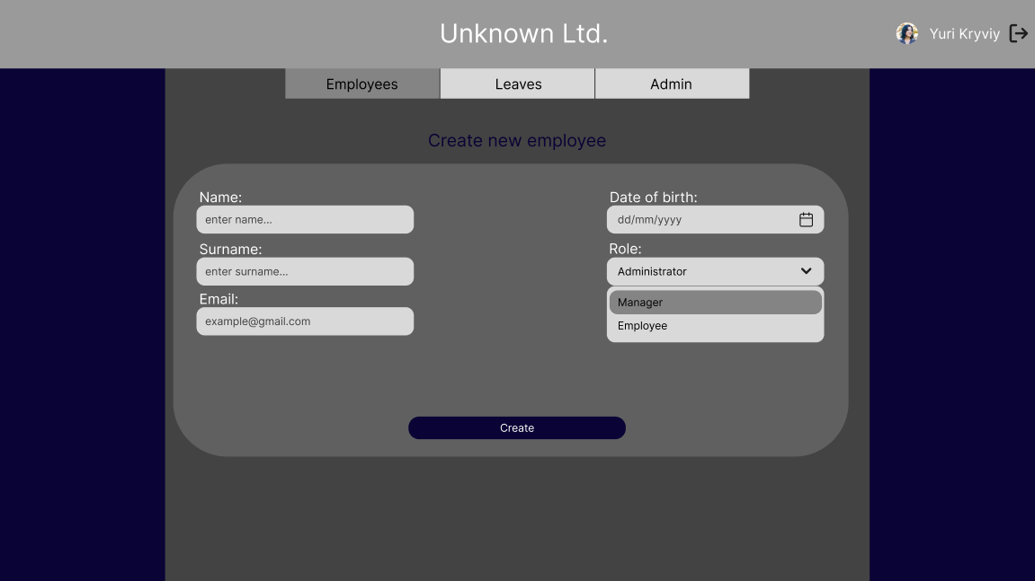
Figure 7. Employee creation page (source: author's Figma mock-up)

As shown on Figure 8, if the email address is already taken, meaning a database entry with such email already exists, it will be impossible to create an account and a corresponding error will be displayed.

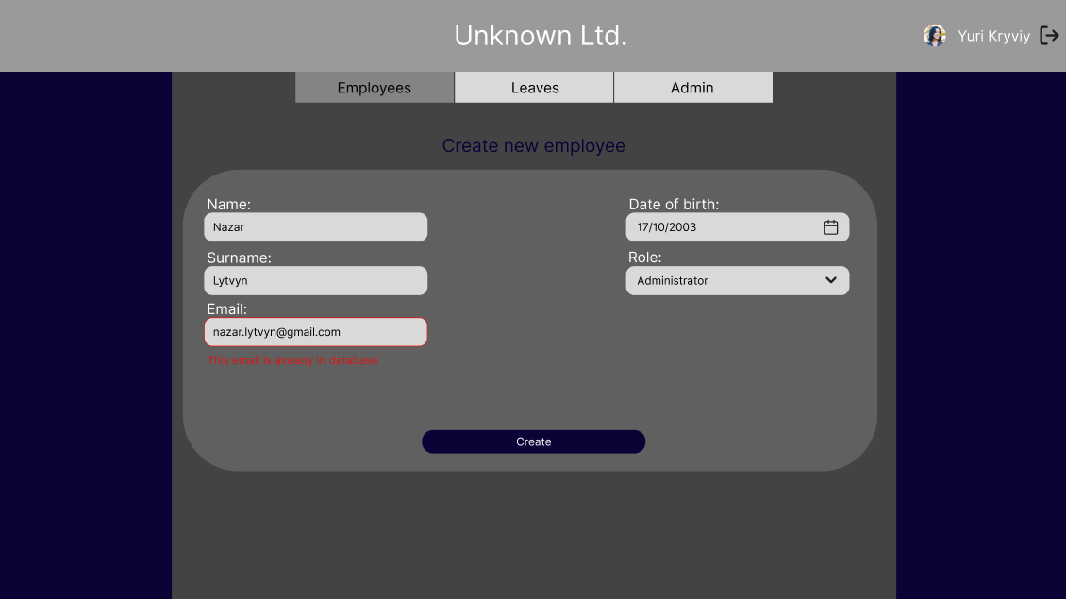
Figure 8. Email is already in database error (source: author's Figma mock-up)
After the creation of the account, user will get an email into the mailbox written in email field in creation form. User would need to approve account creation by clicking the link. After that they would need to create a password and upload an avatar as shown on Figure 9.
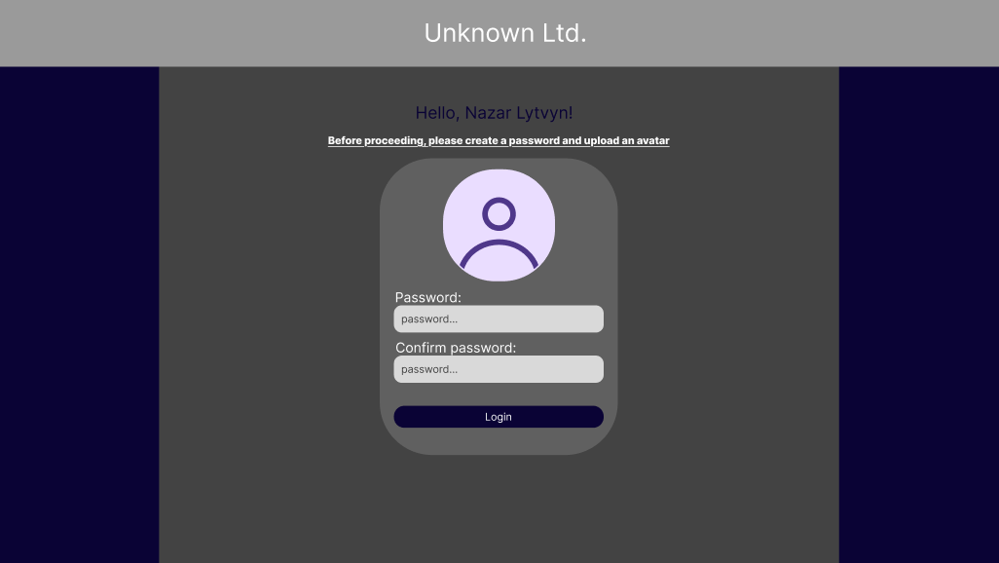
Figure 9. User confirmation page (source: author's Figma mock-up)
To create an account basic information like name, surname, email, password and date of birth of the user should be provided. Each manual input is checked on the backend to ensure that no wrong data was provided which is presented on Figure 10. Additionally, when user themselves confirms account creation, they need to double-input their password to avoid wrong password creation. Since password strength is essential, backend checks its complexity as well.
Figure 10 shows corresponding field checks but not password.
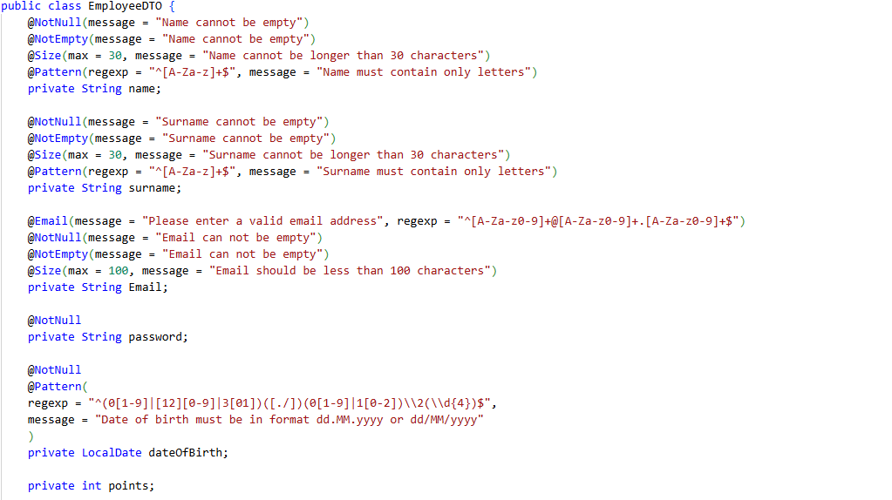
Figure 10. Basic fields validity check (source: author's source code presented in VS Code)

Password is kept encoded in the database, so server itself does not know any password any user. It is checked on security and encoded when user first registers and when they try to log in – the encoded version from request and from database are being compared which is shown on Figure 10a and Figure 10b.
Figure 10a. Password pattern (source: author's source code presented in VS Code)
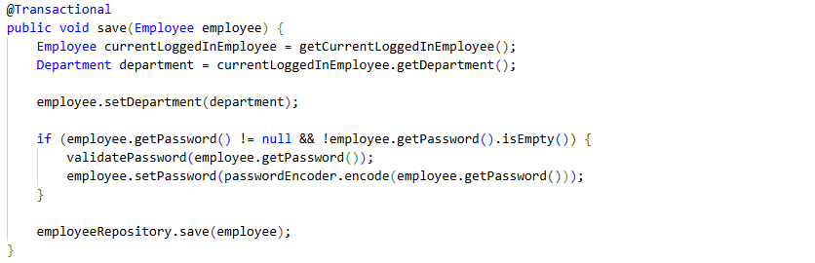
Figure 10b. Employee creation with password validation check (source: author's source code presented in VS Code)
After account creation and confirmation, User will be able to login from general login page as displayed on Figure 11.
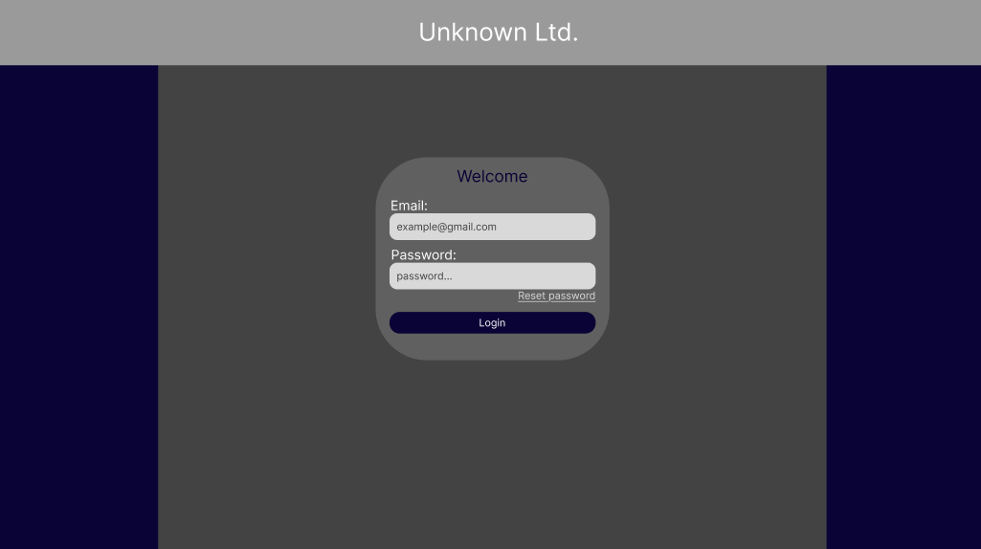
Figure 11. Login page (source: author's Figma mock-up)

The following Figure 12 shows how authorization is handled on the backend. By default, Spring refuses any data sent to controller and requires CSRF (Cross Site Request Forgery) token. With the use of RestAPI approach CSRF is not possible, hence check for corresponding token is disabled which allows Spring to correctly receive and process data.
As can be seen on the same Figure 12, only the corresponding roles: MANAGER and ADMIN have access to use PATCH, POST and DELETE HTTP methods. This is a convenient way of implementation since regular employee should not have access neither to update nor delete those. Use of /auth/login and /auth/registration endpoints are permitted to all, and for any other request user must be authenticated.
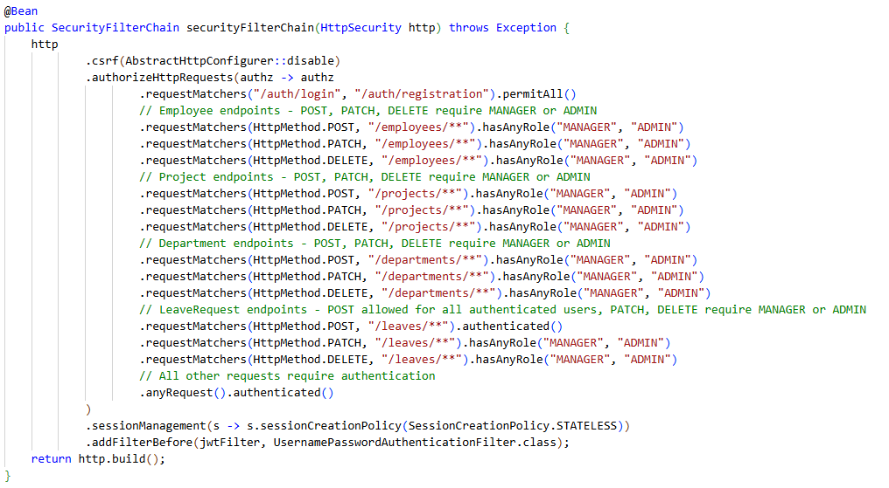
Figure 12. Authorization implementation (source: author's source code presented in VS Code)

The authentication is implemented with the use of JWT token as showed on Figure 13. The common way to use these is to place them in Authorization header in HTTP request and has a prefix of Bearer word with single space afterwards. With JWT, server does not store the state of the user and all their data is save inside that token.
Because of such approach, Spring’s session management configuration should be changed, precisely session creation policy to stateless.
To build JWT token, server should specify subject – description of what data does JWT contains, claim – what is used to distinguish user, when and who has issued the token with its expiration date. At the very end the token is signed using an algorithm, author’s choice is HMAC256, and a secret. Secret is usually a complex set of digits and numbers that only server knows. When user send any request, it is not possible to decrypt it without the secret.
With every user request server checks whether their passed token is a JWT token and if it is valid. For this, a custom filter needs to be implemented and then added to a FilterChain which is a Spring filter chain through which goes corresponding request.
JWT token is encrypted with the use of HMAC256 algorithm and has lifespan of 60 minutes . After 60 minutes of login or registration user should renew his JWT token by logging in again.

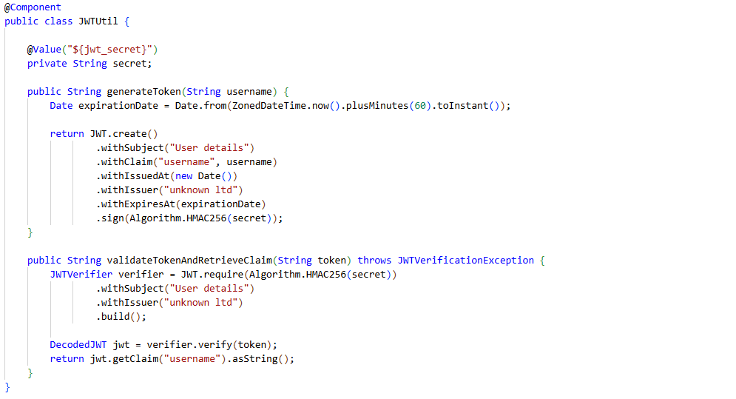
Figure 13. JWT configuration (source: author's source code presented in VS Code)
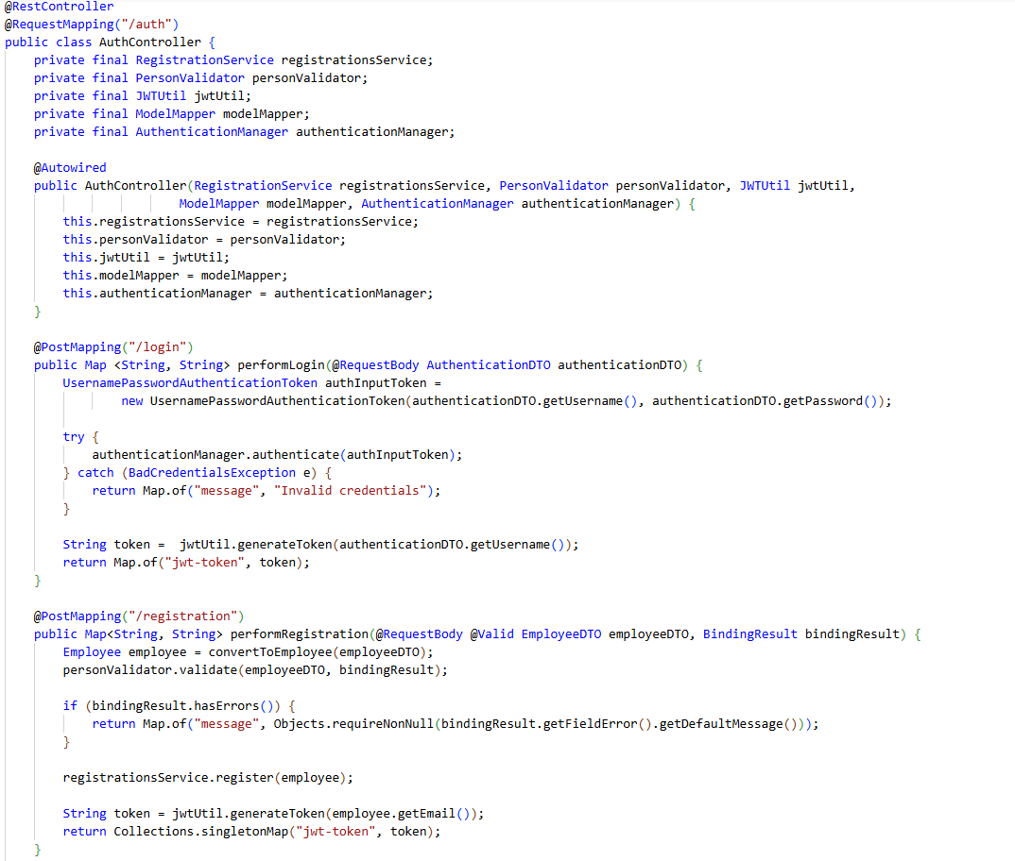
Figure 14. Login and registartion controller (source: author's source code presented in VS Code)
A controller that handles requests sent to an application is shown on Figure 14. To encapsulate data more and not to send and receive not needed fields those can be potentially harmful as well as wrapper class is used for every entity that is sent or received. This wrapper class is called DTO (Data Transfer Object) and is widely used. Each controller has a converter that converts normal entity object to a DTO object which is shown of Figure 15.
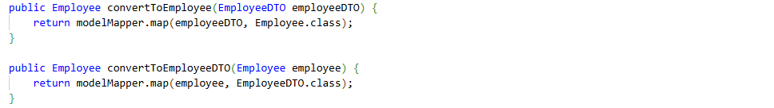
Figure 15. DTO convertors (source: author's source code presented in VS Code)
To speed up the process and not to manually ‘cast’ each object via re-assigning of field, Model Mapper is used. “The goal of ModelMapper is to make object mapping easy, by automatically determining how one object model maps to another, based on conventions, in the same way that a human would - while providing a simple, refactoring-safe API for handling specific use cases” [8].
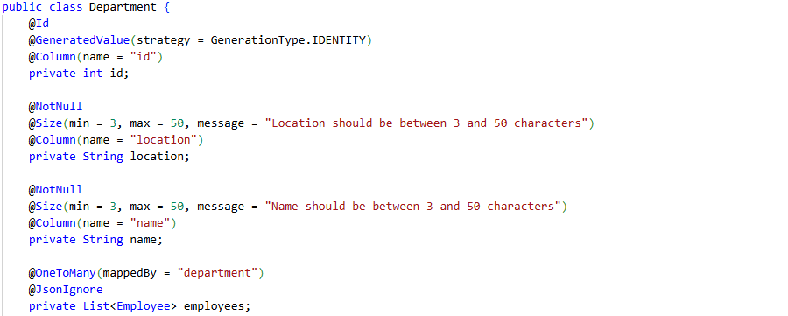
Figure 16a. Department class (source: author's source code presented in VS Code)
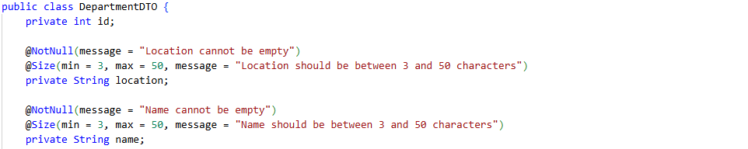
Figure 16b. DepartmentDTO class (source: author's source code presented in VS Code)
“DTOs or Data Transfer Objects are objects that carry data between processes in order to reduce the number of methods calls. The pattern was first introduced by Martin Fowler in his book EAA” [9].

Point-based system implementation
To implement a points-based system an Employee entity was provisioned with points field (Figure 17a).
Figure 17a. Points field in Employee entity (source: author's source code presented in VS Code)
At the end of every month each employee gets a point that is added to the points number they already have (Figure 17b). To implement such functionality @Scheduled annotation from Spring was used. This annotation allows to execute a method at specific intervals. Author’s implementation adds a point on the first day of every month.
To manage points accruals for individual achievements, a special endpoint is available that triggers another method in a service which adds points to an employee.
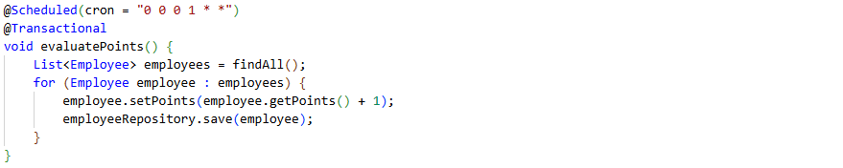
Figure 17b. Implementation of points accruals (source: author's source code presented in VS Code)
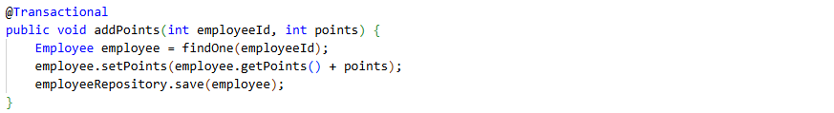
Figure 17c. add-points endpoint (source: author's source code presented in VS Code)

Leave request evaluation implementation
Figure 18 presents how leave request page form looks like from user perspective. After the user selects dates, near the Request button text will appear with information on how many points will user loose. Also, if the user would like not to use their points and provide any valid legal document that frees them from the work on that day, they could check the box to avoid loosing points.
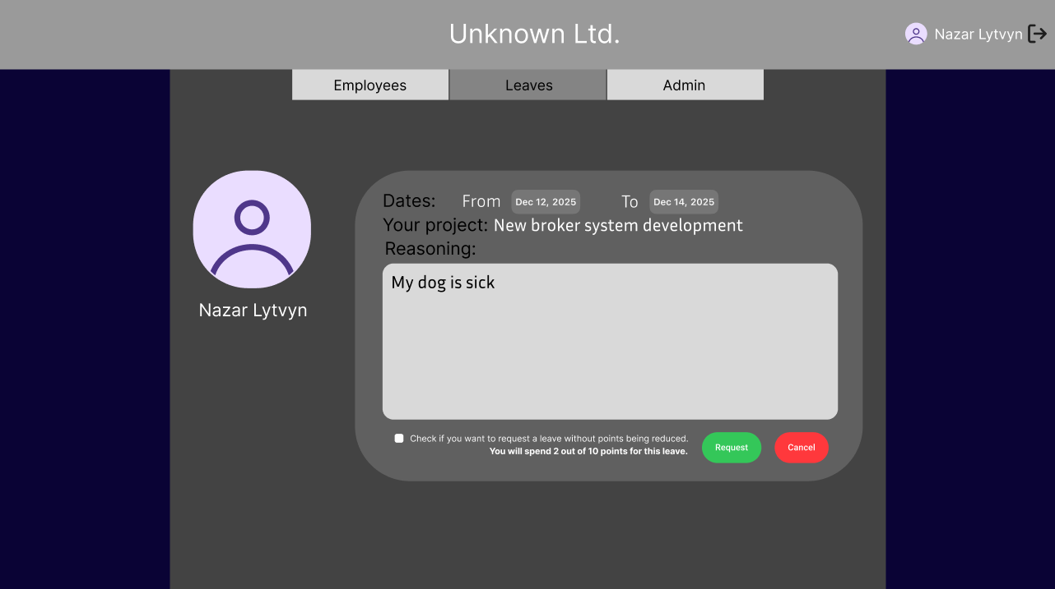
Figure 18. Leave request form page (source: author's Figma mock-up)
When administrator tries to view the page with leave requests, they will be able to see leave requests from all departments. However, when a manager tries to access the same page, they will be able to see only leave requests from their department. This is done to speed up bug fixing issues and from author’s point of view it is more convenient. A leave requests page is presented on Figure 19.
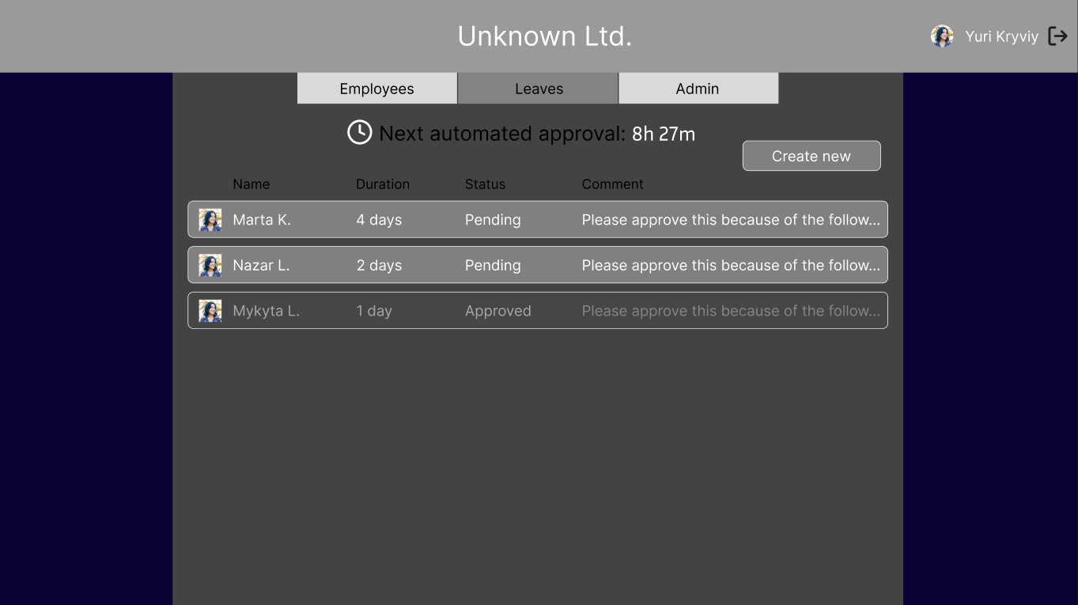
Figure 19. Leave requests administrator view (source: author's Figma mock-up)
In meantime a manager from the same department or administrator can approve any request themselves. For this process, a separate entity which is called LeaveRequestEvaluation with a database table exists. With this way of implementation logic of leave request lifecycle and logic of evaluation of leave request is kept separate from each other. A database table of previously mentioned entity is a middle-table for many-to-many relationship.
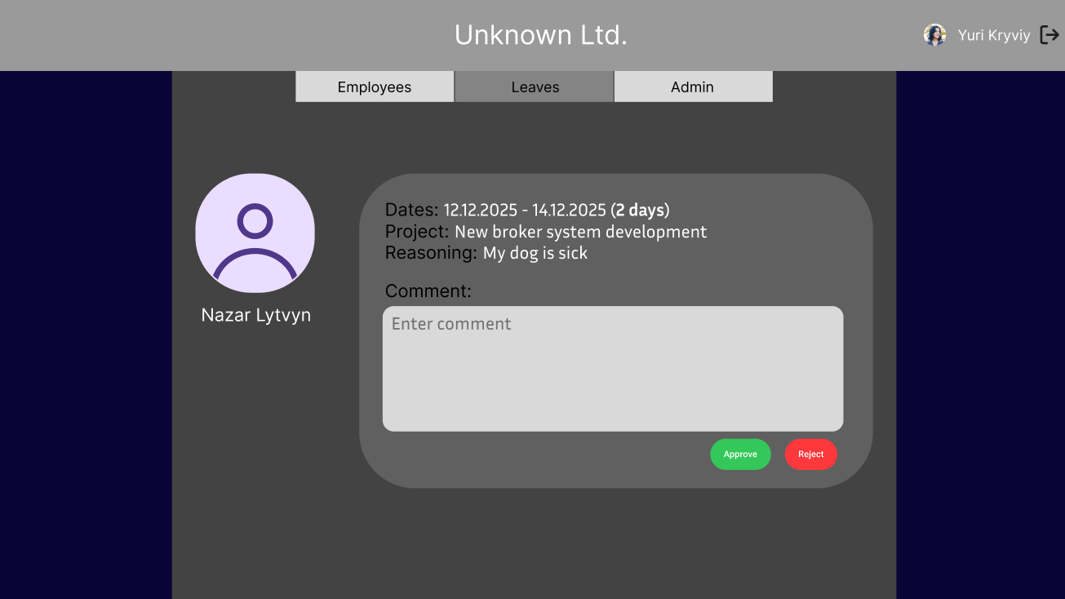
Figure 20. Leave request evaluation page (source: author's Figma mock-up)
For receiving calls about leave requests LeaveRequestController is responsible, main methods of which are displayed on Figure 21. 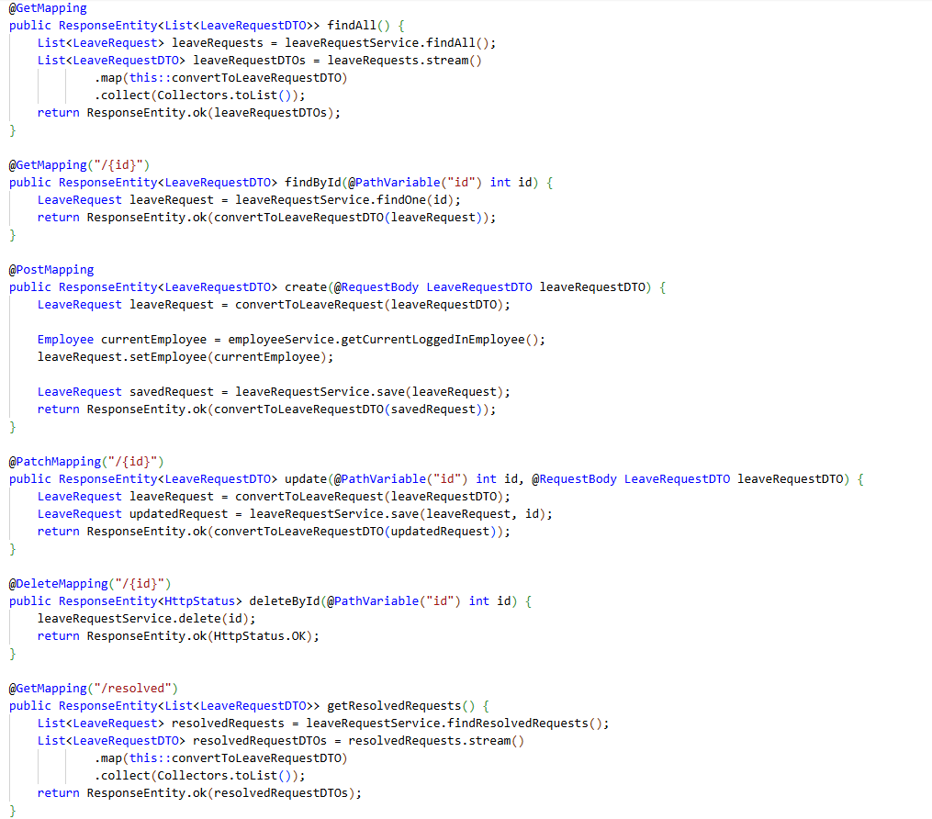
Figure 21. LeaveRequest controller main methods implementation (source: author's source code presented in VS Code)

Automatic leave request evaluation implementation
An automatic leave request evaluation implementation is done in a separate service to isolate evaluation logic as described previously in this section. In author’s work this evaluation is implemented with a number of constraints which are listed in section 2, point b in this thesis.

As presented on Figure 22, automatic evaluation is done by use of Spring @Scheduled annotation. It happens every hour. The method goes through each leave request and:
- Checks whether its status is PENDING, meaning it was not evaluated yet.
- Checks if option not to use points was chosen. If it was, then status of the request is changed to MANUAL, meaning it should be evaluated manually by manager or administrator.
- Checks whether employee has enough points to request this leave. If they do not, then status is changed to DECLINED_S where S after underscore means System and differs from normal DECLINED status.
- Then the main set of constraints – project constraints is checked. The first condition is to project not to have status CRUCIAL and its deadline to be later then 14 days from the date of method execution. The second condition is to project not to have status IMPORTANT and to have more than 70% of employees working on it at the date of method execution, meaning that anyone of those 70% does not have leave predefined in the system already. A nested method that verifies those conditions is presented on Figure 23.
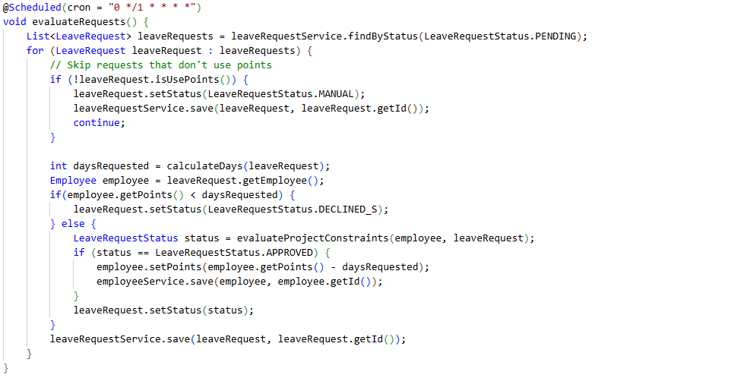
Figure 22. Main request evaluation method implementation (source: author's source code presented in VS Code)

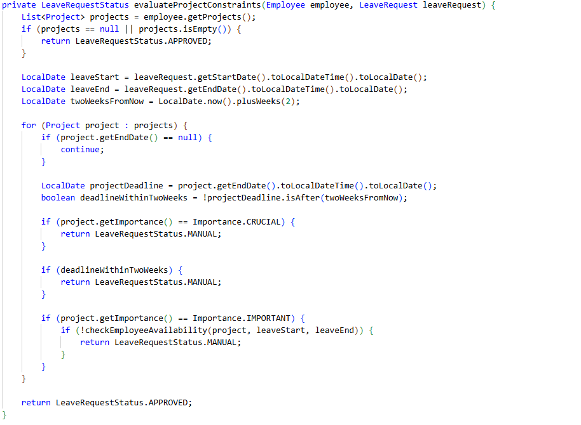
Figure 23a. Nested method to check project constraints implementation (source: author's source code presented in VS Code)
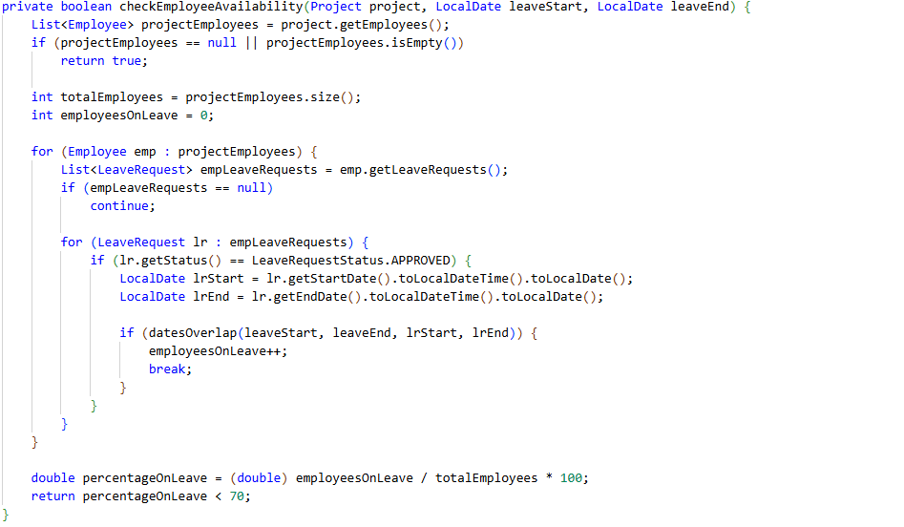
Figure 23b. Nested method to check 70% employee’s availability (source: author's source code presented in VS Code)
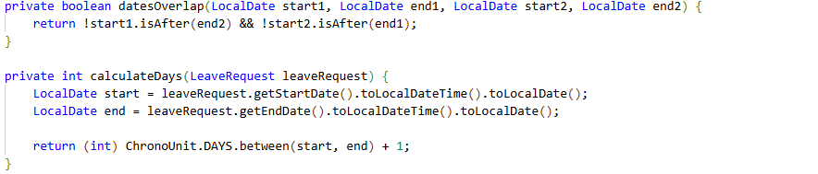
Figure 23c. Two more nested method those finish the automatic evaluation implementation (source: author's source code presented in VS Code)

Future of the platform

Bibliography
[1] https://www.sinequa.com/resources/assets/digital-transformation-guide/
[2] https://performance.eleapsoftware.com/effective-leave-management-best-practices-for-hr-teams/#:~:text=Measuring%20Leave%20Management%20Success%20Effective%20leave%20management,organizations%20continually%20refine%20their%20leave%20management%20approaches.
[3][4] https://en.wikipedia.org/wiki/Java_(programming_language)#:~:text=Java%20was%20designed%20by%20James,component%20of%20Sun's%20Java%20platform.
[5] https://en.wikipedia.org/wiki/PostgreSQL
[6] https://en.wikipedia.org/wiki/Spring_Framework
[7] https://en.wikipedia.org/wiki/Spring_Boot
[8] https://modelmapper.org/
[9] https://www.baeldung.com/java-dto-pattern

