REPORT
Object-Oriented Programming Project
Game is written using Java and applying principles in OOP

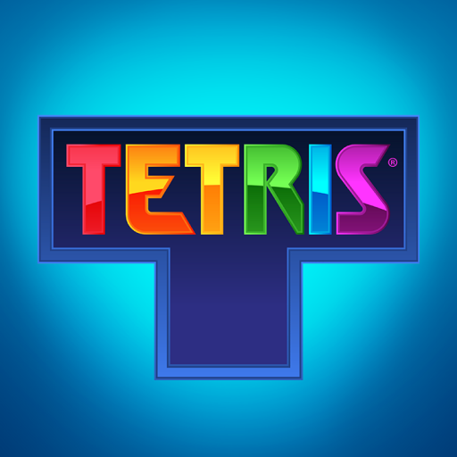

MEMBERS:
TRẦN THÀNH CÔNG - ITITIU19089
DƯƠNG MINH LỘC - ITITIU19024
LƯƠNG PHÚC ĐIỀN - ITITIU19010
VĂN HOÀNG QUẾ ANH - ITITIU19003

CONTENT
- Introduction
- Github repository
- Game Rules
  - Goal
  - Rule
- UML diagram
- Methodology
- Main class - Function - Explain
  - MainGame
  - GridBoard
  - FormBlock
- Evaluation
  - Result
  - Limited
  - Conclusion

- Introduction
In the world that the Software Technology industry is growing rapidly day by day, the classic Procedural-Oriented Programming method cannot meet all the demands completely. That leads to the invention of a new method from Alan - Key called Object-Oriented Programming to satisfy all the demand.
Applying Object-oriented programming methods and using Java language, this game is creating in the way that it:
- Is clear, concise, and easy to understand.
- Is logically organized with many combined classes.
- Contains classes that each has many Methods which take on different behaviors.
- Can be reused as a resource.
The purpose of this project is to create a game which builds on the foundation of OOP’s principles. Our group decided to recreate the game Tetris from the original Tetris game of Alexey Pajitnov based on these principles. This game will clearly show the object–oriented property, the combination of classes, between class and object. Tetris is a simple game that requires players to rearrange different shapes of cubes to fulfil the lines. Although Tetris has appeared for a long time, our Tetris game has been developed with new design, speed of the game, not required the configuration of the computer and especially this game is built based on the Object – Oriented Method.
Moreover, besides the reason mentioned above, we also create this game in order to apply all the knowledge we have learnt during this course such as working with Class, Object, and using the applications of algorithms to make the software run effectively. Though challenging, we desire to make a step further on our way to ultimately become an advanced and professional software developer.

- Github repository
Click here to have more details about the project through the source code.

- Game Rules
- Goal
The blocks fall down from the top of the board. You can move the blocks around (move left, right, down) and rotate it, until it falls. Your objective is to position the blocks in order to create a horizontal line filled with cubes. Whenever a line is fulfilled with cubes, it will disappear, and you will be awarded with some points.
- Rule
The rule of Tetris is very simple. Press left, right, down arrows to move the blocks. You cannot move the blocks upwards. If the blocks reach to the top of the board, game over.

- UML diagram
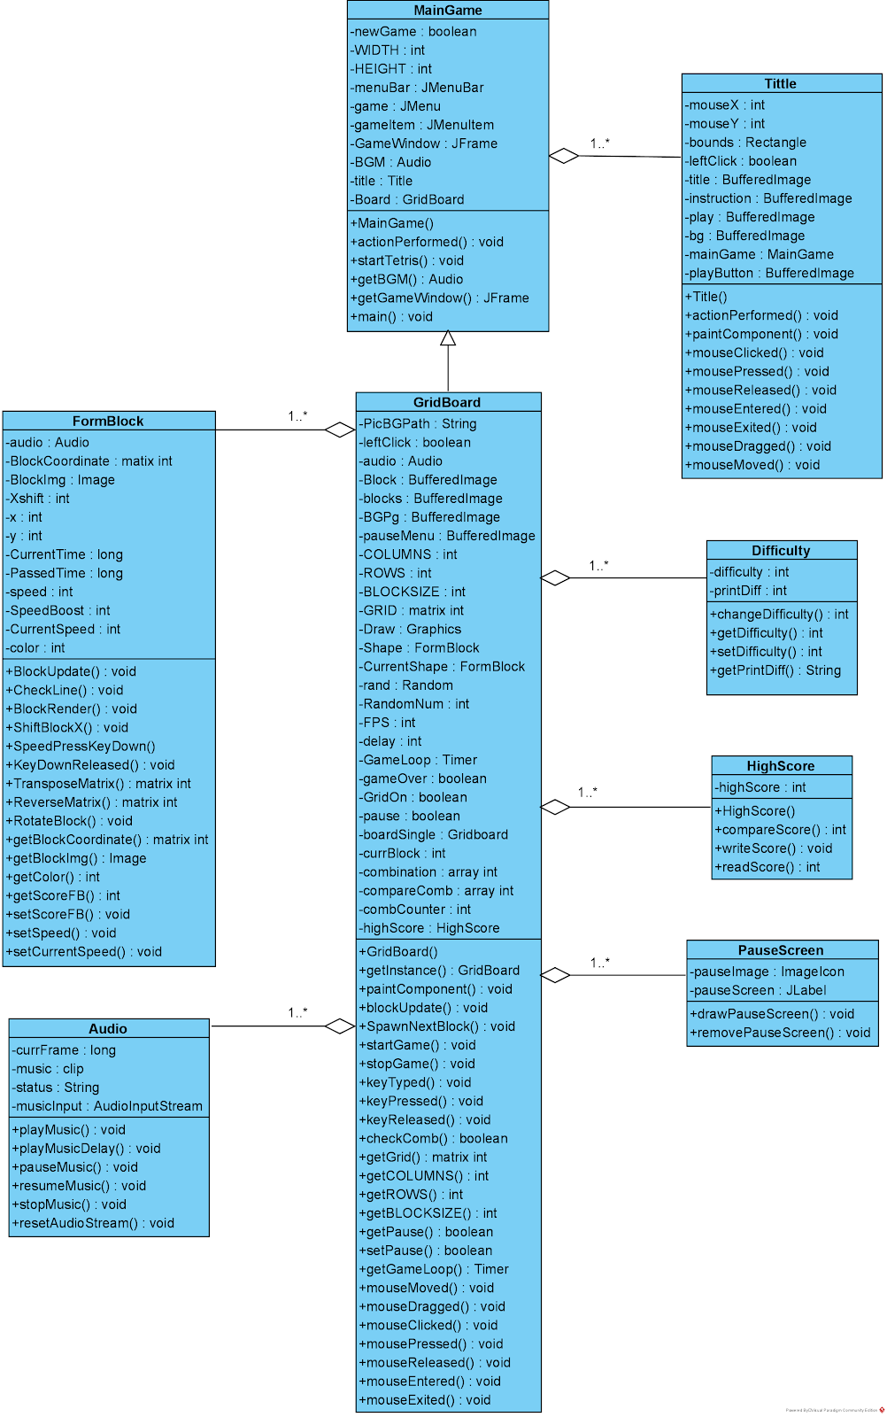

- Methodology
This project consists of 8 classes: MainGame, GridBoard, FormBlock, Difficulty, HighScore, PauseScreen, Title and Audio. Based on OOP’s method, we focus on two main classes: GridBoard and FormBlock.
First, we create FormBlock. There are 8 kinds of shapes that are implemented from FormBlock class: Z,J,O,T,L,I,S. Each object was inherited from the parent Shape and can be reused. The Shape can be updated, rotated, collided,…
As referred before, in a serious game the fun factor must be maintained in the first place. Therefore, to provide a rich and engaging environment that presents educational goals the best practices of pedagogical psychology are needed. But the best pedagogic practices are those that are interpreted as fun .
Real learning does happen in games, and this learning process shares many characteristics with the pedagogy of problem-based learning. Players must solve problems to progress through the game and they can only solve a given problem by accumulating the necessary experience and tools in lower levels of the game.
The pedagogy used is akin to problem-based learning where the structure and narrative of the game provide the purpose of learning and an immediate motivation for pursuing the knowledge required. Furthermore, it must include meaningful problems to solve with the purpose of learning the contents.
The learning must occur within multiple mechanisms, such as mini-games, puzzles, and quizzes, played in parallel to the main game environment but also by the gameplay and solving quests in the game. The educational component must be mainly based on the interaction with these learning mechanisms, where the concepts to be learned are embedded. However, the player must have missions to complete in the main game in order to obtain the requirements and tools to progress in game through the access to these mechanisms. For example, collect several items to be used in a mini-game or in a puzzle for a specific learning outcome. Thus, the player has the opportunity to learn some contents provided by a specific learning mechanism, keeping the main game more fun and engaging.
This methodology must be applied also into each game layer, which means that the learning contents can be distributed by all layers. Therefore, the player must have several quests to complete per layer and also several learning mechanisms to overcome, in order to learn the concepts associated to each layer of the game. Figure 1 shows the diagram of our methodology, where a game is divided by levels and each level can be composed by several learning mechanisms . For each layer of the game, the player has missions to overcome as a way to access the learning mechanisms and thus progress in the game.
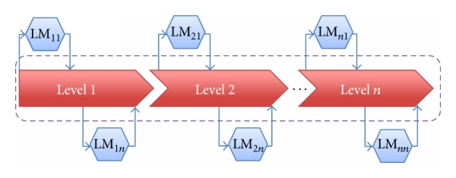

- Main class - Function – Explain

- MainGame
- Constructor:
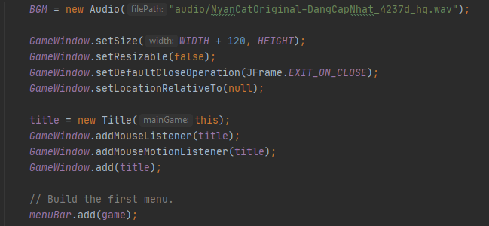
-Initialize the new obj BGM
-Set the size, do not allow resize, the position appears ... of the game window
-Create a new obj Menu
-Add mouse sensor for game window

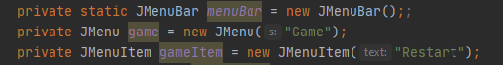

-When declaring the variable JMenuBar, I already have a menu bar, but nothing on it
- I declare JMenu game = new JMenu ("Game") and then add the game variable to the JMenuBar variable to have a box named "Game" on the menu bar

- In the box "Game" I divided into 3 items Restart (starting a new game), Pause / Unpause (pause game), Exit (exit game), called JMenuItem

- After creating the "Game" box, similarly I created the "Difficulty" box, I created a new obj in the available variable game = new JMenu ("Difficulty")

- In the "Difficulty" box, there will be 4 difficulty items of the game, the default difficulty is always easy when entering the game

- With "Impossible" difficulty, there will be a secret combo, helping players to reach 100 points immediately and then stop the game oThis is the menu bar I want

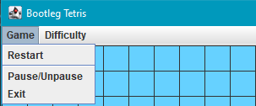

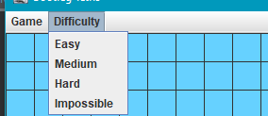

-We did not create a new class for the menu bar but put it in main because we have not thought of a way to create a class for this menu bar

-We did not create a new class for the menu bar but put it in main because we have not thought of a way to create a class for this menu bar

-First we create a "Restart" in the "Game" box

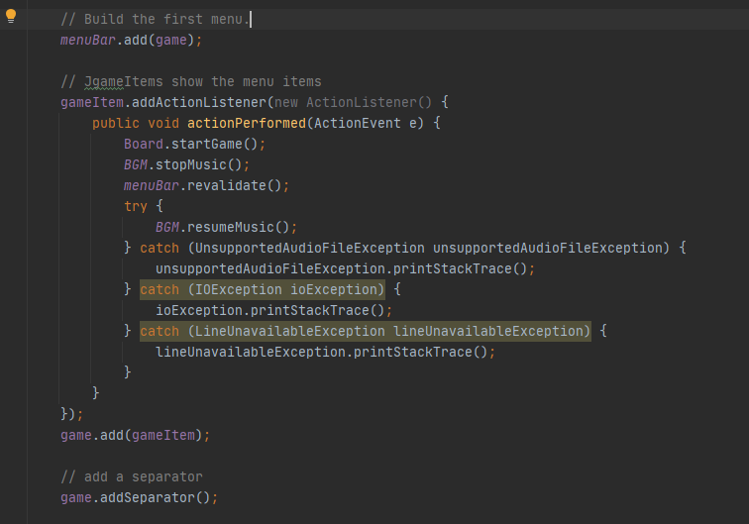

▪ Board.startGame (): function startGame () in the GridBoard class will be explained in more detail in the following section.
The idea is that this function will stop the game time for a very short amount of time, then fill the entire array to 0.
There may be a better way to fill the array to 0, but compared to creating a new obj GridBoard, a new BGM obj, this way can fix the game lag by using less memory (creating a new obj very memory consuming)
▪game.add (gameItem): After creating an item, add it to the "Game" box, because the following items, I still use the gameItem variable.
▪game.addSeperator (): this is JMenu's inbuilt function that helps create horizontal lines

Create Pause and Exit in the "Game" box
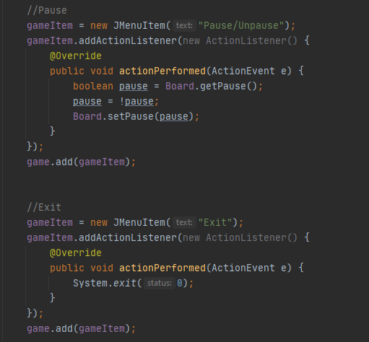

1To create a Pause, I create a new obj with the available gameItem variable name, gameItem = new JMenuItem ("Pause / Unpause")
▪-The Pause button handling function is located in the GridBoard class, which will be explained in more detail later
▪-game.add (gameItem): add pause button to "Game" box
▪- Continue to create Exit, I create a new obj with the available variable gameItem, gameItem = new JMenuItem ("Exit")
▪-System.exit (0): This function is available in Java, stops the whole thing, then exits
▪-game.add (gameItem): add the exit button to the box "Game"

Similar to the "Game" box creating "Difficulty" box

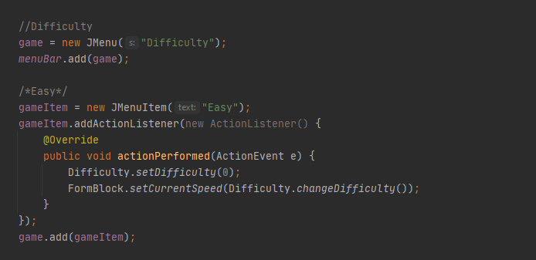
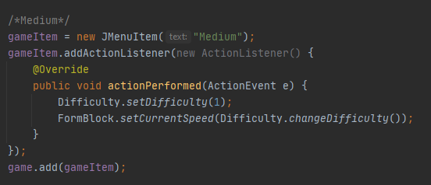
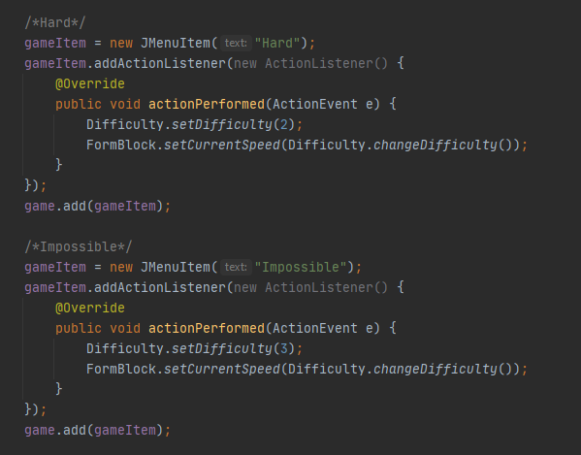
-We have a Difficulty class with setDifficulty () function that accepts numbers 0 to 3 with a corresponding difficulty from easy to impossible.

-For each number from 0 to 3, the Difficulty.changeDifficulty () function will return a number corresponding to the speed of the block.
▪
-Then sets that number at the infinite speed of the block FormBloc.setCurrentSpeed ​​(Difficulty.changeDifficulty ())

After the initialization is complete so that the user can see the game, then setVisible (true)

Function startTetris ():
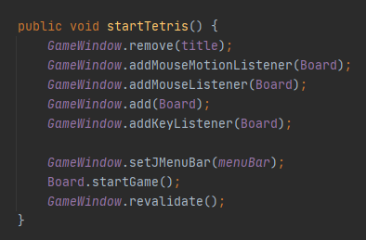

-Function startTetris () is used for the PLAY button in class Title
-It is located here because this is where the GameWindow variable is

- Main:
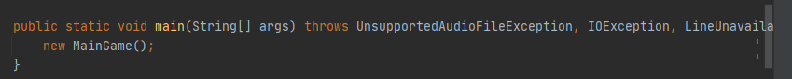
Create a new MainGame obj Why create a new obj, no variable name, nothing but the game is still running, this is still a mystery of the group

- GridBoard
In this class, we use ImageIO.read(new File(“pathname”)) to read image from address pathname. There are 7 shapes correspond to 7 blocks.
Constructor: 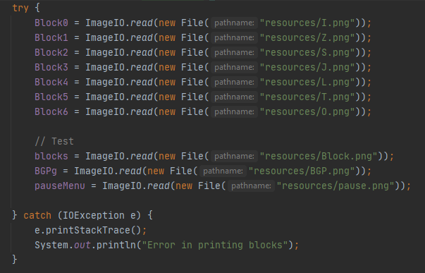
3 formblock
constructor
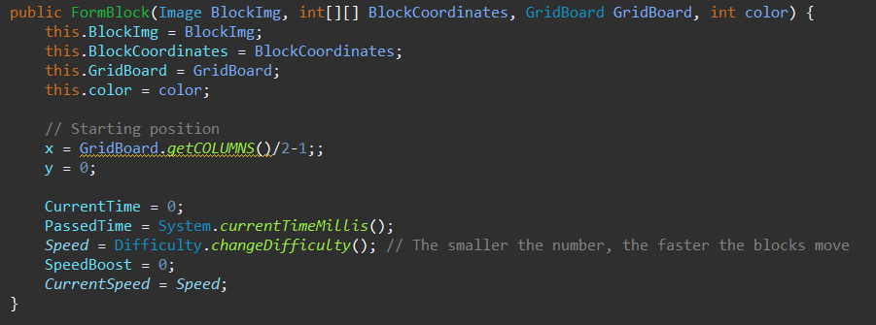

The bottom half is used to control how fast / slow the block is when it falls, adjustable via the game difficulty switch.

blockupdate
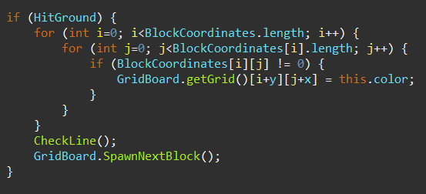

Check if the block hits the ground or not, if so, set the block's grounding position to the block's color and start generating a new block through the function SpawnNextBlock ()

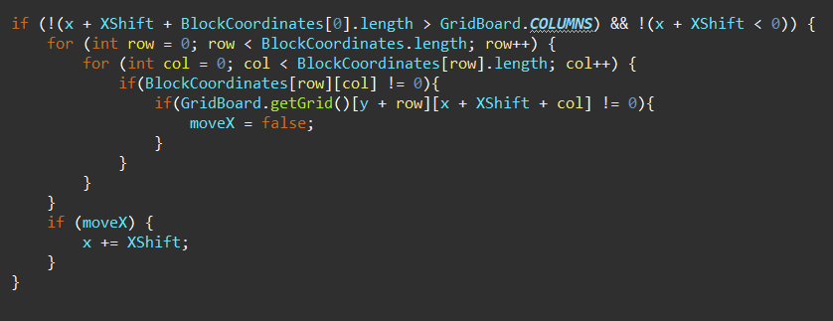

Check if the block is hit 2 left / right or not, if so, the block will not be moved left / right
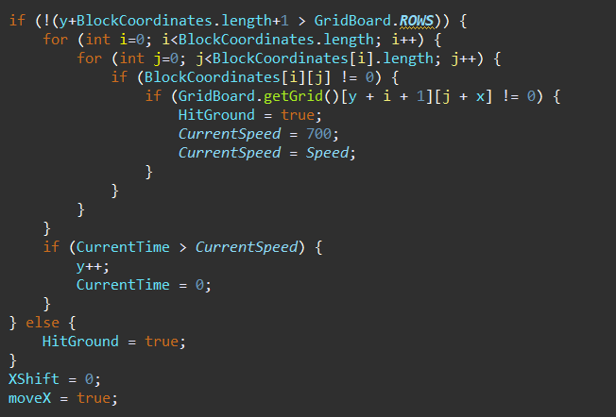

Similar to the left / right check but for the ground, if the block hits the bottom then HitGround = true, then do the event when the block hits the ground.
•CheckLine ()
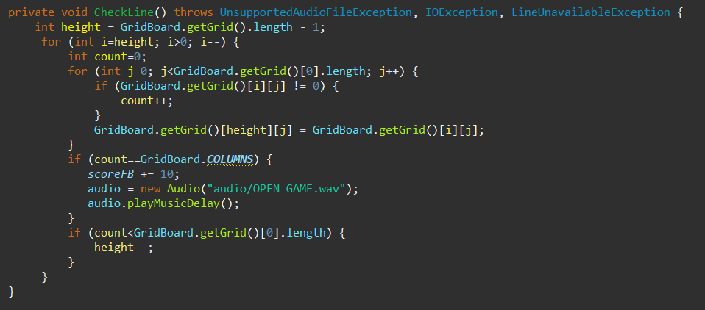

The function is used to check whether the blocks have completed a row, if any, delete that row and push the blocks above down, add points and play the sound effect.
•BlockRender ()
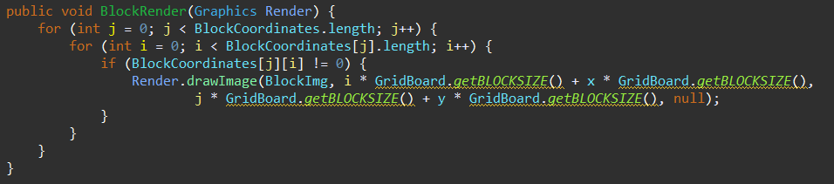
Feedback
Fucntion is used to draw blocks based on the numbered on the GridBoard array, otherwise 0 will draw the block
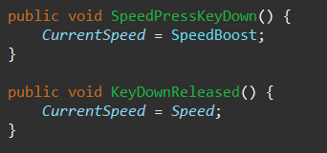
2 functions used to detect when the player presses the down arrow key, this time the block will fall faster

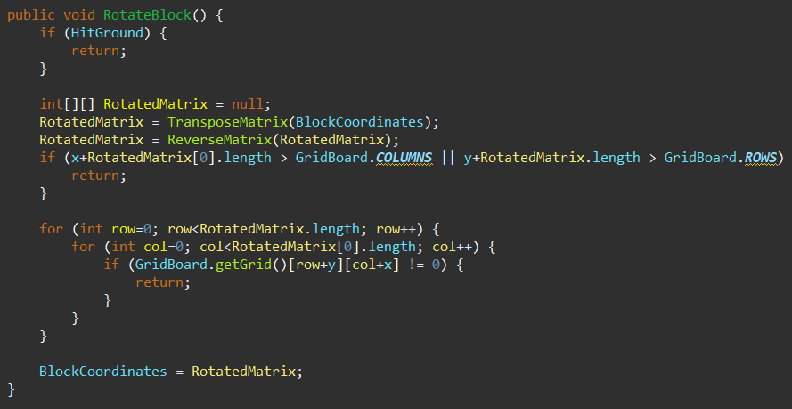
The function is used to rotate the block, based on how it is done: copy the array of the block to a new array, if the player rotates once, then change x with y of the block, and 2 times, then reverse the array.

- Evaluation

  - Result
We have completed our Tetris game with basic rules and properties of the original Tetris game applying principles of OOP. The classes and objects are connected logically. Moreover, user now can control the program with their mouse and keyboard devices.
In addition, we have created some new features for the game: the sound when playing, pause/unpause button, restart button and the levels of difficulty. The user interface is more attractive.
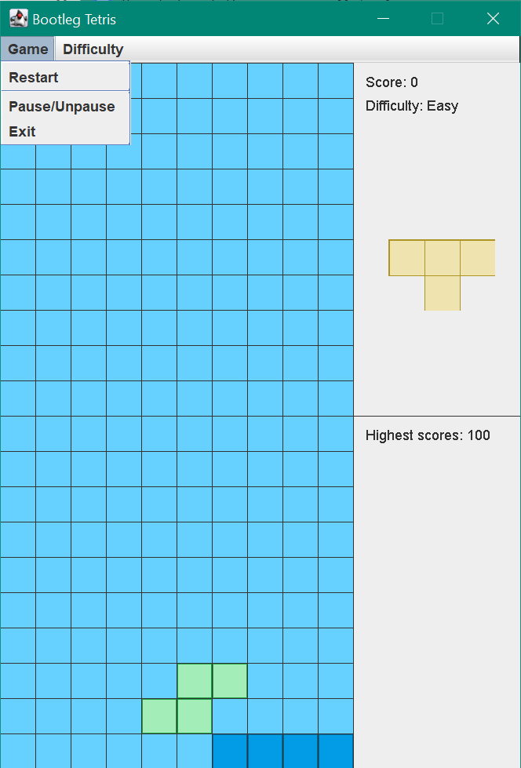
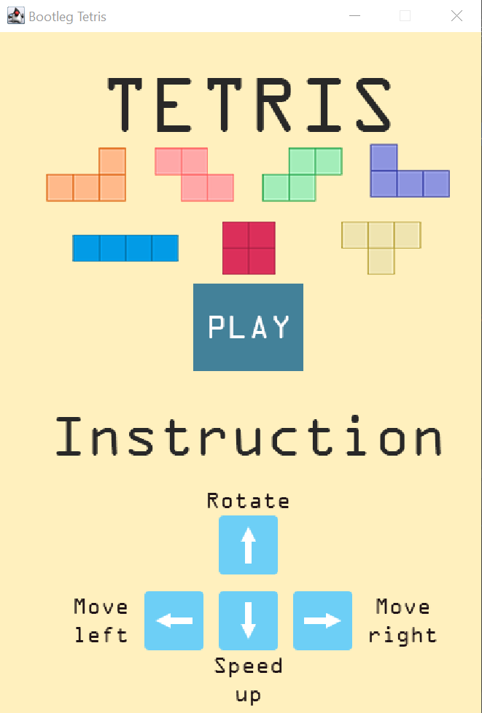
PLAY BUTTON
CLOSE
USER INTERFACE OF TETRIS GAME
NEXT SHAPE
SCORE

LEVEL OF DIFFICULTY
EXIT BUTTON
PAUSE/UNPAUSE BUTTON
RESTART BUTTON

  - Limited
Beside the successful, our Tetris game is lacking some features that can make the game more interesting because in our game:
- Only 1 player can play at a time.
- Users cannot input their name.

  - Conclusion
Applying object-oriented programming’s principles, the game we create is organized more logically and easier to understand than applying the traditional method. This clearly shows 4 principles of OOP: polymorphism, inheritance, encapsulation, and data abstraction. Besides that, learning more knowledge out of
the limited of this course is one of the important things to do while
performing this project.

