TITANIC

Meet

2023-03-28

# Working on data

#### Loading required library to work upon data in *R*

library(tidyverse)  
library(ggplot2)  
library(randomForest)

#### Importing data from the train model of *Titanic* dataset

train_df <- read_csv("train.csv", show_col_types = FALSE)  
test_df <- read_csv("test.csv", show_col_types = FALSE)

Now that we have imported the datasets, lets review them and observe some insights.

#### Review the dataset

head(train_df)

## # A tibble: 6 × 12  
## PassengerId Survived Pclass Name Sex Age SibSp Parch Ticket Fare Cabin  
## <dbl> <dbl> <dbl> <chr> <chr> <dbl> <dbl> <dbl> <chr> <dbl> <chr>  
## 1 1 0 3 Braund… male 22 1 0 A/5 2… 7.25 <NA>   
## 2 2 1 1 Cuming… fema… 38 1 0 PC 17… 71.3 C85   
## 3 3 1 3 Heikki… fema… 26 0 0 STON/… 7.92 <NA>   
## 4 4 1 1 Futrel… fema… 35 1 0 113803 53.1 C123   
## 5 5 0 3 Allen,… male 35 0 0 373450 8.05 <NA>   
## 6 6 0 3 Moran,… male NA 0 0 330877 8.46 <NA>   
## # … with 1 more variable: Embarked <chr>

glimpse(train_df)

## Rows: 891  
## Columns: 12  
## $ PassengerId <dbl> 1, 2, 3, 4, 5, 6, 7, 8, 9, 10, 11, 12, 13, 14, 15, 16, 17,…  
## $ Survived <dbl> 0, 1, 1, 1, 0, 0, 0, 0, 1, 1, 1, 1, 0, 0, 0, 1, 0, 1, 0, 1…  
## $ Pclass <dbl> 3, 1, 3, 1, 3, 3, 1, 3, 3, 2, 3, 1, 3, 3, 3, 2, 3, 2, 3, 3…  
## $ Name <chr> "Braund, Mr. Owen Harris", "Cumings, Mrs. John Bradley (Fl…  
## $ Sex <chr> "male", "female", "female", "female", "male", "male", "mal…  
## $ Age <dbl> 22, 38, 26, 35, 35, NA, 54, 2, 27, 14, 4, 58, 20, 39, 14, …  
## $ SibSp <dbl> 1, 1, 0, 1, 0, 0, 0, 3, 0, 1, 1, 0, 0, 1, 0, 0, 4, 0, 1, 0…  
## $ Parch <dbl> 0, 0, 0, 0, 0, 0, 0, 1, 2, 0, 1, 0, 0, 5, 0, 0, 1, 0, 0, 0…  
## $ Ticket <chr> "A/5 21171", "PC 17599", "STON/O2. 3101282", "113803", "37…  
## $ Fare <dbl> 7.2500, 71.2833, 7.9250, 53.1000, 8.0500, 8.4583, 51.8625,…  
## $ Cabin <chr> NA, "C85", NA, "C123", NA, NA, "E46", NA, NA, NA, "G6", "C…  
## $ Embarked <chr> "S", "C", "S", "S", "S", "Q", "S", "S", "S", "C", "S", "S"…

str(train_df)

## spc_tbl_ [891 × 12] (S3: spec_tbl_df/tbl_df/tbl/data.frame)  
## $ PassengerId: num [1:891] 1 2 3 4 5 6 7 8 9 10 ...  
## $ Survived : num [1:891] 0 1 1 1 0 0 0 0 1 1 ...  
## $ Pclass : num [1:891] 3 1 3 1 3 3 1 3 3 2 ...  
## $ Name : chr [1:891] "Braund, Mr. Owen Harris" "Cumings, Mrs. John Bradley (Florence Briggs Thayer)" "Heikkinen, Miss. Laina" "Futrelle, Mrs. Jacques Heath (Lily May Peel)" ...  
## $ Sex : chr [1:891] "male" "female" "female" "female" ...  
## $ Age : num [1:891] 22 38 26 35 35 NA 54 2 27 14 ...  
## $ SibSp : num [1:891] 1 1 0 1 0 0 0 3 0 1 ...  
## $ Parch : num [1:891] 0 0 0 0 0 0 0 1 2 0 ...  
## $ Ticket : chr [1:891] "A/5 21171" "PC 17599" "STON/O2. 3101282" "113803" ...  
## $ Fare : num [1:891] 7.25 71.28 7.92 53.1 8.05 ...  
## $ Cabin : chr [1:891] NA "C85" NA "C123" ...  
## $ Embarked : chr [1:891] "S" "C" "S" "S" ...  
## - attr(*, "spec")=  
## .. cols(  
## .. PassengerId = col_double(),  
## .. Survived = col_double(),  
## .. Pclass = col_double(),  
## .. Name = col_character(),  
## .. Sex = col_character(),  
## .. Age = col_double(),  
## .. SibSp = col_double(),  
## .. Parch = col_double(),  
## .. Ticket = col_character(),  
## .. Fare = col_double(),  
## .. Cabin = col_character(),  
## .. Embarked = col_character()  
## .. )  
## - attr(*, "problems")=<externalptr>

summary(train_df)

## PassengerId Survived Pclass Name   
## Min. : 1.0 Min. :0.0000 Min. :1.000 Length:891   
## 1st Qu.:223.5 1st Qu.:0.0000 1st Qu.:2.000 Class :character   
## Median :446.0 Median :0.0000 Median :3.000 Mode :character   
## Mean :446.0 Mean :0.3838 Mean :2.309   
## 3rd Qu.:668.5 3rd Qu.:1.0000 3rd Qu.:3.000   
## Max. :891.0 Max. :1.0000 Max. :3.000   
##   
## Sex Age SibSp Parch   
## Length:891 Min. : 0.42 Min. :0.000 Min. :0.0000   
## Class :character 1st Qu.:20.12 1st Qu.:0.000 1st Qu.:0.0000   
## Mode :character Median :28.00 Median :0.000 Median :0.0000   
## Mean :29.70 Mean :0.523 Mean :0.3816   
## 3rd Qu.:38.00 3rd Qu.:1.000 3rd Qu.:0.0000   
## Max. :80.00 Max. :8.000 Max. :6.0000   
## NA's :177   
## Ticket Fare Cabin Embarked   
## Length:891 Min. : 0.00 Length:891 Length:891   
## Class :character 1st Qu.: 7.91 Class :character Class :character   
## Mode :character Median : 14.45 Mode :character Mode :character   
## Mean : 32.20   
## 3rd Qu.: 31.00   
## Max. :512.33   
##

summary(test_df)

## PassengerId Pclass Name Sex   
## Min. : 892.0 Min. :1.000 Length:418 Length:418   
## 1st Qu.: 996.2 1st Qu.:1.000 Class :character Class :character   
## Median :1100.5 Median :3.000 Mode :character Mode :character   
## Mean :1100.5 Mean :2.266   
## 3rd Qu.:1204.8 3rd Qu.:3.000   
## Max. :1309.0 Max. :3.000   
##   
## Age SibSp Parch Ticket   
## Min. : 0.17 Min. :0.0000 Min. :0.0000 Length:418   
## 1st Qu.:21.00 1st Qu.:0.0000 1st Qu.:0.0000 Class :character   
## Median :27.00 Median :0.0000 Median :0.0000 Mode :character   
## Mean :30.27 Mean :0.4474 Mean :0.3923   
## 3rd Qu.:39.00 3rd Qu.:1.0000 3rd Qu.:0.0000   
## Max. :76.00 Max. :8.0000 Max. :9.0000   
## NA's :86   
## Fare Cabin Embarked   
## Min. : 0.000 Length:418 Length:418   
## 1st Qu.: 7.896 Class :character Class :character   
## Median : 14.454 Mode :character Mode :character   
## Mean : 35.627   
## 3rd Qu.: 31.500   
## Max. :512.329   
## NA's :1

We can see in the summary that **177** missing values of Age is there in the *train_df* dataset but Age is an important factor in the survival on *Titanic*.

### Cleaning Data

#### Missing Values

Now lets make the **missing values** and the **space values** if any into **NA** to avoid any future confusions.  
We will create a copy of *train_df* and name it *train_df2*

train_df2 <- train_df  
train_df2[train_df2=="" | train_df2==" "] <- NA

Lets do the same for *test_df* dataset.

test_df2 <- test_df  
test_df2[test_df2=="" | test_df2==" "] <- NA

For future convenience, let’s combine the dataset but the main problem is that the *test* dataset don’t contain the column **Survived**.  
So we are going to bind the column with values **NA**.

test_df2 <- cbind(test_df2, Survived = NA)

Now that we have added the column to the dataset, both the datasets contains same columns so now we will bind the rows to combine both data.

alldata <- rbind(train_df2, test_df2)

Take a look at the summary of the combined data

summary(alldata)

## PassengerId Survived Pclass Name   
## Min. : 1 Min. :0.0000 Min. :1.000 Length:1309   
## 1st Qu.: 328 1st Qu.:0.0000 1st Qu.:2.000 Class :character   
## Median : 655 Median :0.0000 Median :3.000 Mode :character   
## Mean : 655 Mean :0.3838 Mean :2.295   
## 3rd Qu.: 982 3rd Qu.:1.0000 3rd Qu.:3.000   
## Max. :1309 Max. :1.0000 Max. :3.000   
## NA's :418   
## Sex Age SibSp Parch   
## Length:1309 Min. : 0.17 Min. :0.0000 Min. :0.000   
## Class :character 1st Qu.:21.00 1st Qu.:0.0000 1st Qu.:0.000   
## Mode :character Median :28.00 Median :0.0000 Median :0.000   
## Mean :29.88 Mean :0.4989 Mean :0.385   
## 3rd Qu.:39.00 3rd Qu.:1.0000 3rd Qu.:0.000   
## Max. :80.00 Max. :8.0000 Max. :9.000   
## NA's :263   
## Ticket Fare Cabin Embarked   
## Length:1309 Min. : 0.000 Length:1309 Length:1309   
## Class :character 1st Qu.: 7.896 Class :character Class :character   
## Mode :character Median : 14.454 Mode :character Mode :character   
## Mean : 33.295   
## 3rd Qu.: 31.275   
## Max. :512.329   
## NA's :1

### Observing Data

Now we observed that the there is one missing value in *Fare* column. So let’s observe the profile of the row to fill the data.

alldata %>%   
 filter(is.na(Fare))

## # A tibble: 1 × 12  
## PassengerId Survived Pclass Name Sex Age SibSp Parch Ticket Fare Cabin  
## <dbl> <dbl> <dbl> <chr> <chr> <dbl> <dbl> <dbl> <chr> <dbl> <chr>  
## 1 1044 NA 3 Storey… male 60.5 0 0 3701 NA <NA>   
## # … with 1 more variable: Embarked <chr>

#### Assigning suitable value in Fare

fare_df <- alldata %>%   
 filter(Embarked=="S", Sex=="male", Pclass==3, Age>=55)  
head(fare_df)

## # A tibble: 5 × 12  
## PassengerId Survived Pclass Name Sex Age SibSp Parch Ticket Fare Cabin  
## <dbl> <dbl> <dbl> <chr> <chr> <dbl> <dbl> <dbl> <chr> <dbl> <chr>  
## 1 95 0 3 Coxon,… male 59 0 0 364500 7.25 <NA>   
## 2 153 0 3 Meo, M… male 55.5 0 0 A.5. … 8.05 <NA>   
## 3 327 0 3 Nysvee… male 61 0 0 345364 6.24 <NA>   
## 4 852 0 3 Svenss… male 74 0 0 347060 7.78 <NA>   
## 5 1044 NA 3 Storey… male 60.5 0 0 3701 NA <NA>   
## # … with 1 more variable: Embarked <chr>

From the data we can get idea about the **Median** of the data.  
Now let’s check and verify the data that is there any variation in Fare prices in *Pclass=3*.

ggplot(data=alldata %>% filter(Pclass==3))+  
 geom_histogram(mapping=aes(x=Fare))+  
 labs(x="Fare Prices", y="No. of Passengers", title="Mapping of Fare Prices")

## `stat_bin()` using `bins = 30`. Pick better value with `binwidth`.

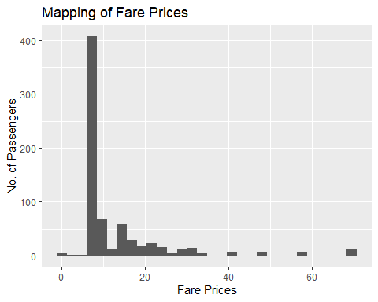

It’s around the **median** which is obtained by the filtered data.  
Now lets calculate the median and assign the value to **NA**.

alldata$Fare[is.na(alldata$Fare)] <- median(fare_df$Fare, na.rm=T)  
  
alldata %>%   
 filter(Age==60.5)

## # A tibble: 1 × 12  
## PassengerId Survived Pclass Name Sex Age SibSp Parch Ticket Fare Cabin  
## <dbl> <dbl> <dbl> <chr> <chr> <dbl> <dbl> <dbl> <chr> <dbl> <chr>  
## 1 1044 NA 3 Storey… male 60.5 0 0 3701 7.51 <NA>   
## # … with 1 more variable: Embarked <chr>

**NOTE**: *na.rm* is used to remove the missing values from the input vector.

#### Converting *Sex* column into numericals

Let’s check the **NA** values in the *Sex* column if any.

table(is.na(alldata$Sex))

##   
## FALSE   
## 1309

There is no **NA** values.  
Now, assign the value **1** for *male* and **0** for *female*.

alldata$Sex[alldata$Sex == "male"] <- 1  
alldata$Sex[alldata$Sex == "female"] <- 0  
head(alldata)

## # A tibble: 6 × 12  
## PassengerId Survived Pclass Name Sex Age SibSp Parch Ticket Fare Cabin  
## <dbl> <dbl> <dbl> <chr> <chr> <dbl> <dbl> <dbl> <chr> <dbl> <chr>  
## 1 1 0 3 Braund… 1 22 1 0 A/5 2… 7.25 <NA>   
## 2 2 1 1 Cuming… 0 38 1 0 PC 17… 71.3 C85   
## 3 3 1 3 Heikki… 0 26 0 0 STON/… 7.92 <NA>   
## 4 4 1 1 Futrel… 0 35 1 0 113803 53.1 C123   
## 5 5 0 3 Allen,… 1 35 0 0 373450 8.05 <NA>   
## 6 6 0 3 Moran,… 1 NA 0 0 330877 8.46 <NA>   
## # … with 1 more variable: Embarked <chr>

## Name

### Separating Title

Lets take a look at the sample of the 30 *Name* column to draw the conclusions about professional title they have.

sample(alldata$Name, 30)

## [1] "Barkworth, Mr. Algernon Henry Wilson"   
## [2] "Warren, Mr. Frank Manley"   
## [3] "Walcroft, Miss. Nellie"   
## [4] "Cameron, Miss. Clear Annie"   
## [5] "Kirkland, Rev. Charles Leonard"   
## [6] "Davies, Mr. Alfred J"   
## [7] "Hansen, Mr. Claus Peter"   
## [8] "Dean, Mr. Bertram Frank"   
## [9] "Barbara, Mrs. (Catherine David)"   
## [10] "Dorking, Mr. Edward Arthur"   
## [11] "Colley, Mr. Edward Pomeroy"   
## [12] "Larsson-Rondberg, Mr. Edvard A"   
## [13] "Moubarek, Mrs. George (Omine Amenia\" Alexander)\""   
## [14] "Augustsson, Mr. Albert"   
## [15] "Flynn, Mr. John Irwin (\"Irving\")"   
## [16] "Shine, Miss. Ellen Natalia"   
## [17] "Geiger, Miss. Amalie"   
## [18] "Lang, Mr. Fang"   
## [19] "Hays, Mrs. Charles Melville (Clara Jennings Gregg)"   
## [20] "Holverson, Mrs. Alexander Oskar (Mary Aline Towner)"  
## [21] "Morley, Mr. William"   
## [22] "Bishop, Mr. Dickinson H"   
## [23] "Asplund, Master. Edvin Rojj Felix"   
## [24] "Hodges, Mr. Henry Price"   
## [25] "Jefferys, Mr. Clifford Thomas"   
## [26] "Coelho, Mr. Domingos Fernandeo"   
## [27] "Moor, Mrs. (Beila)"   
## [28] "Dennis, Mr. William"   
## [29] "Davies, Mr. Charles Henry"   
## [30] "Nourney, Mr. Alfred (Baron von Drachstedt\")\""

Let’s separate the *Professional_title* data from *Name* column.

alldata <- alldata %>%   
 separate(Name, into=c('name2', 'name3'), sep=', ')

alldata <- alldata %>%   
 separate(name3, into=c('Professional_title', 'name4'), sep='. ')

## Warning: Expected 2 pieces. Additional pieces discarded in 845 rows [1, 2, 4, 5, 7, 8,  
## 9, 10, 11, 13, 14, 15, 16, 18, 19, 21, 23, 24, 25, 26, ...].

alldata <- alldata %>%   
 select(-name2,-name4)

### Mapping

Check for the **NA** if any,

table(is.na(alldata$Professional_title))

##   
## FALSE   
## 1309

As there is no **NA** so lets make a plot of total counts of all titles.

ggplot(data=alldata) +  
 geom_bar(mapping=aes(x=Professional_title), fill='blue') +  
 labs(title="Professional Title") +  
 theme(axis.text.x = element_text(angle=45))

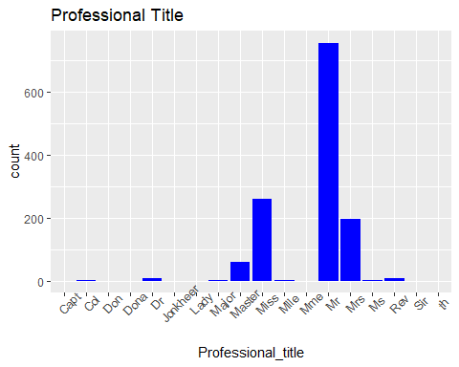

Now, we observe the popular title to have the idea about Survival for different title holders.

ggplot(data = alldata %>% filter(Professional_title %in% c("Mr", "Miss", "Mrs", "Master"))) +  
 geom_histogram(mapping=aes(x=Survived, fill=Professional_title))+  
 facet_grid(~Professional_title)+  
 labs(title="Mapping of popular title", x="Survived=1")+  
 theme(axis.text.x=element_text(angle=90))

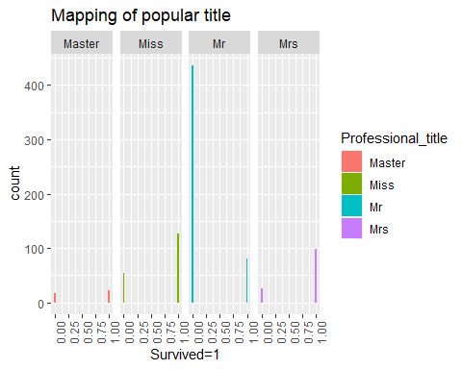

### Converting the rare titles into popular ones

Let’s observe the data of *male title* and draw some insights about them.

alldata %>%   
 filter(Professional_title %in% c("Capt", "Col", "Don", "Dr", "Jonkheer", "Major", "Rev", "Sir"))

## # A tibble: 26 × 12  
## PassengerId Survi…¹ Pclass Profe…² Sex Age SibSp Parch Ticket Fare Cabin  
## <dbl> <dbl> <dbl> <chr> <chr> <dbl> <dbl> <dbl> <chr> <dbl> <chr>  
## 1 31 0 1 Don 1 40 0 0 PC 17… 27.7 <NA>   
## 2 150 0 2 Rev 1 42 0 0 244310 13 <NA>   
## 3 151 0 2 Rev 1 51 0 0 S.O.P… 12.5 <NA>   
## 4 246 0 1 Dr 1 44 2 0 19928 90 C78   
## 5 250 0 2 Rev 1 54 1 0 244252 26 <NA>   
## 6 318 0 2 Dr 1 54 0 0 29011 14 <NA>   
## 7 399 0 2 Dr 1 23 0 0 244278 10.5 <NA>   
## 8 450 1 1 Major 1 52 0 0 113786 30.5 C104   
## 9 537 0 1 Major 1 45 0 0 113050 26.6 B38   
## 10 600 1 1 Sir 1 49 1 0 PC 17… 56.9 A20   
## # … with 16 more rows, 1 more variable: Embarked <chr>, and abbreviated  
## # variable names ¹​Survived, ²​Professional_title

Let’s rename the titles like *Capt*, *Col*, *Don*, *Dr*, *Jonkheer*, *Major*, *Rev*, *Sir* into *Mr* for making our life easy as there is no important insight and No. of Survived are equivalent to *Mr*….

alldata$Professional_title[alldata$Professional_title %in% c("Capt", "Col", "Don", "Dr", "Jonkheer", "Major", "Rev", "Sir")] <- "Mr"

Do the same process with *female title*.

alldata %>%   
 filter(Professional_title %in% c("Dona", "Lady", "Mlle", "Mme", "th"))

## # A tibble: 6 × 12  
## PassengerId Survived Pclass Profe…¹ Sex Age SibSp Parch Ticket Fare Cabin  
## <dbl> <dbl> <dbl> <chr> <chr> <dbl> <dbl> <dbl> <chr> <dbl> <chr>  
## 1 370 1 1 Mme 0 24 0 0 PC 17… 69.3 B35   
## 2 557 1 1 Lady 0 48 1 0 11755 39.6 A16   
## 3 642 1 1 Mlle 0 24 0 0 PC 17… 69.3 B35   
## 4 711 1 1 Mlle 0 24 0 0 PC 17… 49.5 C90   
## 5 760 1 1 th 0 33 0 0 110152 86.5 B77   
## 6 1306 NA 1 Dona 0 39 0 0 PC 17… 109. C105   
## # … with 1 more variable: Embarked <chr>, and abbreviated variable name  
## # ¹​Professional_title

Let’s rename the titles like *Dona*, *Lady*, *Mlle*, *Mme*, *th* into *Mrs* and *Ms* into *Miss* as Ms is basically the short of Miss.

alldata$Professional_title[alldata$Professional_title %in% c("Dona", "Lady", "Mlle", "Mme", "th")] <- "Mrs"

alldata$Professional_title[alldata$Professional_title == "Ms"] <- "Miss"

ggplot(data=alldata) +  
 geom_bar(mapping=aes(x=Professional_title)) +  
 labs(title="Professional Title (Only Populars)") +  
 theme(axis.text.x = element_text(angle=45))

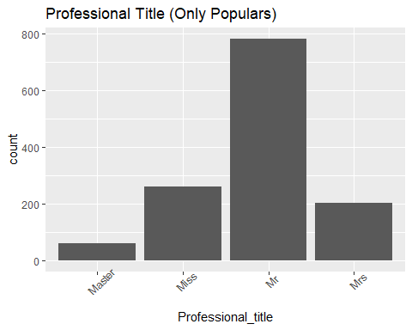

## Embarked

First of all see the **NA** value if any in the *Embarked* column

table(is.na(alldata$Embarked))

##   
## FALSE TRUE   
## 1307 2

### Observe the data

Review the both rows and draw the conclusion to fill the missing values.

alldata %>%   
 filter(is.na(Embarked))

## # A tibble: 2 × 12  
## PassengerId Survived Pclass Profe…¹ Sex Age SibSp Parch Ticket Fare Cabin  
## <dbl> <dbl> <dbl> <chr> <chr> <dbl> <dbl> <dbl> <chr> <dbl> <chr>  
## 1 62 1 1 Miss 0 38 0 0 113572 80 B28   
## 2 830 1 1 Mrs 0 62 0 0 113572 80 B28   
## # … with 1 more variable: Embarked <chr>, and abbreviated variable name  
## # ¹​Professional_title

We can see that both have *Pclass*=1, same *Ticket* number, *Fare*=80, same *Cabin* and both *female*.

ggplot(alldata %>% filter(Pclass==1)) +  
 geom_boxplot(mapping=aes(x=Embarked, y=Fare, fill=Sex)) +  
 labs(title="Mapping of data taking Pclass=1")

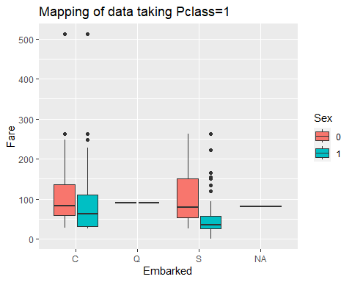

With the help of plot we can conclude that missing value is the **C**.

### Filling the missing value

alldata$Embarked[is.na(alldata$Embarked)] <- "C"

## Age

Let’s see the **NA** value if any in the *Age* column.

table(is.na(alldata$Age))

##   
## FALSE TRUE   
## 1046 263

Let’ draw a plot to have a better idea about *age* and *title* as they can have some relationship to fill our missing.

ggplot(alldata) +  
 geom_boxplot(mapping=aes(x=Professional_title, y=Age)) +  
 labs(title = "Median of the different titles")

## Warning: Removed 263 rows containing non-finite values (`stat_boxplot()`).

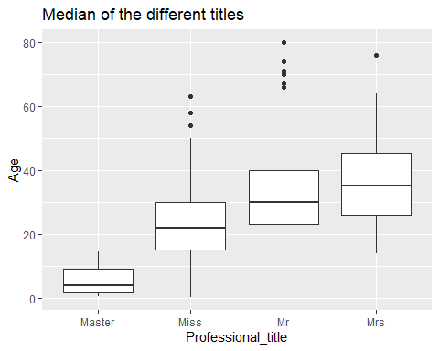

Let’s take the **median** of the respective *Professional_title* and fill the missing value respectively.

### Filling Master title

master_df <- alldata %>%   
 filter(Professional_title=="Master")  
master_df$Age[is.na(master_df$Age)] <- median(master_df$Age, na.rm=T)

### Filling Miss title

miss_df <- alldata %>%   
 filter(Professional_title=="Miss")  
miss_df$Age[is.na(miss_df$Age)] <- median(miss_df$Age, na.rm=T)

### Filling Mr title

mr_df <- alldata %>%   
 filter(Professional_title=="Mr")  
mr_df$Age[is.na(mr_df$Age)] <- median(mr_df$Age, na.rm=T)

### Filling Mrs title

mrs_df <- alldata %>%   
 filter(Professional_title=="Mrs")  
mrs_df$Age[is.na(mrs_df$Age)] <- median(mrs_df$Age, na.rm=T)

### Binding

Now, merge the data into again *alldata* dataset.

alldata <- rbind(master_df, miss_df, mr_df, mrs_df)  
alldata <- alldata %>%   
 arrange(PassengerId)

## Ticket

Check the **NA** if any,

table(is.na(alldata$Ticket))

##   
## FALSE   
## 1309

Take the sample and observe the data of *ticket* column.

sample(alldata$Ticket, 30)

## [1] "F.C.C. 13529" "243847" "347080" "SOTON/O2 3101287"  
## [5] "28220" "248738" "29108" "C.A. 29566"   
## [9] "11765" "315095" "349251" "315090"   
## [13] "F.C.C. 13540" "C.A. 34644" "C.A. 17248" "237671"   
## [17] "1601" "237789" "382649" "C 4001"   
## [21] "PP 4348" "4133" "349238" "315089"   
## [25] "PC 17558" "248727" "239059" "345777"   
## [29] "9234" "CA 31352"

Can’t have any relevance to the survival of the passengers, so decided to remove the column

alldata <- alldata %>%   
 select(-Ticket)

## Pclass

Check the **NA** if any,

table(is.na(alldata$Pclass))

##   
## FALSE   
## 1309

## SibSp

Check the **NA** if any,

table(is.na(alldata$SibSp))

##   
## FALSE   
## 1309

## Parch

Check the **NA** if any,

table(is.na(alldata$Parch))

##   
## FALSE   
## 1309

## Cabin

Check the **NA** if any,

table(is.na(alldata$Cabin))

##   
## FALSE TRUE   
## 295 1014

As there are many empty cells in the *Cabin* column so best possible solution is to drop the column only.

alldata <- alldata %>%   
 select(-Cabin)

# Appling Model into our cleaned data

### Let’s apply a randomForest

Honestly didn’t know the shit about this models right now :(  
but let’s apply to our data.

i <- is.na(alldata$Survived)  
myforest <- randomForest(data=alldata[!i,], Survived ~ Pclass + Age + SibSp + Parch + Fare + Embarked + Sex + Professional_title,  
 ntree=10000, sampsize = 400, mtry=4)

## Warning in randomForest.default(m, y, ...): The response has five or fewer  
## unique values. Are you sure you want to do regression?

Now let’s look the **model** works decent or not…

table(round(predict(myforest, newdata=alldata[!i,])) == alldata[!i,]$Survived)

##   
## FALSE TRUE   
## 89 802

Add the predictions into our data for submissions

alldata$forestpred <- round(predict(myforest, newdata=alldata))  
rm(myforest)

Export the **.csv** file

write.csv(alldata %>%   
 filter(PassengerId %in% c(892:1310)) %>%   
 select(PassengerId, forestpred) %>%   
 rename(Survived = forestpred), "submission.csv")

Now deleted the No. column in the Excel manually and submitted the data……..**0.77272**  
Great for my first Project.

Thank you