ScrollView嵌套ListView

NestedScrollView嵌套RecyclerView
都会出现 ScrollView展示的第一条数据，是ListView的第一条数据， 在ListView之上的布局， 是看不见的，
解决办法：android:descendantFocusability="blocksDescendants"

<android.support.v4.widget.NestedScrollView
android:layout_width="match_parent"
android:layout_height="match_parent">
<LinearLayout
android:descendantFocusability="blocksDescendants"
android:layout_width="match_parent"
android:layout_height="match_parent"
android:orientation="vertical">

beforeDescendants：viewgroup会优先其子类控件而获取到焦点
afterDescendants：viewgroup只有当其子类控件不需要获取焦点时才获取焦点
blocksDescendants：viewgroup会覆盖子类控件而直接获得焦点

CoordinateLayout嵌套水平的RecyclerView

Java
rvTotal.setNestedScrollingEnabled(false);
rvWeekly.setNestedScrollingEnabled(false);
....
LinearLayoutManager layoutManager = new LinearLayoutManager(getContext());
layoutManager.setSmoothScrollbarEnabled(true);
layoutManager.setAutoMeasureEnabled(true);
mNearbyCtivists.setLayoutManager(layoutManager);
mNearbyCtivists.setHasFixedSize(true);
mNearbyCtivists.setNestedScrollingEnabled(false);

xml

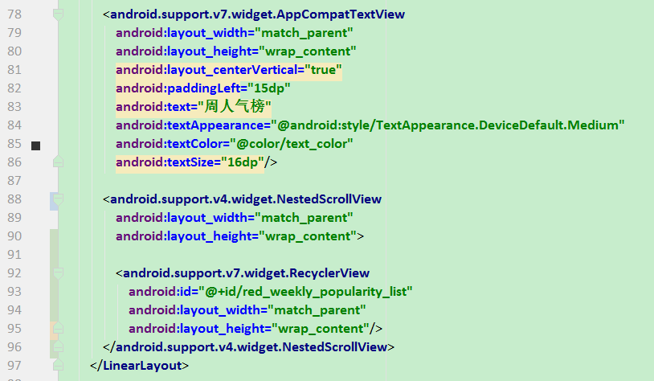

65535问题
java.lang.NoClassDefFoundError: com.gomejr.myf.mine.login.LoginActivity
正常来说，会报65535的问题， 我的确实只是报了 NoClassDefFoundError

java.lang.NoClassDefFoundError: com.gomejr.myf.mine.login.LoginActivity

Error:Execution failed for task ':ttt:transformClassesWithDexForDebug'.
com.android.build.api.transform.TransformException: com.android.ide.common.process.ProcessException:
java.util.concurrent.ExecutionException: com.android.dex.DexIndexOverflowException: method ID not in [0, 0xffff]: 65536
解决
主模块的gradle
defaultConfig {
multiDexEnabled true
}

compile 'com.android.support:multidex:1.0.0'

@Override
protected void attachBaseContext(Context base) {
super.attachBaseContext(base);
MultiDex.install(this);
}

Uri_7.0

java代码

/**
* 安装apk
*/
public void installApk(File file) {
try {
Intent intent = new Intent();
intent.setAction(Intent.ACTION_VIEW);
intent.setFlags(Intent.FLAG_ACTIVITY_NEW_TASK);
LogTrack.e(file.getAbsolutePath());
Uri uriForFile;
if (Build.VERSION.SDK_INT >= Build.VERSION_CODES.N) {
uriForFile = FileProvider.getUriForFile(this.activity, this.activity.getApplicationContext().getPackageName() + ".provider", file);
intent.addFlags(Intent.FLAG_GRANT_READ_URI_PERMISSION);
} else {
uriForFile = Uri.fromFile(file);
}
intent.setDataAndType(uriForFile, "application/vnd.android.package-archive");
LogTrack.e("开始安装--");
activity.startActivity(intent);
} catch (Exception ex) {
LogTrack.e(ex);
}
}

res/xml/file_paths.xml
<?xml version="1.0" encoding="utf-8"?>
<paths xmlns:android="http://schemas.android.com/apk/res/android">
<external-path name="external_files" path="."/>
</paths>

清单文件
<manifest xmlns:android="http://schemas.android.com/apk/res/android"
package="com.alex.install">
<application
>
<!-- android:authorities="包名.provider" -->
<provider
android:name="android.support.v4.content.FileProvider"
android:authorities="com.alex.install.provider"
android:grantUriPermissions="true"
android:exported="false"
>
<meta-data
android:name="android.support.FILE_PROVIDER_PATHS"
android:resource="@xml/file_paths" />
</provider>
</application>
</manifest>

