Handler机制
Handler 需要初始化， 也就是要 new 出来的， 在Handler的构造函数里面，会调用 Looper.myLoop方法， 获得一个looper，
由于初始化的这个looper会传给静态的 ThreadLocal 对象， 所以looper是唯一的， messageQueue不一定是唯一的了。

在线程中使用Handler
/*Looper源码给的注释*/
class LooperThread extends Thread {
public Handler mHandler;
public void run() {
Looper.prepare();
mHandler = new Handler() {
public void handleMessage(Message msg) {
// process incoming messages here
}
};
Looper.loop();
}
}
Looper.prepare会初始化一个 MessageQueue，
Handler发送的消息， 最终会由messageQueue将这条消息拉进消息队列的，
当 Looper.loop(); 执行后， 会不断的从消息队列迭代出消息，
哪个handler发送的消息， 经由 looper回调给哪个handler去处理-handlerMessage，

为什么，handlerMessage会工作在U线程？
因为Looper只有一个， Looper第一次初始化在哪个线程？
Looper第一次被初始化在ActivityThread的main方法中， 所以handlerMessage就是工作在UI线程

Handler

Handler初始化
会初始化一个 Looper和一个
public Handler() {
this(null, false);
}
public Handler(Callback callback, boolean async) {
if (FIND_POTENTIAL_LEAKS) {
final Class<? extends Handler> klass = getClass();
if ((klass.isAnonymousClass() || klass.isMemberClass() || klass.isLocalClass()) &&
(klass.getModifiers() & Modifier.STATIC) == 0) {
Log.w(TAG, "The following Handler class should be static or leaks might occur: " +
klass.getCanonicalName());
}
}
mLooper = Looper.myLooper();
if (mLooper == null) {
throw new RuntimeException(
"Can't create handler inside thread that has not called Looper.prepare()");
}
mQueue = mLooper.mQueue;
mCallback = callback;
mAsynchronous = async;
}

handler发送消息
无论是send还是post 最终都会调用
private boolean enqueueMessage(MessageQueue queue, Message msg, long uptimeMillis) {
msg.target = this;
if (mAsynchronous) {
msg.setAsynchronous(true);
}
return queue.enqueueMessage(msg, uptimeMillis);
}

Looper

myLooper
public static @Nullable Looper myLooper()
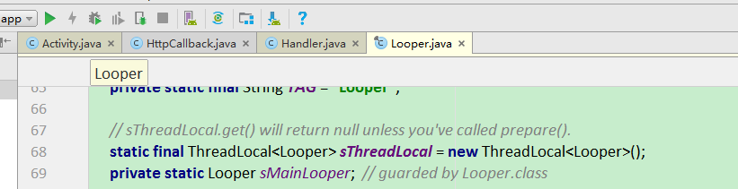
public static @Nullable Looper myLooper() {
return sThreadLocal.get();
}

prepare
如果在Thread中 直接 new Handler().sendMessge();
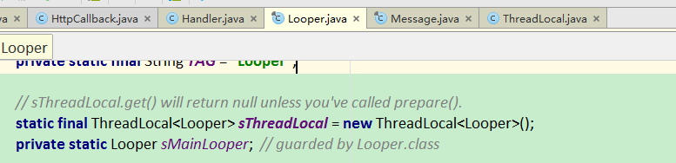
private static void prepare(boolean quitAllowed) {
if (sThreadLocal.get() != null) {
throw new RuntimeException("Only one Looper may be created per thread");
}
sThreadLocal.set(new Looper(quitAllowed));
}
private Looper(boolean quitAllowed) {
mQueue = new MessageQueue(quitAllowed);
mThread = Thread.currentThread();
}

loop
public static void loop() {
final Looper me = myLooper();
if (me == null) {
throw new RuntimeException("No Looper; Looper.prepare() wasn't called on this thread.");
}
final MessageQueue queue = me.mQueue;
Binder.clearCallingIdentity();
final long ident = Binder.clearCallingIdentity();
for (;;) {
Message msg = queue.next(); // might block
if (msg == null) {
// No message indicates that the message queue is quitting.
return;
}
// This must be in a local variable, in case a UI event sets the logger
final Printer logging = me.mLogging;
if (logging != null) {
logging.println(">>>>> Dispatching to " + msg.target + " " + msg.callback + ": " + msg.what);
}
final long traceTag = me.mTraceTag;
if (traceTag != 0 && Trace.isTagEnabled(traceTag)) {
Trace.traceBegin(traceTag, msg.target.getTraceName(msg));
}
try {
/*最终是， 谁发的消息， 交给谁处理*/
msg.target.dispatchMessage(msg);
} finally {
if (traceTag != 0) {
Trace.traceEnd(traceTag);
}
}
if (logging != null) {
logging.println("<<<<< Finished to " + msg.target + " " + msg.callback);
}
// Make sure that during the course of dispatching the identity of the thread wasn't corrupted.
final long newIdent = Binder.clearCallingIdentity();
if (ident != newIdent) {
Log.wtf(TAG, "Thread identity changed from 0x" + Long.toHexString(ident) + " to 0x" + Long.toHexString(newIdent) + " while dispatching to " + msg.target.getClass().getName() + " " + msg.callback + " what=" + msg.what);
}
msg.recycleUnchecked();
}
}

ActivityThread

main方法
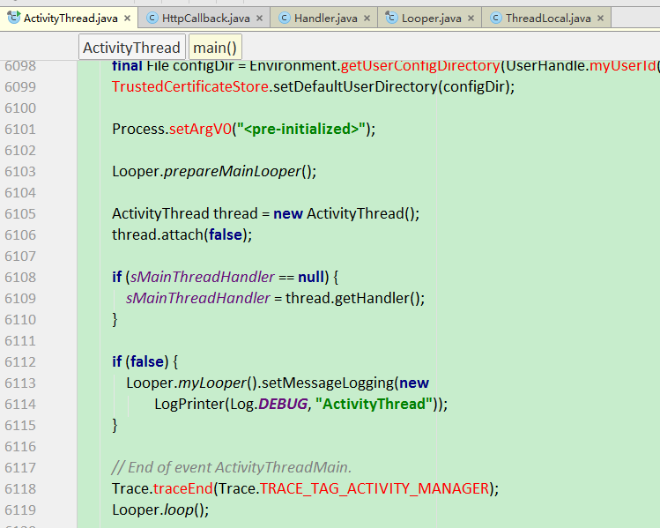

performLaunchActivity
private Activity performLaunchActivity(ActivityClientRecord r, Intent customIntent)
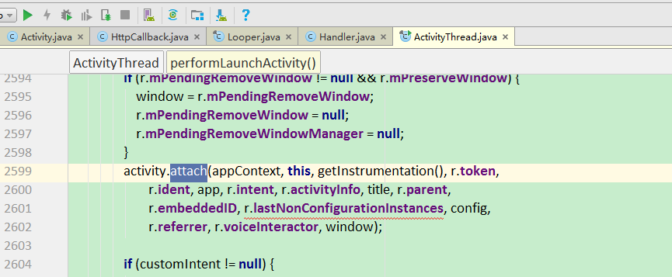7

参考
http://blog.sina.com.cn/s/blog_6813fb240100z9cs.html

