概念
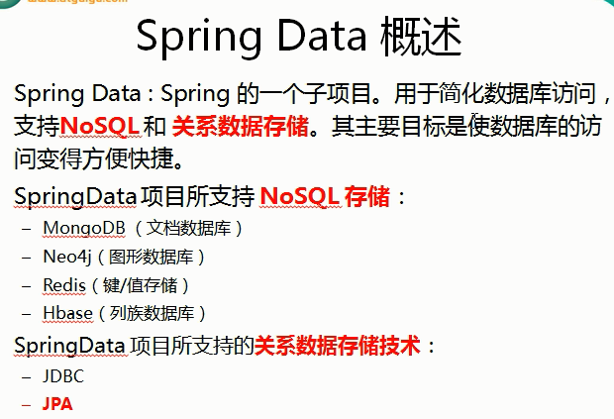

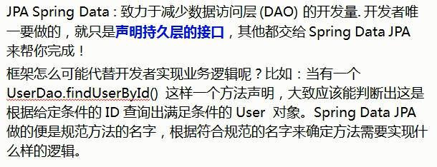

Sample步骤
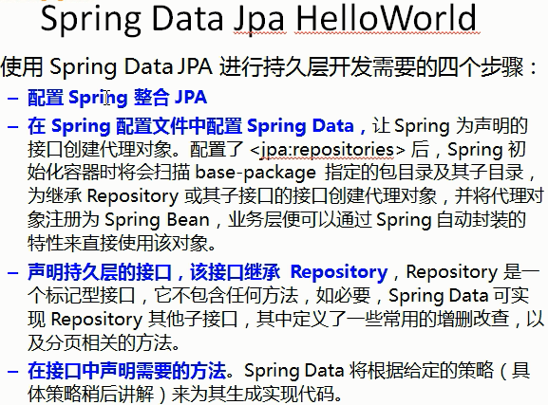

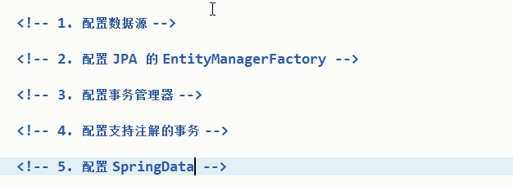

appconfig.properties
jdbc.driver=com.mysql.jdbc.Driver
jdbc.url=jdbc:mysql://127.0.0.1:3306/maternalshop?useUnicode=true&characterEncoding=UTF-8
jdbc.username=root
jdbc.password=root

applicationContext.xml
<?xml version="1.0" encoding="UTF-8"?>
<beans xmlns="http://www.springframework.org/schema/beans"
xmlns:xsi="http://www.w3.org/2001/XMLSchema-instance"
xmlns:context="http://www.springframework.org/schema/context" xmlns:tx="http://www.springframework.org/schema/tx"
xmlns:jpa="http://www.springframework.org/schema/data/jpa"
xsi:schemaLocation="http://www.springframework.org/schema/beans http://www.springframework.org/schema/beans/spring-beans.xsd http://www.springframework.org/schema/context http://www.springframework.org/schema/context/spring-context.xsd http://www.springframework.org/schema/tx http://www.springframework.org/schema/tx/spring-tx.xsd http://www.springframework.org/schema/data/jpa http://www.springframework.org/schema/data/jpa/spring-jpa.xsd">
<context:property-placeholder location="classpath:appconfig.properties"/>
<bean id="dataSource" class="com.mchange.v2.c3p0.ComboPooledDataSource">
<property name="driverClass" value="${jdbc.driver}"/>
<property name="jdbcUrl" value="${jdbc.url}"/>
<property name="user" value="${jdbc.username}"/>
<property name="password" value="${jdbc.password}"/>
</bean>
<bean id="entityManagerFactory" class="org.springframework.orm.jpa.LocalContainerEntityManagerFactoryBean">
<property name="dataSource" ref="dataSource"/>
<property name="jpaVendorAdapter">
<bean class="org.springframework.orm.jpa.vendor.HibernateJpaVendorAdapter"/>
</property>
<property name="packagesToScan" value="com.alex.springdatasample">
</property>
<property name="jpaProperties">
<props>
<prop key="hibernate.ejb.naming_strategy">org.hibernate.cfg.ImprovedNamingStrategy</prop>
<prop key="hibernate.dialect">org.hibernate.dialect.MySQL5InnoDBDialect</prop>
<prop key="hibernate.format_sql">true</prop>
<prop key="hibernate.show_sql">true</prop>
<prop key="hibernate.hbm2ddl.auto">update</prop>
</props>
</property>
</bean>
<bean id="transactionManager"
class="org.springframework.orm.jpa.JpaTransactionManager">
<property name="entityManagerFactory" ref="entityManagerFactory"/>
</bean>
<tx:annotation-driven transaction-manager="transactionManager"/>
<!--自动扫描 Repository 的Bean-->
<jpa:repositories base-package="com.alex.springdatasample" entity-manager-factory-ref="entityManagerFactory"/>
</beans>

UserDao
public interface UserDao extends Repository<UserEntity, Integer> {
void save(UserEntity entity);
List<UserEntity> findUserEntityByNickname(String nickname);
}

测试
fun testJpa() {
val userDao = applicationContext.getBean(UserDao::class.java)
userDao.findUserEntityByNickname("Alex01").forEach{
it.logE()
}
}

Repository
public interface UserDao extends Repository<UserEntity, Integer> {
void save(UserEntity entity);
List<UserEntity> findUserEntityByNickname(String nickname);
}

@RepositoryDefinition(domainClass = UserEntity.class, idClass = Integer.class)
public interface UserDao extends UserContract.Dao{
void save(UserEntity entity);
List<UserEntity> findUserEntityByNickname(String nickname);
}
fun testJpa() {
val userDao = applicationContext.getBean(UserContract.Dao::class.java)
userDao.findUserEntityByNickname("Alex01").forEach{
it.logE()
}
}

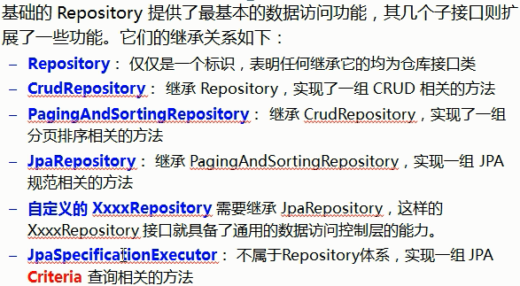

方法名规范-简单查询
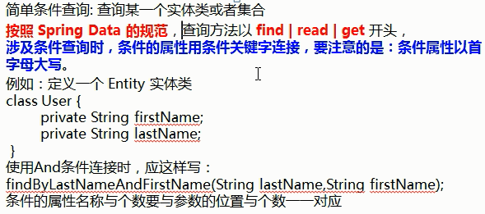
查询支持的关键字
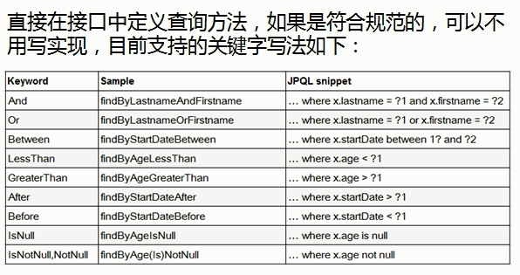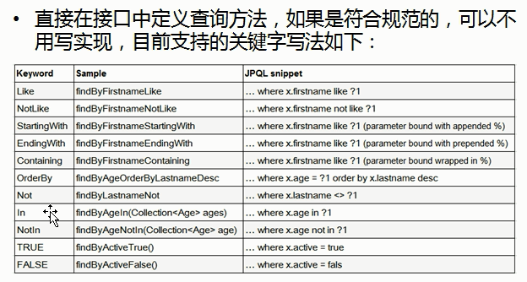

读操作-Query
/**
* 注意这里用的是 实体类 UserEntity 而不是表明 t_user
* */
@Query(value = "select u from UserEntity u where u.id = (select max(u2.id) from UserEntity u2)")
UserEntity findEntity4MaxId();

fun testJpa() {
val userDao = applicationContext.getBean(UserDao::class.java)
userDao.findEntity4MaxId().logE()
}

传递参数
@Query("select u from UserEntity u where u.id = ?1")
UserEntity findEntityById(Integer id);

字符串拼接
@Query(value = "select u from UserEntity u where u.nickname like concat('%', :nickname, '%')")
List<UserEntity> findEntityByNicknameLike(@Param("nickname") String nickname);

使用原生sql
@Query(value = "SELECT * FROM t_user WHERE nickname LIKE concat('%', :nickname, '%')", nativeQuery = true)
List<UserEntity> findEntityByNicknameLikeSQL(@Param("nickname") String nickname);

写操作
//@RepositoryDefinition(domainClass = UserEntity.class, idClass = Integer.class)
public interface UserDao extends Repository<UserEntity, Integer> {
@Modifying
@Query(value = "UPDATE t_user SET nickname = :nickname WHERE id =:id", nativeQuery = true)
void updateNicknameById(@Param("id") Integer id, @Param("nickname") String nickname);
}
@Service(value = "userService")
public class UserService {
@Resource(name = "userDao")
private UserDao userDao;
@Transactional
public UserEntity updateNicknameById(Integer id, String nickname) {
userDao.updateNicknameById(id, nickname);
return userDao.findEntityById(id);
}
}
测试
fun testJpa() {
val userService = applicationContext.getBean(UserService::class.java)
userService.updateNicknameById(13, "cmook").logE()
}

CrudRepository
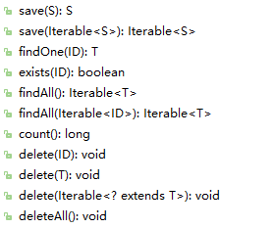

分页PagingAndSortingRepository
//@RepositoryDefinition(domainClass = UserEntity.class, idClass = Integer.class)
public interface UserDao extends PagingAndSortingRepository<UserEntity, Integer> {
}
测试
fun testJpa() {
val userDao = applicationContext.getBean(UserDao::class.java)
var pageSize = 5
val rowCount = userDao.count().toInt()
val pageIndex = (rowCount / pageSize.toFloat()).toIntCeil() - 1
for (page in 0..pageIndex) {
val pageable = PageRequest(page, pageSize)
userDao.findAll(pageable).apply {
"共$totalElements 条记录； 共有$totalPages 页； 每页$pageSize 条记录".logE()
"当前页下标是 $number； 当前页有$numberOfElements 条".logE()
}.forEach {
it.logE()
}
}
}

排序
fun testJpa() {
val userDao = applicationContext.getBean(UserDao::class.java)
val pageSize = 5
val rowCount = userDao.count().toInt()
val pageIndex = (rowCount / pageSize.toFloat()).toIntCeil() - 1
val orderById = Sort.Order(Sort.Direction.DESC, "id")
val orderByNickname = Sort.Order(Sort.Direction.ASC, "nickname")
val sort = Sort(orderById, orderByNickname)
for (page in 0..pageIndex) {
val pageable = PageRequest(page, pageSize, sort)
userDao.findAll(pageable).apply {
"共$totalElements 条记录； 共有$totalPages 页； 每页$pageSize 条记录".logE()
"当前页下标是 $number； 当前页有$numberOfElements 条".logE()
}.forEach {
it.logE()
}
}
}

分页-带查询条件-JpaSpecificationExecutor

Specification
public interface Specification<T> {
/**
* @param root 查询的实体类
* @param query 可以从中得到 root对象， 即告知 Jpa CriteriaQuery 要查询哪一个实体类，还可以添加查询条件，
* 还可以结合EntityManager对象得到最终查询的TypeQuery对象
* @param cb 用于创建 Criteria 相关对象工厂， 可以从中获取到 Predicate 对象
*/
Predicate toPredicate(Root<T> root, CriteriaQuery<?> query, CriteriaBuilder cb);
}

public interface UserDao extends PagingAndSortingRepository<UserEntity, Integer>, JpaSpecificationExecutor<UserEntity> {
}

fun testJpa() {
val userDao = applicationContext.getBean(UserDao::class.java)
val pageSize = 20
val rowCount = userDao.count().toInt()
val pageIndex = (rowCount / pageSize.toFloat()).toIntCeil() - 1
val orderByNickname = Sort.Order(Sort.Direction.ASC, "nickname")
val sort = Sort(orderByNickname)
val specification = Specification<UserEntity> { root, _, cb ->
/**
* @param root 查询的实体类
* @param query 可以从中得到 root对象， 即告知 Jpa CriteriaQuery 要查询哪一个实体类，还可以添加查询条件，
* 还可以结合EntityManager对象得到最终查询的TypeQuery对象
* @param cb 用于创建 Criteria 相关对象工厂， 可以从中获取到 Predicate 对象
*/
val pathAccountBalance: Path<BigDecimal> = root.get("accountBalance")
cb.gt(pathAccountBalance, 2000.0)
}
(0..pageIndex).forEach { page ->
val pageable = PageRequest(page, pageSize, sort)
userDao.findAll(specification, pageable).apply {
(numberOfElements > 0).yes{
"共$totalElements 条记录； 共有$totalPages 页； 每页容量是$pageSize 条".logE()
"当前页下标是 $number； 当前页有$numberOfElements 条".logE()
}
}.forEach {
it.logE()
}
}
}

测试
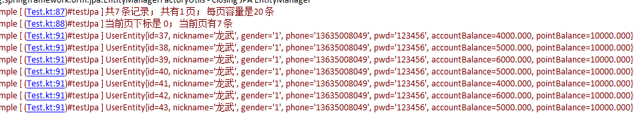

error
org.springframework.dao.InvalidDataAccessApiUsageException:
Unable to locate Attribute with the the given name [account_balance] on this ManagedType [com.alex.springdatasample.usercenter.model.UserEntity];

nested exception is java.lang.IllegalArgumentException:
Unable to locate Attribute with the the given name [account_balance] on this ManagedType [com.alex.springdatasample.usercenter.model.UserEntity];
百度了半天，并没有解决这个破问题，其实，如果英语好一点的话，这半个多小时可以好好陪陪家人了；
意思是 无法定位到属性值 account_balance，因为在这个受管理的类型UserEntity内，并没有提供这个属性；
在数据库中 叫 account_balance 在实体类中叫 accountBalance

参考
http://docs.spring.io/spring-data/jpa/docs/current/reference/html/

