配置环境

官网
http://maven.apache.org/download.cgi

下载文件
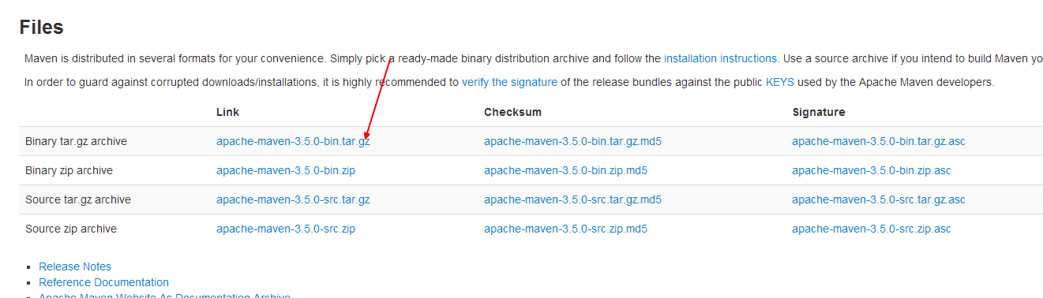

解压缩
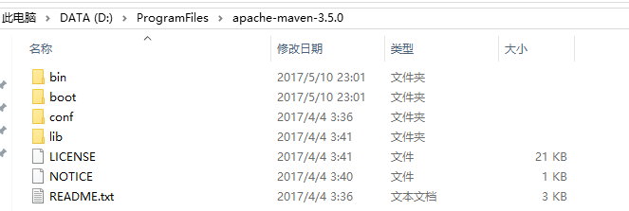

打开配置文件
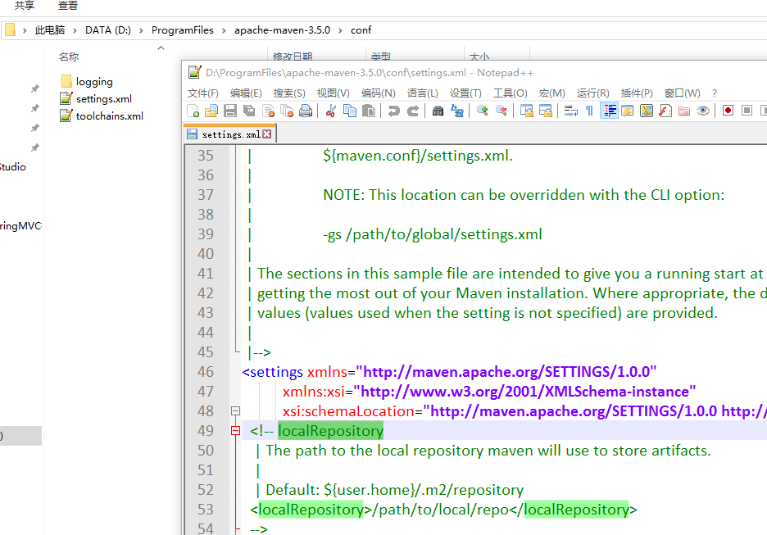

修改localRepository
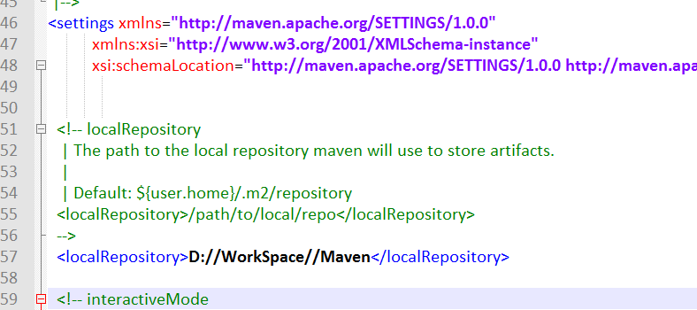

修改Win环境变量
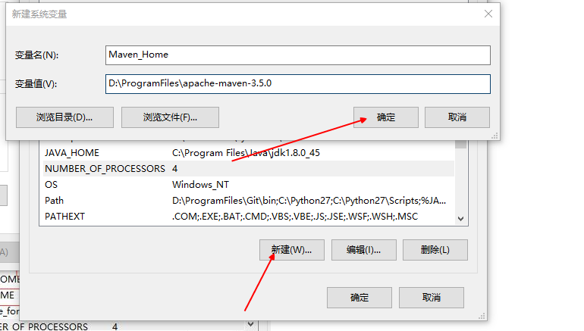

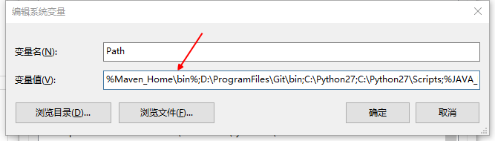

IntelliJ 配置Maven
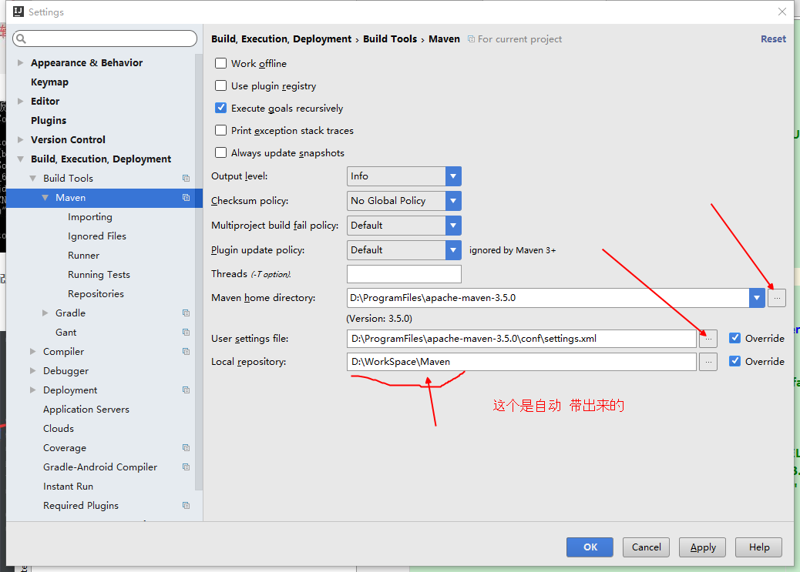

关联maven仓库

新建一个 pom.xml
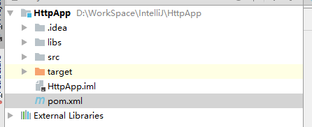
<?xml version="1.0" encoding="UTF-8"?>
<project xmlns="http://maven.apache.org/POM/4.0.0"
xmlns:xsi="http://www.w3.org/2001/XMLSchema-instance"
xsi:schemaLocation="http://maven.apache.org/POM/4.0.0 http://maven.apache.org/xsd/maven-4.0.0.xsd">
<modelVersion>4.0.0</modelVersion>
<groupId>com.alex.springmvcapp</groupId>
<artifactId>springmvcapp</artifactId>
<version>1.0-SNAPSHOT</version>
<build>
<plugins>
<plugin>
<groupId>org.apache.maven.plugins</groupId>
<artifactId>maven-compiler-plugin</artifactId>
<configuration>
<source>1.8</source>
<target>1.8</target>
</configuration>
</plugin>
</plugins>
</build>
<dependencies>
<!-- https://mvnrepository.com/artifact/com.google.code.gson/gson -->
<dependency>
<groupId>com.google.code.gson</groupId>
<artifactId>gson</artifactId>
<version>2.8.0</version>
</dependency>
</dependencies>
</project>

把 xml 文件标记为maven仓库
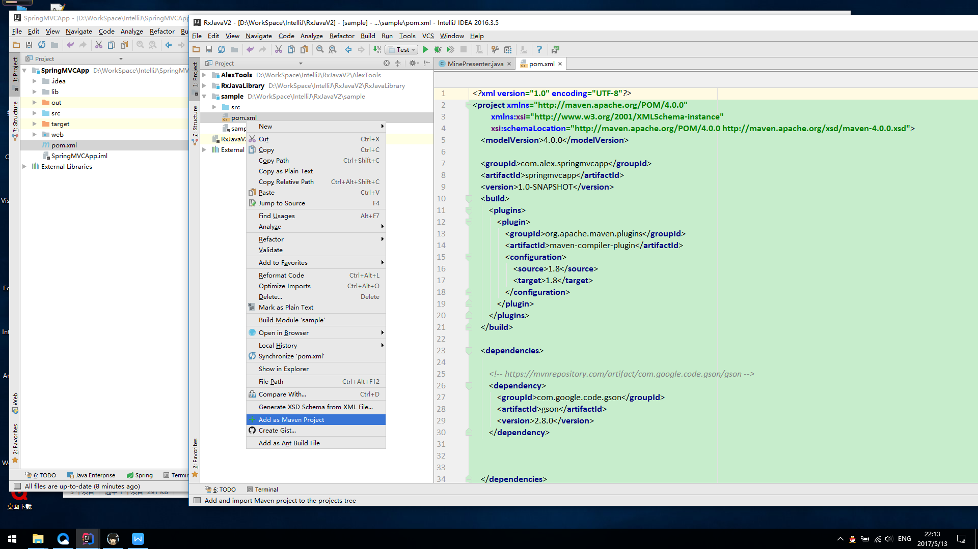

同步Maven
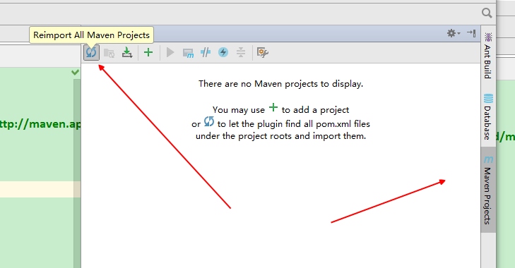

正确的结果
