Jpa的概念
JPA全称Java Persistence API.JPA通过JDK 5.0注解或XML描述对象－关系表的映射关系，并将运行期的实体对象持久化到数据库中。
JPA 是 JCP 组织发布的 Java EE 标准之一，因此任何声称符合 JPA 标准的框架都遵循同样的架构，提供相同的访问API，
这保证了基于JPA开发的企业应用能够经过少量的修改就能够在不同的JPA框架下运行。

Jpa-IntelliJ
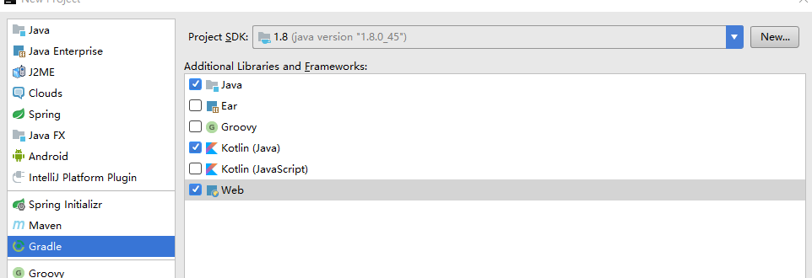

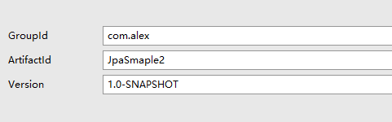

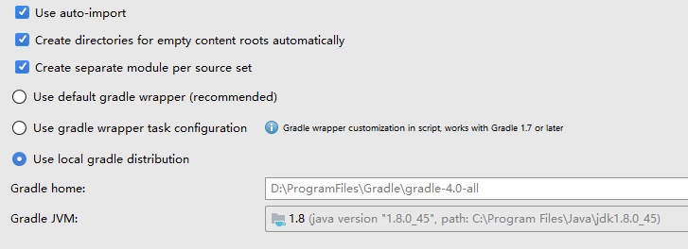

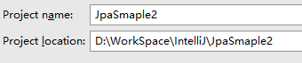

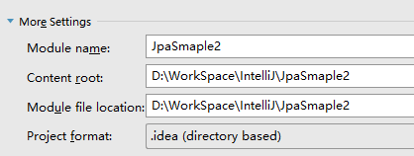

Gradle
group 'com.alex'
version '1.0-SNAPSHOT'
apply plugin: 'java'
apply plugin: 'kotlin'
apply plugin: 'eclipse'
apply plugin: 'war'
apply plugin: 'org.springframework.boot'
sourceCompatibility = 1.8
buildscript {
ext.kotlin_version = '1.1.3'
ext {
springBootVersion = '1.5.4.RELEASE'
}
repositories {
/*当 有多个仓库的时候，会按照仓库的顺序，找对应的依赖*/
mavenLocal()
mavenCentral()
jcenter()
}
dependencies {
classpath("org.springframework.boot:spring-boot-gradle-plugin:${springBootVersion}")
classpath "org.jetbrains.kotlin:kotlin-gradle-plugin:$kotlin_version"
}
}
repositories {
/*当 有多个仓库的时候，会按照仓库的顺序，找对应的依赖*/
mavenLocal()
mavenCentral()
jcenter()
}
compileKotlin {
kotlinOptions.jvmTarget = "1.8"
}
compileTestKotlin {
kotlinOptions.jvmTarget = "1.8"
}
dependencies {
testCompile group: 'junit', name: 'junit', version: '4.11'
testCompile group: 'junit', name: 'junit', version: '4.12'
compile "org.jetbrains.kotlin:kotlin-stdlib-jre8:$kotlin_version"
compile('org.springframework.boot:spring-boot-starter-data-jpa')
compile('org.springframework.boot:spring-boot-starter-data-mongodb')
compile('org.springframework.boot:spring-boot-starter-data-redis')
compile('org.springframework.boot:spring-boot-starter-jdbc')
compile('org.springframework.boot:spring-boot-starter-jta-atomikos')
compile('org.springframework.boot:spring-boot-starter-jta-bitronix')
compile('org.springframework.boot:spring-boot-starter-jta-narayana')
compile('org.mybatis.spring.boot:mybatis-spring-boot-starter:1.3.0')
compile('org.springframework.boot:spring-boot-starter-web')
runtime('mysql:mysql-connector-java')
testCompile('org.springframework.boot:spring-boot-starter-test')
}

配置环境DB

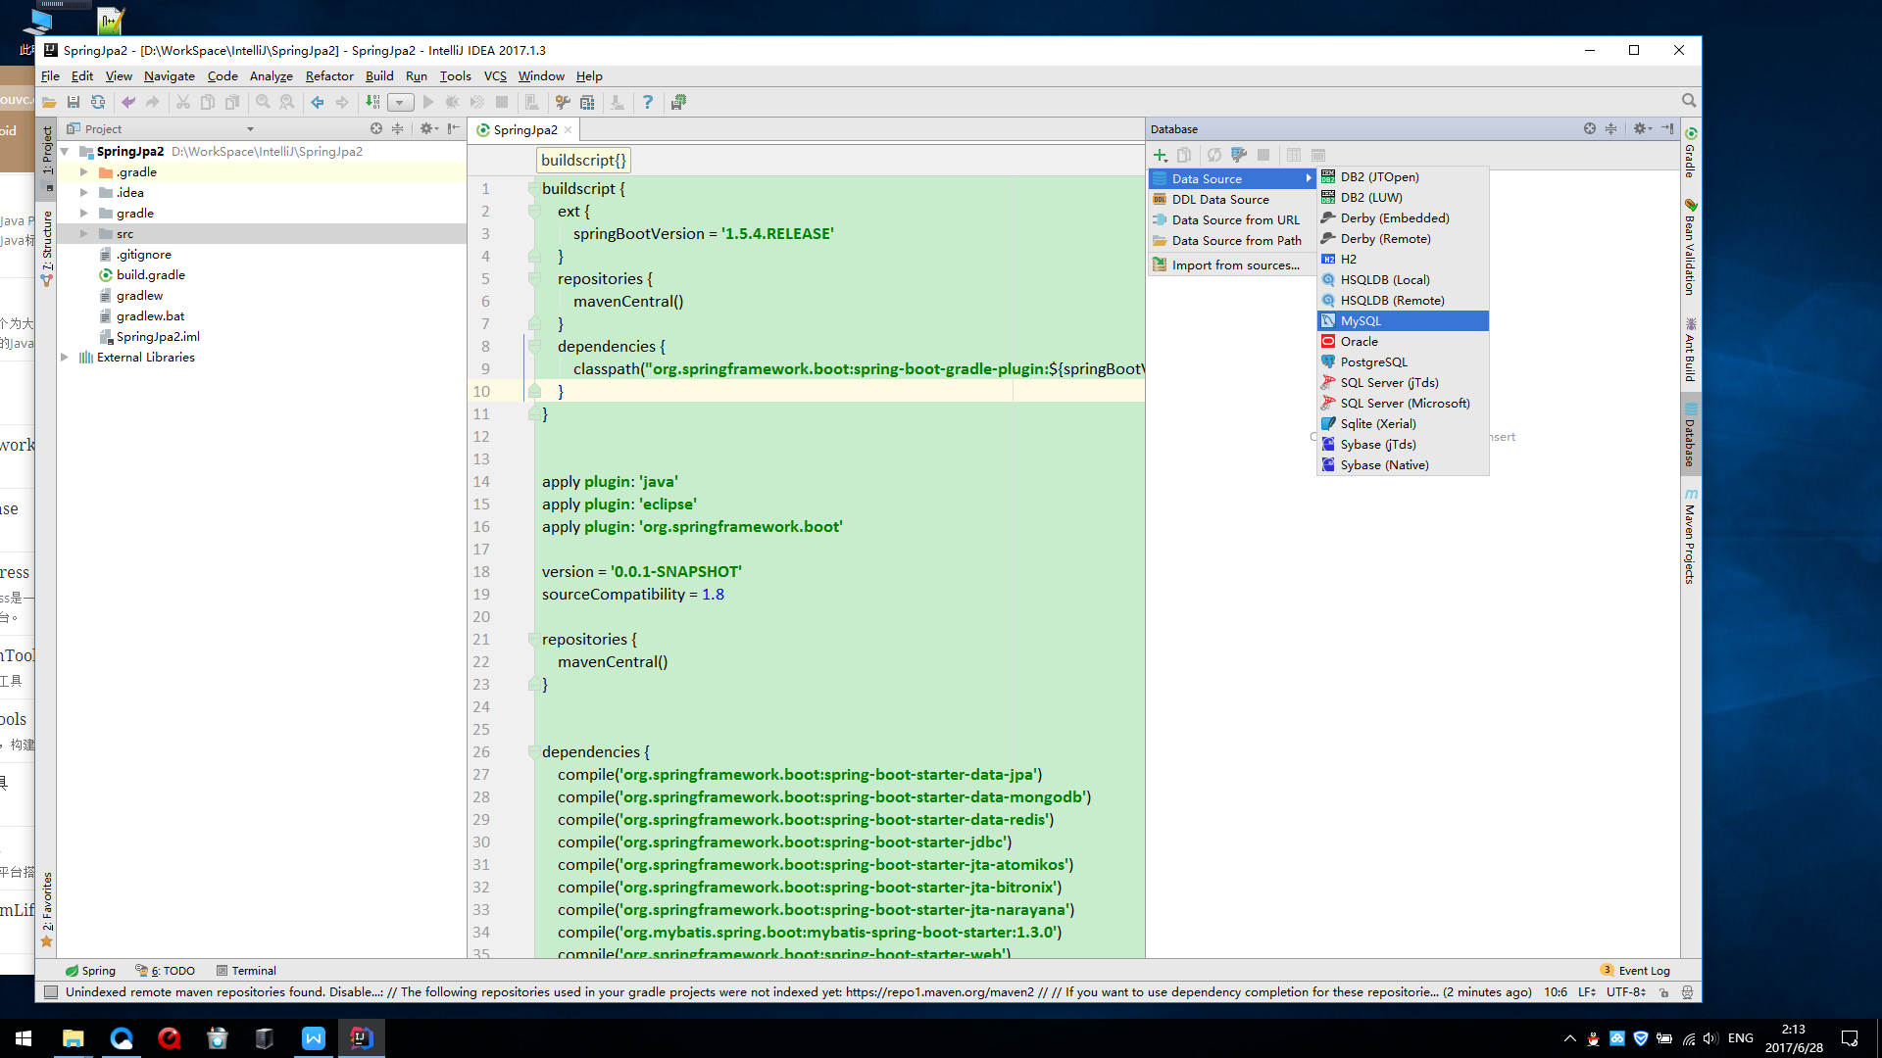

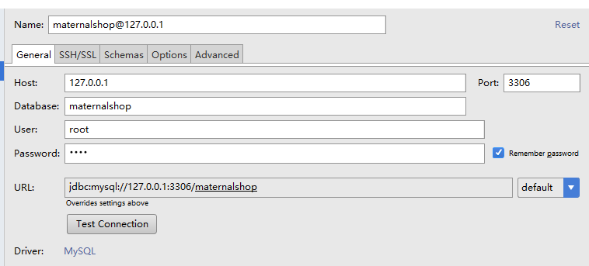

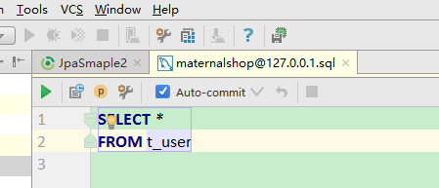

关联JPA

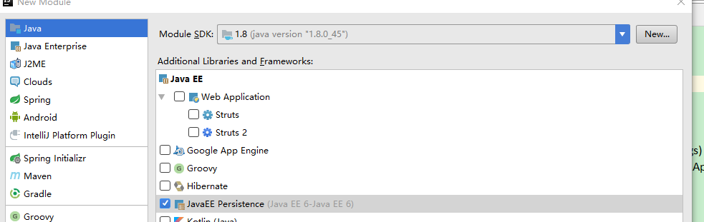

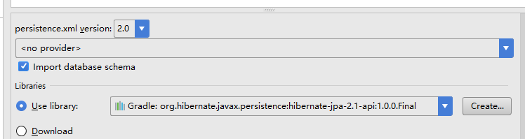

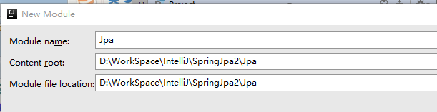

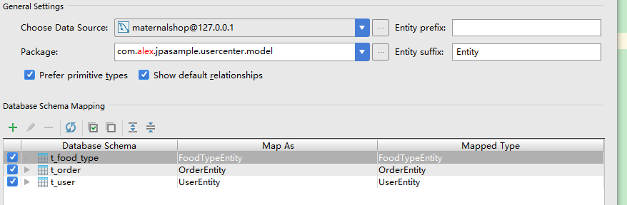

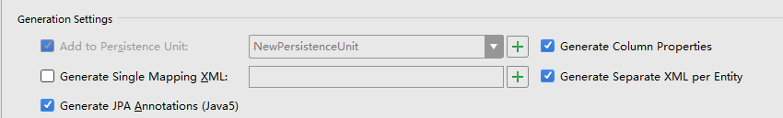

关联Hibernate

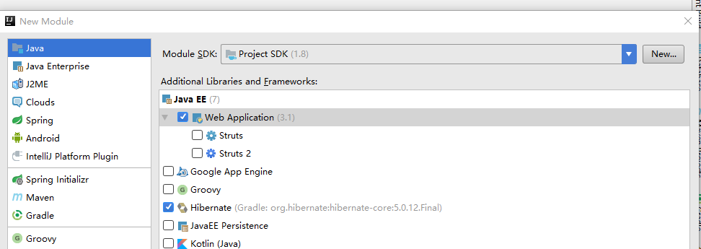

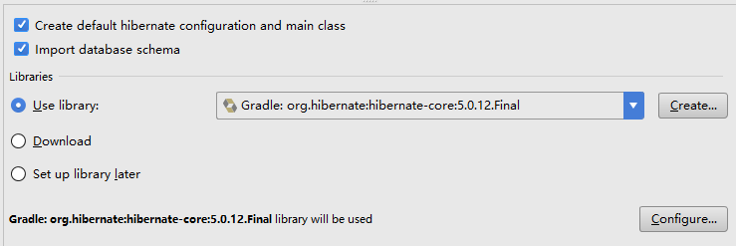

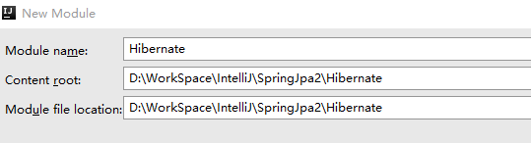

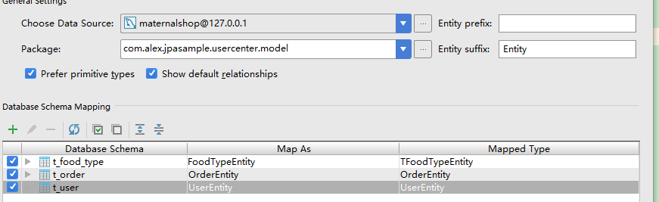

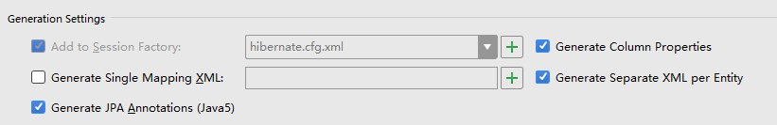

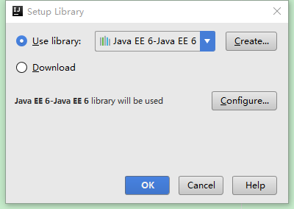

persistence.xml
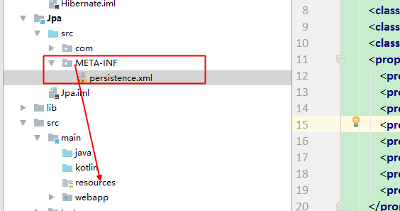


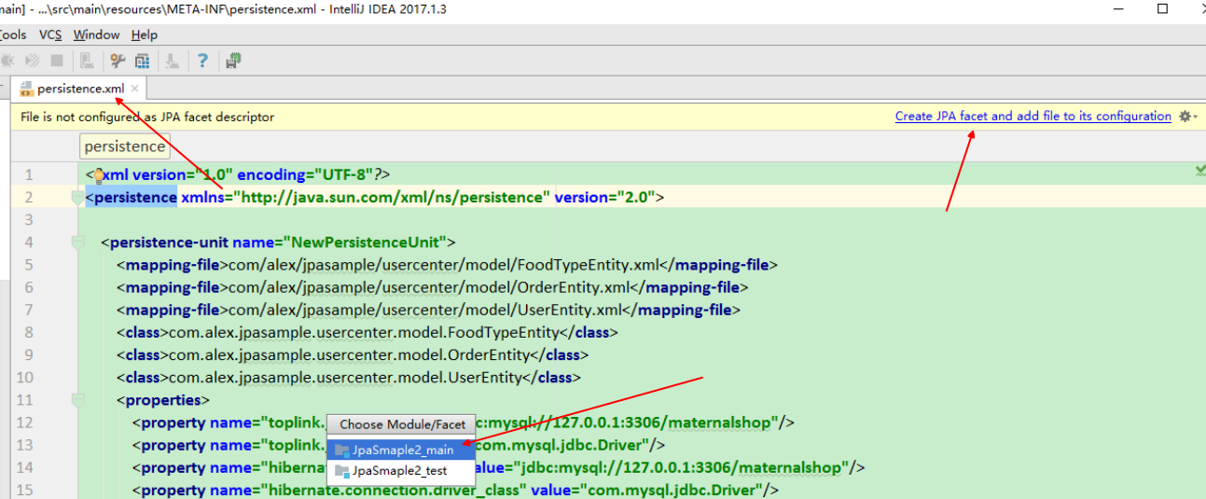

<?xml version="1.0" encoding="UTF-8"?>
<persistence xmlns="http://java.sun.com/xml/ns/persistence" version="2.0">
<persistence-unit name="jpa-1">
<provider>org.hibernate.ejb.HibernatePersistence</provider>
<properties>
<property name="javax.persistence.jdbc.url" value="jdbc:mysql://127.0.0.1:3306/maternalshop"/>
<property name="javax.persistence.jdbc.driver" value="com.mysql.jdbc.Driver"/>
<property name="javax.persistence.jdbc.user" value="root"/>
<property name="javax.persistence.jdbc.password" value="root"/>
<property name="hibernate.format_sql" value="true"/>
<property name="hibernate.show_sql" value="true"/>
<property name="hibernate.hbm2ddl.auto" value="update"/>
</properties>
</persistence-unit>
</persistence>

UserEntity

package com.alex.jpasample.usercenter.model;
import javax.persistence.*;
import java.math.BigDecimal;
/**
* 作者：Alex
* 时间：2017/6/29 23:36
* 简述：
*/
@Entity
@Table(name = "t_user", schema = "maternalshop" )
public class UserEntity {
private int id;
private String nickname;
private String gender;
private String phone;
private String pwd;
private BigDecimal accountBalance;
private BigDecimal pointBalance;
@Id
@Column(name = "id", nullable = false)
public int getId() {
return id;
}
public void setId(int id) {
this.id = id;
}
@Basic
@Column(name = "nickname", nullable = true, length = 8)
public String getNickname() {
return nickname;
}
public void setNickname(String nickname) {
this.nickname = nickname;
}
@Basic
@Column(name = "gender", nullable = true, length = 2)
public String getGender() {
return gender;
}
public void setGender(String gender) {
this.gender = gender;
}
@Basic
@Column(name = "phone", nullable = false, length = 20)
public String getPhone() {
return phone;
}
public void setPhone(String phone) {
this.phone = phone;
}
@Basic
@Column(name = "pwd", nullable = false, length = 20)
public String getPwd() {
return pwd;
}
public void setPwd(String pwd) {
this.pwd = pwd;
}
@Basic
@Column(name = "account_balance", nullable = true, precision = 3)
public BigDecimal getAccountBalance() {
return accountBalance;
}
public void setAccountBalance(BigDecimal accountBalance) {
this.accountBalance = accountBalance;
}
@Basic
@Column(name = "point_balance", nullable = true, precision = 3)
public BigDecimal getPointBalance() {
return pointBalance;
}
public void setPointBalance(BigDecimal pointBalance) {
this.pointBalance = pointBalance;
}
@Override
public boolean equals(Object o) {
if (this == o) return true;
if (o == null || getClass() != o.getClass()) return false;
UserEntity that = (UserEntity) o;
if (id != that.id) return false;
if (nickname != null ? !nickname.equals(that.nickname) : that.nickname != null) return false;
if (gender != null ? !gender.equals(that.gender) : that.gender != null) return false;
if (phone != null ? !phone.equals(that.phone) : that.phone != null) return false;
if (pwd != null ? !pwd.equals(that.pwd) : that.pwd != null) return false;
if (accountBalance != null ? !accountBalance.equals(that.accountBalance) : that.accountBalance != null)
return false;
if (pointBalance != null ? !pointBalance.equals(that.pointBalance) : that.pointBalance != null) return false;
return true;
}
@Override
public int hashCode() {
int result = id;
result = 31 * result + (nickname != null ? nickname.hashCode() : 0);
result = 31 * result + (gender != null ? gender.hashCode() : 0);
result = 31 * result + (phone != null ? phone.hashCode() : 0);
result = 31 * result + (pwd != null ? pwd.hashCode() : 0);
result = 31 * result + (accountBalance != null ? accountBalance.hashCode() : 0);
result = 31 * result + (pointBalance != null ? pointBalance.hashCode() : 0);
return result;
}
}

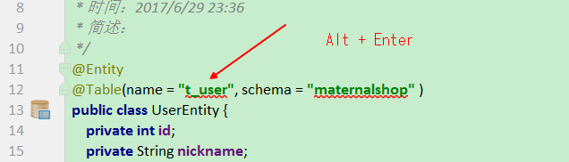

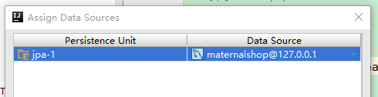

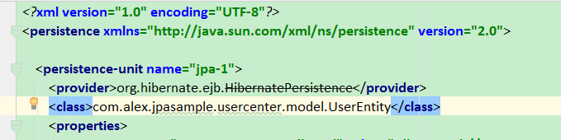

Test
fun main(args: Array<String>) {
val persistenceUnitName = "jpa-1"
val entityManagerFactory = Persistence.createEntityManagerFactory(persistenceUnitName)
val entityManager = entityManagerFactory.createEntityManager()
val entityTransaction = entityManager.transaction
entityTransaction.begin()
val userEntity = UserEntity().apply {
phone = "1314566777"
pwd = "12345"
nickname = "NickKong"
}
entityManager.persist(userEntity)
entityTransaction.commit()
entityManager.close()
entityManagerFactory.close()
}

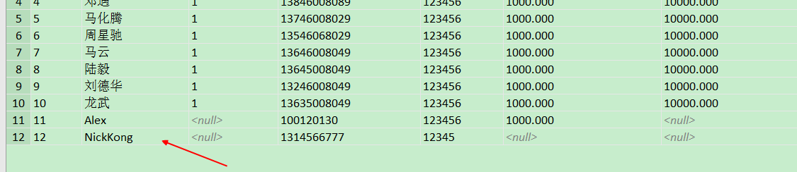

参考
http://www.jetbrains.com/help/idea/enabling-jpa-support.html
http://www.souvc.com/?p=2555#MavenJpaDemo

