SpringBoot-Start
https://start.spring.io/
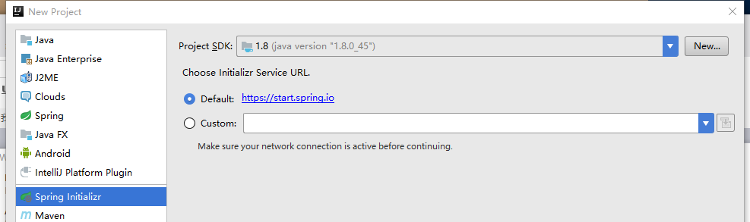
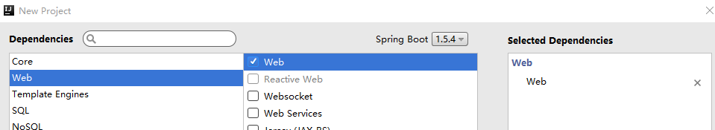
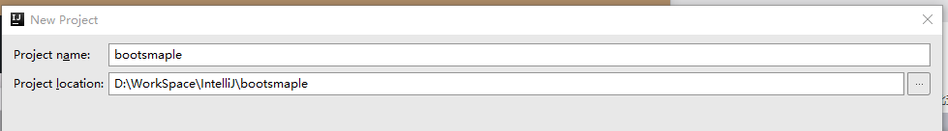
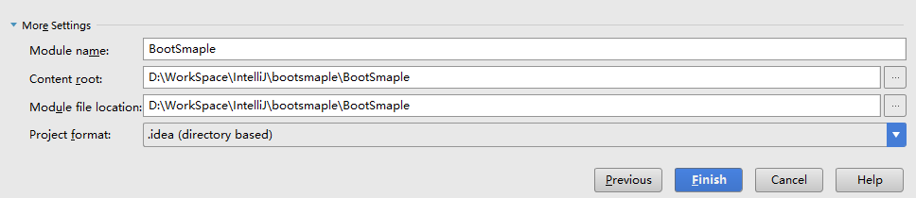
LoginController

测试
http://127.0.0.1:8081/AppServer/login
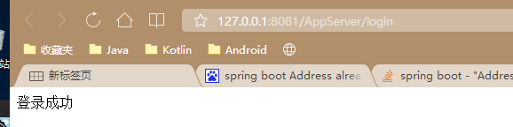

基础用法-1

读取配置文件 ConfigurationProperties
UserProperty.java
@Component
@ConfigurationProperties(prefix = "userProperty")
public class UserProperty {
private String name;
private String phone;
private int age;
public String getName() {
return name;
}
public void setName(String name) {
this.name = name;
}
public String getPhone() {
return phone;
}
public void setPhone(String phone) {
this.phone = phone;
}
public int getAge() {
return age;
}
public void setAge(int age) {
this.age = age;
}
@Override
public String toString() {
return "UserProperty{" +
"name='" + name + '\'' +
", phone='" + phone + '\'' +
", age=" + age +
'}';
}
}
application.yml
userProperty:
name: Alex
phone: 13146008029
age: 25

LoginController
@RestController
public class LoginController {
@Autowired
private UserProperty userProperty;
@RequestMapping(value = "login", method = {RequestMethod.POST, RequestMethod.GET})
@ResponseBody
public String login() {
return "登录成功 "+userProperty;
}
}

切换开发环境 和 线上环境
application.yml
spring:
profiles:
active: sit

application-sit.yml 必须是- 不能是其他分隔符
server:
context-path: /AppServer
port: 8081
userProperty:
name: SIT
phone: 13146008029
age: 25

注解介绍
@Controller
处理http请求
@RestController
Spring4之后新加的注解，解决返回Json，等同于@ResponseBody 配合 @Controller
@RequestMapping
配置url映射

Dao-Jpa
配置application.yml
spring:
profiles:
active: dev
datasource:
driver-class-name: com.mysql.jdbc.Driver
url: jdbc:mysql://127.0.0.1:3306/maternalshop
username: root
password: root
jpa:
hibernate:
ddl-auto: create
show-sql: true
新建一个JavaBean
@Entity(name = "t_user")
public class UserBean {
/**
*
*/
private static final long serialVersionUID = -693323309422224951L;
@Id
@GeneratedValue
private Integer id;
/**
* 一定要有 无参构造 否则会
* */
public UserBean() {
}
}

查询一条数据
public interface UserDao extends JpaRepository<UserBean, Integer> {
/** 方法名称 必须 按照这个 规范*/
UserBean findByPhone(String value);
}

@RequestMapping(value = {"login", "Login"}, method = {RequestMethod.POST, RequestMethod.GET})
public WrapperBean login() {
/** 根据 id 查询*/
UserBean userBean = dao.findOne(2);

/** 根据 phone 查询*/
UserBean userBean = dao.findByPhone("13146008029");
LogTrack.e(userBean);
return ControllerUtil.respController(userBean, CodeEnum.SUCCESS);
}

application.properties
json
# 过滤掉 value 为空的 key ，就是 不存在 "key":null
spring.jackson.default-property-inclusion=non_null

server.port=8080
server.address=127.0.0.1
###################################### Spring 配置
spring.http.encoding.charset=UTF-8
spring.http.encoding.enabled=true
spring.http.encoding.force=true
spring.datasource.driver-class-name=com.mysql.jdbc.Driver
spring.datasource.url=jdbc:mysql://127.0.0.1:3306/maternalshop?useUnicode=true&characterEncoding=gbk&zeroDateTimeBehavior=convertToNull
spring.datasource.username=root
spring.datasource.password=root
# create 每次都会删除新建表；update
spring.jpa.hibernate.ddl-auto=update
spring.jpa.show-sql=true
###################################### Log 配置
logging.pattern.level=debug
# com.alex.appserver 包下所有class以 debug 级别输出
logging.level.com.alex.appserver=debug
logging.level.org.alex=debug
# root日志以 warn 级别输出
logging.level.root=warn

tomcat
spring.datasource.tomcat.initial-size=5
spring.datasource.tomcat.remove-abandoned-timeout=60
spring.datasource.tomcat.log-abandoned=true
spring.datasource.tomcat.remove-abandoned=true
spring.datasource.tomcat.jdbc-interceptors=org.apache.tomcat.jdbc.pool.interceptor.ConnectionState;org.apache.tomcat.jdbc.pool.interceptor.StatementFinalizer;
# 最大建立连接等待时间。如果超过此时间将接到异常。设为-1表示无限制。
spring.datasource.tomcat.max-wait=10000
# 连接池的最大数据库连接数。设为0表示无限制
spring.datasource.tomcat.max-active=50
# 最大空闲数，数据库连接的最大空闲时间。默认100
# 超过空闲时间，数据库连接将被标记为不可用，然后被释放。设为0表示无限制。
spring.datasource.tomcat.max-idle=10
spring.datasource.tomcat.min-idle=8
spring.datasource.tomcat.jmx-enabled=true
# 间隔多久才进行一次检测，检测需要关闭的空闲连接，单位是毫秒
spring.datasource.tomcat.time-between-eviction-runs-millis=30000
#一个连接在池中最小生存的时间，单位是毫秒
spring.datasource.tomcat.min-evictable-idle-time-millis=300000
# 该选项用来验证数据库连接的有效性。
spring.datasource.tomcat.validation-query=SELECT 1
spring.datasource.tomcat.test-while-idle=true
spring.datasource.tomcat.test-on-borrow=true
spring.datasource.tomcat.test-on-return=false

参考 http://blog.csdn.net/hjx601496320/article/details/54630286

日志管理
###################################### Log 配置
logging.pattern.level=debug
# com.alex.appserver 包下所有class以 debug 级别输出
logging.level.com.alex.appserver=debug
logging.level.org.alex=debug
# root日志以 warn 级别输出
logging.level.root=warn

统一出错处理
application.properties
# #### #### #### #### 统一出错处理 开始
# mvc 出现错误时, 直接抛出异常
spring.mvc.throw-exception-if-no-handler-found=true
#不要为我们工程中的资源文件建立映射
spring.resources.add-mappings=false
# #### #### #### #### 统一出错处理 结束

SimpleExceptionHandler
@ControllerAdvice
public class SimpleExceptionHandler {
@ExceptionHandler(Exception.class)
public String handleException(Exception ex) {
ex.printStackTrace();
LogTrack.e(ex);
return ex.toString();
}
}

ObtainExceptionController
@RestController
@ControllerAdvice
public class ObtainExceptionController {
@ExceptionHandler(value = Exception.class)
@ResponseBody
public WrapperEntity defaultErrorHandler(HttpServletRequest req, Exception ex) throws Exception {
LogTrack.e(ex);
return ControllerUtil.respController(null, CodeEnum.EXCEPTION, ex.getMessage(), req);
}
}

引入Aop
application.properties
# #### #### #### #### Aop 开始
spring.aop.auto=true
spring.aop.proxy-target-class=false
# #### #### #### #### Aop 结束

定时任务Scheduling
SimpleScheduling
@SuppressWarnings("DanglingJavadoc")
@Configuration
@EnableScheduling
public class SimpleScheduling {
/**
* 距 上一次开始执行时间点后 3秒 再次执行
* */
//@Scheduled(fixedRate=3000)
/**
* 距 上一次执行完毕时间点后 3秒 再次执行
*/
//@Scheduled(fixedDelay = 3000)
/**
* 第一次延迟1秒执行，然后 距上一次执行完毕时间点后 3秒 再次执行；
*/
//@Scheduled(initialDelay = 1000, fixedDelay = 3000)
/**
* 每天 23点27分50秒 执行
* cron表达式中各时间元素使用空格进行分割，分别表示如下含义：
* 从左 到右 按顺序依次为
* 秒（0~59）
* 分钟（0~59）
* 小时（0~23）
* 天（月）（0~31，但是你需要考虑你月的天数）
* 月（0~11）
* 天（星期）（1~7 1=SUN 或 SUN，MON，TUE，WED，THU，FRI，SAT）
* 7.年份（1970－2099）
*/
//@Scheduled(cron = "50 27 23 * * ?")
@Scheduled(cron = "0/20 * * * * ?")
public void hello() {
LogTrack.w("定时任务");
}
}

InterceptorController
@Aspect
@Component
public class InterceptorController extends AbsInterceptorController {
/**
* 拦截 com.alex.appserver 下的所有的类 同时被 RequestMapping 标记 的 方法
*/
@Pointcut("bean(*Controller) && @annotation(org.springframework.web.bind.annotation.RequestMapping)")
public void requestMappingPointcut() {
}
@Around("requestMappingPointcut()")
public Object interceptor(ProceedingJoinPoint proceedingJoinPoint) {
String className = proceedingJoinPoint.getTarget().getClass().getName();
String simpleClassName = proceedingJoinPoint.getTarget().getClass().getSimpleName();
String methodName = proceedingJoinPoint.getSignature().getName();
ServletRequestAttributes attributes = (ServletRequestAttributes) RequestContextHolder.getRequestAttributes();
HttpServletRequest request = attributes.getRequest();
LogTrack.w("匹配到 " + TimeUtil.currentTimeMillisFormat() + " " + simpleClassName + " " + methodName + " (" + className + ")");
printLog4Request(request);
Object result = null;
/*被拦截的 方法的 签名*/
Object[] proceedingJoinPointArgs = proceedingJoinPoint.getArgs();
for (int i = 0; proceedingJoinPointArgs != null && i < proceedingJoinPointArgs.length; i++) {
Object proceedingJoinPointArg = proceedingJoinPointArgs[i];
LogTrack.e("入口参数 " + proceedingJoinPointArg);
}
// 一切正常的情况下，继续执行被拦截的方法
try {
result = proceedingJoinPoint.proceed();
} catch (Throwable throwable) {
throwable.printStackTrace();
}
return result;
}
}

SpringBootApplication
@SpringBootApplication注解等价于以默认属性使用@Configuration，@EnableAutoConfiguration和@ComponentScan：

多数据源
application.properties
spring.datasource.driver-class-name=com.mysql.jdbc.Driver
spring.datasource.url=jdbc:mysql://127.0.0.1:3306/maternalshop?useUnicode=true&characterEncoding=utf-8&zeroDateTimeBehavior=convertToNull&serverTimezone=UTC
spring.datasource.username=root
spring.datasource.password=root
# 这里定义好规则， 在 DynamicDataSourceRegister 进行解析
myDS.datasource.names=ds2, ds3
myDS.datasource.ds2.driver-class-name=com.mysql.jdbc.Driver
myDS.datasource.ds2.url=jdbc:mysql://127.0.0.1:3306/maternalshop2?useUnicode=true&characterEncoding=utf-8&zeroDateTimeBehavior=convertToNull&serverTimezone=UTC
myDS.datasource.ds2.username=root
myDS.datasource.ds2.password=root
myDS.datasource.ds3.driver-class-name=com.mysql.jdbc.Driver
myDS.datasource.ds3.url=jdbc:mysql://127.0.0.1:3306/maternalshop3?useUnicode=true&characterEncoding=utf-8&zeroDateTimeBehavior=convertToNull&serverTimezone=UTC
myDS.datasource.ds3.username=root
myDS.datasource.ds3.password=root

DynamicPrefix
public interface DynamicPrefix {
String VALUE = "myDS";
String NAMES = "names";
String DRIVER_CLASS_NAME = "driver-class-name";
String URL = "url";
String TYPE = "type";
String USERNAME = "username";
String PASSWORD = "password";
}
TargetDataSource
@SuppressWarnings("unused")
@Target({ ElementType.METHOD, ElementType.TYPE })
@Retention(RetentionPolicy.RUNTIME)
@Documented
@Inherited
public @interface TargetDataSource {
String value();
String DS2 = "ds2";
String DS3 = "ds3";
}

DynamicDataSourceContextHolder
public class DynamicDataSourceContextHolder {
/*
* 当使用ThreadLocal维护变量时，ThreadLocal为每个使用该变量的线程提供独立的变量副本，
* 所以每一个线程都可以独立地改变自己的副本，而不会影响其它线程所对应的副本。
*/
private static final ThreadLocal<String> contextHolder = new ThreadLocal<>();
/*
* 管理所有的数据源id;
* 主要是为了判断数据源是否存在;
*/
public static List<String> dataSourceIds = new ArrayList<>();
/**
* 使用setDataSourceType设置当前的
*
* @param dataSourceType
*/
public static void setDataSourceType(String dataSourceType) {
contextHolder.set(dataSourceType);
}
public static String getDataSourceType() {
return contextHolder.get();
}
public static void clearDataSourceType() {
contextHolder.remove();
}
/**
* 判断指定DataSource当前是否存在
*
* @param dataSourceId
*/
public static boolean containsDataSource(String dataSourceId) {
return dataSourceIds.contains(dataSourceId);
}
}

DynamicDataSourceRegister
@SuppressWarnings({"JavaDoc", "WeakerAccess", "unchecked"})
public class DynamicDataSourceRegister implements ImportBeanDefinitionRegistrar, EnvironmentAware {
//如配置文件中未指定数据源类型，使用该默认值
private static final Object DATASOURCE_TYPE_DEFAULT = "org.apache.tomcat.jdbc.pool.DataSource";
private ConversionService conversionService = new DefaultConversionService();
private PropertyValues dataSourcePropertyValues;
// 默认数据源
private DataSource defaultDataSource;
private Map<String, DataSource> myDataSourcesMap = new HashMap<>();
/**
* 加载多数据源配置
*/
@Override
public void setEnvironment(Environment environment) {
initDefaultDataSource(environment);
initCustomDataSources(environment);
}
/**
* 加载主数据源配置.
*
* @param env
*/
private void initDefaultDataSource(Environment env) {
// 读取主数据源
RelaxedPropertyResolver propertyResolver = new RelaxedPropertyResolver(env, "spring.datasource.");
Map<String, Object> dsMap = new HashMap<>();
dsMap.put(DynamicPrefix.TYPE, propertyResolver.getProperty(DynamicPrefix.TYPE));
dsMap.put(DynamicPrefix.DRIVER_CLASS_NAME, propertyResolver.getProperty(DynamicPrefix.DRIVER_CLASS_NAME));
dsMap.put(DynamicPrefix.URL, propertyResolver.getProperty(DynamicPrefix.URL));
dsMap.put(DynamicPrefix.USERNAME, propertyResolver.getProperty(DynamicPrefix.USERNAME));
dsMap.put(DynamicPrefix.PASSWORD, propertyResolver.getProperty(DynamicPrefix.PASSWORD));
//创建数据源;
defaultDataSource = buildDataSource(dsMap);
dataBinder(defaultDataSource, env);
}
/**
* 初始化更多数据源
*
* @author SHANHY
* @create 2016年1月24日
*/
private void initCustomDataSources(Environment env) {
// 读取配置文件获取更多数据源，也可以通过defaultDataSource读取数据库获取更多数据源
RelaxedPropertyResolver propertyResolver = new RelaxedPropertyResolver(env, DynamicPrefix.VALUE + ".datasource.");
String dsPrefixes = propertyResolver.getProperty(DynamicPrefix.NAMES);
if (dsPrefixes == null) {
LogTrack.e("application.properties文件中缺少 " + DynamicPrefix.VALUE + ".datasource.names 属性的配置");
return;
}
StringBuilder prefixBuilder = new StringBuilder();
for (int i = 0; i < dsPrefixes.length(); i++) {
char charAt = dsPrefixes.charAt(i);
if (charAt != ' ') {/*过滤掉 万恶的 空格*/
prefixBuilder.append(charAt);
}
}
for (String dsPrefix : prefixBuilder.toString().split(",")) {// 多个数据源
Map<String, Object> dsMap = propertyResolver.getSubProperties(dsPrefix + ".");
DataSource ds = buildDataSource(dsMap);
myDataSourcesMap.put(dsPrefix, ds);
dataBinder(ds, env);
}
}
/**
* 创建datasource.
*
* @param dsMap
* @return
*/
public DataSource buildDataSource(Map<String, Object> dsMap) {
if (dsMap == null) {
return null;
}
LogTrack.w("多数据源 = " + dsMap);
Object type = dsMap.get(DynamicPrefix.TYPE);
if (type == null) {
type = DATASOURCE_TYPE_DEFAULT;// 默认DataSource
}
Class<? extends DataSource> dataSourceType;
try {
dataSourceType = (Class<? extends DataSource>) Class.forName((String) type);
Object dcnObj = dsMap.get(DynamicPrefix.DRIVER_CLASS_NAME);
String driverClassName = dcnObj != null ? dcnObj.toString() : "com.mysql.jdbc.Driver";
String url = dsMap.get(DynamicPrefix.URL).toString();
String username = dsMap.get(DynamicPrefix.USERNAME).toString();
String password = dsMap.get(DynamicPrefix.PASSWORD).toString();
DataSourceBuilder factory = DataSourceBuilder.create().driverClassName(driverClassName).url(url).username(username).password(password).type(dataSourceType);
return factory.build();
} catch (ClassNotFoundException e) {
e.printStackTrace();
}
return null;
}
/**
* 为DataSource绑定更多数据
*
* @param dataSource
* @param env
*/
private void dataBinder(DataSource dataSource, Environment env) {
RelaxedDataBinder dataBinder = new RelaxedDataBinder(dataSource);
dataBinder.setConversionService(conversionService);
dataBinder.setIgnoreNestedProperties(false);//false
dataBinder.setIgnoreInvalidFields(false);//false
dataBinder.setIgnoreUnknownFields(true);//true
if (dataSourcePropertyValues == null) {
Map<String, Object> rpr = new RelaxedPropertyResolver(env, "spring.datasource").getSubProperties(".");
Map<String, Object> values = new HashMap<>(rpr);
// 排除已经设置的属性
values.remove(DynamicPrefix.TYPE);
values.remove(DynamicPrefix.DRIVER_CLASS_NAME);
values.remove(DynamicPrefix.URL);
values.remove(DynamicPrefix.USERNAME);
values.remove(DynamicPrefix.PASSWORD);
dataSourcePropertyValues = new MutablePropertyValues(values);
}
dataBinder.bind(dataSourcePropertyValues);
}
@Override
public void registerBeanDefinitions(AnnotationMetadata importingClassMetadata, BeanDefinitionRegistry registry) {
Map<Object, Object> targetDataSources = new HashMap<>();
// 将主数据源添加到更多数据源中
targetDataSources.put("dataSource", defaultDataSource);
DynamicDataSourceContextHolder.dataSourceIds.add("dataSource");
// 添加更多数据源
targetDataSources.putAll(myDataSourcesMap);
for (String key : myDataSourcesMap.keySet()) {
if (key != null) {
DynamicDataSourceContextHolder.dataSourceIds.add(key);
}
}
// 创建DynamicDataSource
GenericBeanDefinition beanDefinition = new GenericBeanDefinition();
beanDefinition.setBeanClass(DynamicDataSource.class);
beanDefinition.setSynthetic(true);
MutablePropertyValues mpv = beanDefinition.getPropertyValues();
//添加属性：AbstractRoutingDataSource.defaultTargetDataSource
mpv.addPropertyValue("defaultTargetDataSource", defaultDataSource);
mpv.addPropertyValue("targetDataSources", targetDataSources);
registry.registerBeanDefinition("dataSource", beanDefinition);
}
}

DynamicDataSourceAspect
@Aspect
@Order(-10)//保证该AOP在 @Transactional 之前执行
@Component
public class DynamicDataSourceAspect {
/*
* @Before("@annotation(ds)")
* 的意思是：
*
* @Before：在方法执行之前进行执行：
* @annotation(targetDataSource)：
* 会拦截注解targetDataSource的方法，否则不拦截;
*/
@Before("@annotation(targetDataSource)")
public void changeDataSource(JoinPoint point, TargetDataSource targetDataSource) throws Throwable {
//获取当前的指定的数据源;
String dsId = targetDataSource.value();
//如果不在我们注入的所有的数据源范围之内，那么输出警告信息，系统自动使用默认的数据源。
if (!DynamicDataSourceContextHolder.containsDataSource(dsId)) {
LogTrack.e("数据源[{}]不存在，使用默认数据源 > {}" + targetDataSource.value() + point.getSignature());
} else {
LogTrack.w("Use DataSource : {} > {}" + targetDataSource.value() + point.getSignature());
//找到的话，那么设置到动态数据源上下文中。
DynamicDataSourceContextHolder.setDataSourceType(targetDataSource.value());
}
}
@After("@annotation(targetDataSource)")
public void restoreDataSource(JoinPoint point, TargetDataSource targetDataSource) {
LogTrack.w("Revert DataSource : {} > {}" + targetDataSource.value() + point.getSignature());
//方法执行完毕之后，销毁当前数据源信息，进行垃圾回收。
DynamicDataSourceContextHolder.clearDataSourceType();
}
}

ServerApplication
@Import({DynamicDataSourceRegister.class})
@SpringBootApplication
public class ServerApplication {

}

UserService
@SuppressWarnings("SpringJavaAutowiringInspection")
@Service
public class UserService extends AbsService<UserDao, UserEntity> {
/**
* 根据 id 找到 对应 的 实体类
*
* @param id
*/
@Override
@TargetDataSource(TargetDataSource.DS2)
public UserEntity findEntityById(String id) {
return super.findEntityById(id);
}
/**
* 迭代出 所有的 实体类
*/
@Override
@TargetDataSource(TargetDataSource.DS3)
public List<UserEntity> findEntityByAll() {
return super.findEntityByAll();
}
}

测试
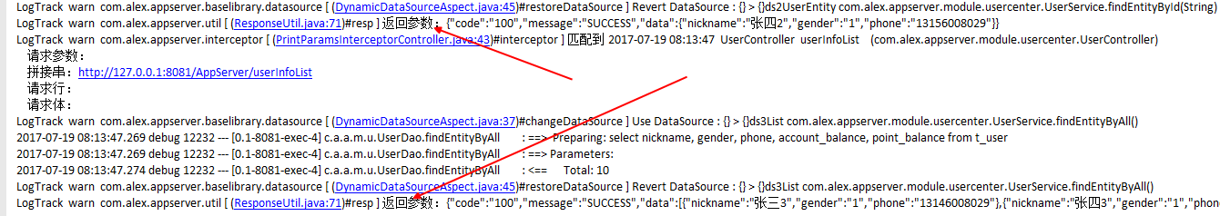

参考 http://412887952-qq-com.iteye.com/blog/2303075

多文件上传

application.propertity
spring.http.multipart.max-file-size=100MB
spring.http.multipart.max-request-size=100MB

MultipartConfiguration
@Configuration
public class MultipartConfiguration {
@Bean
public MultipartConfigElement multipartConfigElement() {
MultipartConfigFactory config = new MultipartConfigFactory();
config.setMaxFileSize("100MB");
config.setMaxRequestSize("100MB");
return config.createMultipartConfig();
}
}

UploadController
@Controller
@RequestMapping(value = AppCon.BASE_URL)
public class UploadController extends AbsController<UserService> {
/**
* 上传 用户 头像
*
* @return
*/
@FormWholeCheck
@ResponseBody
@RequestMapping(value = {"uploadUserPortrait", "UploadUserPortrait"}, method = {RequestMethod.POST/*, RequestMethod.GET*/})
public Wrapper uploadUserPortrait(String id, MultipartHttpServletRequest request) throws IOException {
UserEntity userEntity = getService().findEntityById(id);
LogTrack.w(userEntity);
if (TrivialUtil.isEmpty(userEntity)) {
return ResponseUtil.resp("没有查到对用用户信息", CodeEnum.FAIL);
}
CommonsMultipartResolver multipartResolver = new CommonsMultipartResolver(request.getServletContext());
if (!multipartResolver.isMultipart(request)) {
return ResponseUtil.resp("没有任何文件被提交", CodeEnum.FAIL);
}
List<MultipartFile> fileList = new ArrayList<>();
fileList.addAll(request.getFiles("file"));
fileList.addAll(request.getFiles("userPortrait"));
long totalStartTimeMillis = System.currentTimeMillis();
for (int i = 0; i < fileList.size(); i++) {
long startTimeMillis = System.currentTimeMillis();
MultipartFile multipartFile = fileList.get(i);
if (multipartFile != null) {
String originalFilename = multipartFile.getOriginalFilename();
String filePath = CacheEnum.getFileUploadPath() + multipartFile.getName() + "/" + originalFilename;
File localFile = new File(filePath);
FileUtil.createOrExistsFile(localFile);
multipartFile.transferTo(localFile);
LogTrack.w(filePath + " 耗时 " + (System.currentTimeMillis() - startTimeMillis) + " 毫秒");
}
}
LogTrack.w("所有文件耗时 " + (System.currentTimeMillis() - totalStartTimeMillis) + " 毫秒");
return ResponseUtil.resp("上传成功", CodeEnum.SUCCESS);
}
}

文件下载

崩溃日志
org.apache.catalina.connector.ClientAbortException: java.io.IOException: 你的主机中的软件中止了一个已建立的连接。
at org.apache.catalina.connector.OutputBuffer.realWriteBytes(OutputBuffer.java:356)
at org.apache.catalina.connector.OutputBuffer.appendByteArray(OutputBuffer.java:785)
at org.apache.catalina.connector.OutputBuffer.append(OutputBuffer.java:714)
at org.apache.catalina.connector.OutputBuffer.writeBytes(OutputBuffer.java:391)
at org.apache.catalina.connector.OutputBuffer.write(OutputBuffer.java:369)
at org.apache.catalina.connector.CoyoteOutputStream.write(CoyoteOutputStream.java:96)
at com.alex.appserver.module.multipartfile.MultipartFileController.downloadTextFile(MultipartFileController.java:99)
at com.alex.appserver.module.multipartfile.MultipartFileController$$FastClassBySpringCGLIB$$f6856409.invoke(<generated>)
at org.springframework.cglib.proxy.MethodProxy.invoke(MethodProxy.java:204)
at org.springframework.aop.framework.CglibAopProxy$CglibMethodInvocation.invokeJoinpoint(CglibAopProxy.java:738)
at org.springframework.aop.framework.ReflectiveMethodInvocation.proceed(ReflectiveMethodInvocation.java:157)
at org.springframework.aop.aspectj.MethodInvocationProceedingJoinPoint.proceed(MethodInvocationProceedingJoinPoint.java:85)
at com.alex.appserver.interceptor.PrintParamsInterceptorController.interceptor(PrintParamsInterceptorController.java:49)
at sun.reflect.NativeMethodAccessorImpl.invoke0(Native Method)
at sun.reflect.NativeMethodAccessorImpl.invoke(NativeMethodAccessorImpl.java:62)
at sun.reflect.DelegatingMethodAccessorImpl.invoke(DelegatingMethodAccessorImpl.java:43)
at java.lang.reflect.Method.invoke(Method.java:497)
at org.springframework.aop.aspectj.AbstractAspectJAdvice.invokeAdviceMethodWithGivenArgs(AbstractAspectJAdvice.java:629)
at org.springframework.aop.aspectj.AbstractAspectJAdvice.invokeAdviceMethod(AbstractAspectJAdvice.java:618)
at org.springframework.aop.aspectj.AspectJAroundAdvice.invoke(AspectJAroundAdvice.java:70)
at org.springframework.aop.framework.ReflectiveMethodInvocation.proceed(ReflectiveMethodInvocation.java:168)
at org.springframework.aop.aspectj.MethodInvocationProceedingJoinPoint.proceed(MethodInvocationProceedingJoinPoint.java:85)
at com.alex.appserver.interceptor.FormWholeCheckInterceptorController.formWholeInterceptor(FormWholeCheckInterceptorController.java:80)
at sun.reflect.NativeMethodAccessorImpl.invoke0(Native Method)
at sun.reflect.NativeMethodAccessorImpl.invoke(NativeMethodAccessorImpl.java:62)
at sun.reflect.DelegatingMethodAccessorImpl.invoke(DelegatingMethodAccessorImpl.java:43)
at java.lang.reflect.Method.invoke(Method.java:497)
at org.springframework.aop.aspectj.AbstractAspectJAdvice.invokeAdviceMethodWithGivenArgs(AbstractAspectJAdvice.java:629)
at org.springframework.aop.aspectj.AbstractAspectJAdvice.invokeAdviceMethod(AbstractAspectJAdvice.java:618)
at org.springframework.aop.aspectj.AspectJAroundAdvice.invoke(AspectJAroundAdvice.java:70)
at org.springframework.aop.framework.ReflectiveMethodInvocation.proceed(ReflectiveMethodInvocation.java:168)
at org.springframework.aop.interceptor.ExposeInvocationInterceptor.invoke(ExposeInvocationInterceptor.java:92)
at org.springframework.aop.framework.ReflectiveMethodInvocation.proceed(ReflectiveMethodInvocation.java:179)
at org.springframework.aop.framework.CglibAopProxy$DynamicAdvisedInterceptor.intercept(CglibAopProxy.java:673)
at com.alex.appserver.module.multipartfile.MultipartFileController$$EnhancerBySpringCGLIB$$1ce62f07.downloadTextFile(<generated>)
at sun.reflect.NativeMethodAccessorImpl.invoke0(Native Method)
at sun.reflect.NativeMethodAccessorImpl.invoke(NativeMethodAccessorImpl.java:62)
at sun.reflect.DelegatingMethodAccessorImpl.invoke(DelegatingMethodAccessorImpl.java:43)
at java.lang.reflect.Method.invoke(Method.java:497)
at org.springframework.web.method.support.InvocableHandlerMethod.doInvoke(InvocableHandlerMethod.java:205)
at org.springframework.web.method.support.InvocableHandlerMethod.invokeForRequest(InvocableHandlerMethod.java:133)
at org.springframework.web.servlet.mvc.method.annotation.ServletInvocableHandlerMethod.invokeAndHandle(ServletInvocableHandlerMethod.java:97)
at org.springframework.web.servlet.mvc.method.annotation.RequestMappingHandlerAdapter.invokeHandlerMethod(RequestMappingHandlerAdapter.java:827)
at org.springframework.web.servlet.mvc.method.annotation.RequestMappingHandlerAdapter.handleInternal(RequestMappingHandlerAdapter.java:738)
at org.springframework.web.servlet.mvc.method.AbstractHandlerMethodAdapter.handle(AbstractHandlerMethodAdapter.java:85)
at org.springframework.web.servlet.DispatcherServlet.doDispatch(DispatcherServlet.java:967)
at org.springframework.web.servlet.DispatcherServlet.doService(DispatcherServlet.java:901)
at org.springframework.web.servlet.FrameworkServlet.processRequest(FrameworkServlet.java:970)
at org.springframework.web.servlet.FrameworkServlet.doPost(FrameworkServlet.java:872)
at javax.servlet.http.HttpServlet.service(HttpServlet.java:661)
at org.springframework.web.servlet.FrameworkServlet.service(FrameworkServlet.java:846)
at javax.servlet.http.HttpServlet.service(HttpServlet.java:742)
at org.apache.catalina.core.ApplicationFilterChain.internalDoFilter(ApplicationFilterChain.java:231)
at org.apache.catalina.core.ApplicationFilterChain.doFilter(ApplicationFilterChain.java:166)
at org.apache.tomcat.websocket.server.WsFilter.doFilter(WsFilter.java:52)
at org.apache.catalina.core.ApplicationFilterChain.internalDoFilter(ApplicationFilterChain.java:193)
at org.apache.catalina.core.ApplicationFilterChain.doFilter(ApplicationFilterChain.java:166)
at org.apache.shiro.web.servlet.ProxiedFilterChain.doFilter(ProxiedFilterChain.java:61)
at org.apache.shiro.web.servlet.OncePerRequestFilter.doFilter(OncePerRequestFilter.java:112)
at org.apache.shiro.web.servlet.ProxiedFilterChain.doFilter(ProxiedFilterChain.java:66)
at org.apache.shiro.web.servlet.AbstractShiroFilter.executeChain(AbstractShiroFilter.java:449)
at org.apache.shiro.web.servlet.AbstractShiroFilter$1.call(AbstractShiroFilter.java:365)
at org.apache.shiro.subject.support.SubjectCallable.doCall(SubjectCallable.java:90)
at org.apache.shiro.subject.support.SubjectCallable.call(SubjectCallable.java:83)
at org.apache.shiro.subject.support.DelegatingSubject.execute(DelegatingSubject.java:387)
at org.apache.shiro.web.servlet.AbstractShiroFilter.doFilterInternal(AbstractShiroFilter.java:362)
at org.apache.shiro.web.servlet.OncePerRequestFilter.doFilter(OncePerRequestFilter.java:125)
at org.apache.catalina.core.ApplicationFilterChain.internalDoFilter(ApplicationFilterChain.java:193)
at org.apache.catalina.core.ApplicationFilterChain.doFilter(ApplicationFilterChain.java:166)
at org.apache.shiro.web.servlet.AdviceFilter.executeChain(AdviceFilter.java:108)
at org.apache.shiro.web.servlet.AdviceFilter.doFilterInternal(AdviceFilter.java:137)
at org.apache.shiro.web.servlet.OncePerRequestFilter.doFilter(OncePerRequestFilter.java:125)
at org.apache.catalina.core.ApplicationFilterChain.internalDoFilter(ApplicationFilterChain.java:193)
at org.apache.catalina.core.ApplicationFilterChain.doFilter(ApplicationFilterChain.java:166)
at com.alibaba.druid.support.http.WebStatFilter.doFilter(WebStatFilter.java:123)
at org.apache.catalina.core.ApplicationFilterChain.internalDoFilter(ApplicationFilterChain.java:193)
at org.apache.catalina.core.ApplicationFilterChain.doFilter(ApplicationFilterChain.java:166)
at com.alibaba.druid.support.http.WebStatFilter.doFilter(WebStatFilter.java:123)
at org.apache.catalina.core.ApplicationFilterChain.internalDoFilter(ApplicationFilterChain.java:193)
at org.apache.catalina.core.ApplicationFilterChain.doFilter(ApplicationFilterChain.java:166)
at org.springframework.web.filter.RequestContextFilter.doFilterInternal(RequestContextFilter.java:99)
at org.springframework.web.filter.OncePerRequestFilter.doFilter(OncePerRequestFilter.java:107)
at org.apache.catalina.core.ApplicationFilterChain.internalDoFilter(ApplicationFilterChain.java:193)
at org.apache.catalina.core.ApplicationFilterChain.doFilter(ApplicationFilterChain.java:166)
at org.springframework.web.filter.HttpPutFormContentFilter.doFilterInternal(HttpPutFormContentFilter.java:105)
at org.springframework.web.filter.OncePerRequestFilter.doFilter(OncePerRequestFilter.java:107)
at org.apache.catalina.core.ApplicationFilterChain.internalDoFilter(ApplicationFilterChain.java:193)
at org.apache.catalina.core.ApplicationFilterChain.doFilter(ApplicationFilterChain.java:166)
at org.springframework.web.filter.HiddenHttpMethodFilter.doFilterInternal(HiddenHttpMethodFilter.java:81)
at org.springframework.web.filter.OncePerRequestFilter.doFilter(OncePerRequestFilter.java:107)
at org.apache.catalina.core.ApplicationFilterChain.internalDoFilter(ApplicationFilterChain.java:193)
at org.apache.catalina.core.ApplicationFilterChain.doFilter(ApplicationFilterChain.java:166)
at org.springframework.web.filter.CharacterEncodingFilter.doFilterInternal(CharacterEncodingFilter.java:197)
at org.springframework.web.filter.OncePerRequestFilter.doFilter(OncePerRequestFilter.java:107)
at org.apache.catalina.core.ApplicationFilterChain.internalDoFilter(ApplicationFilterChain.java:193)
at org.apache.catalina.core.ApplicationFilterChain.doFilter(ApplicationFilterChain.java:166)
at org.apache.catalina.core.StandardWrapperValve.invoke(StandardWrapperValve.java:198)
at org.apache.catalina.core.StandardContextValve.invoke(StandardContextValve.java:96)
at org.apache.catalina.authenticator.AuthenticatorBase.invoke(AuthenticatorBase.java:478)
at org.apache.catalina.core.StandardHostValve.invoke(StandardHostValve.java:140)
at org.apache.catalina.valves.ErrorReportValve.invoke(ErrorReportValve.java:80)
at org.apache.catalina.core.StandardEngineValve.invoke(StandardEngineValve.java:87)
at org.apache.catalina.connector.CoyoteAdapter.service(CoyoteAdapter.java:342)
at org.apache.coyote.http11.Http11Processor.service(Http11Processor.java:799)
at org.apache.coyote.AbstractProcessorLight.process(AbstractProcessorLight.java:66)
at org.apache.coyote.AbstractProtocol$ConnectionHandler.process(AbstractProtocol.java:861)
at org.apache.tomcat.util.net.NioEndpoint$SocketProcessor.doRun(NioEndpoint.java:1455)
at org.apache.tomcat.util.net.SocketProcessorBase.run(SocketProcessorBase.java:49)
at java.util.concurrent.ThreadPoolExecutor.runWorker(ThreadPoolExecutor.java:1142)
at java.util.concurrent.ThreadPoolExecutor$Worker.run(ThreadPoolExecutor.java:617)
at org.apache.tomcat.util.threads.TaskThread$WrappingRunnable.run(TaskThread.java:61)
at java.lang.Thread.run(Thread.java:745)

解决办法

ClientAbortException
Generally, you can just ignore it. This exception will be thrown when the client has abruptly aborted the HTTP request while the page is still loading.
This will occur when the client pressed Esc, or hastily navigated away, or closed the browser, or got network outage, or even caught fire. All of this is totally out your control.

int charResult = bufferedInputStream.read(buff);
long currCount = 0;
while (charResult != -1) {
currCount += buff.length;
LogTrack.e("读取 " + FileUtil.byte2FitSize(currCount));
try {
outputStream.write(buff, 0, buff.length);
} catch (ClientAbortException ex) {
}
try {
outputStream.flush();
} catch (ClientAbortException ex) {
}
charResult = bufferedInputStream.read(buff);
}

SpringSecurity

compile libs.spring_boot_starter_security

druid
https://github.com/alibaba/druid/wiki
https://github.com/alibaba/druid/tree/master/druid-spring-boot-starter

application.properties
spring.datasource.separator=;
spring.datasource.initialize=true
spring.datasource.platform=mysql
spring.datasource.tomcat.max-idle=10
spring.datasource.tomcat.jmx-enabled=true
spring.datasource.tomcat.log-abandoned=true
spring.datasource.tomcat.remove-abandoned=true
spring.datasource.tomcat.remove-abandoned-timeout=60
spring.datasource.tomcat.connection-properties=druid.stat.mergeSql=true;druid.stat.slowSqlMillis=5000
spring.datasource.tomcat.jdbc-interceptors=org.apache.tomcat.jdbc.pool.interceptor.ConnectionState;org.apache.tomcat.jdbc.pool.interceptor.StatementFinalizer;
spring.datasource.druid.initial-size=5
spring.datasource.druid.min-idle=8
spring.datasource.druid.max-active=50
spring.datasource.druid.max-wait=60000
spring.datasource.druid.minEvictableIdleTimeMillis=30000
spring.datasource.druid.timeBetweenEvictionRunsMillis=60000
spring.datasource.druid.maxPoolPreparedStatementPerConnectionSize=20
spring.datasource.druid.poolPreparedStatements=false
spring.datasource.druid.validationQuery=SELECT 'x'
spring.datasource.druid.testWhileIdle=true
spring.datasource.druid.testOnBorrow=false
spring.datasource.druid.testOnReturn=false
spring.datasource.druid.filters=stat,wall,log4j
spring.datasource.druid.web-stat-filter.enabled=true
spring.datasource.druid.stat-view-servlet.enabled=true

ServerApplication
@EnableAutoConfiguration
@EnableAspectJAutoProxy
@EnableTransactionManagement
@ComponentScan
@MapperScan("com.alex.appserver")
@Import({DynamicDataSourceRegister.class})
@SpringBootApplication
@ServletComponentScan
public class ServerApplication {
public static void main(String[] args) {
SpringApplication.run(ServerApplication.class, args);
}
@Bean
public DataSource dataSource(Environment env){
DruidDataSource dataSource = DruidDataSourceBuilder
.create()
.build(env,"spring.datasource.druid.");//使用自定义前缀
return dataSource;
}
}

AppCon
public class AppCon {
public static final String BASE_URL_NAME = "AppServer";
public static final String BASE_URL = BASE_URL_NAME + "/";
/**
* 最好 叫 druid 别跟 BASE_URL_NAME 重复
* */
public static final String DRUID_URL_PATTERNS = "/druid/*";
}

DruidStatFilter
import com.alex.appserver.constant.AppCon;
import com.alibaba.druid.support.http.WebStatFilter;
import javax.servlet.annotation.WebFilter;
import javax.servlet.annotation.WebInitParam;
@WebFilter(filterName = "druidWebStatFilter", urlPatterns = "/*",initParams = {@WebInitParam(name = "exclusions", value = "*.js,*.gif,*.jpg,*.bmp,*.png,*.css,*.ico," + AppCon.DRUID_URL_PATTERNS)})
public class DruidStatFilter extends WebStatFilter {
}

测试
要访问 这个 链接才能 看到监控， 并没有人 告诉我这样的， 感觉好忧伤， 记不得怎么发现的了
http://127.0.0.1:8081/druid/index.html
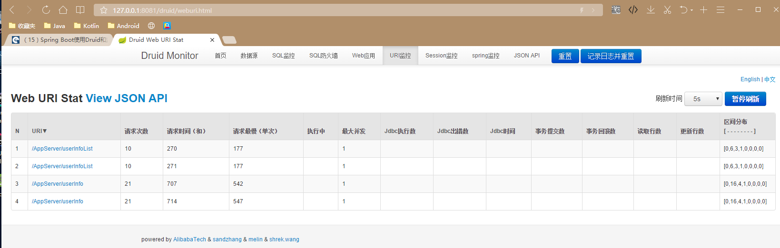

事务

Isolation 事务隔离级别
DEFAULT：这是默认值，表示使用底层数据库的默认隔离级别。对大部分数据库而言，通常这值就是：READ_COMMITTED。
READ_UNCOMMITTED：该隔离级别表示一个事务可以读取另一个事务修改但还没有提交的数据。该级别不能防止脏读和不可重复读，因此很少使用该隔离级别。
READ_COMMITTED：该隔离级别表示一个事务只能读取另一个事务已经提交的数据。该级别可以防止脏读，这也是大多数情况下的推荐值。
REPEATABLE_READ：该隔离级别表示一个事务在整个过程中可以多次重复执行某个查询，并且每次返回的记录都相同。即使在多次查询之间有新增的数据满足该查询，这些新增的记录也会被忽略。该级别可以防止脏读和不可重复读。
SERIALIZABLE：所有的事务依次逐个执行，这样事务之间就完全不可能产生干扰，也就是说，该级别可以防止脏读、不可重复读以及幻读。但是这将严重影响程序的性能。通常情况下也不会用到该级别。

Propagation事务的传播行为
所谓事务的传播行为是指，如果在开始当前事务之前，一个事务上下文已经存在，此时有若干选项可以指定一个事务性方法的执行行为。
REQUIRED：如果当前存在事务，则加入该事务；如果当前没有事务，则创建一个新的事务。
SUPPORTS：如果当前存在事务，则加入该事务；如果当前没有事务，则以非事务的方式继续运行。
MANDATORY：如果当前存在事务，则加入该事务；如果当前没有事务，则抛出异常。
REQUIRES_NEW：创建一个新的事务，如果当前存在事务，则把当前事务挂起。
NOT_SUPPORTED：以非事务方式运行，如果当前存在事务，则把当前事务挂起。
NEVER：以非事务方式运行，如果当前存在事务，则抛出异常。
NESTED：如果当前存在事务，则创建一个事务作为当前事务的嵌套事务来运行；如果当前没有事务，则该取值等价于REQUIRED。

实例-1

Https

application.properties
server.port=8443
server.address=192.168.0.7
server.session.timeout=120
server.ssl.key-store=keystore.p12
server.ssl.key-store-password=Alex123123
#server.ssl.keyStoreType=JKS
server.ssl.keyStoreType=PKCS12
server.ssl.key-alias=tomcat
server.ssl.enabled=true
server.ssl.key-password=Alex123123

Http2HttpsConfig
@Configuration
public class Http2HttpsConfig {
@Bean
public EmbeddedServletContainerFactory servletContainer() {
TomcatEmbeddedServletContainerFactory tomcat = new TomcatEmbeddedServletContainerFactory(){//1
protected void postProcessContext(Context context) {
SecurityConstraint securityConstraint = new SecurityConstraint();
securityConstraint.setUserConstraint("CONFIDENTIAL");
SecurityCollection collection = new SecurityCollection();
collection.addPattern("/*");
securityConstraint.addCollection(collection);
context.addConstraint(securityConstraint);
}
};
tomcat.addAdditionalTomcatConnectors(httpConnector());
return tomcat;
}
@Bean
public Connector httpConnector(){//2
Connector connector = new Connector("org.apache.coyote.http11.Http11NioProtocol");
connector.setScheme("http");
connector.setPort(8081);
connector.setSecure(false);
connector.setRedirectPort(8443);
return connector;
}
}

浏览器访问 8081
http://192.168.0.7:8081/AppServer/login
会被立刻重定向到8443
https://192.168.0.7:8443/AppServer/login
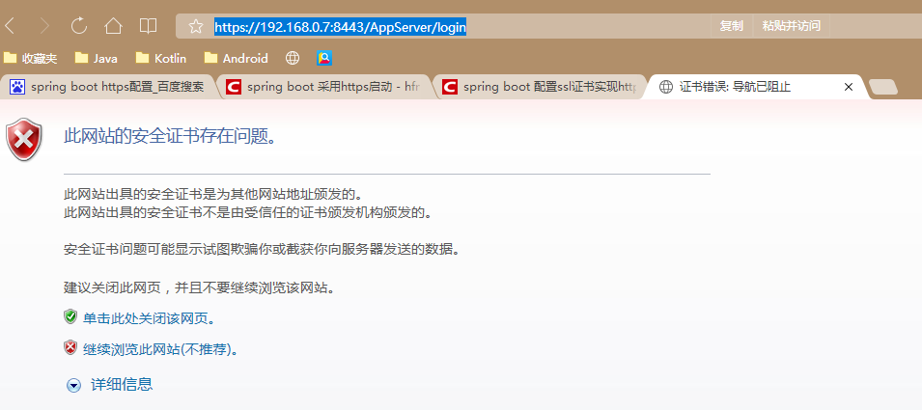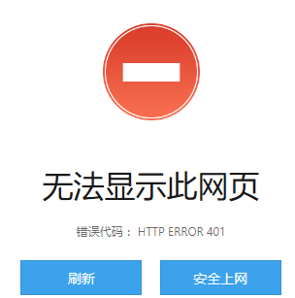

基础架构篇-泛型代替编码

BaseDao

public interface BaseDao<T> {
/**
* 根据 id 找到 对应 的 实体类
*/
// @Select("select * from t_user where id = #{id}")
T findEntityById(@Param("id") String id);
/**
* 迭代出 所有的 实体类
*/
// @Select("select * from t_user")
List<T> findEntityByAll();
}

BaseService

public interface BaseService<T> {
Long ERROR_ID = -1L;
/**
* 根据 id 找到 对应 的 实体类
*/
T findEntityById(String id);
/**
* 迭代出 所有的 实体类
*/
List<T> findEntityByAll();
/**
* 插入一条 实体类
*
* @param entity
* @return 如果插入成功 返回这条实体类得 id ， 不成功 返回 -1
*/
Long insertEntity(T entity);
}

AbsService

@SuppressWarnings({"unused", "WeakerAccess"})
@EnableAsync(proxyTargetClass = true)
@EnableCaching(proxyTargetClass = true)
public abstract class AbsService<DAO extends BaseDao<ENTITY>, ENTITY> implements BaseService<ENTITY> {
DAO dao;
DAO getDao() {
return dao;
}
@Autowired
void setDao(DAO dao) {
this.dao = dao;
}
/**
* 根据 id 找到 对应 的 实体类
*
* @param id
*/
@Override
public ENTITY findEntityById(String id) {
return getDao().findEntityById(id);
}
/**
* 迭代出 所有的 实体类
*/
@Override
public List<ENTITY> findEntityByAll() {
return getDao().findEntityByAll();
}
/**
* 插入一条 实体类
*
* @param entity
* @return 如果插入成功 返回这条实体类得 id ， 不成功 返回 -1
*/
@Override
public Long insertEntity(ENTITY entity) {
return ERROR_ID;
}
}

AbsController

@SuppressWarnings({"unused", "WeakerAccess"})
@EnableAsync(proxyTargetClass = true)
@EnableCaching(proxyTargetClass = true)
public class AbsController<SERVICE> {
SERVICE service;
public SERVICE getService() {
return service;
}
@Autowired
public void setService(SERVICE service) {
this.service = service;
}
}

实例1

UserDao
@Mapper
public interface UserDao extends BaseDao<UserEntity> {
}

UserService
@SuppressWarnings("SpringJavaAutowiringInspection")
@Service
public class UserService extends AbsService<UserDao, UserEntity> {
}

UserController
@Controller
@RequestMapping(value = BASE_URL)
public class UserController extends AbsController<UserService>{
@RequestMapping(value = {"userList", "UserList"}, method = {RequestMethod.POST, RequestMethod.GET})
@ResponseBody
public Wrapper userInfoList() {
List<UserEntity> list = getService().findEntityByAll();
return ControllerUtil.respController(list);
}
@RequestMapping(value = {"userInfoCompact", "UserInfoCompact"}, method = {RequestMethod.POST, RequestMethod.GET})
@ResponseBody
public Wrapper userInfoCompact(String id) {
UserEntity bean = getService().findEntityById(id);
return ControllerUtil.respController(bean);
}
}

基础架构篇-表单完整性校验

UserController
@Controller
@RequestMapping(value = BASE_URL)
public class UserController extends AbsController<UserService> {
@FormWholeCheck
@RequestMapping(value = {"register", "Register"}, method = {RequestMethod.POST, RequestMethod.GET})
@ResponseBody
public Wrapper insertUser(String nickname, String phone, String pwd) {
UserEntity entity = new UserEntity();
entity.setNickname(nickname);
entity.setPhone(phone);
entity.setPwd(pwd);
getService().insertEntity(entity);
if (entity.getId() > 0) {
return ControllerUtil.respController(entity);
}
return ControllerUtil.respController("注册失败", CodeEnum.FAIL);
}
}

FormWholeCheck
/**
* 作者：Alex
* 时间：2017/7/9 02:22
* 简述： 参数完整性 校验， 对象不能是 空 不能是 空串
*
* @Retention(RetentionPolicy.RUNTIME) 必须是 RetentionPolicy.RUNTIME， 之前 写的是 RetentionPolicy.SOURCE， 妈的 AOP 方法不执行， 自己自己坑了3H
*/
@Documented
@Inherited
@Retention(RetentionPolicy.RUNTIME)
@Target({ElementType.METHOD, ElementType.FIELD, ElementType.TYPE, ElementType.PARAMETER})
public @interface FormWholeCheck {
}

FormWholeCheckInterceptorController
@SuppressWarnings("StringConcatenationInsideStringBufferAppend")
@Aspect
@Order(InterceptorOrder.FORM_WHOLE_CHECK)
@Component
public class FormWholeCheckInterceptorController extends AbsInterceptorController {
/**
* 日存缓存， 提升效率， 拿空间 换时间 的策略
*/
private Map<String, String[]> fieldsNameMap;
/**
* 拦截 com.alex.appserver 下的所有的类 同时被 RequestMapping 标记 的 方法
*/
@Pointcut("@annotation(org.alex.spring.interceptor.FormWholeCheck)")
public void formWholeInterceptorRequestMappingPointcut() {
}
@Around("formWholeInterceptorRequestMappingPointcut()")
public Object formWholeInterceptor(ProceedingJoinPoint proceedingJoinPoint) {
String className = proceedingJoinPoint.getTarget().getClass().getName();
String simpleClassName = proceedingJoinPoint.getTarget().getClass().getSimpleName();
String methodName = proceedingJoinPoint.getSignature().getName();
ServletRequestAttributes attributes = (ServletRequestAttributes) RequestContextHolder.getRequestAttributes();
HttpServletRequest request = attributes.getRequest();
LogTrack.w("匹配到 " + TimeUtil.currentTimeMillisFormat() + " " + simpleClassName + " " + methodName + " (" + className + ")");
Object result = null;
/*被拦截的 方法的 签名*/
StringBuilder errorMessageBuilder = new StringBuilder();
Object[] proceedingJoinPointArgs = proceedingJoinPoint.getArgs();
fieldsNameMap = (fieldsNameMap == null) ? new HashMap<>() : fieldsNameMap;
String[] fieldsName = fieldsNameMap.get(className + methodName);
if (fieldsName == null) {
LogTrack.e("内存中 没有 重新去 反射 一下吧");
fieldsName = getFieldsName(className, methodName);
fieldsNameMap.put(className + methodName, fieldsName);
}
boolean isParamsError = false;
String split = ", ";
for (int i = 0; proceedingJoinPointArgs != null && i < proceedingJoinPointArgs.length; i++) {
Object proceedingJoinPointArg = proceedingJoinPointArgs[i];
if (proceedingJoinPointArg == null || proceedingJoinPointArg.toString().length() <= 0) {
errorMessageBuilder.append(fieldsName[i] + split);
isParamsError = true;
}
}
if (isParamsError) {
errorMessageBuilder.delete(errorMessageBuilder.length() - split.length(), errorMessageBuilder.length());
return ControllerUtil.respController(null, CodeEnum.EXCEPTION, "请求参数 [" + errorMessageBuilder.toString() + "] 为空", request);
}
/*一切正常的情况下，继续执行被拦截的方法*/
try {
result = proceedingJoinPoint.proceed();
} catch (Throwable throwable) {
throwable.printStackTrace();
}
return result;
}
}

测试
先说一下，为什么要这么做，之前做安卓开发，每次后端都只是告诉我缺少必填参数，究竟缺少什么了，这个破问题能搞死我
客户端 for 循环 1000次 请求，

服务端结果
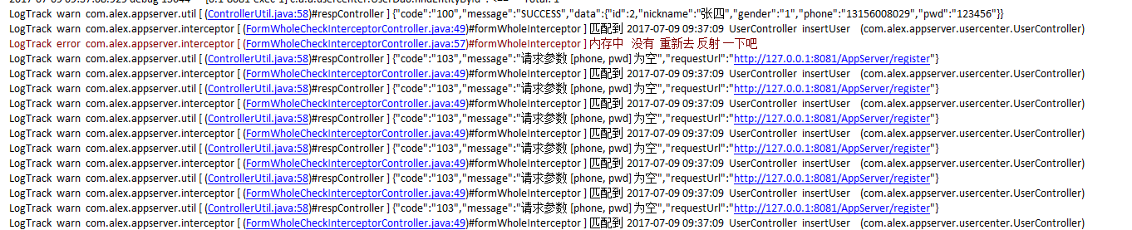

客户端结果

出错

端口被占用
Caused by: java.net.BindException: Address already in use: bind
at sun.nio.ch.Net.bind0(Native Method) ~[na:1.8.0_45]
at sun.nio.ch.Net.bind(Net.java:437) ~[na:1.8.0_45]
at sun.nio.ch.Net.bind(Net.java:429) ~[na:1.8.0_45]
at sun.nio.ch.ServerSocketChannelImpl.bind(ServerSocketChannelImpl.java:223) ~[na:1.8.0_45]

解决
application.properties
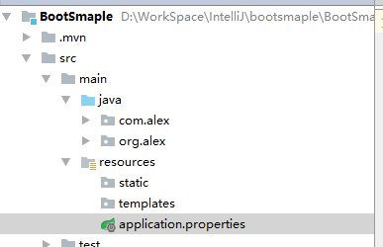
添加
server.port=8081

配置文件注解未找到

Spring Boot Configuration Anotation Processor not found in classpath
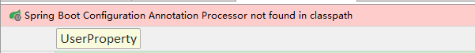

解决
<dependency>
<groupId>org.springframework.boot</groupId>
<artifactId>spring-boot-configuration-processor</artifactId>
<optional>true</optional>
</dependency>

附录
spring-boot-starter-logging ：使用 Spring Boot 默认的日志框架 Logback。
spring-boot-starter-log4j ：添加 Log4j 的支持。
spring-boot-starter-web ：支持 Web 应用开发，包含 Tomcat 和 spring-mvc。
spring-boot-starter-tomcat ：使用 Spring Boot 默认的 Tomcat 作为应用服务器。
spring-boot-starter-jetty ：使用 Jetty 而不是默认的 Tomcat 作为应用服务器。
spring-boot-starter-test ：包含常用的测试所需的依赖，如 JUnit、Hamcrest、Mockito 和 spring-test 等。
spring-boot-starter-aop ：包含 spring-aop 和 AspectJ 来支持面向切面编程（AOP）。
spring-boot-starter-security ：包含 spring-security。
spring-boot-starter-jdbc ：支持使用 JDBC 访问数据库。
spring-boot-starter-redis ：支持使用 Redis。
spring-boot-starter-data-mongodb ：包含 spring-data-mongodb 来支持 MongoDB。
spring-boot-starter-data-jpa ：包含 spring-data-jpa、spring-orm 和 Hibernate 来支持 JPA。
spring-boot-starter-amqp ：通过 spring-rabbit 支持 AMQP。
spring-boot-starter-actuator ： 添加适用于生产环境的功能，如性能指标和监测等功能。

