先看整体目录结构
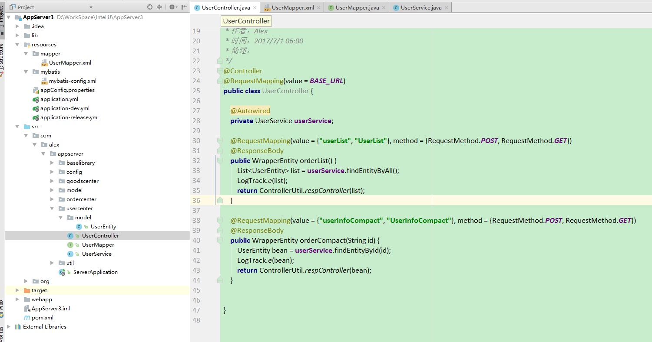

新建一个WebApp项目
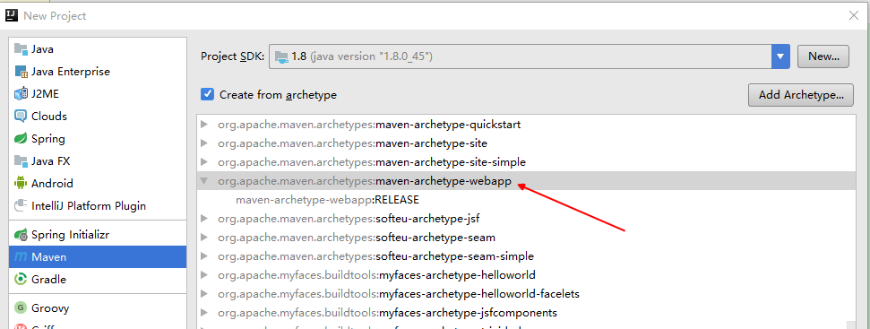

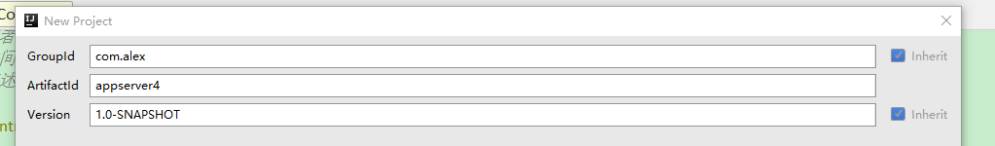

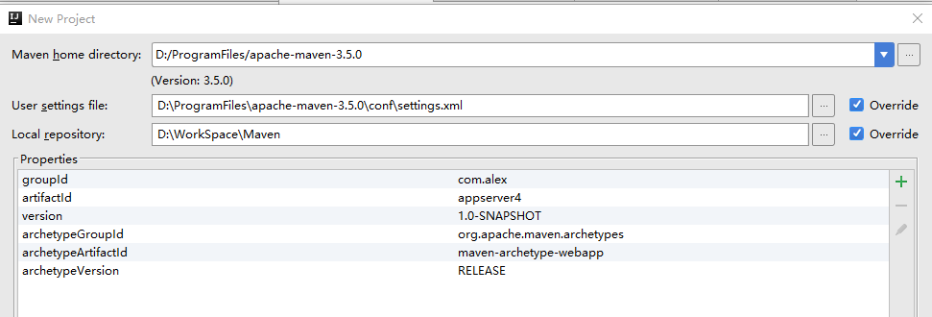

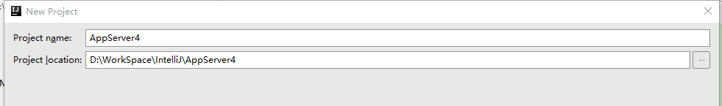
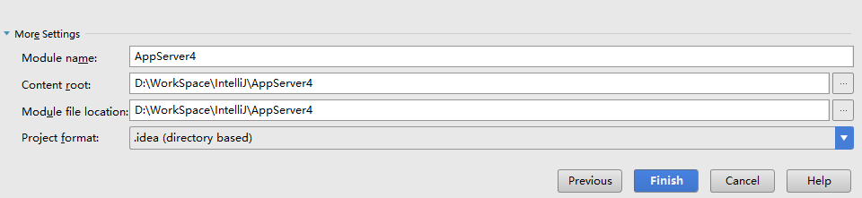

等待加载... ...

pom.xml
不管需要不需要， 先拷贝进去
<project xmlns="http://maven.apache.org/POM/4.0.0" xmlns:xsi="http://www.w3.org/2001/XMLSchema-instance"
xsi:schemaLocation="http://maven.apache.org/POM/4.0.0 http://maven.apache.org/maven-v4_0_0.xsd">
<modelVersion>4.0.0</modelVersion>
<groupId>com.alex</groupId>
<artifactId>AppServer</artifactId>
<packaging>war</packaging>
<version>1.0-SNAPSHOT</version>
<name>AppServer Maven Webapp</name>
<url>http://maven.apache.org</url>
<properties>
<!-- https://mvnrepository.com/artifact/org.springframework/spring-context -->
<spring_version>4.3.9.RELEASE</spring_version>
<spring_groupId>org.springframework</spring_groupId>
<!--http://mvnrepository.com/search?q=spring-boot-->
<spring_boot_groupId>org.springframework.boot</spring_boot_groupId>
<spring_boot_version>1.5.4.RELEASE</spring_boot_version>
<!-- http://mvnrepository.com/search?q=org.mybatis-->
<mybatis_groupId>org.mybatis</mybatis_groupId>
<!--http://mvnrepository.com/artifact/com.fasterxml.jackson.core-->
<jackson_groupId>com.fasterxml.jackson.core</jackson_groupId>
<jackson_version>2.8.8</jackson_version>
</properties>
<dependencies>
<!-- https://mvnrepository.com/artifact/junit/junit -->
<dependency>
<groupId>junit</groupId>
<artifactId>junit</artifactId>
<version>4.12</version>
</dependency>
<!-- https://mvnrepository.com/artifact/com.google.code.gson/gson -->
<dependency>
<groupId>com.google.code.gson</groupId>
<artifactId>gson</artifactId>
<version>2.8.0</version>
</dependency>
<!--Spring Maven 配置 开始-->
<dependency>
<groupId>${spring_groupId}</groupId>
<artifactId>spring-context</artifactId>
<version>${spring_version}</version>
</dependency>
<dependency>
<groupId>${spring_groupId}</groupId>
<artifactId>spring-context-support</artifactId>
<version>${spring_version}</version>
</dependency>
<dependency>
<groupId>${spring_groupId}</groupId>
<artifactId>spring-aop</artifactId>
<version>${spring_version}</version>
</dependency>
<dependency>
<groupId>${spring_groupId}</groupId>
<artifactId>spring-core</artifactId>
<version>${spring_version}</version>
</dependency>
<dependency>
<groupId>${spring_groupId}</groupId>
<artifactId>spring-beans</artifactId>
<version>${spring_version}</version>
</dependency>
<dependency>
<groupId>${spring_groupId}</groupId>
<artifactId>spring-expression</artifactId>
<version>${spring_version}</version>
</dependency>
<dependency>
<groupId>${spring_groupId}</groupId>
<artifactId>spring-webmvc</artifactId>
<version>${spring_version}</version>
</dependency>
<dependency>
<groupId>${spring_groupId}</groupId>
<artifactId>spring-web</artifactId>
<version>${spring_version}</version>
</dependency>
<dependency>
<groupId>${spring_groupId}</groupId>
<artifactId>spring-orm</artifactId>
<version>${spring_version}</version>
</dependency>
<dependency>
<groupId>${spring_groupId}</groupId>
<artifactId>spring-jdbc</artifactId>
<version>${spring_version}</version>
</dependency>
<dependency>
<groupId>${spring_groupId}</groupId>
<artifactId>spring-tx</artifactId>
<version>${spring_version}</version>
</dependency>
<dependency>
<groupId>${spring_groupId}</groupId>
<artifactId>spring-oxm</artifactId>
<version>3.2.5.RELEASE</version>
</dependency>
<!--Spring Maven 配置 结束-->
<!-- Spring Boot Maven 配置 开始 -->
<dependency>
<groupId>${spring_boot_groupId}</groupId>
<version>${spring_boot_version}</version>
<artifactId>spring-boot</artifactId>
</dependency>
<dependency>
<groupId>${spring_boot_groupId}</groupId>
<version>${spring_boot_version}</version>
<artifactId>spring-boot-starter-test</artifactId>
<scope>test</scope>
</dependency>
<dependency>
<groupId>${spring_boot_groupId}</groupId>
<version>${spring_boot_version}</version>
<artifactId>spring-boot-starter-web</artifactId>
</dependency>
<dependency>
<groupId>${spring_boot_groupId}</groupId>
<version>${spring_boot_version}</version>
<artifactId>spring-boot-starter</artifactId>
</dependency>
<dependency>
<groupId>${spring_boot_groupId}</groupId>
<version>${spring_boot_version}</version>
<artifactId>spring-boot-starter-actuator</artifactId>
</dependency>
<dependency>
<groupId>${spring_boot_groupId}</groupId>
<version>${spring_boot_version}</version>
<artifactId>spring-boot-actuator</artifactId>
</dependency>
<!-- Spring Boot Maven 配置 结束 -->
<!--Mybatis 配置 开始-->
<dependency>
<groupId>${mybatis_groupId}</groupId>
<artifactId>mybatis</artifactId>
<version>3.4.4</version>
</dependency>
<dependency>
<groupId>${mybatis_groupId}</groupId>
<artifactId>mybatis-spring</artifactId>
<version>1.3.1</version>
</dependency>
<dependency>
<groupId>${mybatis_groupId}</groupId>
<artifactId>mybatis-guice</artifactId>
<version>3.9</version>
</dependency>
<dependency>
<groupId>${mybatis_groupId}</groupId>
<artifactId>mybatis-typehandlers-jsr310</artifactId>
<version>1.0.2</version>
</dependency>
<dependency>
<groupId>${mybatis_groupId}</groupId>
<artifactId>mybatis-migrations</artifactId>
<version>3.3.1</version>
</dependency>
<dependency>
<groupId>${mybatis_groupId}</groupId>
<artifactId>mybatis-ehcache</artifactId>
<version>1.0.0</version>
</dependency>
<!--Mybatis 配置 结束-->
<!--log4j 配置 开始-->
<dependency>
<groupId>log4j</groupId>
<artifactId>log4j</artifactId>
<version>1.2.17</version>
</dependency>
<dependency>
<groupId>commons-logging</groupId>
<artifactId>commons-logging</artifactId>
<version>1.2</version>
</dependency>
<!--log4j 配置 结束-->
<!-- javax -->
<dependency>
<groupId>javax.servlet</groupId>
<artifactId>servlet-api</artifactId>
<version>2.5</version>
<scope>provided</scope>
</dependency>
<dependency>
<groupId>javax.servlet.jsp</groupId>
<artifactId>jsp-api</artifactId>
<version>2.1</version>
<scope>provided</scope>
</dependency>
<dependency>
<groupId>javax.servlet</groupId>
<artifactId>jstl</artifactId>
<version>1.2</version>
</dependency>
<dependency>
<groupId>javax.ws.rs</groupId>
<artifactId>javax.ws.rs-api</artifactId>
<version>2.0</version>
</dependency>
<dependency>
<groupId>javax.websocket</groupId>
<artifactId>javax.websocket-api</artifactId>
<version>1.0</version>
</dependency>
<dependency>
<groupId>javax.annotation</groupId>
<artifactId>javax.annotation-api</artifactId>
<version>1.2</version>
</dependency>
<dependency>
<groupId>javax.transaction</groupId>
<artifactId>javax.transaction-api</artifactId>
<version>1.2</version>
</dependency>
<!-- https://mvnrepository.com/artifact/javax.persistence/persistence-api -->
<dependency>
<groupId>javax.persistence</groupId>
<artifactId>persistence-api</artifactId>
<version>1.0.2</version>
</dependency>
<dependency>
<groupId>mysql</groupId>
<artifactId>mysql-connector-java</artifactId>
<version>5.1.29</version>
</dependency>
<!-- https://mvnrepository.com/artifact/com.alibaba/druid -->
<dependency>
<groupId>com.alibaba</groupId>
<artifactId>druid</artifactId>
<version>1.0.31</version>
</dependency>
<!-- 数据解析 jackSon-->
<!-- https://mvnrepository.com/artifact/com.fasterxml.jackson.core/jackson-core -->
<dependency>
<artifactId>jackson-core</artifactId>
<groupId>${jackson_groupId}</groupId>
<version>${jackson_version}</version>
</dependency>
<dependency>
<artifactId>jackson-annotations</artifactId>
<groupId>${jackson_groupId}</groupId>
<version>${jackson_version}</version>
</dependency>
<dependency>
<artifactId>jackson-databind</artifactId>
<groupId>${jackson_groupId}</groupId>
<version>${jackson_version}</version>
</dependency>
<!-- https://mvnrepository.com/artifact/commons-fileupload/commons-fileupload -->
<dependency>
<groupId>commons-fileupload</groupId>
<artifactId>commons-fileupload</artifactId>
<version>1.3.2</version>
</dependency>
<!-- https://mvnrepository.com/artifact/commons-io/commons-io -->
<dependency>
<groupId>commons-io</groupId>
<artifactId>commons-io</artifactId>
<version>2.5</version>
</dependency>
</dependencies>
<build>
<plugins>
<plugin>
<groupId>org.springframework.boot</groupId>
<artifactId>spring-boot-maven-plugin</artifactId>
</plugin>
<plugin>
<groupId>org.apache.maven.plugins</groupId>
<artifactId>maven-surefire-plugin</artifactId>
<configuration>
<skip>true</skip>
</configuration>
</plugin>
</plugins>
</build>
</project>

同步一下Maven
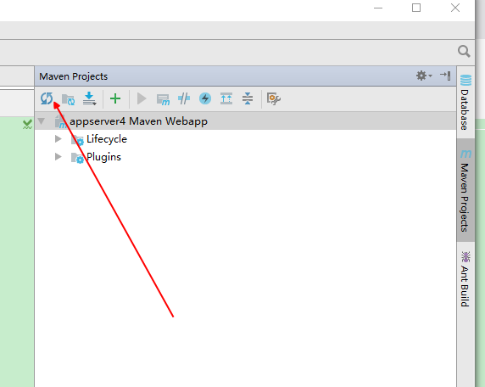

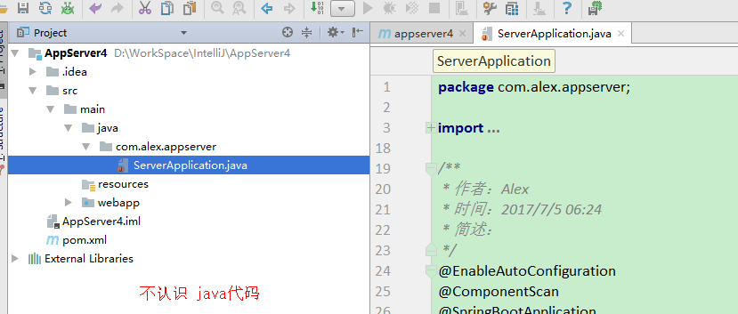

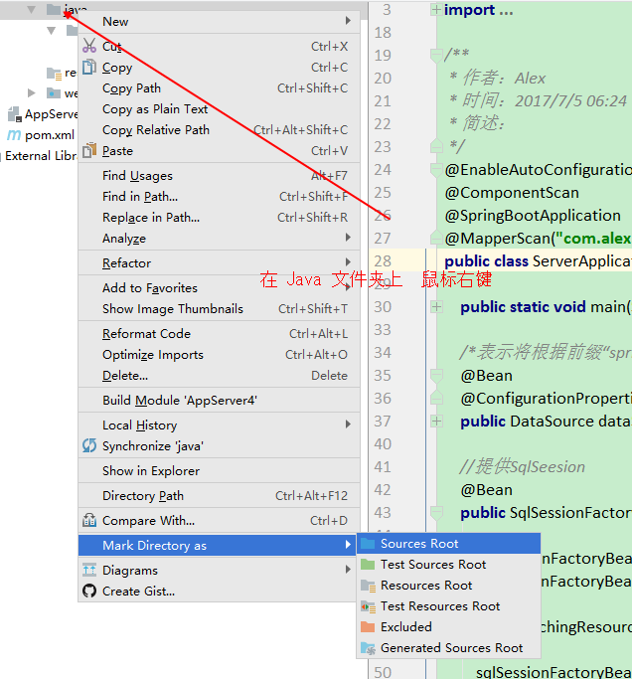

UserEntity

package com.alex.appserver.usercenter.model;
import com.alex.appserver.ordercenter.model.OrderEntity;
import javax.persistence.*;
import java.io.Serializable;
import java.math.BigDecimal;
/**
* 作者：Alex
* 时间：2017/6/29 23:36
* 简述：
*/
@Entity(name = "t_user")
public class UserEntity implements Serializable{
private static final long serialVersionUID = -693323309422224951L;
/**
* 这里的 id 不能是int类型， 必须是Integer类型；
* int 有默认值0， Integer默认值是null
*/
@Id
@GeneratedValue
private Integer id;
private String nickname;
private String gender;
private String phone;
private String pwd;
private BigDecimal accountBalance;
private BigDecimal pointBalance;
private OrderEntity orderEntity;
/**
* Mysql下 AUTO 总是失败的，选用 GenerationType.IDENTITY
* */
@Id
@Column(name="id")
@GeneratedValue(strategy = GenerationType.IDENTITY)
public Integer getId() {
return id;
}
public void setId(Integer id) {
this.id = id;
}
@Basic
@Column(name = "nickname",length = 8)
public String getNickname() {
return nickname;
}
public void setNickname(String nickname) {
this.nickname = nickname;
}
@Basic
@Column(name = "gender" , length = 2)
public String getGender() {
return gender;
}
public void setGender(String gender) {
this.gender = gender;
}
@Basic
@Column(name = "phone", nullable = false, length = 20)
public String getPhone() {
return phone;
}
public void setPhone(String phone) {
this.phone = phone;
}
@Basic
@Column(name = "pwd", nullable = false, length = 20)
public String getPwd() {
return pwd;
}
public void setPwd(String pwd) {
this.pwd = pwd;
}
@Basic
@Column(name = "account_balance" , precision = 3)
public BigDecimal getAccountBalance() {
return accountBalance;
}
public void setAccountBalance(BigDecimal accountBalance) {
this.accountBalance = accountBalance;
}
@Basic
@Column(name = "point_balance", precision = 3)
public BigDecimal getPointBalance() {
return pointBalance;
}
public void setPointBalance(BigDecimal pointBalance) {
this.pointBalance = pointBalance;
}
@OneToOne(mappedBy = "userEntity")
public OrderEntity getOrderEntity() {
return orderEntity;
}
public void setOrderEntity(OrderEntity orderEntity) {
this.orderEntity = orderEntity;
}
@Override
public boolean equals(Object o) {
if (this == o) return true;
if (o == null || getClass() != o.getClass()) return false;
UserEntity that = (UserEntity) o;
if (id != that.id) return false;
if (nickname != null ? !nickname.equals(that.nickname) : that.nickname != null) return false;
if (gender != null ? !gender.equals(that.gender) : that.gender != null) return false;
if (phone != null ? !phone.equals(that.phone) : that.phone != null) return false;
if (pwd != null ? !pwd.equals(that.pwd) : that.pwd != null) return false;
if (accountBalance != null ? !accountBalance.equals(that.accountBalance) : that.accountBalance != null)
return false;
if (pointBalance != null ? !pointBalance.equals(that.pointBalance) : that.pointBalance != null) return false;
return true;
}
@Override
public int hashCode() {
int result = id;
result = 31 * result + (nickname != null ? nickname.hashCode() : 0);
result = 31 * result + (gender != null ? gender.hashCode() : 0);
result = 31 * result + (phone != null ? phone.hashCode() : 0);
result = 31 * result + (pwd != null ? pwd.hashCode() : 0);
result = 31 * result + (accountBalance != null ? accountBalance.hashCode() : 0);
result = 31 * result + (pointBalance != null ? pointBalance.hashCode() : 0);
return result;
}
@Override
public String toString() {
return "UserEntity{" +
"id=" + id +
", nickname='" + nickname + '\'' +
", gender='" + gender + '\'' +
", phone='" + phone + '\'' +
", pwd='" + pwd + '\'' +
", accountBalance=" + accountBalance +
", pointBalance=" + pointBalance +
'}';
}
}

UserController
package com.alex.appserver.usercenter;
import com.alex.appserver.model.WrapperEntity;
import com.alex.appserver.usercenter.model.UserEntity;
import com.alex.appserver.util.ControllerUtil;
import org.alex.util.LogTrack;
import org.springframework.beans.factory.annotation.Autowired;
import org.springframework.stereotype.Controller;
import org.springframework.web.bind.annotation.RequestMapping;
import org.springframework.web.bind.annotation.RequestMethod;
import org.springframework.web.bind.annotation.ResponseBody;
import java.util.List;
import static com.alex.appserver.config.AppCon.BASE_URL;
/**
* 作者：Alex
* 时间：2017/7/1 06:00
* 简述：
*/
@Controller
@RequestMapping(value = BASE_URL)
public class UserController {
@Autowired
private UserService userService;
@RequestMapping(value = {"userList", "UserList"}, method = {RequestMethod.POST, RequestMethod.GET})
@ResponseBody
public WrapperEntity orderList() {
List<UserEntity> list = userService.findEntityByAll();
LogTrack.e(list);
return ControllerUtil.respController(list);
}
@RequestMapping(value = {"userInfoCompact", "UserInfoCompact"}, method = {RequestMethod.POST, RequestMethod.GET})
@ResponseBody
public WrapperEntity orderCompact(String id) {
UserEntity bean = userService.findEntityById(id);
LogTrack.e(bean);
return ControllerUtil.respController(bean);
}
}

UserService
package com.alex.appserver.usercenter;
import com.alex.appserver.usercenter.model.UserEntity;
import org.springframework.beans.factory.annotation.Autowired;
import org.springframework.stereotype.Service;
import java.util.List;
/**
* 作者：Alex
* 时间：2017/7/1 05:54
* 简述：
*/
@Service
public class UserService {
@Autowired
UserMapper userMapper;
UserEntity findEntityById(String id) {
return userMapper.findEntityById(id);
}
List<UserEntity> findEntityByAll() {
return userMapper.findEntityByAll();
}
}

UserDao
package com.alex.appserver.usercenter;
import com.alex.appserver.usercenter.model.UserEntity;
import org.apache.ibatis.annotations.Mapper;
import org.apache.ibatis.annotations.Param;
import java.util.List;
/**
* 作者：Alex
* 时间：2017/7/1 05:54
* 简述：
*/
@Mapper
public interface UserDao {
// @Select("select * from t_user where id = #{id}")
UserEntity findEntityById(@Param("id") String id);
// @Select("select * from t_user")
List<UserEntity> findEntityByAll();
}

ServerApplication
package com.alex.appserver;
import com.alibaba.druid.pool.DruidDataSource;
import org.apache.ibatis.session.SqlSessionFactory;
import org.mybatis.spring.SqlSessionFactoryBean;
import org.mybatis.spring.annotation.MapperScan;
import org.springframework.boot.SpringApplication;
import org.springframework.boot.autoconfigure.EnableAutoConfiguration;
import org.springframework.boot.autoconfigure.SpringBootApplication;
import org.springframework.boot.context.properties.ConfigurationProperties;
import org.springframework.context.annotation.Bean;
import org.springframework.context.annotation.ComponentScan;
import org.springframework.core.io.support.PathMatchingResourcePatternResolver;
import org.springframework.jdbc.datasource.DataSourceTransactionManager;
import org.springframework.transaction.PlatformTransactionManager;
import javax.sql.DataSource;
/**
* 作者：Alex
* 时间：2017/7/5 06:24
* 简述：
*/
@EnableAutoConfiguration
@ComponentScan
@SpringBootApplication
@MapperScan("com.alex.appserver")
public class ServerApplication {
public static void main(String[] args) {
SpringApplication.run(ServerApplication.class, args);
}
/*表示将根据前缀“spring.datasource”从application.yml 中匹配相关属性值。*/
@Bean
@ConfigurationProperties(prefix = "spring.datasource")
public DataSource dataSource() {
return new DruidDataSource();
}
//提供SqlSeesion
@Bean
public SqlSessionFactory sqlSessionFactoryBean() throws Exception {
SqlSessionFactoryBean sqlSessionFactoryBean = new SqlSessionFactoryBean();
sqlSessionFactoryBean.setDataSource(dataSource());
PathMatchingResourcePatternResolver resolver = new PathMatchingResourcePatternResolver();
sqlSessionFactoryBean.setMapperLocations(resolver.getResources("classpath:/mapper/*.xml"));
return sqlSessionFactoryBean.getObject();
}
@Bean
public PlatformTransactionManager transactionManager() {
return new DataSourceTransactionManager(dataSource());
}
}

UserMapper.xml
<?xml version="1.0" encoding="UTF-8" ?>
<!DOCTYPE mapper
PUBLIC "-//mybatis.org//DTD Mapper 3.0//EN"
"http://mybatis.org/dtd/mybatis-3-mapper.dtd">
<mapper namespace="com.alex.appserver.usercenter.UserDao">
<select id="findEntityById" resultType="com.alex.appserver.usercenter.model.UserEntity">
select * from t_user where id=#{id}
</select>
<select id="findEntityByAll" resultType="com.alex.appserver.usercenter.model.UserEntity">
select * from t_user
</select>
</mapper>

application.yml
server.port: 8080
server.address: 127.0.0.1
spring.http.encoding.charset: UTF-8
spring.http.encoding.enabled: true
spring.http.encoding.force: true
spring.datasource.driver-class-name: com.mysql.jdbc.Driver
spring.datasource.url: jdbc:mysql://127.0.0.1:3306/maternalshop?useUnicode=true&characterEncoding=gbk&zeroDateTimeBehavior=convertToNull
spring.datasource.username: root
spring.datasource.password: root
spring.jpa.hibernate.ddl-auto: update # create 每次都会删除新建表；update
spring.jpa.show-sql: true
#mybatis.typeAliasesPackage: com.alex.appserver.**.model
#mybatis.mapperLocations: classpath:mapper/*.xml
#mybatis.configLocation: classpath:mybatis/mybatis-config.xml
# LOGGING
logging.level: debug

响应结果
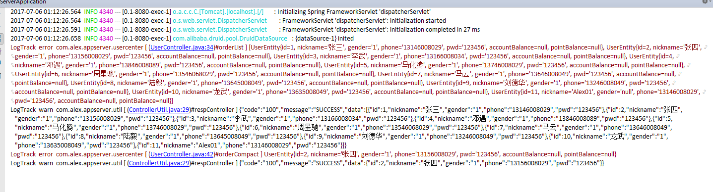

SpringBoot-Mybatis-Gradle-Start

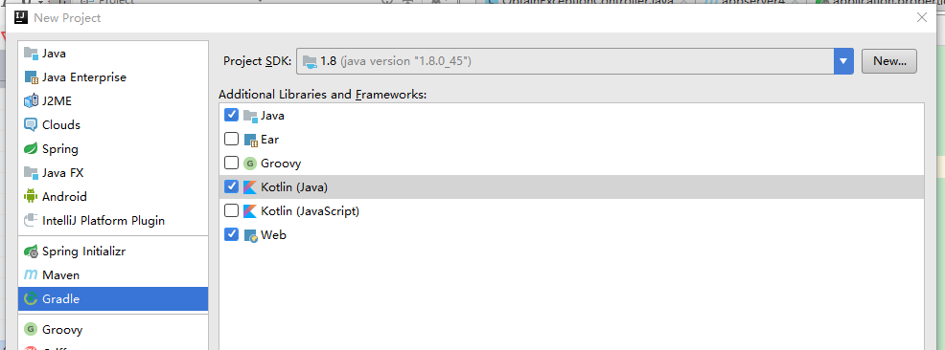

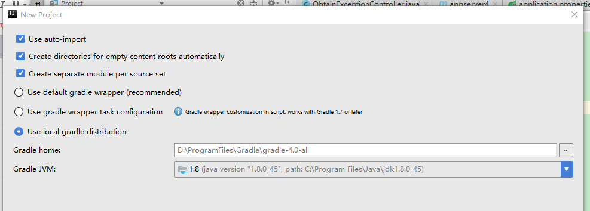

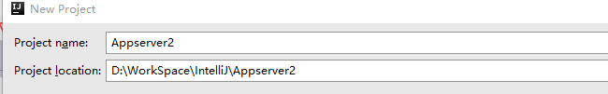
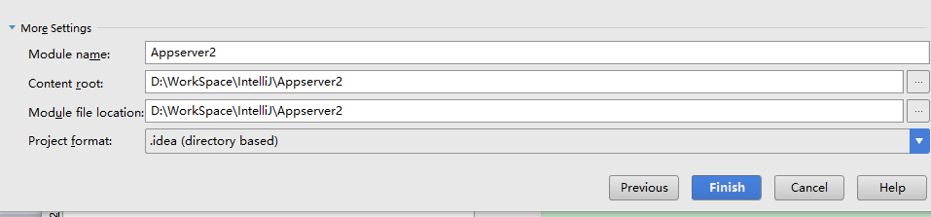



目录结构
