New Project
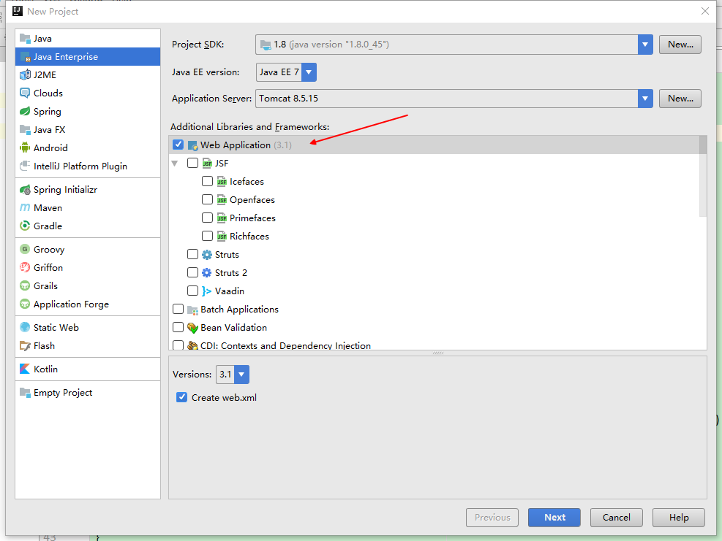
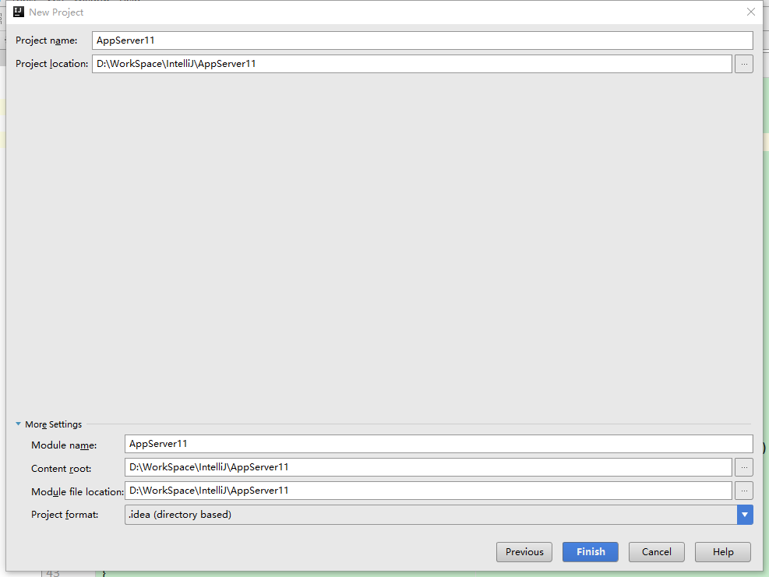

maven环境

pom.xml
<project xmlns="http://maven.apache.org/POM/4.0.0" xmlns:xsi="http://www.w3.org/2001/XMLSchema-instance"
xsi:schemaLocation="http://maven.apache.org/POM/4.0.0 http://maven.apache.org/maven-v4_0_0.xsd">
<modelVersion>4.0.0</modelVersion>
<groupId>com.alex</groupId>
<artifactId>AppServer11</artifactId>
<packaging>war</packaging>
<version>1.0-SNAPSHOT</version>
<name>AppServer11 Maven Webapp</name>
<url>http://maven.apache.org</url>
</project>

add as maven project
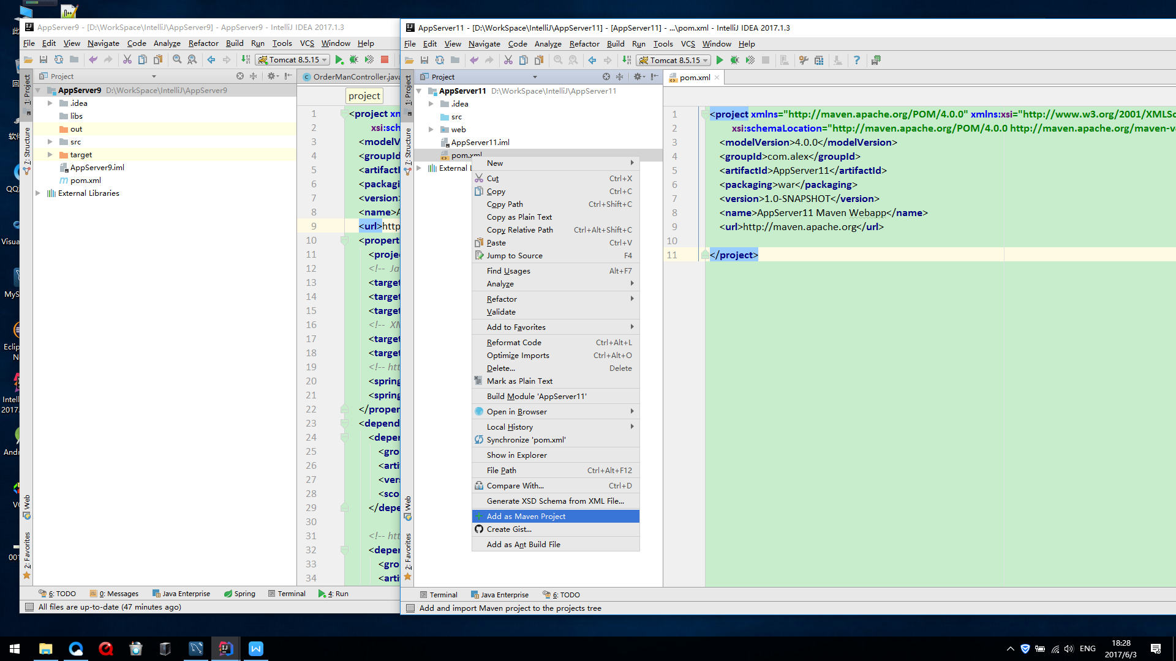

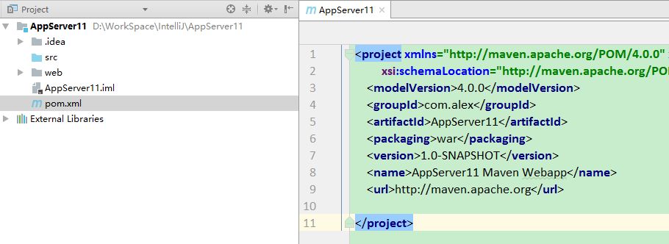

Reimport All Maven Project
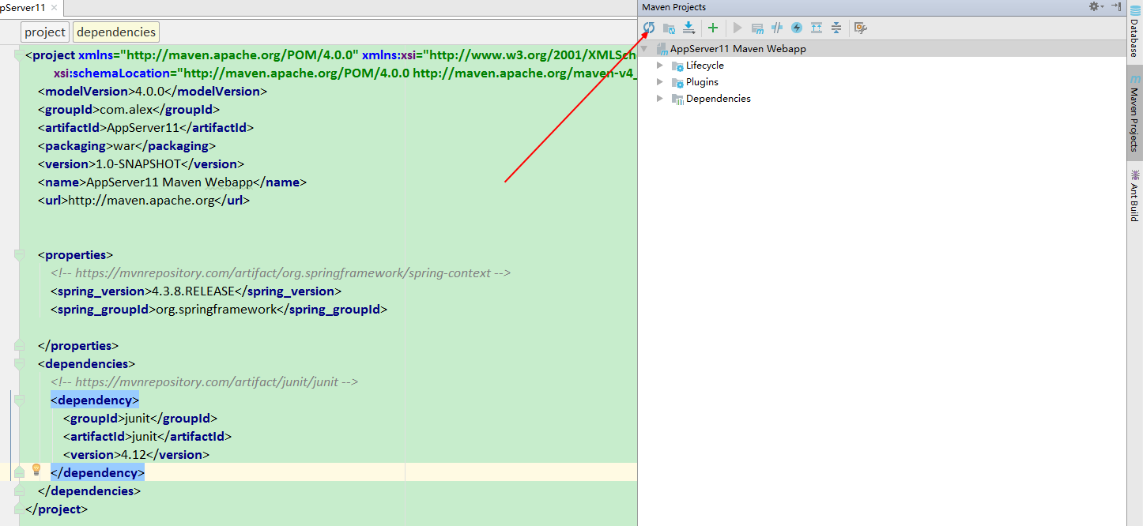

resource
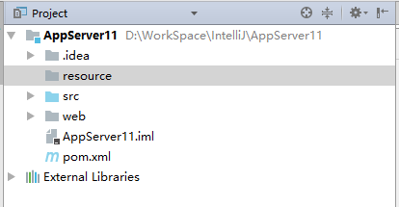

Make Directory as Resources Root
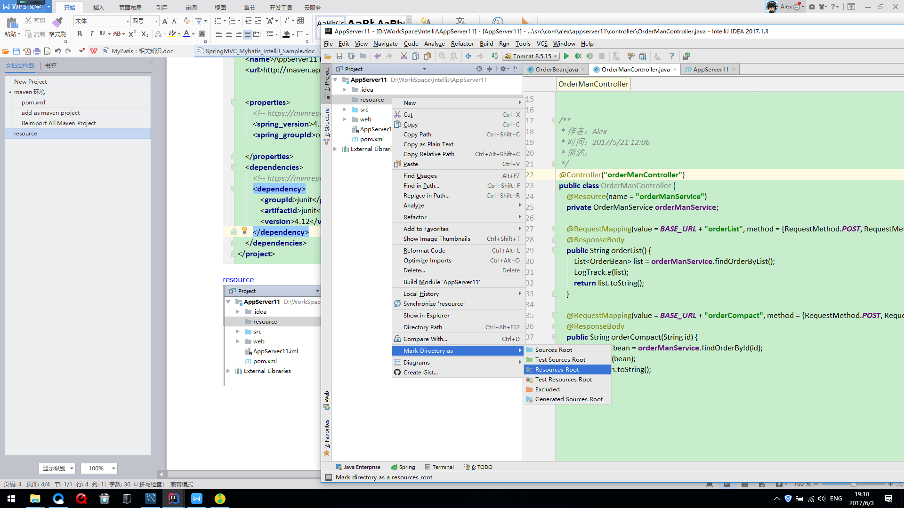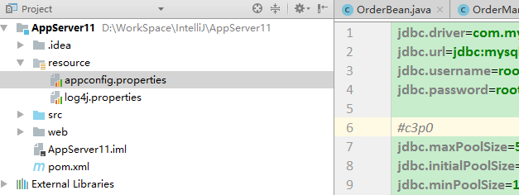

web.xml
路径
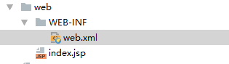
内容
<?xml version="1.0" encoding="UTF-8"?>
<web-app xmlns="http://xmlns.jcp.org/xml/ns/javaee"
xmlns:xsi="http://www.w3.org/2001/XMLSchema-instance"
xsi:schemaLocation="http://xmlns.jcp.org/xml/ns/javaee http://xmlns.jcp.org/xml/ns/javaee/web-app_3_1.xsd"
version="3.1">
<display-name>Archetype Created Web Application</display-name>
<!--第一步-->
<context-param>
<param-name>contextConfigLocation</param-name>
<param-value>classpath:applicationContext.xml</param-value>
</context-param>
<listener>
<listener-class>org.springframework.web.context.ContextLoaderListener</listener-class>
</listener>
<servlet>
<servlet-name>springMVC</servlet-name>
<servlet-class>org.springframework.web.servlet.DispatcherServlet</servlet-class>
<init-param>
<param-name>contextConfigLocation</param-name>
<param-value>classpath:springMVC-servlet.xml</param-value>
</init-param>
<load-on-startup>1</load-on-startup>
</servlet>
<servlet-mapping>
<servlet-name>springMVC</servlet-name>
<url-pattern>/</url-pattern>
</servlet-mapping>
</web-app>

applicationContext
新建 spring配置之applicationContext.xml

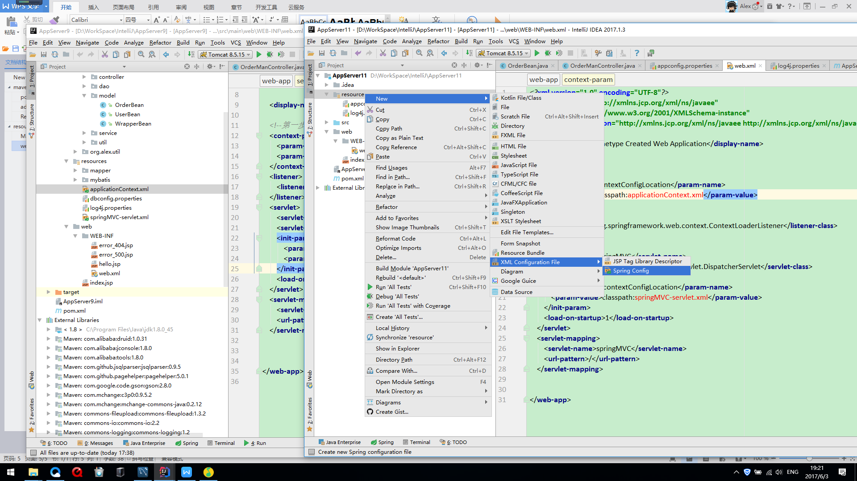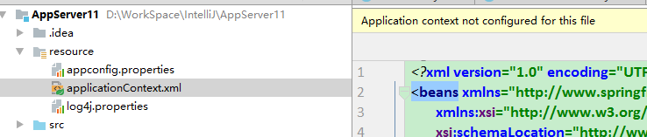
内容
<?xml version="1.0" encoding="UTF-8"?>
<beans xmlns="http://www.springframework.org/schema/beans"
xmlns:xsi="http://www.w3.org/2001/XMLSchema-instance"
xmlns:context="http://www.springframework.org/schema/context"
xmlns:aop="http://www.springframework.org/schema/aop" xmlns:tx="http://www.springframework.org/schema/tx"
xsi:schemaLocation="http://www.springframework.org/schema/beans http://www.springframework.org/schema/beans/spring-beans.xsd http://www.springframework.org/schema/context http://www.springframework.org/schema/context/spring-context.xsd http://www.springframework.org/schema/aop http://www.springframework.org/schema/aop/spring-aop.xsd http://www.springframework.org/schema/tx http://www.springframework.org/schema/tx/spring-tx.xsd">
<!-- 第一步 ：开启注解-->
<context:annotation-config/>
<!-- 自动扫描所有注解该路径 -->
<context:component-scan base-package="com.alex.appserver11.service"/>
<context:component-scan base-package="com.alex.appserver11.dao"/>
<aop:aspectj-autoproxy/>
<!--数据源-->
<context:property-placeholder location="classpath:appconfig.properties"/>
<bean id="dataSource" class="com.alibaba.druid.pool.DruidDataSource" init-method="init" destroy-method="close">
<property name="driverClassName" value="${jdbc.driver}"/>
<property name="url" value="${jdbc.url}"/>
<property name="username" value="${jdbc.username}"/>
<property name="password" value="${jdbc.password}"/>
<property name="filters" value="stat"/>
<property name="maxActive" value="20"/>
<property name="initialSize" value="1"/>
<property name="maxWait" value="60000"/>
<property name="minIdle" value="1"/>
<property name="timeBetweenEvictionRunsMillis" value="60000"/>
<property name="minEvictableIdleTimeMillis" value="300000"/>
<property name="validationQuery" value="SELECT 'x'"/>
<property name="testWhileIdle" value="true"/>
<property name="testOnBorrow" value="false"/>
<property name="testOnReturn" value="false"/>
</bean>
<!--配置 SqlSessionFactoryBean-->
<bean id="sqlSessionFactory" class="org.mybatis.spring.SqlSessionFactoryBean">
<!-- 数据库连接池 -->
<property name="dataSource" ref="dataSource"/>
<property name="mapperLocations">
<array>
<value>classpath:mapper/*.xml</value>
</array>
</property>
<!-- 加载Mybatis全局配置文件 -->
<property name="configLocation" value="classpath:mybatis/mybatis-config.xml"/>
<!--配置别名-->
<property name="typeAliasesPackage" value="com.alex.appserver11.model"/>
</bean>
<bean id="sqlSession" class="org.mybatis.spring.SqlSessionTemplate" scope="prototype">
<constructor-arg index="0" ref="sqlSessionFactory"/>
</bean>
<!--事物管理-->
<bean id="transactionManager" class="org.springframework.jdbc.datasource.DataSourceTransactionManager">
<property name="dataSource" ref="dataSource"/>
</bean>
<tx:advice id="txAdvice" transaction-manager="transactionManager">
<tx:attributes>
<tx:method name="select*" read-only="true"/>
<tx:method name="find*" read-only="true"/>
<tx:method name="get*" read-only="true"/>
<tx:method name="*"/>
</tx:attributes>
</tx:advice>
<!-- 配置mapper扫描器 -->
<bean class="org.mybatis.spring.mapper.MapperScannerConfigurer">
<!-- 扫描包路径，如果需要扫描多个包中间用半角逗号隔开 -->
<property name="basePackage" value="com.alex.appserver11.dao"></property>
<property name="sqlSessionFactoryBeanName" value="sqlSessionFactory"/>
</bean>
</beans>

springMVC-servlet.xml
<?xml version="1.0" encoding="UTF-8"?>
<beans xmlns="http://www.springframework.org/schema/beans"
xmlns:xsi="http://www.w3.org/2001/XMLSchema-instance"
xmlns:context="http://www.springframework.org/schema/context"
xmlns:mvc="http://www.springframework.org/schema/mvc"
xsi:schemaLocation="http://www.springframework.org/schema/beans http://www.springframework.org/schema/beans/spring-beans.xsd http://www.springframework.org/schema/context http://www.springframework.org/schema/context/spring-context.xsd http://www.springframework.org/schema/mvc http://www.springframework.org/schema/mvc/spring-mvc.xsd">
<!-- 第一步 ：开启注解-->
<context:annotation-config/>
<mvc:default-servlet-handler/>
<!--扫描 controller-->
<context:component-scan base-package="com.alex.appserver11.controller"/>
<mvc:annotation-driven/>
<bean id="viewResolver" class="org.springframework.web.servlet.view.InternalResourceViewResolver">
</bean>
</beans>

mybatis-config.xml
<?xml version="1.0" encoding="UTF-8" ?>
<!DOCTYPE configuration
PUBLIC "-//mybatis.org//DTD Config 3.0//EN"
"mybatis-3-config.dtd">
<configuration>
<!-- 配置全局属性 -->
<settings>
<!-- 使用jdbc的getGeneratedKeys获取数据库自增主键值 -->
<setting name="useGeneratedKeys" value="true" />
<!-- 使用列别名替换列名 默认:true -->
<setting name="useColumnLabel" value="true" />
<!-- 开启驼峰命名转换:Table{create_time} -> Entity{createTime} -->
<setting name="mapUnderscoreToCamelCase" value="true" />
</settings>
</configuration>

mybatis_order_mapper.xml
<?xml version="1.0" encoding="UTF-8" ?>
<!DOCTYPE mapper
PUBLIC "-//mybatis.org//DTD Mapper 3.0//EN"
"http://mybatis.org/dtd/mybatis-3-mapper.dtd">
<mapper namespace="com.alex.appserver11.dao.OrderManDao">
<select id="findOrderById" resultType="com.alex.appserver11.model.OrderBean">
select * from t_order where id=#{id}
</select>
<select id="findOrderByList" resultType="com.alex.appserver11.model.OrderBean">
select * from t_order
</select>
</mapper>

Java

目录结构

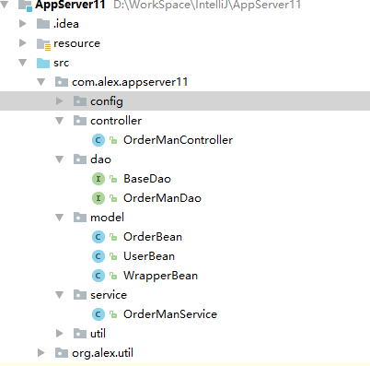

OrderManController
@Controller("orderManController")
public class OrderManController {
@Resource(name = "orderManService")
private OrderManService orderManService;
@RequestMapping(value = BASE_URL + "orderList", method = {RequestMethod.POST, RequestMethod.GET})
@ResponseBody
public String orderList() {
List<OrderBean> list = orderManService.findOrderByList();
LogTrack.e(list);
return list.toString();
}
@RequestMapping(value = BASE_URL + "orderCompact", method = {RequestMethod.POST, RequestMethod.GET})
@ResponseBody
public String orderCompact(String id) {
OrderBean bean = orderManService.findOrderById(id);
LogTrack.e(bean);
return bean.toString();
}
}

OrderManService
@Service(value = "orderManService")
public class OrderManService {
@Resource(name = "orderManDao")
private OrderManDao orderManDao;
public OrderBean findOrderById(String id) {
OrderBean bean = orderManDao.findOrderById(id);
LogTrack.e(orderManDao+" "+bean);
return bean==null ? new OrderBean():bean;
}
public List<OrderBean> findOrderByList() {
return orderManDao.findOrderByList();
}
}

OrderManDao
@Repository(value = "orderManDao")
public interface OrderManDao extends BaseDao {
OrderBean findOrderById(String id);
List<OrderBean> findOrderByList();
}

xml标签不认识
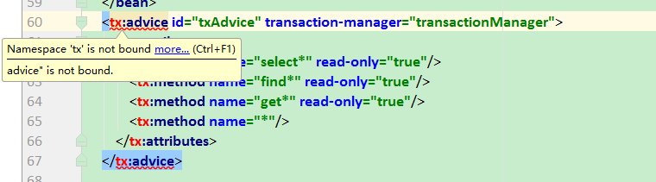

光标放在 : 之前 按Alt + Enter
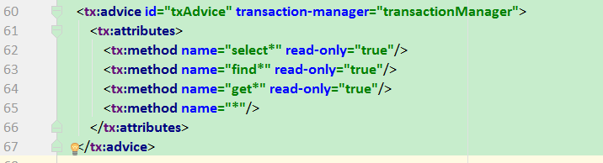

maven依赖
<project xmlns="http://maven.apache.org/POM/4.0.0" xmlns:xsi="http://www.w3.org/2001/XMLSchema-instance"
xsi:schemaLocation="http://maven.apache.org/POM/4.0.0 http://maven.apache.org/maven-v4_0_0.xsd">
<modelVersion>4.0.0</modelVersion>
<groupId>com.alex</groupId>
<artifactId>AppServer11</artifactId>
<packaging>war</packaging>
<version>1.0-SNAPSHOT</version>
<name>AppServer11 Maven Webapp</name>
<url>http://maven.apache.org</url>
<properties>
<!-- https://mvnrepository.com/artifact/org.springframework/spring-context -->
<spring_version>4.3.8.RELEASE</spring_version>
<spring_groupId>org.springframework</spring_groupId>
</properties>
<dependencies>
<!-- https://mvnrepository.com/artifact/junit/junit -->
<dependency>
<groupId>junit</groupId>
<artifactId>junit</artifactId>
<version>4.12</version>
</dependency>
<!-- https://mvnrepository.com/artifact/com.google.code.gson/gson -->
<dependency>
<groupId>com.google.code.gson</groupId>
<artifactId>gson</artifactId>
<version>2.8.0</version>
</dependency>
<!--Spring Maven 配置 开始-->
<dependency>
<groupId>${spring_groupId}</groupId>
<artifactId>spring-context</artifactId>
<version>${spring_version}</version>
</dependency>
<dependency>
<groupId>${spring_groupId}</groupId>
<artifactId>spring-context-support</artifactId>
<version>${spring_version}</version>
</dependency>
<dependency>
<groupId>${spring_groupId}</groupId>
<artifactId>spring-aop</artifactId>
<version>${spring_version}</version>
</dependency>
<dependency>
<groupId>${spring_groupId}</groupId>
<artifactId>spring-core</artifactId>
<version>${spring_version}</version>
</dependency>
<dependency>
<groupId>${spring_groupId}</groupId>
<artifactId>spring-beans</artifactId>
<version>${spring_version}</version>
</dependency>
<dependency>
<groupId>${spring_groupId}</groupId>
<artifactId>spring-expression</artifactId>
<version>${spring_version}</version>
</dependency>
<dependency>
<groupId>${spring_groupId}</groupId>
<artifactId>spring-webmvc</artifactId>
<version>${spring_version}</version>
</dependency>
<dependency>
<groupId>${spring_groupId}</groupId>
<artifactId>spring-web</artifactId>
<version>${spring_version}</version>
</dependency>
<dependency>
<groupId>${spring_groupId}</groupId>
<artifactId>spring-orm</artifactId>
<version>${spring_version}</version>
</dependency>
<dependency>
<groupId>${spring_groupId}</groupId>
<artifactId>spring-jdbc</artifactId>
<version>${spring_version}</version>
</dependency>
<dependency>
<groupId>${spring_groupId}</groupId>
<artifactId>spring-tx</artifactId>
<version>${spring_version}</version>
</dependency>
<dependency>
<groupId>${spring_groupId}</groupId>
<artifactId>spring-oxm</artifactId>
<version>3.2.5.RELEASE</version>
</dependency>
<!--Spring Maven 配置 结束-->
<!--Mybatis 配置 开始-->
<dependency>
<groupId>org.mybatis</groupId>
<artifactId>mybatis</artifactId>
<version>3.4.4</version>
</dependency>
<dependency>
<groupId>org.mybatis</groupId>
<artifactId>mybatis-spring</artifactId>
<version>1.3.1</version>
</dependency>
<!--Mybatis 配置 结束-->
<!--log4j 配置 开始-->
<dependency>
<groupId>log4j</groupId>
<artifactId>log4j</artifactId>
<version>1.2.17</version>
</dependency>
<dependency>
<groupId>commons-logging</groupId>
<artifactId>commons-logging</artifactId>
<version>1.2</version>
</dependency>
<!--log4j 配置 结束-->
<!-- https://mvnrepository.com/artifact/javax.persistence/persistence-api -->
<dependency>
<groupId>javax.persistence</groupId>
<artifactId>persistence-api</artifactId>
<version>1.0.2</version>
</dependency>
<!-- https://mvnrepository.com/artifact/com.alibaba/druid -->
<dependency>
<groupId>com.alibaba</groupId>
<artifactId>druid</artifactId>
<version>1.0.31</version>
</dependency>
</dependencies>
</project>

