SmartCare v0.3 - Domain Model Workbook
Week 6 student resource

Requirement-to-Concept Trace
Requirement | Concept | State/behaviour | Decision
FR-01 / FR-02 | Patient | State: patient_id, name | Keep as a core entity to hold patient details.
FR-06 | Practitioner | State: practitioner_id, name | Keep as a core entity to track practitioner identity and schedule visibility.
FR-01 / US-01 | Appointment | State: appointment_id, patient, practitioner, time | Keep as a core entity to represent the central booking transaction
FR-03 | Appointment | Behaviour: Conflict check / validation logic | Assign responsibility to Appointment slot validation to prevent double-booking.
FR-05 / FR-09 | Appointment | State: status  Behaviour: cancel() | Implement a cancel() function and update the state of the appointment to "Cancelled" without deleting its record
FR-12 / NFR-02 | All Classes | Behaviour: Constructor validation (if not name.strip(): | Implement defensive input checks inside __init__ methods across all entities.
NFR-01 | System Scope | Architecture: High cohesion, low coupling | Reject controller/manager classes (PatientManager, ScheduleEngine) to avoid the "God Class" anti-pattern.
FR-04 / FR-10 | Appointment | Behaviour: Search/filter lookup functions | Assign lookup methods to Appointment to allow reception staff to quickly locate specific records.
FR-07 | Appointment | State: status  Behaviour: Display appointment log | Keep appointment records in memory (and eventually file storage) to build a searchable history.
FR-08 / FR-11 | Appointment | State: time | Make structured date/time fields to allow for future operational report generation.

CRC Cards

Patient
Responsibilities | Collaborators
Holds patient details (patient_id, name). | Appointment.
Validates patients when they attempt to enter the clinic.

Practitioner
Responsibilities | Collaborators
Holds practitioner details (practitioner_id, name). | Appointment.
Tracks practitioners' time slot availability.

Appointment
Responsibilities | Collaborators
Holds the booking time and status for appointments and checks for any conflicts surrounding time slots. | Practitioner.
Handles cancellations of appointments. | Patient.

Optional class
Responsibilities | Collaborators

UML Class Diagram
Insert/draw UML here. Include defensible relationships and multiplicities.
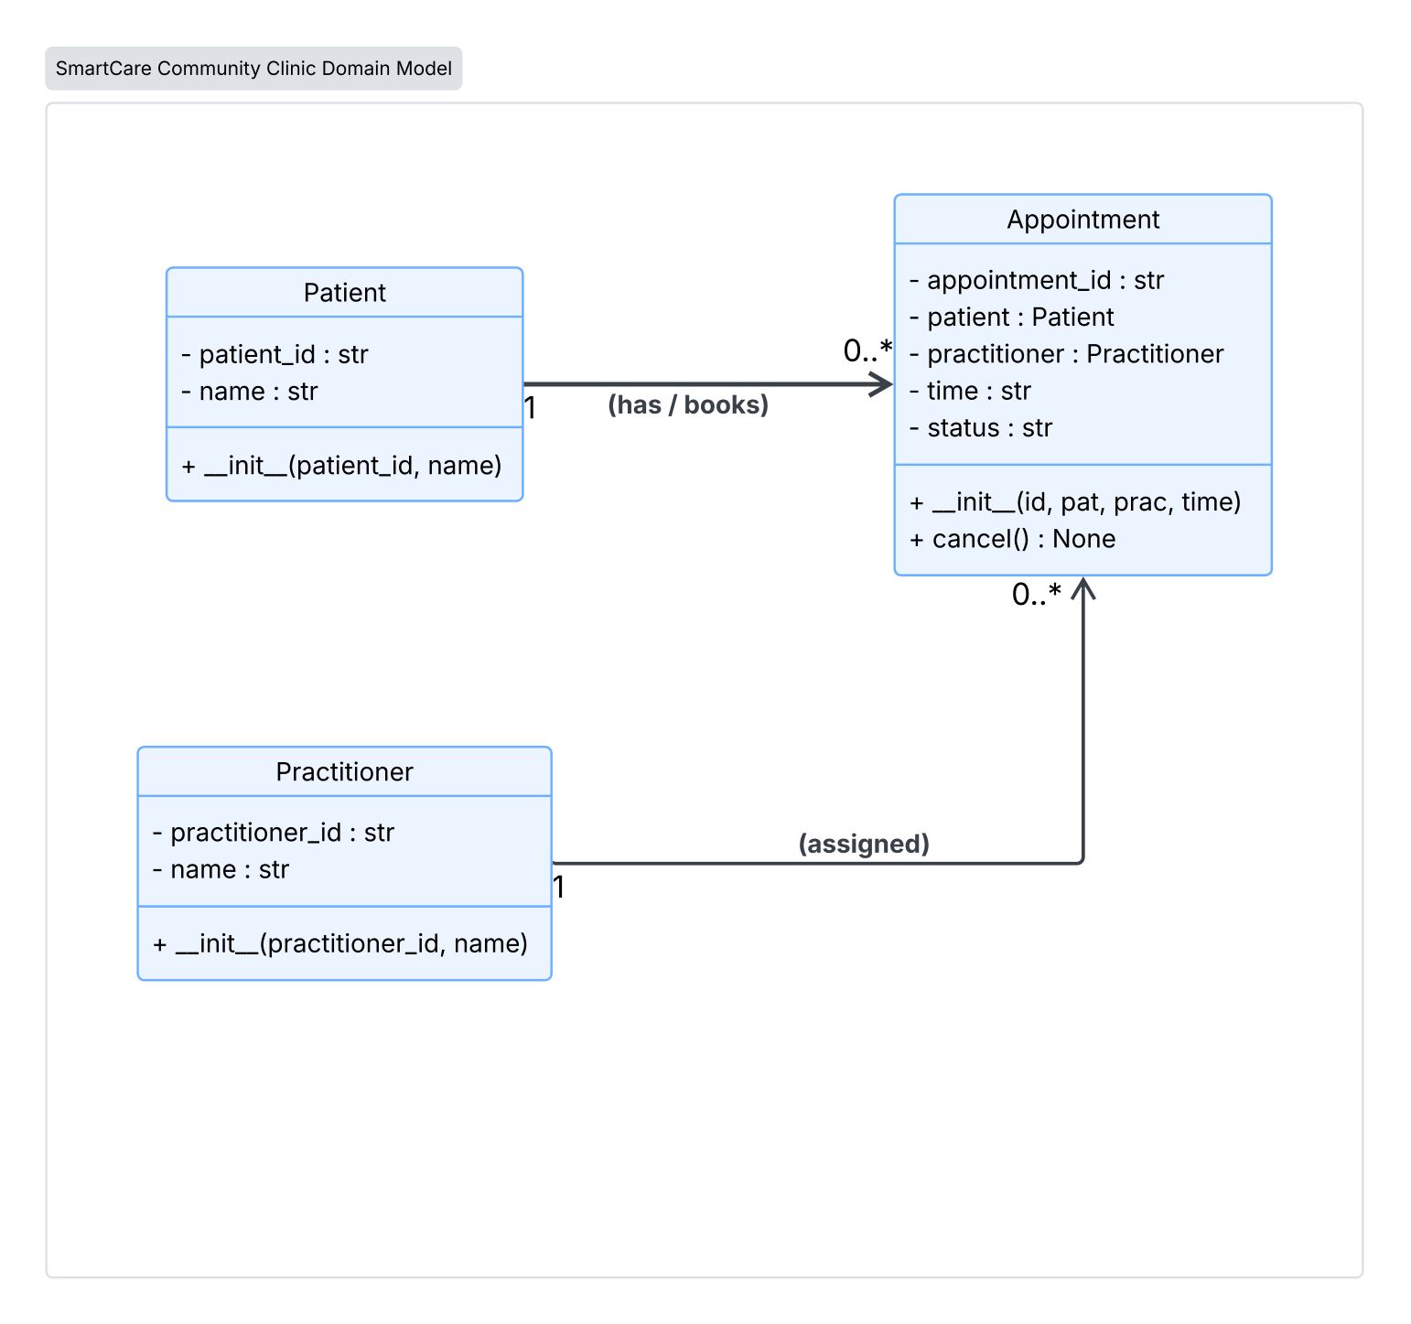

Design Rationale
Explain class selection, responsibility allocation and key relationships.
Class Selection
- Three core entities were selected: Patient, Practitioner, and Appointment.
- Patient holds patient identification details.
- Practitioner holds practitioner identification details and supports consultation schedule visibility.
- Appointment acts as the entity that links a patient and a practitioner to a specific date and time slot to meet for a consultation.
- Utility/Manager classes (e.g., PatientManager, ScheduleEngine, ClinicController) were left out to avoid low cohesion and prevent the "God Class" anti-pattern.
Responsibility Allocation
- Single Responsibility Principle (SRP): Each class is strictly in charge of its own information and rules.
- Patient only holds patient information.
- Practitioner only holds doctor/staff information.
- Appointment handles the actual booking logic.
- Constructor Validation: Rules that block blank or empty inputs (like checking if not name.strip():) live directly inside each class when an object is first created (__init__). This prevents incorrect data from entering the system.
- State Modifications: Changing an appointment's status, like running the cancel() method, happens safely inside the Appointment class itself. This updates the status to "Cancelled" without accidentally erasing past records from the system's history.
Key Relationships & Multiplicities
- Patient to Appointment (1 to 0..*): A single patient can hold zero or many appointment records over time.
- Practitioner to Appointment (1 to 0..*): A single practitioner can be assigned zero or many appointment slots.
- Inheritance Avoidance: Appointment does not inherit from Patient or Practitioner because an appointment is a scheduled event rather than a person entity.

AI Design Review Record
AI suggestion | Evidence | Decision | Reason | Model change
Validate appointment time and status | FR-12 / NFR-02 | Accept | Keeps data clean without adding heavy external dependencies. | Built guard checks directly inside Appointment.__init__
Prevent cancelling past appointments | FR-05 | Modify | Good suggestion, but a simple status check is preferred over complex date-library code to stay within the client's requested scope. | Handled status updates inside cancel() using simple string flags.
Add AppointmentScheduler or ClinicController | NFR-01 | Reject | Centralising logic inside manager classes creates low cohesion and disregards the client’s constraints. | None.
Add Persistence Layer (SQL/ORM Database) | Case Study | Reject | According to the case study, the system must remain lightweight. | None
Keep Patient, Practitioner, and Appointment decoupled | SRP and high cohesion; each class handles only its own data. | Accept | Preserves low coupling and keeps class responsibilities separate from each other. | Kept standard 1-to-0..* multiplicities.

