HW6 responses

I did two things that I consider going “beyond”

1. I made MovementStyle abstract so that I could reduce code redundancy and use a common constructor/variables for the movement values.
2. I made it so that the fish are added in random locations instead of being added in the same spot every time.

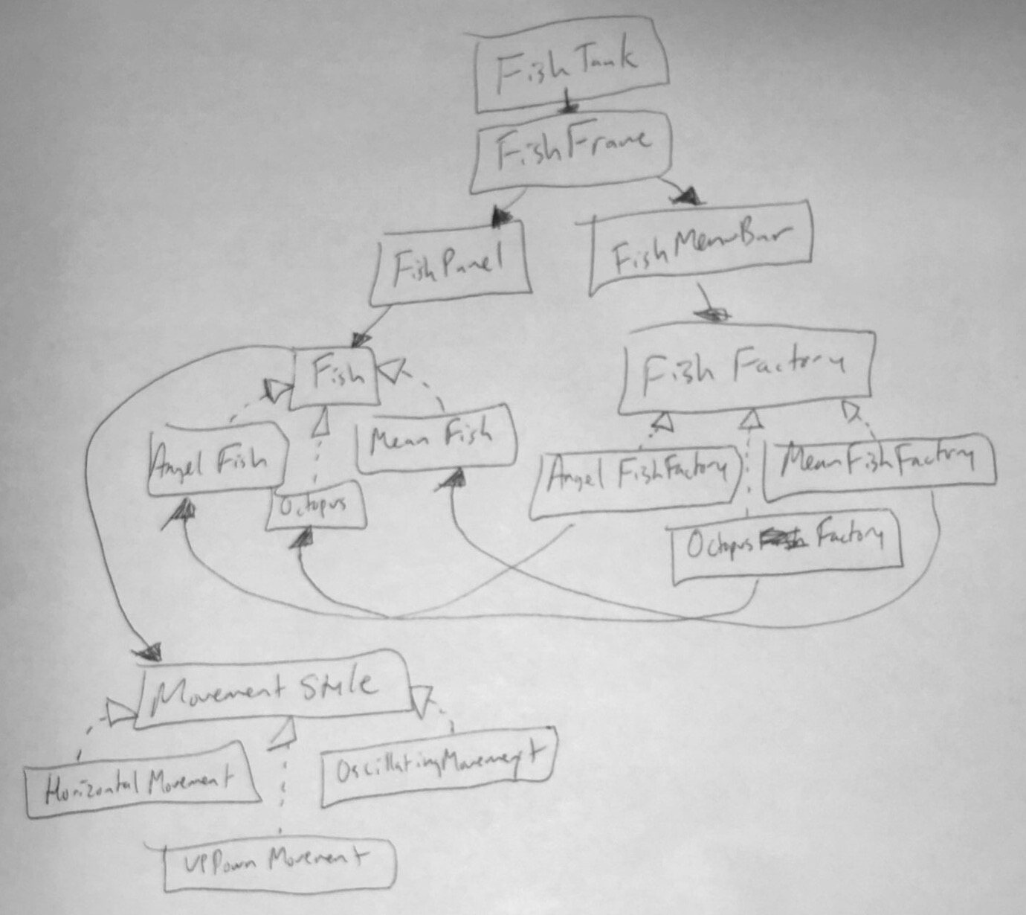

In order to add a new fish, I would need to create a new Fish subclass and a FishFactory subclass for the fish. I would also need to modify the FishMenuBar to have a menu option for the new fish, and I would need to add in the new FishFactory subclass to the getFactory method in FishFactory. If I wanted to make it original, I would also need to add a new gif/img and possibly create a new MovementStyle subclass.