1.

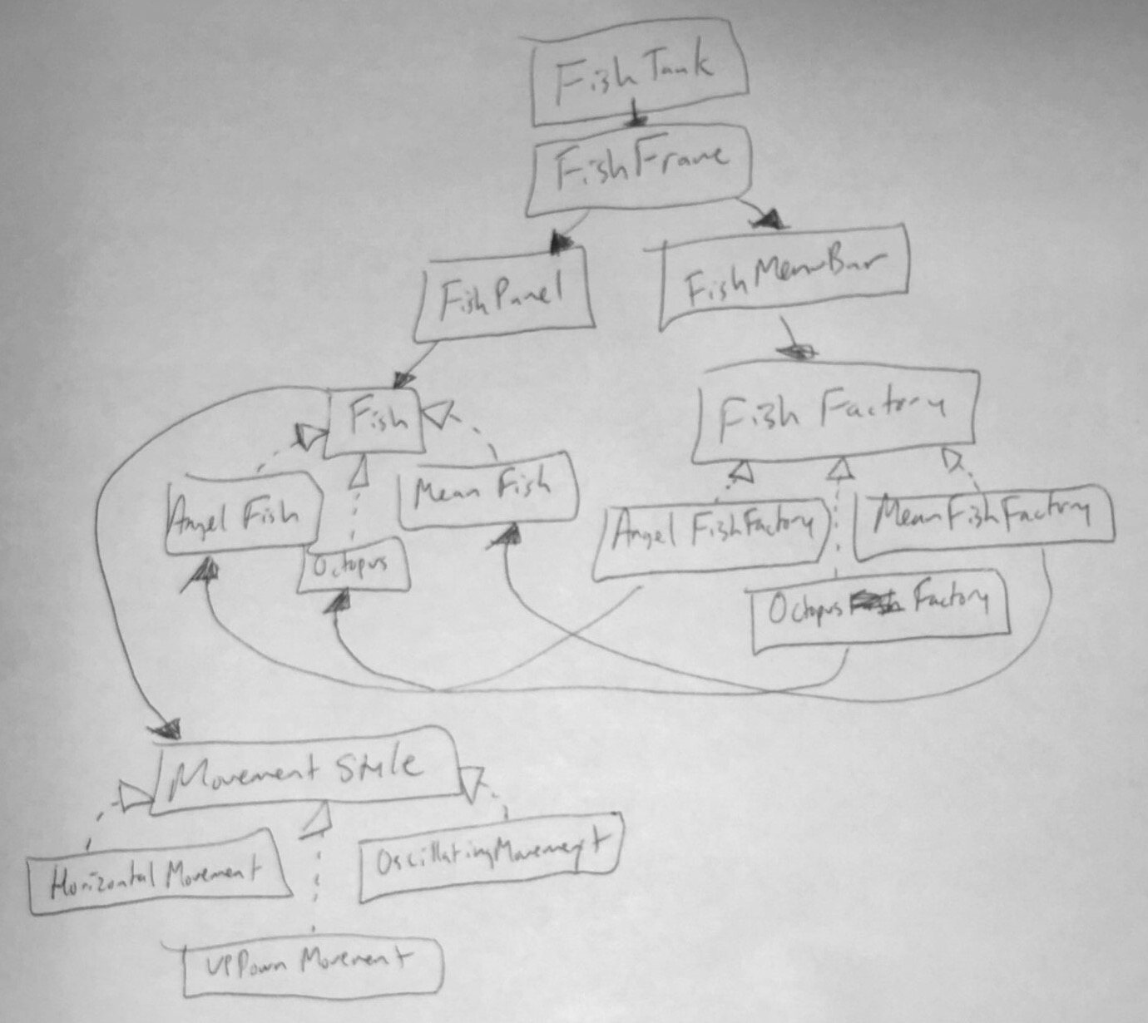

2. a) FishFrame, FishTank, FishMenuBar

b) Fish’s extensions, MovementStyle (and extensions), FishFactory (and extensions)

c) Fish, FishPanel,– the display/paintComponent methods are view-centric, while the rest is model-centric

3. a) Keeps track of all the Fish in the tank

b) The view displays the Fish and the FishMenuBar

c) FishFactrory#create() and some sort of update/move method

d) A method when a FishMenuBar button is clicked

e) some sort of update method

f) Needs create()/addFish() to create/add a fish from a factory

g) The timer should be in FishTankController which hold the listener