Design Notebook

# 2023-02-18 RF Bringup

* Proto RF board bringup
  + SF2312D SAW Filter Datasheet
    - 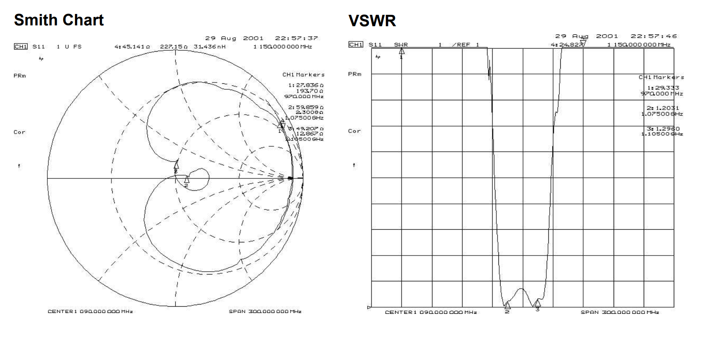
  + RF board S21 frequency response with 30dB attenuator on output
    - 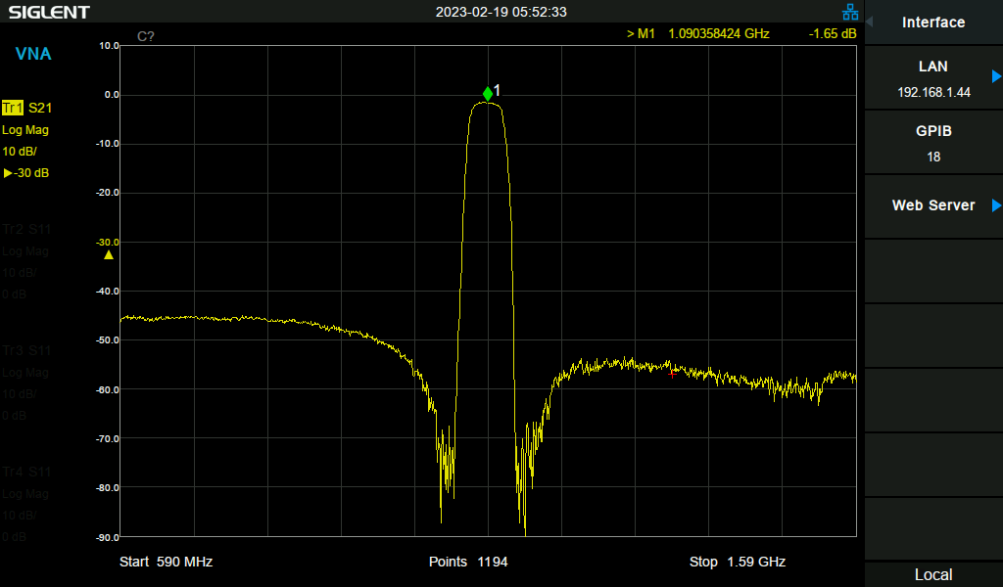
  + RF board S11 input match (powered off)
    - 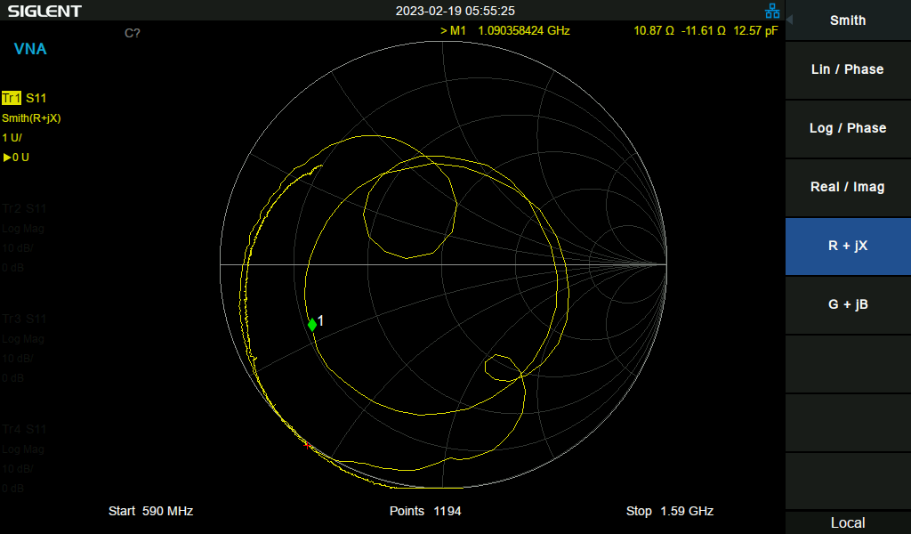
  + RF board S11 input match (powered on)
    - 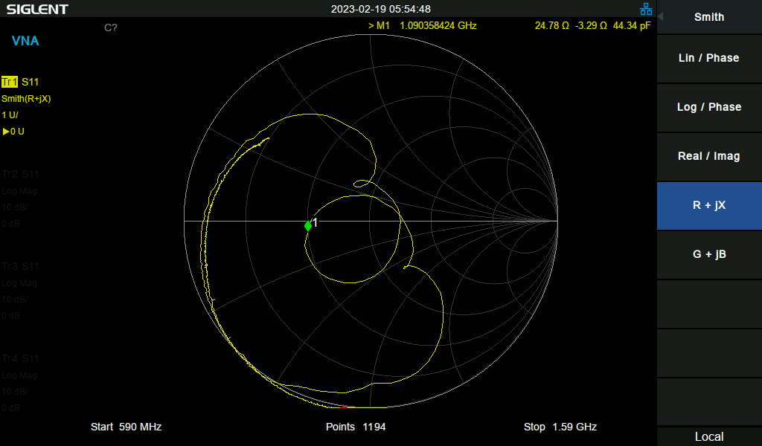
* Proto detector board bringup
  + Input match without power
    - 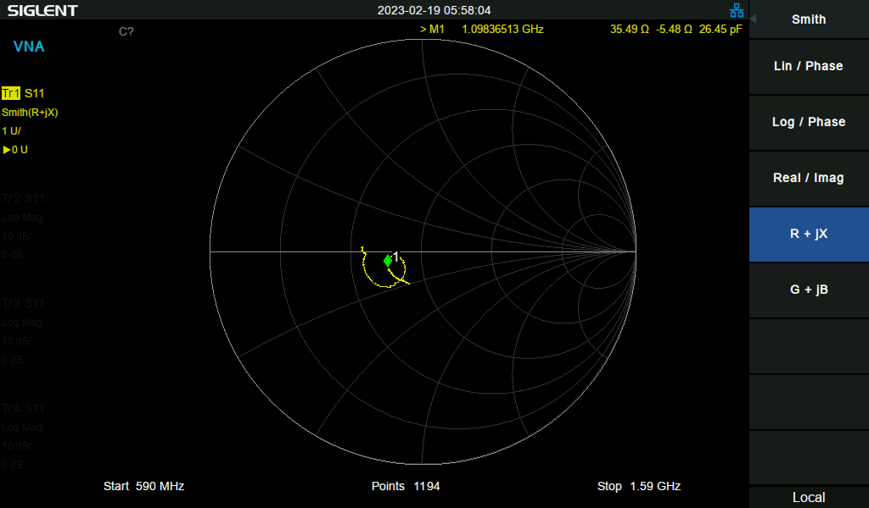
  + Input match with power
    - 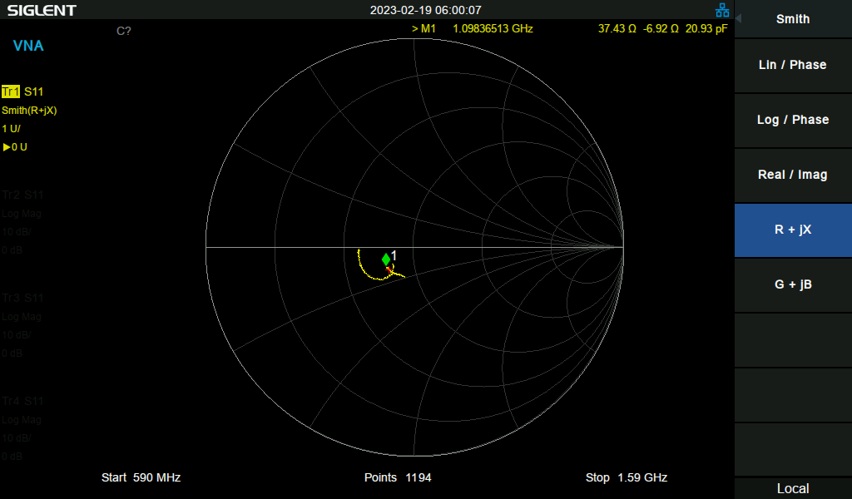
* Decoding ADS-B Messages
  + 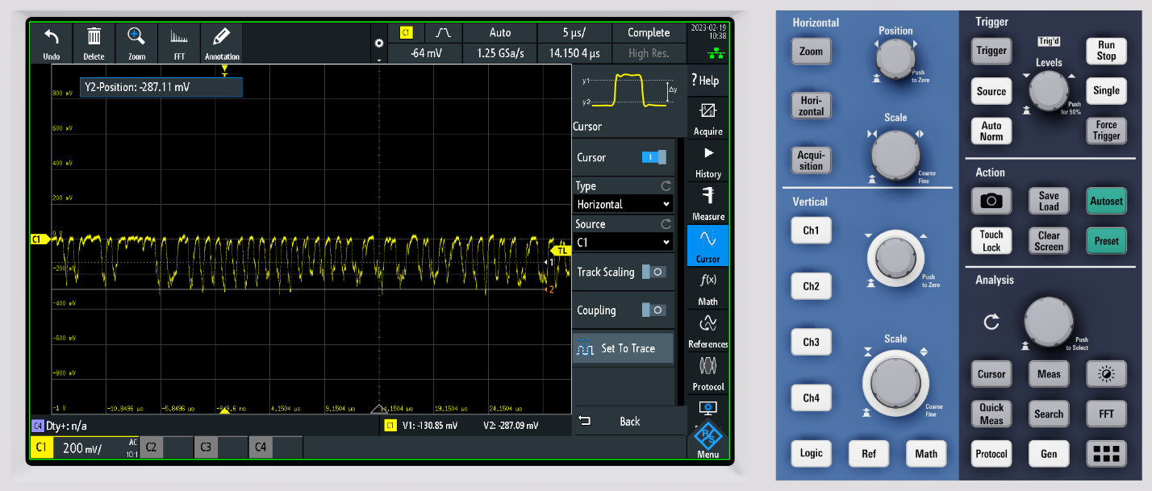
* Notes for next PCB Rev
  + ADS8314 has internal coupling cap, can ditch 39pF cap on input to RF detector board.

## 2023-02-19 MCU Board Bringup

* Notes for next time
  + Remember to look for unconnected in the PCBNew DRC! Boy.
    - 2N7002 MOSFET gate was not connected.
    - Comparator output was not connected to Pi Pico.
  + MCP5941U is a DIFFERENT footprint than the MCP6541! I got the MCP6541U, which is pin compatible with the LMV331 but is different than the MCP6541.
    - 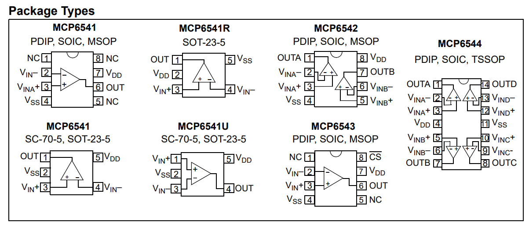
  + MCP6541 is too slow to decode ADS-B at 1MHz. The propagation time is 4us! This results in only a partial slew out of the comparator when the input signal has made the full pulse. Not good.
  + Switched comparator to LMV331 (~400ns propagation time, slowish but maybe fast enough). Need to add an output pullup resistor since the output of the LMV331 is open collector.

## 2023-02-20 Decoding ADS-B?

* Got a nice ADS-B packet!
  + 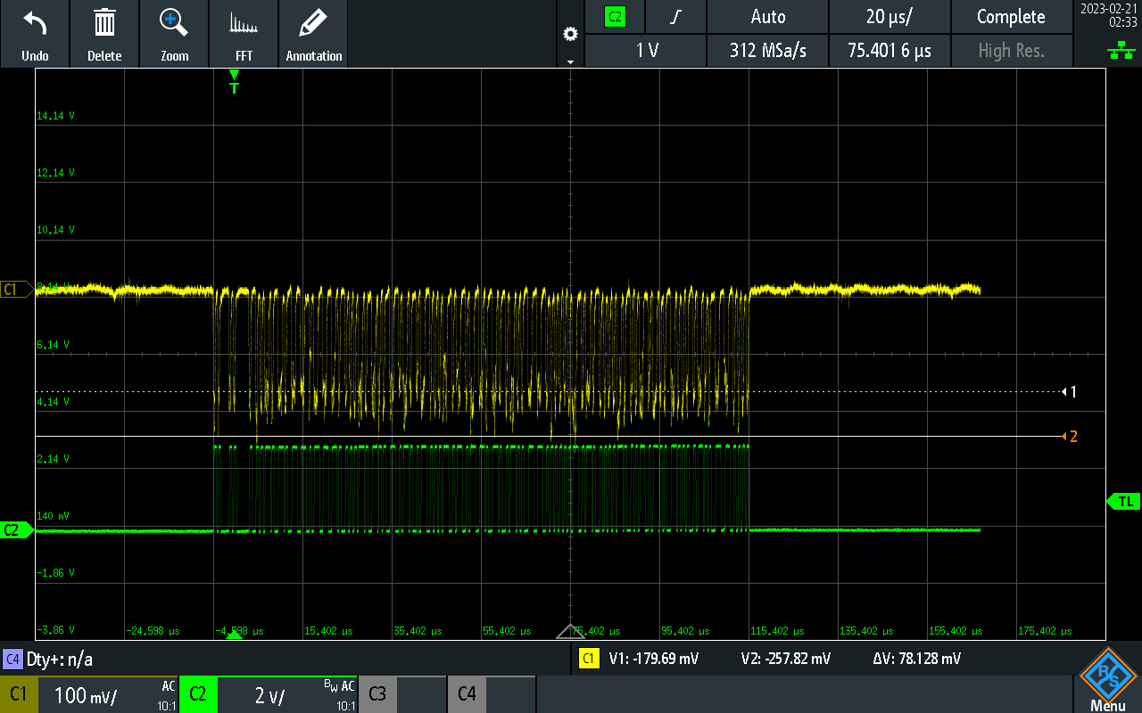
  + Downsampled to 1:20 sample ratio to use with arbitrary function generator. 312Msps/20 = 15.6Msps
  + Replicating ADS-B waveform from comparator output with arbitrary function generator.
* CANRP2040 project has [really good examples and notes](https://github.com/KevinOConnor/can2040/blob/master/docs/Code_Overview.md) about using RP2040 PIO for decoding stuff at 1MHz.
* [RP2040 Datasheet](https://datasheets.raspberrypi.com/rp2040/rp2040-datasheet.pdf)
* [C++ PIO Tutorial](https://www.digikey.com/en/maker/projects/raspberry-pi-pico-and-rp2040-cc-part-3-how-to-use-pio/123ff7700bc547c79a504858c1bd8110)
* Bringing up PIO capture program.
  + Testing with 200 cycle “blink” pulses, PIO clock set to 16MHz.
    - 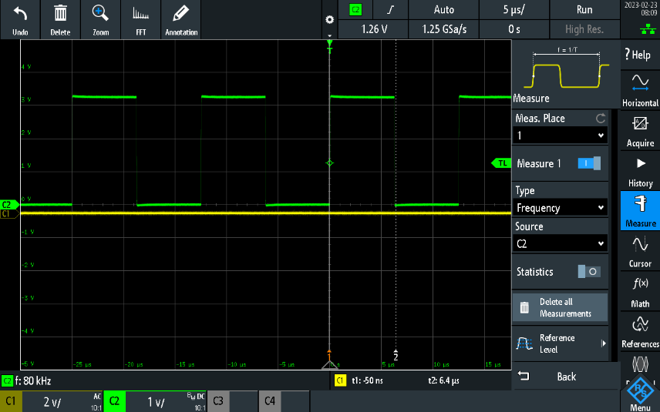
    - 200*80kHz = 16MHz. Not bad!
* Got into some really weird error loops with the debugger when trying to debug PIO. Some troubleshooting tips that may or may not make a difference:
  + Move the SWD cable away from the RF boards / put the cable below the ground planes.
  + Power cycle by turning off the power supply for a full 10 seconds, then reset the board with the debugger and reconnect.
  + Wait until the debugger is done thinking before clicking any buttons.
  + Disable adaptive clocking, set it to something low like 4000kHz (this is not done by default)!
  + This is it!! Launch vs. [attach](https://www.electrorules.com/vscode-cortex-debug-launch-configurations/)! Since I am running an external debugger session, I need to attach to it instead of launching a new one. Now all the issues make sense (things working the first time but not the second, all of the breakpoints being set over each other, etc).

## 2023-02-24 More Decoding ADS-B

* Successful preamble detection on a recorded message!
  + 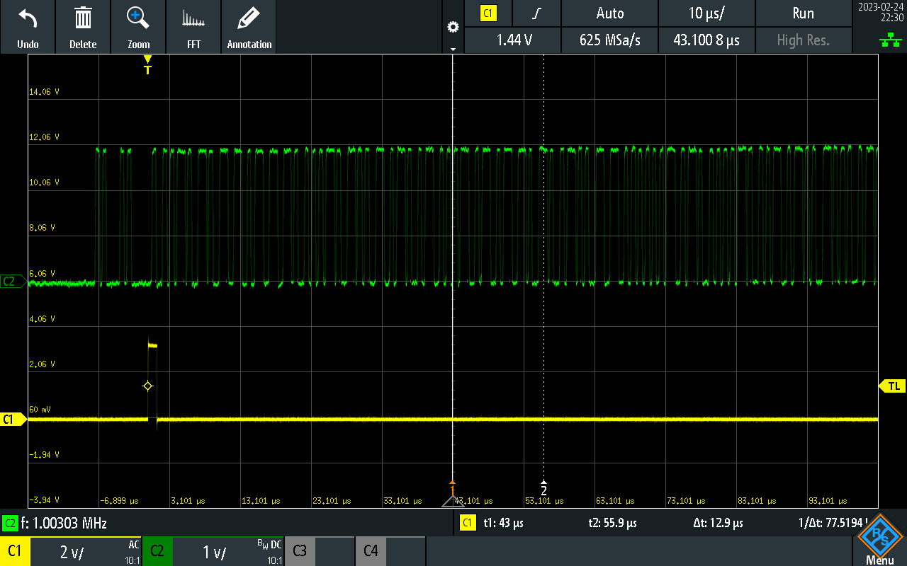
  + Used PIO to detect a preamble and set a GPIO HI right after a valid one was found.