ADSBee 1421 Devkit

Ultra Low-Power Dual Band ADS-B Receiver Module
Programming + Evaluation Kit

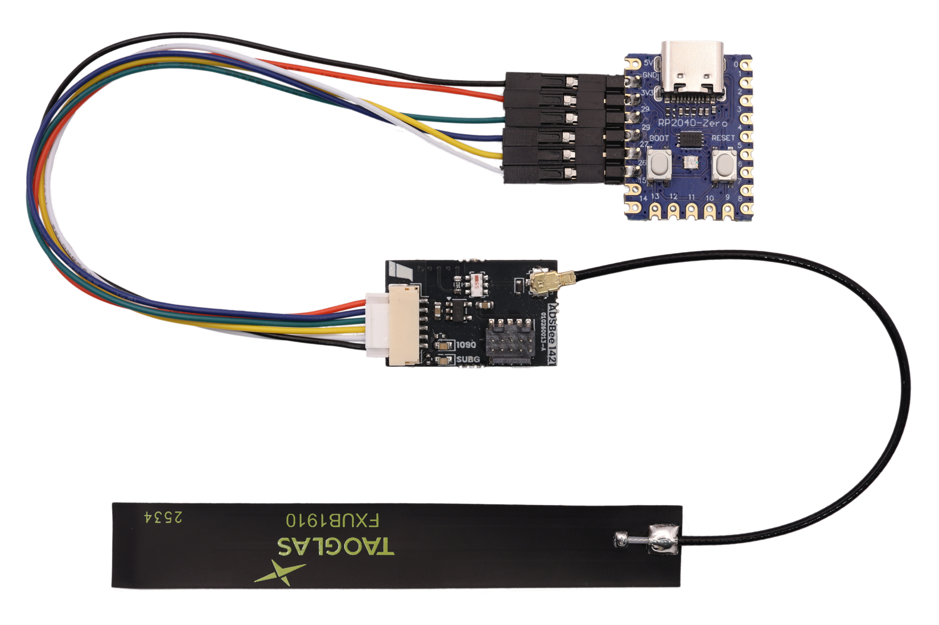

Contents
Revision History 3
Safety Notice 3
1 Overview 4
2 Kit Contents 5
3 Device Pinouts 6
3.1 ADSBee 1421 Devkit PCBA 6
3.2 ADSBee Programmer 6
4 Evaluation 7
4.1 Connection Diagram 7
4.2 Aircraft Map 8
5 Updating Firmware 9
5.1 Updating an ADSBee 1421 / m1421 9
5.2 Updating an ADSBee Programmer 9

Revision History
20260806
- Initial release.
20261014
- Add Safety Notice section.

Safety Notice
We work hard to make ADSBee products performant and reliable, but not all aircraft broadcast their location, messages can be lost or corrupted, and hardware or software can fail. ADSBee cannot guarantee detection or accurate reporting of all traffic. Users are responsible for evaluating its suitability for their application and for the safe operation of any system it is integrated into. See our terms of sale (pantsforbirds.com/terms-of-sale) and license (github.com/CoolNamesAllTaken/adsbee) for full terms.

Overview
This kit contains everything you need to get started developing with ADSBee m1421! The included PCBA is a variant of the ADSBee 1421 with an included 10-pin ARM SWD programming header, allowing breakpoint debugging on the ADSBee m1421 module’s CC1314 RF microcontroller using a compatible debug probe (Segger J-Link or equivalent probe that supports cJTAG is recommended).

The kit also includes a wire harness that breaks out the ADSBee 1421’s 6-pin JST-GH header to 0.1” DuPont pin headers, allowing it to be connected to arbitrary interface devices, or the included ADSBee 1421 Programmer board.

Kit Contents
Part Image | PN | Qty | Description
ADSBee 1421 Devkit PCBA  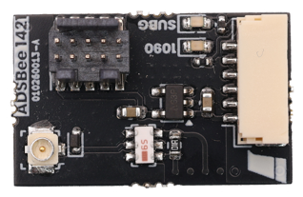 | 010260017 | 1 | Dual-band ADS-B receiver devkit.  Same as the ADSBee 1421, but includes a 10-pin ARM SWD header to allow breakpoint debugging via cJTAG.
Taoglas FXUB1910 1090/978MHz Dual-band Flex Antenna  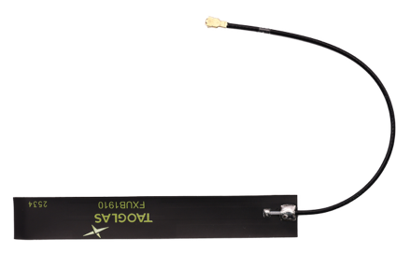 | 070260005 | 1 | Dual-band ADS-B flex antenna.
ADSBee 1421 JST-GH to DuPont Pin Socket Breakout  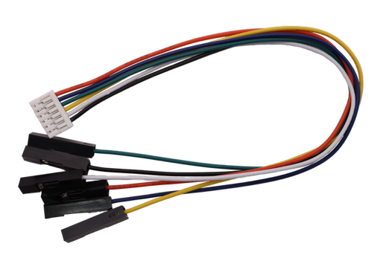 | 050260006 | 1 | Cable for connecting ADSBee 1421 to programmer.
ADSBee 1421 Programmer PCBA  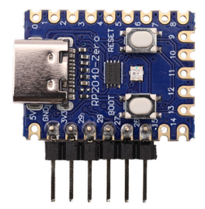 | 010260018 | 1 | ADSBee 1421 programmer and serial bridge.

Device Pinouts

ADSBee 1421 Devkit PCBA
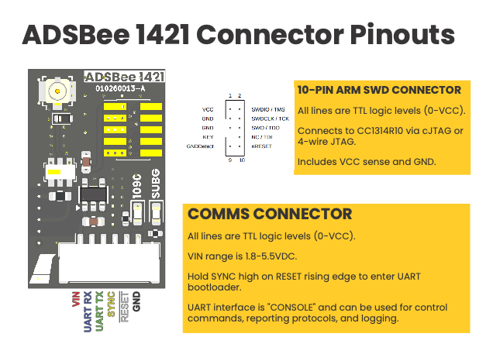

ADSBee Programmer
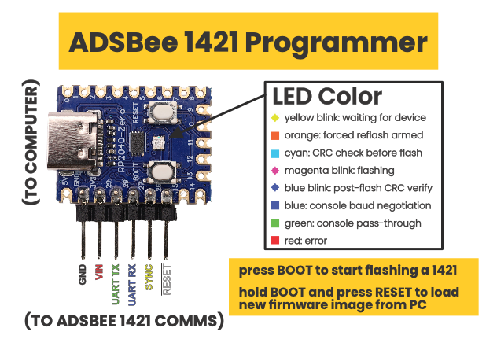

Evaluation

Connection Diagram
For programming and evaluation, connect ADSBee 1421 to the ADSBee 1421 programmer as shown below.

The ADSBee 1421 Programmer will enumerate as a USB CDC device called “ADSBee”. Once the light on the ADSBee 1421 Programmer turns green, it functions as a serial bridge and connects the ADSBee 1421 to the computer. A standard UART to USB converter can be substituted if desired.
Note that the default baud rate on the ADSBee 1421 module is 1000000 baud. Changing the baud rate from this value could result in the module being unable to communicate via the ADSBee 1421 Programmer.

Aircraft Map
A live aircraft map is available from adsbee.aero/1421-console. Use the yellow “Connect” button on the top right corner of the webpage to connect to your ADSBee 1421 via web serial, then click on the “Map” tab to see aircraft you are receiving. The HTML page may also be downloaded for local use (it’s just a single HTML file)!
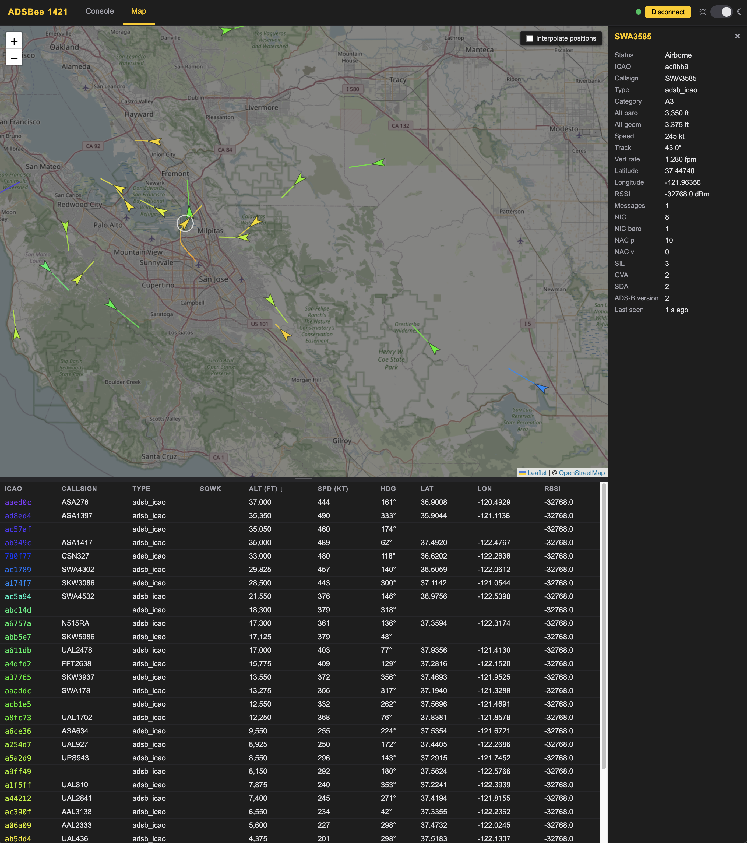

Updating Firmware
The included ADSBee 1421 Programmer board began its life as a humble RP2040 Zero module, but with the addition of some pin headers and firmware, has been transformed into a serial bridge and firmware updater compatible with any ADSBee 1421 / m1421 device.

Updating an ADSBee 1421 / m1421
Each ADSBee 1421 Programmer includes a ADSBee 1421 firmware built into its flash, and when connected to an ADSBee 1421 / m1421 device over UART (with SYNC and RESET also connected), it will automatically connect to the attached ADSBee and bring its firmware up to date. Once the firmware update is complete, the ADSBee 1421 Programmer will function as a USB to serial converter, allowing the user to interact with the ADSBee 1421 / m1421 via USB.

Updating an ADSBee Programmer
To update the firmware image baked into an ADSBee 1421 Programmer, follow the steps below.
- Download the latest firmware release from the releases page in the ADSBee github repository (https://github.com/CoolNamesAllTaken/adsbee/releases). The firmware file will be labelled “adsbee_1421_programmer-X.X.X.uf2”, where X.X.X is the firmware version of the baked-in firmware image (e.g. 0.3.6), and uf2 is the filetype.
- Connect the ADSBee 1421 Programmer to your computer via USB. Hold the BOOT button and click RESET; the ADSBee 1421 Programmer will show up as a flash drive labelled RPI-RP2. Let go of both buttons.
- Drag and drop the adsbee_1421_programmer-X.X.X.uf2 firmware file onto the RPI-RP2 drive and allow the transfer t complete. The ADSBee 1421 Programmer now has a new firmware and is ready to update ADSBee 1421 / m1421 devices via UART.

