SCBS-Pico Single Cell Battery Simulator

# Features

* Settable Output Voltage 2.5-4.5V ±4%
* Output Current 0-200mA (0-600mA peak)
* Output Current Sense 0-200mA ±10%
* Isolated daisy-chainable UART command interface
* Powered by a simple 5V Isolated Power Supply
* SWD programming header
* USB port for power and debug COM port

# Applications

* Battery Management System (BMS) testing
* Programmable micro-scale linear power supply
* Strangely shaped coaster

# Principle of Operation

The SCBS-Pico utilizes a dual rail-to-rail op-amp with a custom BJT-based output stage to provide a regulated linear power supply output between 0V and $V_{supply}$-0.5V, where $V_{supply}$ is the input voltage provided to the device’s 5V power input. The same op-amp is utilized for current sensing on the output via a high-side shunt resistor.

An isolated and level shifted UART interface allows serial communication with 5V voltage levels between multiple SCBS-Pico devices in a daisy-chained configuration. The UART_RX of the first device and the UART_TX of the final device should be connected to the UART master for control of the full chain. NOTE: it is recommended that the first device in the chain (containing the connection from the UART master to isolated UART_RX) have the highest $V_{supply}$ rail, and the last device in the chain (with a level-shifted UART_TX interface) be connected to a GND that is common with the master device. Other topologies can be supported but will require additional isolation on the UART_TX of the last SBCS Pico device.

# Pin Map

|  |  |  |
| --- | --- | --- |
| **Pin Number** | **Pin Name** | **Function** |
| 1 | +5V | DC+ power input. |
| 2 | OUT | Simulated battery positive terminal. |
| 3 | GND | DC- power input.  GND reference for UART_TX_SIG_5V.  Simulated battery negative terminal. |
| 4 | UART_TX_SIG_5V | 5V UART output. |
| 5 | UART_RX_SIG_ISOL | Isolated 5V UART input. |
| 6 | UART_RX_GND_ISOL | Isolated 5V UART input GND reference. |

# Device Form Factor

Due to time and material constraints for an initial prototype, the SCBS-Pico was constructed with a Raspberry Pi Pico 32-bit microcontroller as the communication and control interface for the analog circuit.

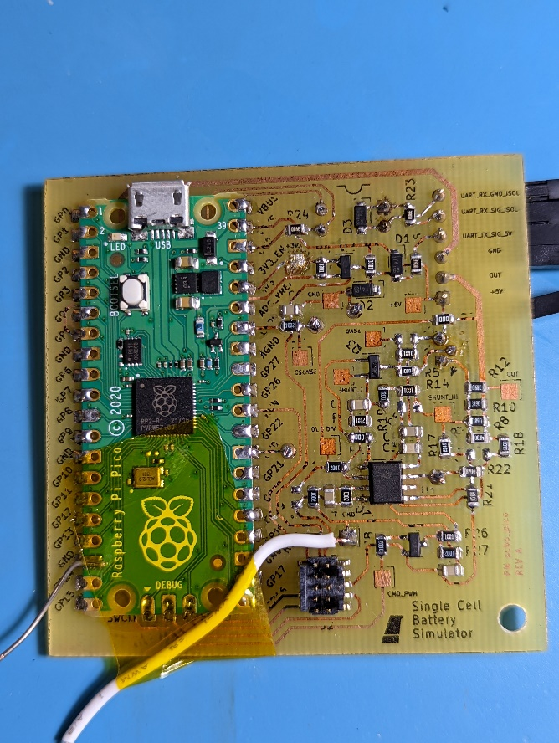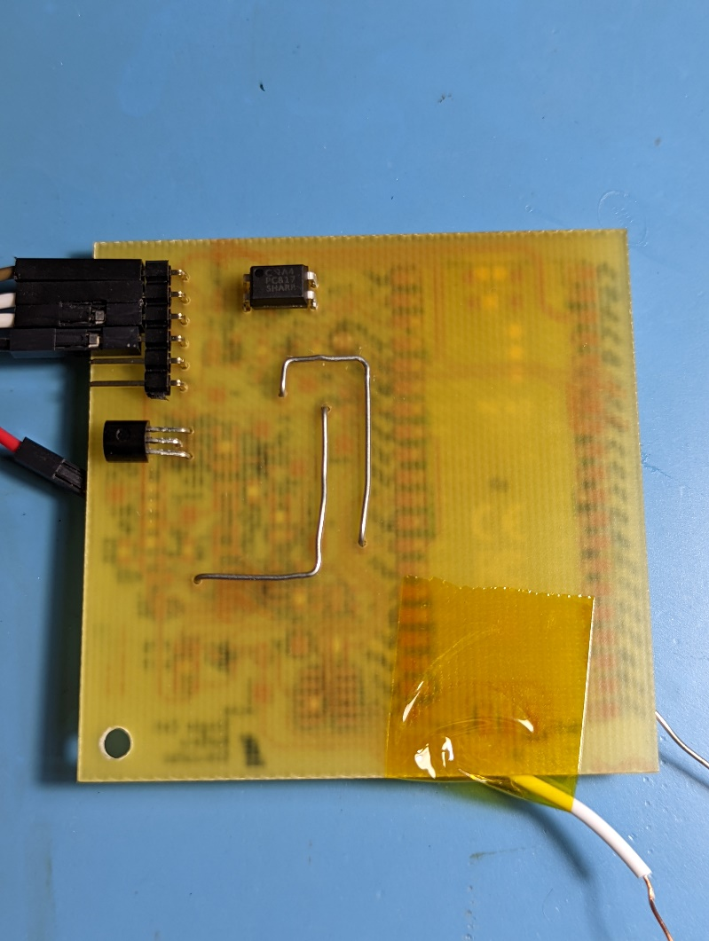

*Left: Device front side. Temporary GND wire (silver, bottom left) and CMD wire (white, bottom middle) attached for testing of analog circuit before firmware bringup. Right: Device bottom side. Note PC817 optocoupler (DIP-4 package, top) and output 2N2907 transistor (TO-92 package, left).*

The SCBS-Pico’s 6-pin 0.1” pin header interface and single M3 mounting hole allow it to be mounted to a motherboard for daisy chaining into an array of devices, in order to allow simulation of a multi-cell battery pack.

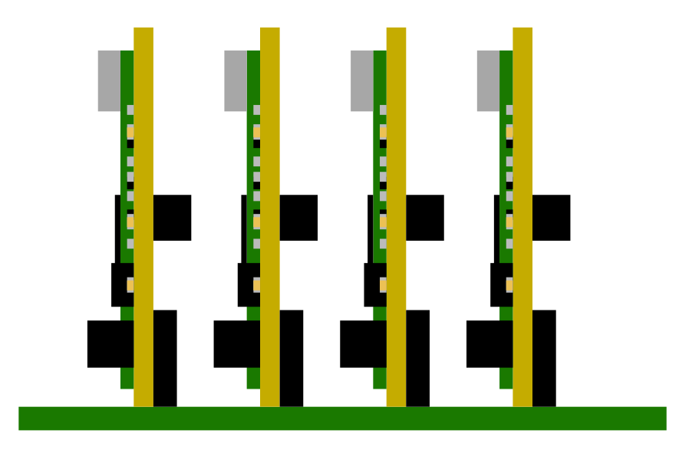 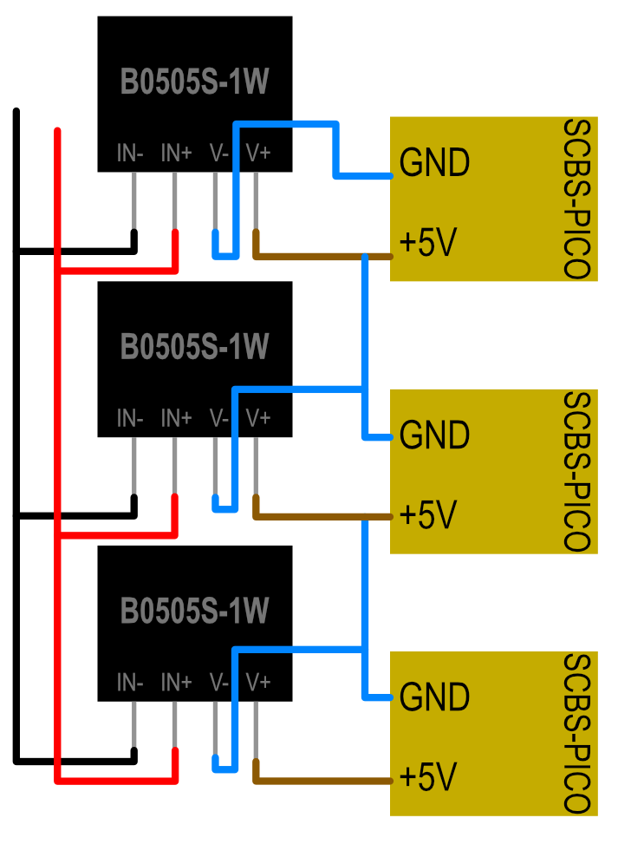

*Left: Suggested daisy-chain configuration of SBS-PICO devices on a motherboard providing isolated power to each device and UART connections between each board and to the master. Right: Suggested daisy-chained power topology.*

# Electrical Characteristics

|  |  |  |  |  |  |
| --- | --- | --- | --- | --- | --- |
| **Parameter** | **Test Conditions** | **Min** | **Typ** | **Max** | **Units** |
| $$V_{supply}$$ |  | 5 |  | 5.25 | V |
| $$V_{out,max}$$ | After 5 minutes of operation at 25°C, $I_{out}≤25mA$. | 4.3 | 4.5 |  | V |
| $$V_{out,min}$$ |  |  | 0 |  | V |
| $$I_{out,max}$$ | $V_{out}≥2.5V$, ambient temp 25°C. |  | 200 |  | mA |

# 

*Output voltage percent error while tracking a 10Hz 0-4.5V square wave with a load current of 200mA on a DC electronic load. Error waveform shown in orange and yellow (bottom). Yellow waveform (CH1) is commanded output voltage, green waveform (CH2) is actual output voltage.*

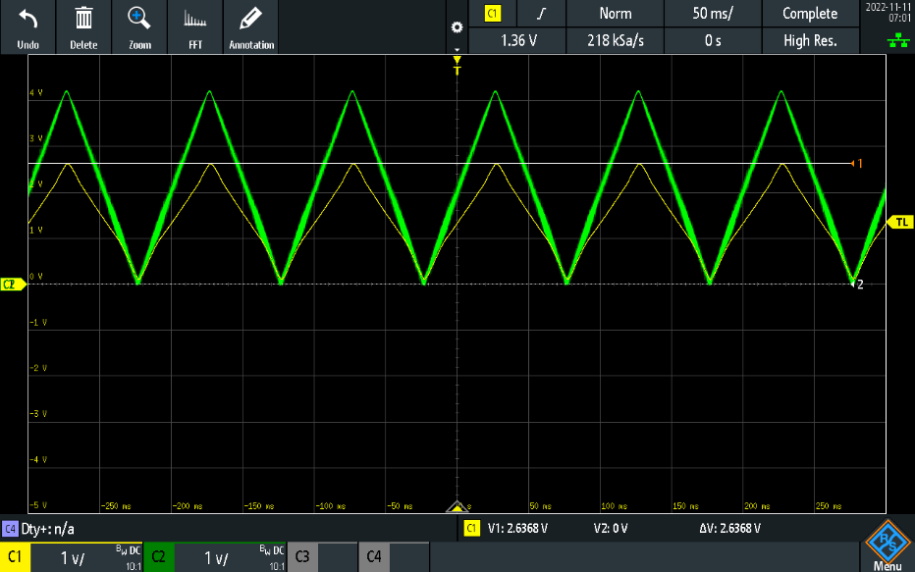

*Current sense waveform (yellow) vs output voltage (green) into a 20Ohm load (physical resistor).*

# Communication Interface

The scbs_pico board provides a daisy chainable UART interface which can be used to communicate with one or more battery simulators. Each battery simulator ingests packets via its UART_RX port, and modifies / re-transmits the packet via its UART_TX port in order to control devices downstream. The UART interface is isolated on the UART_RX pin in order to enable the cells to be interconnected

## Battery Simulator Command Packets

|  |  |
| --- | --- |
| **Packet Type** | **Packet Format** |
| BSDIS | **Battery Simulator Discover**  Discovers all battery simulator devices in the chain. Master transmits a BSDIS packet with LAST_CELL_ID=0, and each device increments LAST_CELL_ID and forwards the packet down the chain. The last device replies to the master with LAST_CELL_ID=n, where n is the number of devices in the chain.  $BSCDS,<LAST_CELL_ID>*<CHECKSUM> |
| BSMRD | **Battery Simulator Multi Read**  **Reads a single register from all battery simulator devices simultaneously. Generates a single BSMRS packet reply upon success.**  **$BSMRD,<REG_ADDR>*<CHECKSUM>** |
| BSMWR | **Battery Simulator Multi Write**  **Writes a value to a single register on all battery simulator devices simultaneously. Generates a single BSMRS packet reply upon success.**  **$BSMWR,<REG_ADDR>,<VALUE>*<CHECKSUM>** |
| BSSRD | **Battery Simulator Single Read**  Reads the value of a register on a single battery simulator, addressed via CELL_ID. Generates a single BSSRS packet reply upon success.  $BSRRD,<CELL_ID>,<REG_ADDR>*<CHECKSUM> |
| BSSWR | **Battery Simulator Single Write**  **Writes a value to a register on a single battery simulator, addressed via CELL_ID. Generates a single BSSRS packet reply upon success.**  $BSRWR,<CELL_ID>,<REG_ADDR>,<VALUE>*<CHECKSUM> |

## Battery Simulator Response Packets

|  |  |
| --- | --- |
| **Packet Type** | **Packet Format** |
| BSSRS | **Battery Simulator Single Response**  Response from a single battery simulator (signed with CELL_ID). Includes a value that is a response to a BSSWR or BSSRD command, or an error created by another (invalid) command.  Value can be “OK” (no error), “ERR:<CODE>” with an included error code, or “<VALUE>” where an actual value of a register is returned.  $BSRSP,<CELL_ID>,<VALUE>*<CHECKSUM> |

# Revision History

|  |  |  |  |
| --- | --- | --- | --- |
| **Revision** | **Date** | **Author** | **Note** |
| 0.1.0 | 2022-11-10 | J. McNelly | Initial release. |
| 1.0.0 | 2022-12-08 | J. McNelly | First draft with finalized serial protocol used in initial CELLSIM prototype. |