Controls

To select left click

To deselect right click

Please don’t open this program on a web based compiler

Use your own computer

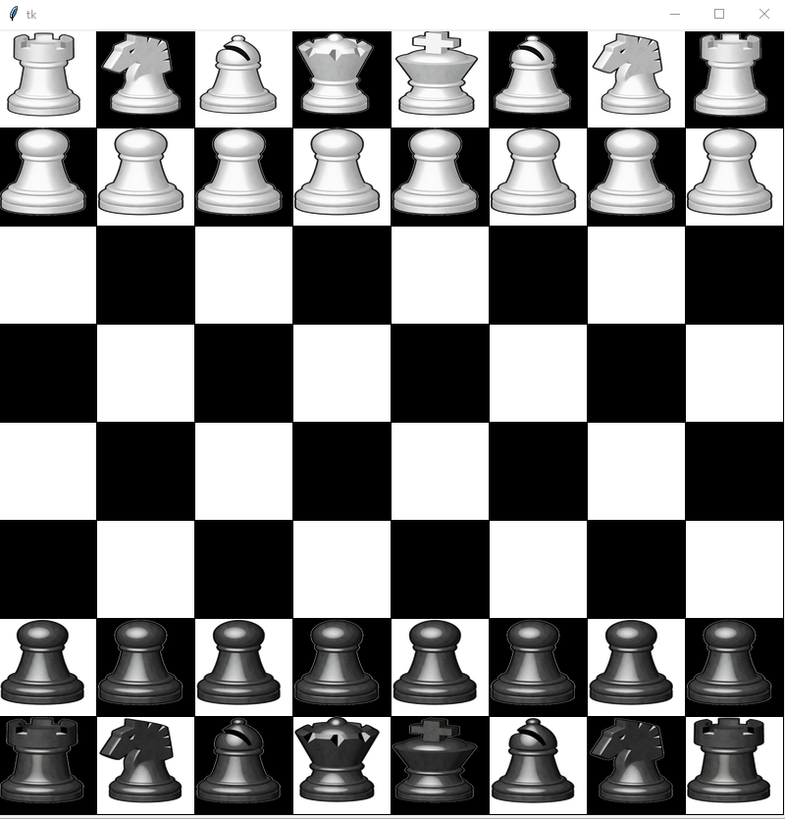

[Chess Game PY - YouTube](https://www.youtube.com/watch?v=CFa_yskgz9Y)