

SimpleCompute Sample for Direct3D 11

*This sample is compatible with the Windows 10 Anniversary Update SDK (14393)*

# Description

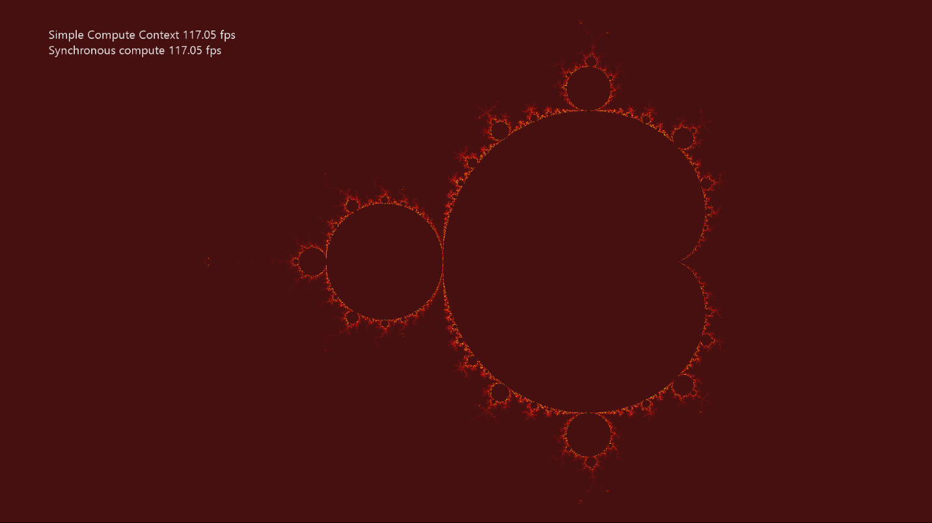

SimpleCompute shows how to use DirectCompute™ (i.e. Direct3D Compute Shader). It updates a texture by computing the Mandelbrot set using a compute shader.

# Using the sample

|  |  |  |
| --- | --- | --- |
| Action | Gamepad | Keyboard |
| Reset Viewport to Default | Y button | Home |
| Pan Viewport | Left stick | WASD |
| Zoom Viewport | Right stick | PgUp/PgDn |
| Increase Zoom Speed | Right trigger | Shift + PgUp/PgDn |
| Exit | View Button | Esc |
| Menu | Show/hide help | F1 |

# Implementation notes

The primary purpose of this sample is to familiarize the reader with creating and using a simple compute shader.

* **CreateDeviceDependentResources**: This is where the compiled compute shader is loaded and the various Direct3D rendering resources are created. The shaders are compiled by Visual Studio.
* **Render**: The compute shader is dispatched before the draw call that needs the results is dispatched. This updates the texture every frame.

## Hardware Feature Level Requirement

The DirectCompute (Shader Model 5) feature of DirectX 11 requires [Direct3D Hardware Feature Level 11.0](https://blogs.msdn.microsoft.com/chuckw/2012/06/20/direct3d-feature-levels/) or better hardware. Note that a limited form of DirectCompute (Shader Model 4.x) is optionally supported on some Feature Levl 10.x hardware, but this scenario is not supported by this sample.

# Update history

Initial release June 2018.