Simple MSAA for DirectX 11

*This sample is compatible with the Windows 10 Anniversary Update SDK (14393)*

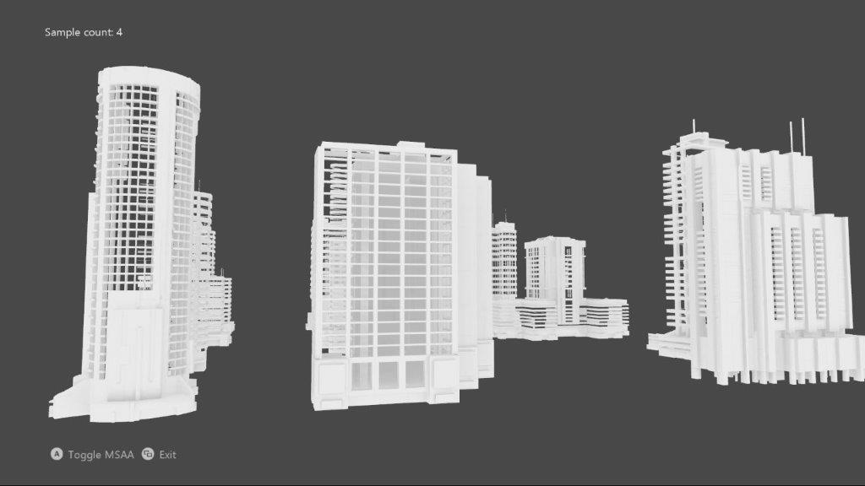

# Description

This sample implements an MSAA render target & depth/stencil buffer for a 3D scene using DirectX 11.

# Using the sample

|  |  |  |
| --- | --- | --- |
| Action | Gamepad | Keyboard |
| Toggle MSAA vs. single-sample | A button | Space |
| Exit | View Button | Esc |

# Implementation notes

The UI is drawn without MSAA, and makes use of an explicit resolve rather than relying on an implicit resolve of an MSAA swap chain.

# Known issues

* Due to a bug in the Windows 10 validation layer prior to the Windows 10 Fall Creators Update (16299), a DirectX 11 Resolve with an sRGB format using new “flip-style” swapchain would fail. This has been fixed in the newer versions of Windows 10.

# Update history

Initial release May 2018.