Simple Texture Sample

# *This sample is compatible with the Windows 10 Anniversary Update SDK (14393)*

# Description

This sample demonstrates how to render a simple textured quad using Direct3D 11.

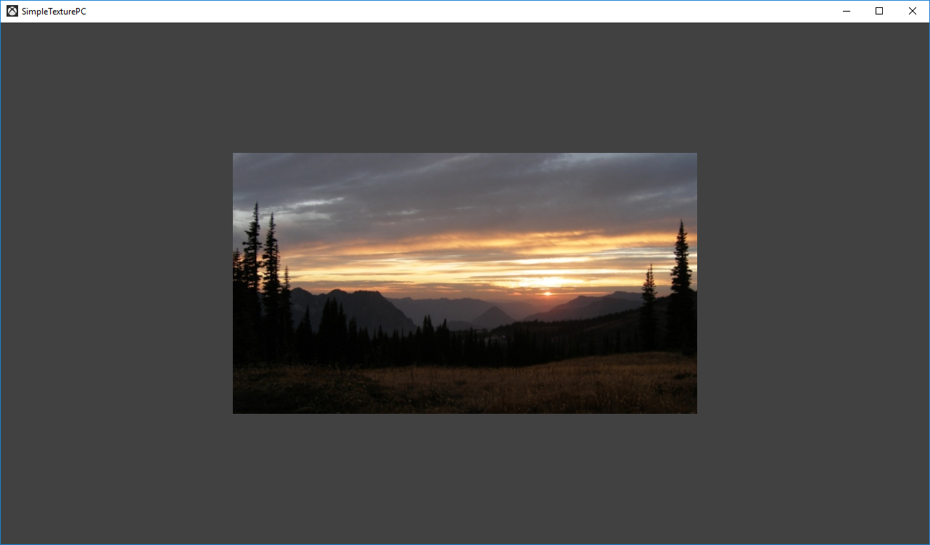

# Using the sample

The sample has no controls other than exiting.

# Implementation notes

The texture is loaded here using a simple helper that uses the Windows Imaging Component (WIC) and is designed for simplicity of learning. For production use, you should look at the DirectX Tool Kit’s [DDSTextureLoader](https://github.com/Microsoft/DirectXTK/wiki/DDSTextureLoader) and [WICTextureLoader](https://github.com/Microsoft/DirectXTK/wiki/WICTextureLoader).

# Update history

Initial release April 2016