Simple Play 3D Sound Sample

# *This sample is compatible with the Windows 10 Creators Update SDK (15063)*

# Description

This sample demonstrates how use XAudio2 and X3DAudio to playback positional audio in a Universal Windows Platform (UWP) app. The listener is static (represented by the white triangle) and emitter (represented by the black triangle) can be moved in 3D space, though the view is top down. The circle around the emitter represents the end of the attenuation curve with the lines showing the inner and outer bounds of the emitter’s cone. For detail on these terms, please see [Common Audio Concepts](https://msdn.microsoft.com/en-us/library/windows/desktop/ee415692%28v=vs.85%29.aspx)

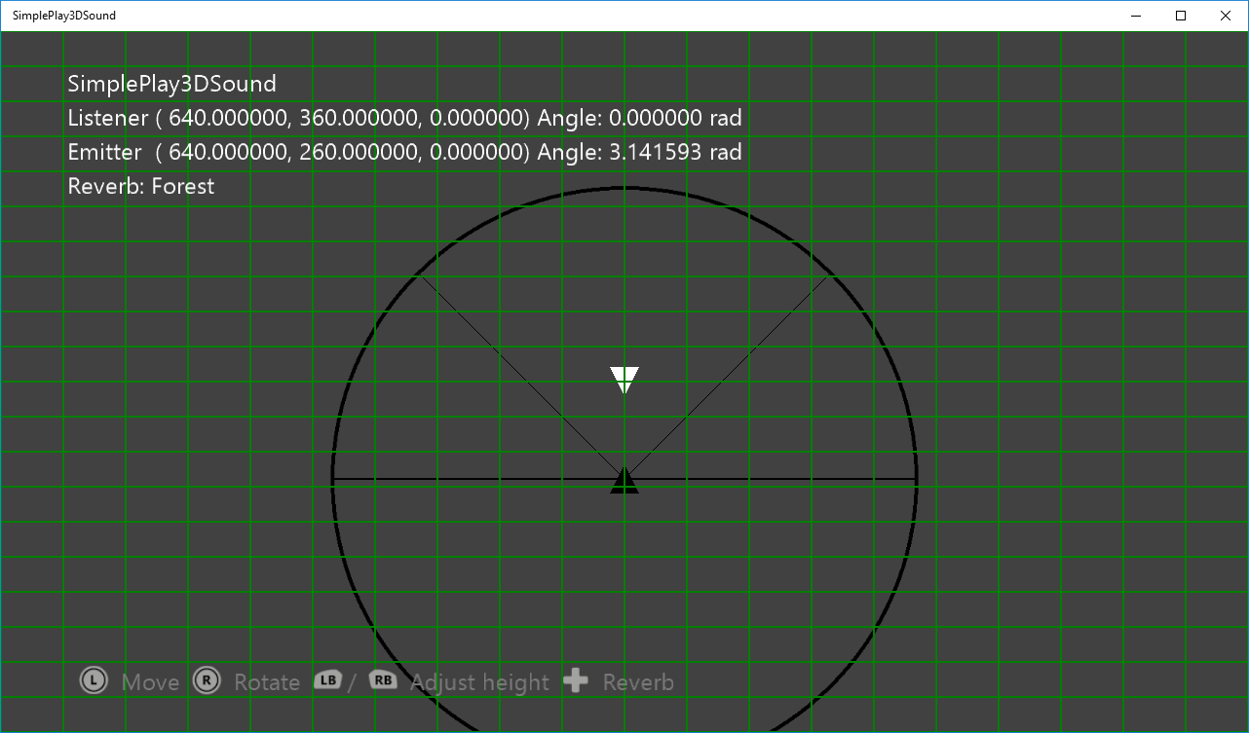

# Using the sample

|  |  |  |
| --- | --- | --- |
| Action | Gamepad | Keyboard |
| Move the emitter | Left thumbstick | Up/Down/Left/Right |
| Rotate emitter | Right thumbstick | A/D |
| Adjust emitter height | Left/Right shoulder buttons | W/S |
| Reset emitter location | Left/Right thumstick | Home |
| Change reverb type | DPad Up/Down | Q/E |

# Implementation notes

This sample demonstrates how to use XAudio2 with X3DAudio to play positional sound. Once XAudio2 has been initialized, a submix channel is added for reverb and a wav file is played in an infinite loop. Each update uses the current position of the emitter calculate the X3DAudio DSP settings to account for position and direction.

# Update history

Initial release May 2016.

# Privacy statement

When compiling and running a sample, the file name of the sample executable will be sent to Microsoft to help track sample usage. To opt-out of this data collection, you can remove the block of code in Main.cpp labeled “Sample Usage Telemetry”.

For more information about Microsoft’s privacy policies in general, see the [Microsoft Privacy Statement](https://privacy.microsoft.com/en-us/privacystatement/).