Simple WASAPI Capture Sample

# *This sample is compatible with the Windows 10 Creators Update SDK (15063)*

# Description

This sample demonstrates how to capture audio using WASAPI in a Universal Windows Platform (UWP) app.

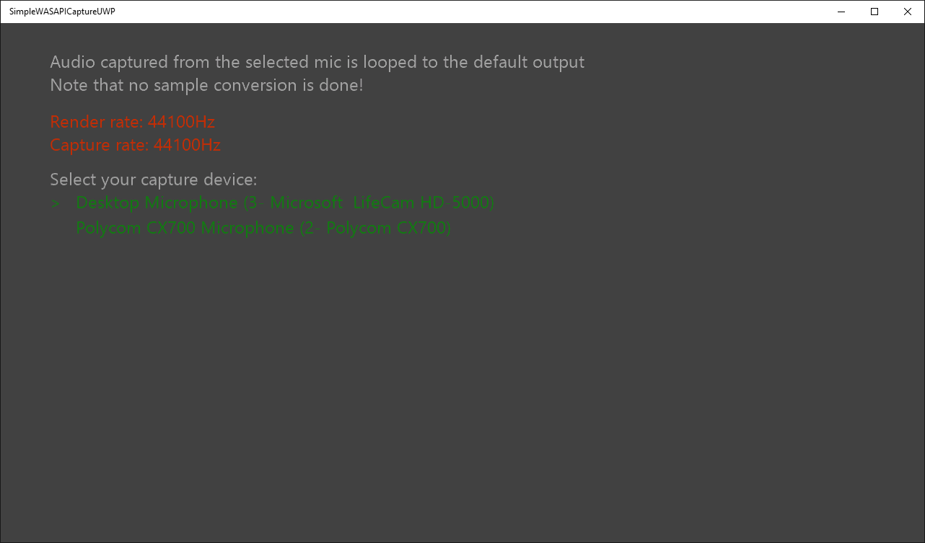

# Using the sample

Use a keyboard or gamepad to select a capture device. The sample automatically uses the default audio renderer and starts by using the default capture device. **Note that there is no sample rate conversion between the capture and render, so playback will not sound correct unless the rates match.**

# Implementation notes

This sample demonstrates how to use WASAPI to capture audio. The samples captured are placed in a circular buffer that is then used for rendering samples. This example also uses a shared WASAPI instance between the renderer and capture. For a more advanced usage of WASAPI, please see the [Windows WASAPI Sample](https://code.msdn.microsoft.com/windowsapps/Windows-Audio-Session-22dcab6b)

# Update history

Initial release May 2016

# Privacy statement

When compiling and running a sample, the file name of the sample executable will be sent to Microsoft to help track sample usage. To opt-out of this data collection, you can remove the block of code in Main.cpp labeled “Sample Usage Telemetry”.

For more information about Microsoft’s privacy policies in general, see the [Microsoft Privacy Statement](https://privacy.microsoft.com/en-us/privacystatement/).