Simple MSAA for DirectX 11

*This sample is compatible with the Windows 10 Creators Update SDK (15063)*

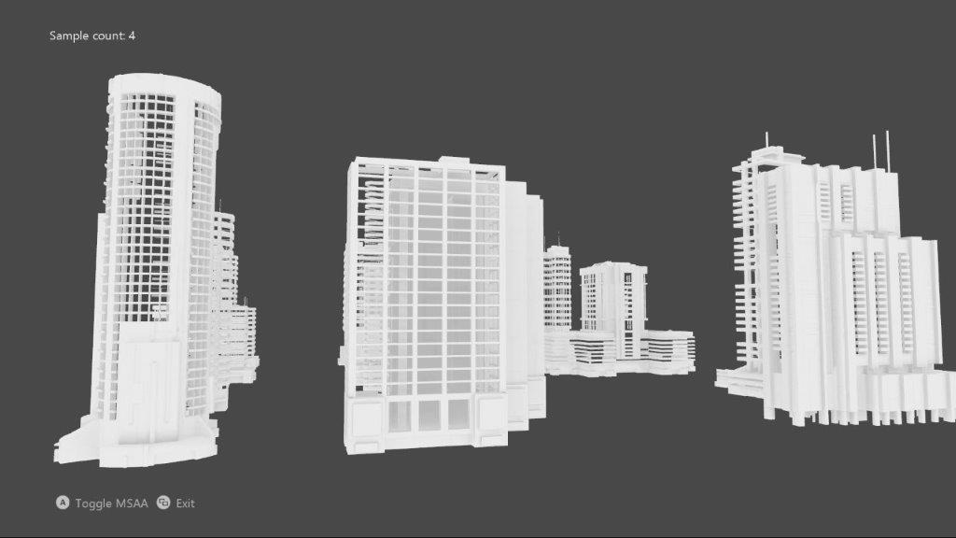

# Description

This sample implements an MSAA render target & depth/stencil buffer for a 3D scene using DirectX 11.

# Using the sample

|  |  |  |
| --- | --- | --- |
| Action | Gamepad | Keyboard |
| Toggle MSAA vs. single-sample | A button | Space |
| Exit | View Button | Esc |

# Implementation notes

The UI is drawn without MSAA, and makes use of an explicit resolve. Note that UWP does not support using an implicit resolve of an MSAA swapchain as was the case with ‘classic’ DirectX 11. See [Multisampling in Universal Windows Platform (UWP) apps](https://docs.microsoft.com/en-us/windows/uwp/gaming/multisampling--multi-sample-anti-aliasing--in-windows-store-apps).

# Update history

Initial release May 2017

# Privacy Statement

When compiling and running a sample, the file name of the sample executable will be sent to Microsoft to help track sample usage. To opt-out of this data collection, you can remove the block of code in Main.cpp labeled “Sample Usage Telemetry”.

For more information about Microsoft’s privacy policies in general, see the [Microsoft Privacy Statement](https://privacy.microsoft.com/en-us/privacystatement/).