

Memory Statistics Sample

*This sample is compatible with the Windows 10 Creators Update SDK (15063)*

# Description

This sample demonstrates querying memory usage at runtime in your UWP applications. The primary API used is GetProcessMemoryInfo to grab a snapshot of resources used by the application. The sample demonstrates grabbing snapshots of the general application, and comparing before and after snapshots of individual functions to determine memory used by those components.

# Using the sample

This sample displays information about the memory usage in the sample. It initially displays a single model in 3D space. More models can be created at runtime to see how they affect resource usage.

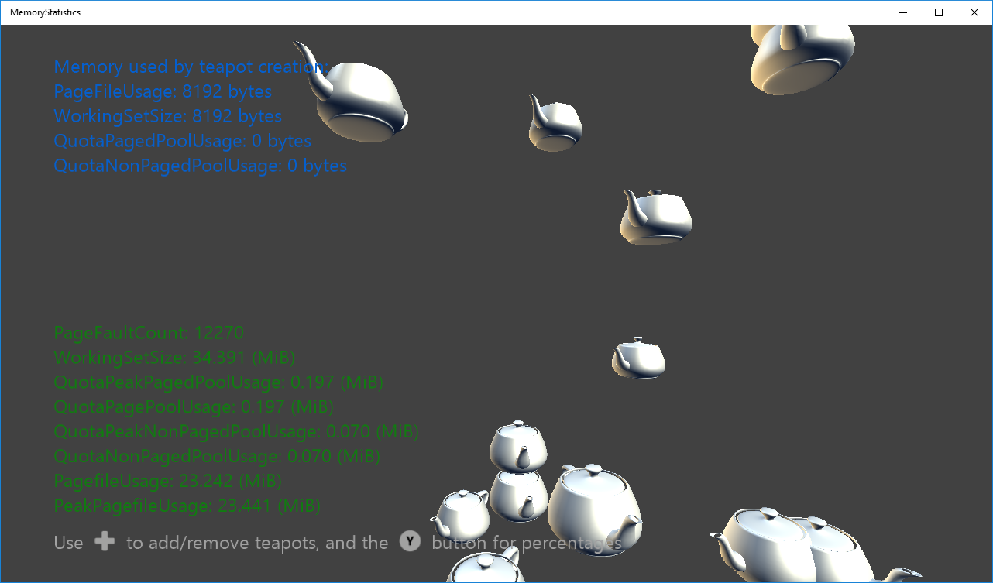

|  |  |  |
| --- | --- | --- |
| Action | Gamepad | Keyboard |
| Increase the number of teapots | DPad Right | Right arrow |
| Decrease the number of teapots | DPad Left | Left arrow |
| Display information about how resource usage at any point during runtime compares to immediately after initialization. | Y button | P |
| Exit | View Button | Esc |

If resource usage displayed by the Y button/P key consistently increases during gameplay this could indicate a memory leak or inefficient resource management.

# Implementation notes

This sample shows three ways the **GetProcessMemoryInfo** API can be used to track memory information.

* It takes a capture of resource usage at the end of the **Initialize** function to compare at any time with resource usage at runtime.
* It takes a capture before and after creating a new teapot to determine how much memory is required for any single operation.
* It also tracks total memory usage to view.

*The* ***GetProcessMemoryInfo*** *API requires linking with kernel32.lib. For this reason, it cannot be used in a version of your game that will be released as it will fail the WACK tool. It can only be used for internal testing and debug builds.*

# Update history

* Initial release – April 2016

# Privacy statement

When compiling and running a sample, the file name of the sample executable will be sent to Microsoft to help track sample usage. To opt-out of this data collection, you can remove the block of code in Main.cpp labeled “Sample Usage Telemetry”.

For more information about Microsoft’s privacy policies in general, see the [Microsoft Privacy Statement](https://privacy.microsoft.com/en-us/privacystatement/).