SystemInfo Sample

*This sample is compatible with the Windows 10 Creators Update SDK (15063)*

# Description

This sample demonstrates a number of Universal Windows Platform (UWP) APIs for querying system information, statistics, and hardware capabilities.

# Using the sample

This sample displays a series of text pages with technical information.

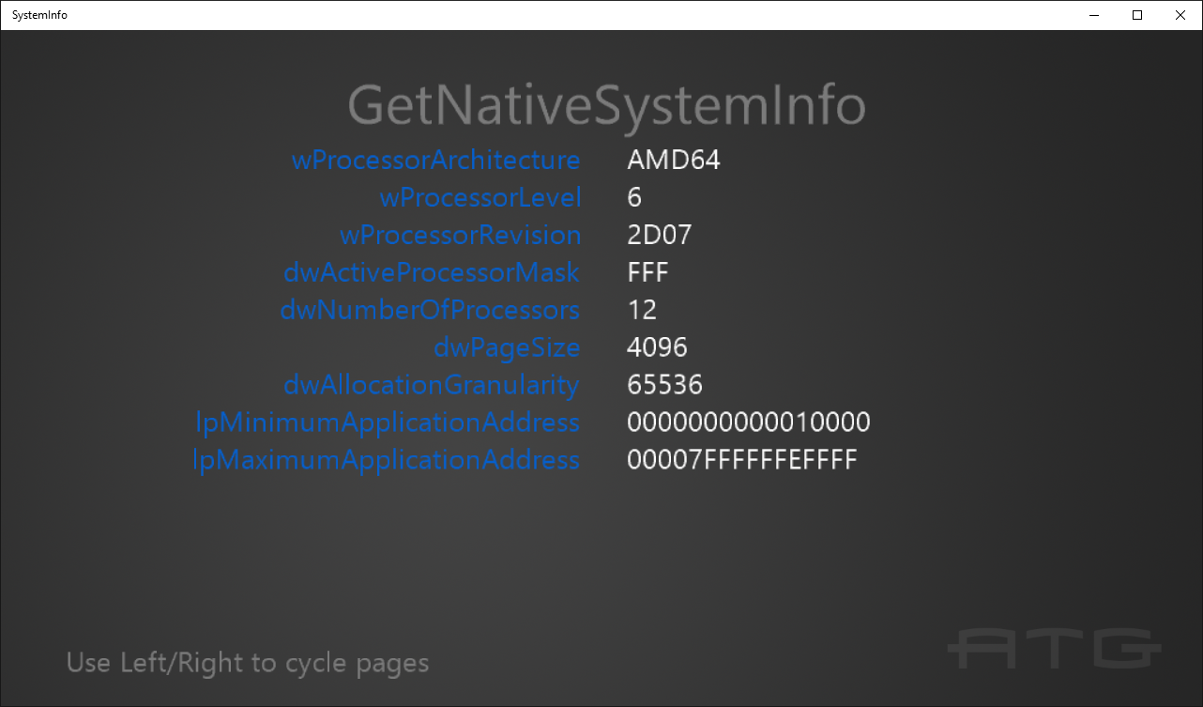

To switch between pages with the keyboard, use the left & right arrow keys.

To switch between pages with the gamepad controller, use A or DPad Right / B or DPad Left.

# Implementation notes

The important code is in the switch case within the **Render** function.

# Update history

Initial release March 2016. It was updated in August 2016 for new Windows 10 Anniversary Update SDK APIs.

December 2016: Added EasClientInformation output.

February 2017: Added DisplayInformation including new Anniversary Update (14393) properties.

# Privacy statement

When compiling and running a sample, the file name of the sample executable will be sent to Microsoft to help track sample usage. To opt-out of this data collection, you can remove the block of code in Main.cpp labeled “Sample Usage Telemetry”.

For more information about Microsoft’s privacy policies in general, see the [Microsoft Privacy Statement](https://privacy.microsoft.com/en-us/privacystatement/).