Advanced Spatial Sound Sample

# *This sample is compatible Windows 10 Creators Update SDK (15063)*

# Description

This sample demonstrates how use ISpatialAudioClient to playback both static and dynamic positional audio using Windows Sonic technologies in a Universal Windows Platform (UWP) app. The static bed plays on startup and dynamic sounds that follow random paths can be added and removed

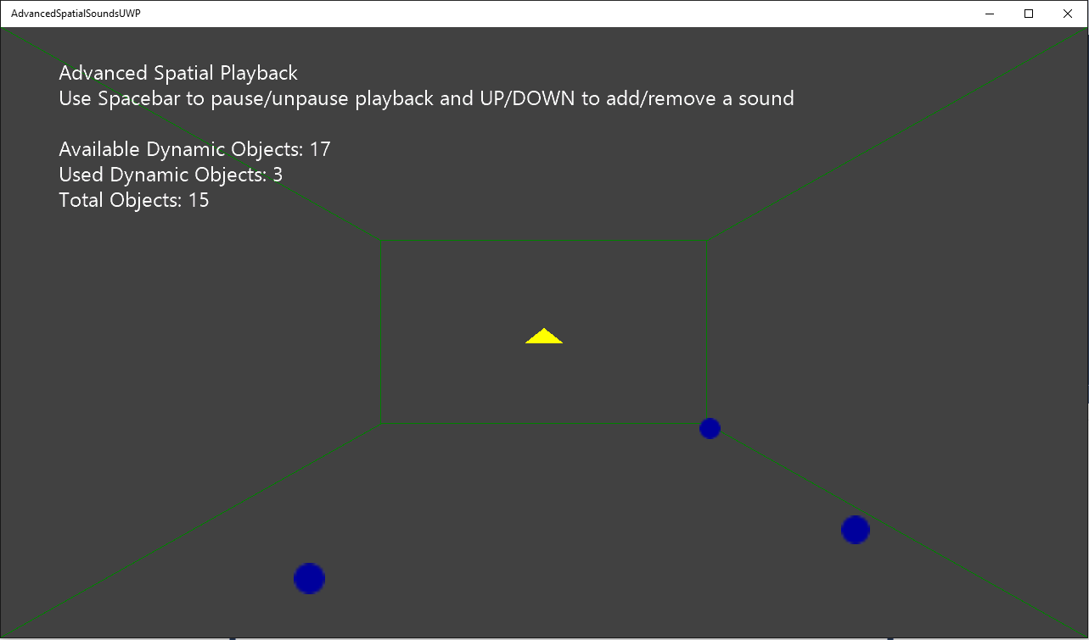

# Using the sample

|  |  |
| --- | --- |
| Action | Keyboard |
| Add a dynamic sound | Up |
| Remove a dynamic sound | Down |

# Implementation notes

This sample demonstrates how to use ISpatialAudioClient to play static and dynamic positional sound using spatial technologies. Once ISpatialAudioClient has been initialized and started, it uses the callback to request buffer frames.

# Privacy statement

When compiling and running a sample, the file name of the sample executable will be sent to Microsoft to help track sample usage. To opt-out of this data collection, you can remove the block of code in Main.cpp labeled “Sample Usage Telemetry”.

For more information about Microsoft’s privacy policies in general, see the [Microsoft Privacy Statement](https://privacy.microsoft.com/en-us/privacystatement/).

# Update history

Initial release March 2017