Simple Spatial Sound Sample

*This sample is compatible with the Windows 10 Fall Creators Update SDK (16299). Requires the Windows 10 Creators Update or later.*

# Description

This sample demonstrates how use ISpatialAudioClient to playback static audio with height channels using Windows Sonic technologies in a Universal Windows Platform (UWP) app. There are two file choices for playback with keyboard controls to start/stop, pause/play, and file select.

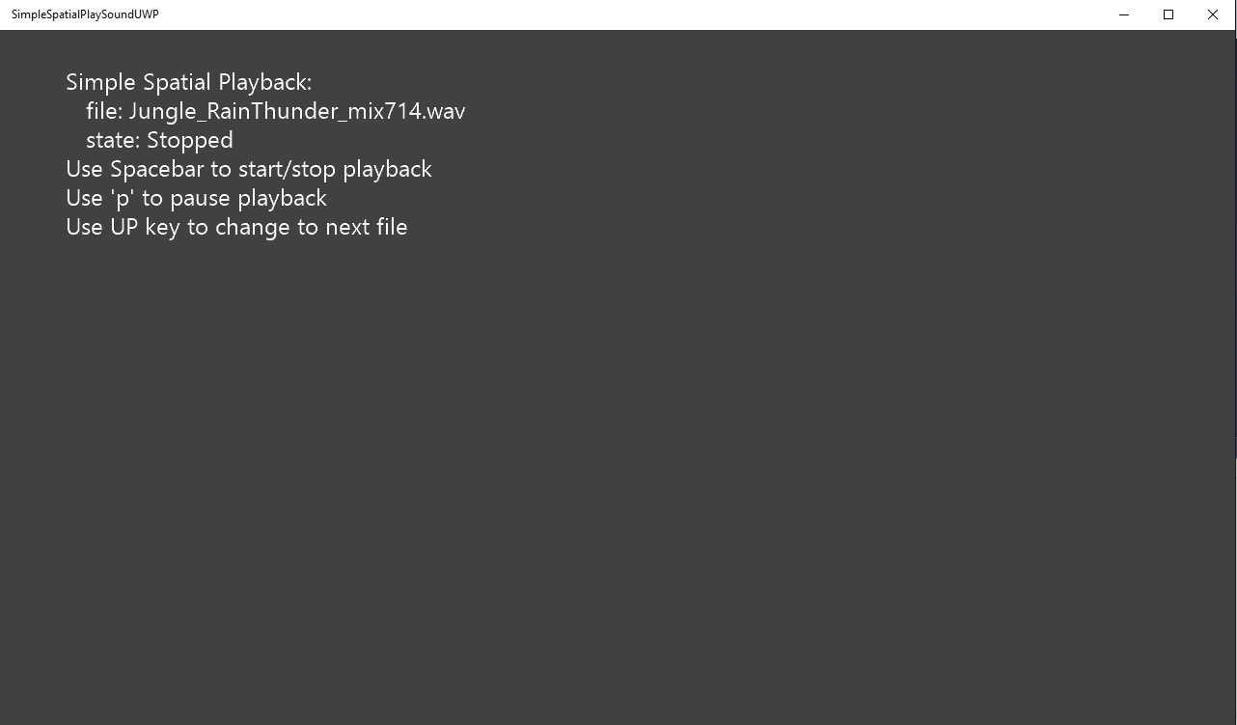

# Using the sample

|  |  |
| --- | --- |
| Action | Keyboard |
| Start/Stop | Space |
| Pause/Play | p |
| Cycle Next File | UP |

# Implementation notes

This sample demonstrates how to use ISpatialAudioClient to play static bed sound using spatial technologies. Once ISpatialAudioClient has been initialized and started, it uses the callback to request buffer frames.

# Privacy statement

When compiling and running a sample, the file name of the sample executable will be sent to Microsoft to help track sample usage. To opt-out of this data collection, you can remove the block of code in Main.cpp labeled “Sample Usage Telemetry”.

For more information about Microsoft’s privacy policies in general, see the [Microsoft Privacy Statement](https://privacy.microsoft.com/en-us/privacystatement/).

# Update history

Initial release March 2017